Practice Problems: Chapter 17, Maintenance and Reliability

Problem 1:

California Instruments, Inc., produces 3,000 computer chips per day. Three hundred are tested for a period of 500 operating hours each. During the test, six failed: two after 50 hours, two at 100 hours, one at 300 hours, and one at 400 hours.

Find FR(%) and FR(N).

Problem 2:

If 300 of these chips are used in building a mainframe computer, how many failures of the computer can be expected per month?

Problem 3:

Find the reliability of this system:

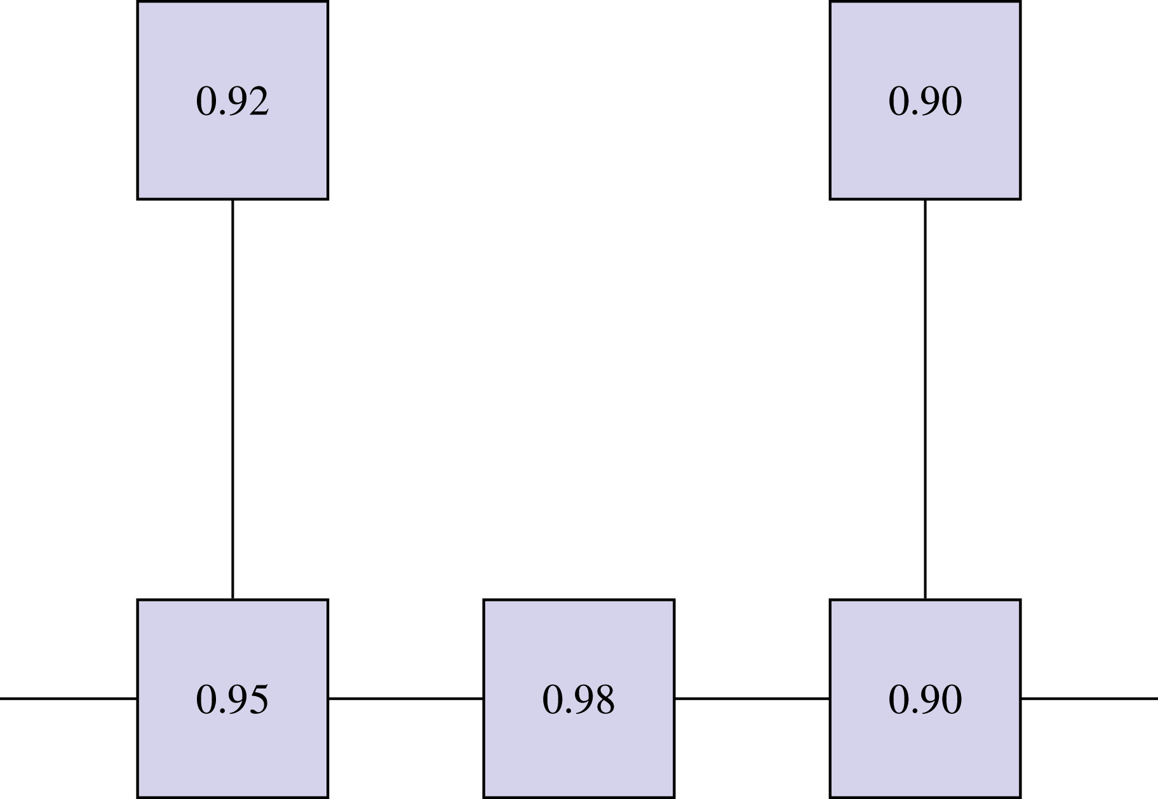

Problem 4:

Given the probabilities below, calculate the expected breakdown cost.

Number of Breakdowns | Daily Frequency
0 | 3
1 | 2
2 | 2
3 | 3

Assume a cost of $10 per breakdown.

ANSWERS

Problem 1:

FR(%) = failures per number tested = 6/300 = 0.02 = 2%
FR(N) = failures per operating time:
Total time = 300 * 500 = 150,000 hours
Downtime = 2(450) + 2(400) + 1(200) + 1(100) = 2,000 hours
Operating time = Total time – Downtime = 150,000 – 2,000 = 148,000
Therefore: FR(N) = 6/148,000 = 0.0000405 failures/hour
MTBF = 1/FR(N) = 24,691 hours

Problem 2:

Converting the units of FR(N) to months:
FR(N) = 0.0000405 * 24 hours/day * 30 days/month = 0.029 failures/month

FR(N) for the 300 units:
FR(N) = 0.029 failures/month * 300 units = 8.75 failures/month

MTBF for the mainframe:
MTBF = 1/FR(N) = 1/8.75 = 0.11 month = 0.11 * 30 = 3.4 days

Calculation for MTBF assumes that failure of any one chip brings down entire system.

Problem 3:

Problem 4:

Number of Breakdowns | Daily Frequency | Probability
0 | 3 | 0.3
1 | 2 | 0.2
2 | 2 | 0.2
3 | 3 | 0.3

Expected number of breakdowns = (0)(0.3) + (1)(0.2) + (2)(0.2) + (3)(0.3)
= 0 + 0.2 + 0.4 + 0.9
= 1.5 breakdowns/day

Expected breakdown cost = Expected number of breakdowns * Cost per breakdown
= 1.5 * $10
= $15/day

