Practical 4

**Aim:**

Create user feedback form using textbox, textarea, checkbox, radio button, select box, button etc.

**Code:**

**Index.html**

<!DOCTYPE html>

<html lang="en">

  <head>

    <meta charset="UTF-8" />

    <meta http-equiv="X-UA-Compatible" content="IE=edge" />

    <meta name="viewport" content="width=device-width, initial-scale=1.0" />

    <link rel="stylesheet" href="main.css" />

    <title>IEEE Event FeedBack Form</title>

  </head>

  <body>

    <form method="POST" action="#">

      <h1>IEEE Event FeedBack Form</h1>

      <input

        name="name"

        type="text"

        class="feedback-input"

        placeholder="Name"

      />

      <input

        name="email"

        type="email"

        class="feedback-input"

        placeholder="Email"

      />

      <div class="drop-down-list">

        <label for="events">Choose an event:</label>

        <select name="events" id="events">

          <option value="mastering-c">Mastering C</option>

          <option value="fresh-code-1.0">Fresh Code 1.0</option>

          <option value="spo">SPO Webinar</option>

          <option value="i-quest" selected>iQuest</option>

        </select>

      </div>

      <div class="drop-down-list">

        <label for="ratings">Your ratings...:</label>

        <select name="ratings" id="ratings">

          <option value="1">Poor ;(</option>

          <option value="2">Bad :(</option>

          <option value="3">Ok Ok :|</option>

          <option value="4">Good :)</option>

          <option value="5" selected>Exceptional! ;)</option>

        </select>

      </div>

      <textarea

        name="text"

        class="feedback-input"

        placeholder="Tell us more about it..."

      ></textarea>

      <input type="submit" value="SUBMIT" />

    </form>

  </body>

</html>

**Main.css**

@import url(https://fonts.googleapis.com/css?family=Montserrat:400,700);

body {

  background: rgb(30, 30, 40);

}

h1,

h2 {

  color: #cc4949;

  text-align: center;

  font-family: "Montserrat", Arial, Helvetica, sans-serif;

}

form {

  max-width: 420px;

  margin: 50px auto;

}

.feedback-input,

.drop-down-list {

  color: white;

  font-family: Helvetica, Arial, sans-serif;

  font-weight: 500;

  font-size: 18px;

  border-radius: 5px;

  line-height: 22px;

  background-color: transparent;

  border: 2px solid #cc6666;

  transition: all 0.3s;

  padding: 13px;

  margin-bottom: 15px;

  width: 100%;

  box-sizing: border-box;

  outline: 0;

}

.drop-down-list label,

::placeholder {

  color: #a9a9a9;

}

.feedback-input:focus,

.drop-down-list select:focus {

  border: 2px solid #cc4949;

}

.drop-down-list select {

  border: none;

  background-color: rgb(30, 30, 40);

  margin-left: 1rem;

  padding: 0.5rem;

  color: white;

  font-family: Helvetica, Arial, sans-serif;

  font-weight: 500;

  font-size: 18px;

}

textarea {

  height: 150px;

  line-height: 150%;

  resize: vertical;

}

[type="submit"] {

  font-family: "Montserrat", Arial, Helvetica, sans-serif;

  width: 100%;

  background: #cc6666;

  border-radius: 5px;

  border: 0;

  cursor: pointer;

  color: white;

  font-size: 24px;

  padding-top: 10px;

  padding-bottom: 10px;

  transition: all 0.3s;

  margin-top: -4px;

  font-weight: 700;

}

[type="submit"]:hover {

  background: #cc4949;

}

**Screenshot:**

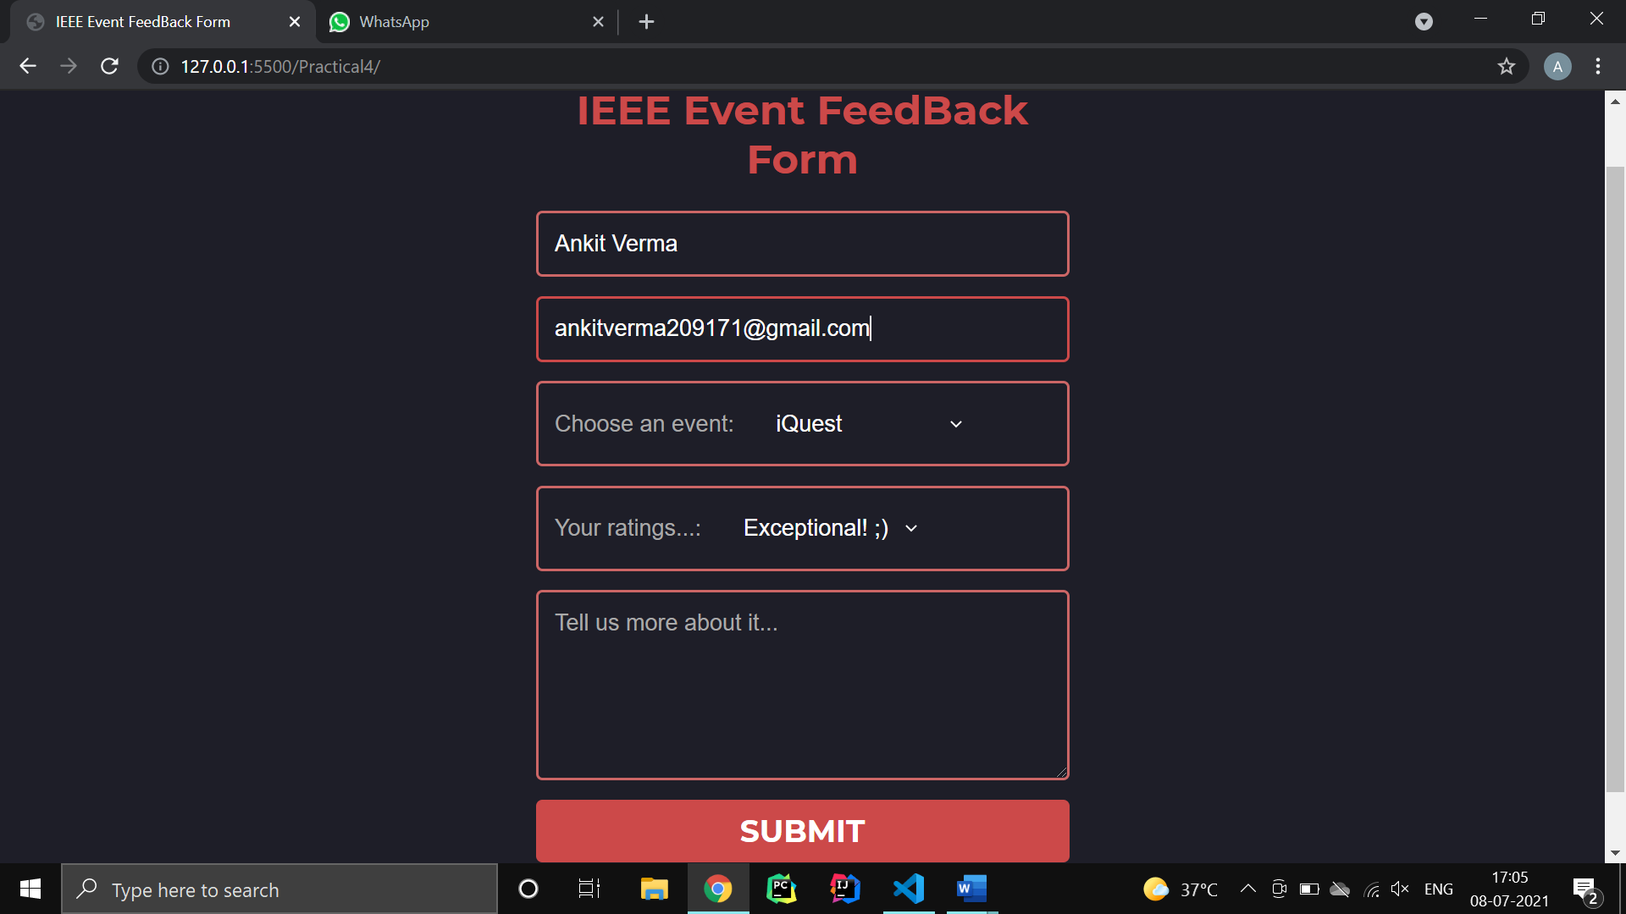

Practical 5

**Aim:**

Create a web page using frame. Divide the page into two parts with Navigation links on left hand side of page (width=20%) and content page on right hand side of page (width = 80%). On clicking the navigation Links corresponding content must be shown on the right hand side.

**Code:**

**Index.html**

<!DOCTYPE html>

<html lang="en">

  <head>

    <meta charset="UTF-8" />

    <meta http-equiv="X-UA-Compatible" content="IE=edge" />

    <meta name="viewport" content="width=device-width, initial-scale=1.0" />

    <title>Portfolio</title>

    <style>

      * {

        margin: 0;

        padding: 0;

        box-sizing: border-box;

      }

    </style>

  </head>

  <body>

    <iframe

      src="nav-frame.html"

      frameborder="0"

      scrolling="yes"

      style="

        overflow: hidden;

        height: 100vh;

        width: 20%;

        float: left;

        color: black;

      "

      align="left"

    >

    </iframe>

    <iframe

      src="me.html"

      frameborder="0"

      scrolling="yes"

      style="overflow: hidden; height: 100vh; position: absolute; width: 80%"

      align="right"

      name="content"

    >

    </iframe>

  </body>

</html>

**Me.html**

<!DOCTYPE html>

<html lang="en">

  <head>

    <meta charset="UTF-8" />

    <meta http-equiv="X-UA-Compatible" content="IE=edge" />

    <meta name="viewport" content="width=device-width, initial-scale=1.0" />

    <title>Navigation</title>

    <link rel="stylesheet" href="css/main.css" />

  </head>

  <body>

    <script src="https://kit.fontawesome.com/b99e675b6e.js"></script>

    <div class="wrapper">

      <div class="main_content">

        <div class="header"><h1>Hi, I'm Ankit</h1></div>

        <div class="info">

          <div>I'm an IT Student.</div>

          <div>

            Lorem ipsum dolor sit, amet consectetur adipisicing elit. A sed

            nobis ut exercitationem atque accusamus sit natus officiis totam

            blanditiis at eum nemo, nulla et quae eius culpa eveniet

            voluptatibus repellat illum tenetur, facilis porro. Quae fuga odio

            perferendis itaque alias sint, beatae non maiores magnam ad, veniam

            tenetur atque ea exercitationem earum eveniet totam ipsam magni

            tempora aliquid ullam possimus? Tempora nobis facere porro,

            praesentium magnam provident accusamus temporibus! Repellendus harum

            veritatis itaque molestias repudiandae ea corporis maiores non

            obcaecati libero, unde ipsum consequuntur aut consectetur culpa

            magni omnis vero odio suscipit vitae dolor quod dignissimos

            perferendis eos? Consequuntur!

          </div>

          <div>

            Lorem ipsum dolor sit, amet consectetur adipisicing elit. A sed

            nobis ut exercitationem atque accusamus sit natus officiis totam

            blanditiis at eum nemo, nulla et quae eius culpa eveniet

            voluptatibus repellat illum tenetur, facilis porro. Quae fuga odio

            perferendis itaque alias sint, beatae non maiores magnam ad, veniam

            tenetur atque ea exercitationem earum eveniet totam ipsam magni

            tempora aliquid ullam possimus? Tempora nobis facere porro,

            praesentium magnam provident accusamus temporibus! Repellendus harum

            veritatis itaque molestias repudiandae ea corporis maiores non

            obcaecati libero, unde ipsum consequuntur aut consectetur culpa

            magni omnis vero odio suscipit vitae dolor quod dignissimos

            perferendis eos? Consequuntur!

          </div>

        </div>

      </div>

    </div>

  </body>

</html>

**Nav-frame.html**

<!DOCTYPE html>

<html lang="en">

  <head>

    <meta charset="UTF-8" />

    <meta http-equiv="X-UA-Compatible" content="IE=edge" />

    <meta name="viewport" content="width=device-width, initial-scale=1.0" />

    <title>Navigation</title>

    <link rel="stylesheet" href="css/main.css" />

  </head>

  <body>

    <script src="https://kit.fontawesome.com/b99e675b6e.js"></script>

    <div class="wrapper">

      <div class="nav">

        <h2>Nav</h2>

        <ul>

          <li>

            <a href="me.html" target="content"

              ><i class="fas fa-home"></i>Home

            </a>

          </li>

          <li>

            <a href="https://en.wikipedia.org/wiki/Main_Page" target="content">

              <i class="fas fa-search"></i>Explore Something New

            </a>

          </li>

          <li>

            <a href="resume.html" target="content"

              ><i class="fas fa-file"></i>Resume

            </a>

          </li>

        </ul>

      </div>

    </div>

  </body>

</html>

**Resume.html**

<!DOCTYPE html>

<html lang="en">

  <head>

    <meta charset="UTF-8" />

    <meta http-equiv="X-UA-Compatible" content="IE=edge" />

    <meta name="viewport" content="width=device-width, initial-scale=1.0" />

    <link

      href="https://fonts.googleapis.com/css?family=Lato:400,300,700"

      rel="stylesheet"

      type="text/css"

    />

    <link rel="stylesheet" href="css/style.css" />

    <title>Ankit Verma | Web Dev - Resume</title>

  </head>

  <body>

    <div class="container">

      <div class="header">

        <div class="full-name">

          <span class="first-name">Ankit</span>

          <span class="last-name">Verma</span>

        </div>

        <div class="contact-info">

          <span class="email">Email: </span>

          <span class="email-val">ankitverma209171@gmail.com</span>

          <span class="separator"></span>

          <span class="phone">Phone: </span>

          <span class="phone-val">932-711-4805</span>

        </div>

        <div class="about">

          <span class="position">Full-Stack Developer </span>

          <span class="desc">

            I am a full-stack developer with more than 1 years of experience

            writing html, css, and js for front-end and django as back-end. I'm

            motivated, result-focused and seeking a successful team-oriented

            company with opportunity to grow.

          </span>

        </div>

      </div>

      <div class="details">

        <div class="section">

          <div class="section__title">Experience</div>

          <div class="section__list">

            <div class="section__list-item">

              <div class="left">

                <div class="name">Freelancer</div>

                <div class="addr">Upwork</div>

                <div class="duration">July 2021 - Current</div>

              </div>

              <div class="right">

                <div class="name">Web Dev</div>

                <div class="desc">

                  Build Web Solutions with latest technologies in industry

                </div>

              </div>

            </div>

            <div class="section__list-item">

              <div class="left">

                <div class="name">Vision Web Solutions</div>

                <div class="addr">Ahmedabad, Gujarat, India</div>

                <div class="duration">Dec 2020 - Feb 2021</div>

              </div>

              <div class="right">

                <div class="name">Web Dev Intern</div>

                <div class="desc">

                  Build support APIs for BuuyIt (E-commerce solution)

                </div>

              </div>

            </div>

          </div>

        </div>

        <div class="section">

          <div class="section__title">Education</div>

          <div class="section__list">

            <div class="section__list-item">

              <div class="left">

                <div class="name">VGEC</div>

                <div class="addr">Ahmedabad, Gujarat, India</div>

                <div class="duration">Aug 2019 - Current</div>

              </div>

              <div class="right">

                <div class="name">Information Technology</div>

                <div class="desc">Bachelor of Engineering (CGPA - 8.75)</div>

              </div>

            </div>

            <div class="section__list-item">

              <div class="left">

                <div class="name">GSFC School</div>

                <div class="addr">Vadodara, Gujarat, India</div>

                <div class="duration">Jun 2017 - Mar 2019</div>

              </div>

              <div class="right">

                <div class="name">Science Stream</div>

                <div class="desc">GHSEB (89%)</div>

              </div>

            </div>

          </div>

        </div>

        <div class="section">

          <div class="section__title">Projects</div>

          <div class="section__list">

            <div class="section__list-item">

              <div class="name">Exam Shield</div>

              <div class="text">

                Exam Shield is an fool-proof examination system developed with

                rich features to conduct fair examinations and evaluations of

                the students online. <b>Technologies:</b> Django | CSS |

                Javascript

              </div>

            </div>

            <div class="section__list-item">

              <div class="name">Radhe Caterering Website</div>

              <div class="text">

                Radhe Caterering Website is a static website developed for

                creating business online presence and attract new customers

                online. <b>Technologies:</b> Django | CSS | Javascript

              </div>

            </div>

          </div>

        </div>

        <div class="section">

          <div class="section__title">Skills</div>

          <div class="skills">

            <div class="skills__item">

              <div class="left"><div class="name">Javascript</div></div>

              <div class="right">

                <input id="ck1" type="checkbox" checked />

                <label for="ck1"></label>

                <input id="ck2" type="checkbox" checked />

                <label for="ck2"></label>

                <input id="ck3" type="checkbox" checked />

                <label for="ck3"></label>

                <input id="ck4" type="checkbox" />

                <label for="ck4"></label>

                <input id="ck5" type="checkbox" />

                <label for="ck5"></label>

              </div>

            </div>

          </div>

          <div class="skills__item">

            <div class="left"><div class="name">CSS</div></div>

            <div class="right">

              <input id="ck1" type="checkbox" checked />

              <label for="ck1"></label>

              <input id="ck2" type="checkbox" checked />

              <label for="ck2"></label>

              <input id="ck3" type="checkbox" checked />

              <label for="ck3"></label>

              <input id="ck4" type="checkbox" checked />

              <label for="ck4"></label>

              <input id="ck5" type="checkbox" />

              <label for="ck5"></label>

            </div>

          </div>

          <div class="skills__item">

            <div class="left"><div class="name">Django</div></div>

            <div class="right">

              <input id="ck1" type="checkbox" checked />

              <label for="ck1"></label>

              <input id="ck2" type="checkbox" checked />

              <label for="ck2"></label>

              <input id="ck3" type="checkbox" checked />

              <label for="ck3"></label>

              <input id="ck4" type="checkbox" checked />

              <label for="ck4"></label>

              <input id="ck5" type="checkbox" checked />

              <label for="ck5"></label>

            </div>

          </div>

        </div>

        <div class="section">

          <div class="section__title">Interests</div>

          <div class="section__list">

            <div class="section__list-item">Reading, drawing, programming.</div>

          </div>

        </div>

      </div>

    </div>

  </body>

</html>

**Main.css**

@import url("https://fonts.googleapis.com/css?family=Josefin+Sans&display=swap");

* {

  margin: 0;

  padding: 0;

  box-sizing: border-box;

  list-style: none;

  text-decoration: none;

  font-family: "Josefin Sans", sans-serif;

}

body {

  background-color: #f3f5f9;

}

.wrapper {

  display: flex;

  position: relative;

}

.wrapper .nav {

  width: 100%;

  height: 100%;

  background: #4b4276;

  padding: 30px 0px;

  position: fixed;

}

.wrapper .nav h2 {

  color: #fff;

  text-transform: uppercase;

  text-align: center;

  margin-bottom: 30px;

}

.wrapper .nav ul li {

  padding: 15px;

  border-bottom: 1px solid #bdb8d7;

  border-bottom: 1px solid rgba(0, 0, 0, 0.05);

  border-top: 1px solid rgba(255, 255, 255, 0.05);

}

.wrapper .nav ul li a {

  color: #bdb8d7;

  display: block;

}

.wrapper .nav ul li a .fas {

  width: 25px;

}

.wrapper .nav ul li:hover {

  background-color: #594f8d;

}

.wrapper .nav ul li:hover a {

  color: #fff;

}

.wrapper .main_content {

  width: 100%;

}

.wrapper .main_content .header {

  padding: 20px;

  background: #fff;

  color: #717171;

  border-bottom: 1px solid #e0e4e8;

}

.wrapper .main_content .info {

  margin: 20px;

  color: #717171;

  line-height: 25px;

}

.wrapper .main_content .info div {

  margin-bottom: 20px;

}

**Style.css**

* {

  margin: 0;

  padding: 0;

  box-sizing: border-box;

}

html {

  height: 100%;

}

body {

  min-height: 100%;

  background: #eee;

  font-family: "Lato", sans-serif;

  font-weight: 400;

  color: #222;

  font-size: 14px;

  line-height: 26px;

  padding-bottom: 50px;

}

.container {

  max-width: 700px;

  background: #fff;

  margin: 0px auto 0px;

  box-shadow: 1px 1px 2px #dad7d7;

  border-radius: 3px;

  padding: 40px;

  margin-top: 50px;

}

.header {

  margin-bottom: 30px;

}

.header .full-name {

  font-size: 40px;

  text-transform: uppercase;

  margin-bottom: 5px;

}

.header .first-name {

  font-weight: 700;

}

.header .last-name {

  font-weight: 300;

}

.header .contact-info {

  margin-bottom: 20px;

}

.header .email,

.header .phone {

  color: #999;

  font-weight: 300;

}

.header .separator {

  height: 10px;

  display: inline-block;

  border-left: 2px solid #999;

  margin: 0px 10px;

}

.header .position {

  font-weight: bold;

  display: inline-block;

  margin-right: 10px;

  text-decoration: underline;

}

.details {

  line-height: 20px;

}

.details .section {

  margin-bottom: 40px;

}

.details .section:last-of-type {

  margin-bottom: 0px;

}

.details .section__title {

  letter-spacing: 2px;

  color: #54afe4;

  font-weight: bold;

  margin-bottom: 10px;

  text-transform: uppercase;

}

.details .section__list-item {

  margin-bottom: 40px;

}

.details .section__list-item:last-of-type {

  margin-bottom: 0;

}

.details .left,

.details .right {

  vertical-align: top;

  display: inline-block;

}

.details .left {

  width: 60%;

}

.details .right {

  text-align: right;

  width: 39%;

}

.details .name {

  font-weight: bold;

}

.details a {

  text-decoration: none;

  color: #000;

  font-style: italic;

}

.details a:hover {

  text-decoration: underline;

  color: #000;

}

.details .skills__item {

  margin-bottom: 10px;

}

.details .skills__item .right input {

  display: none;

}

.details .skills__item .right label {

  display: inline-block;

  width: 20px;

  height: 20px;

  background: #c3def3;

  border-radius: 20px;

  margin-right: 3px;

}

.details .skills__item .right input:checked + label {

  background: #79a9ce;

}

**Screenshot:**

**Resume**

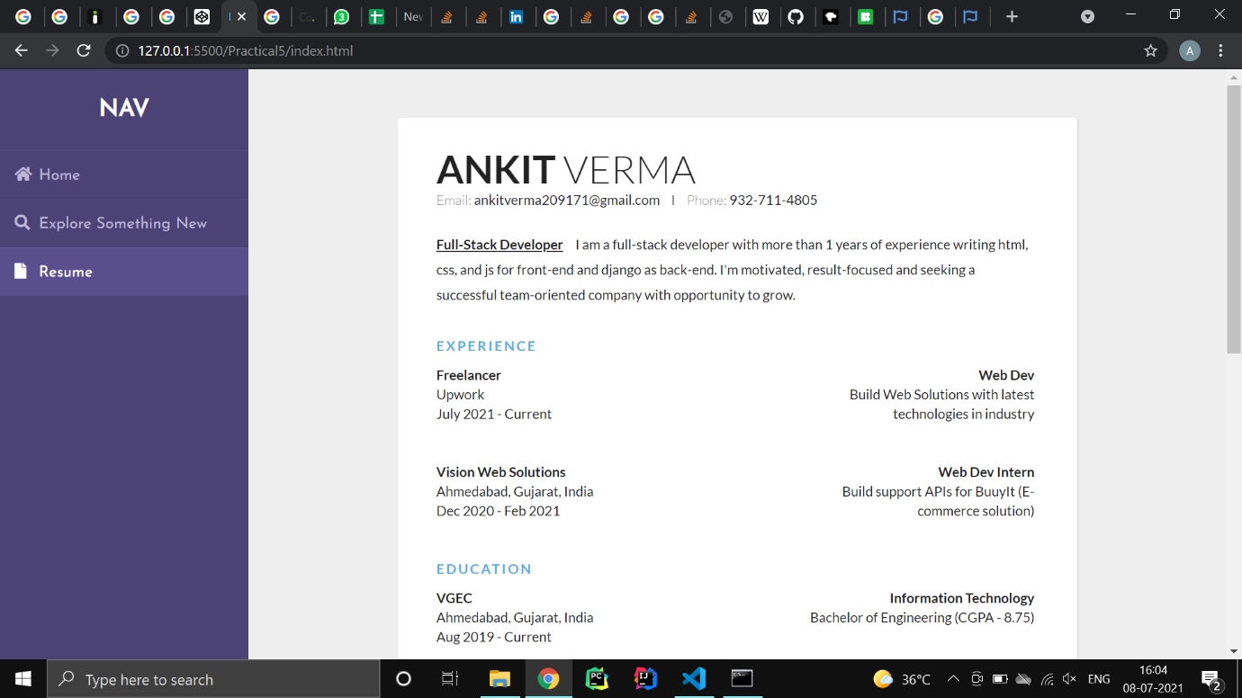

**Explore Something New - Mozilla**

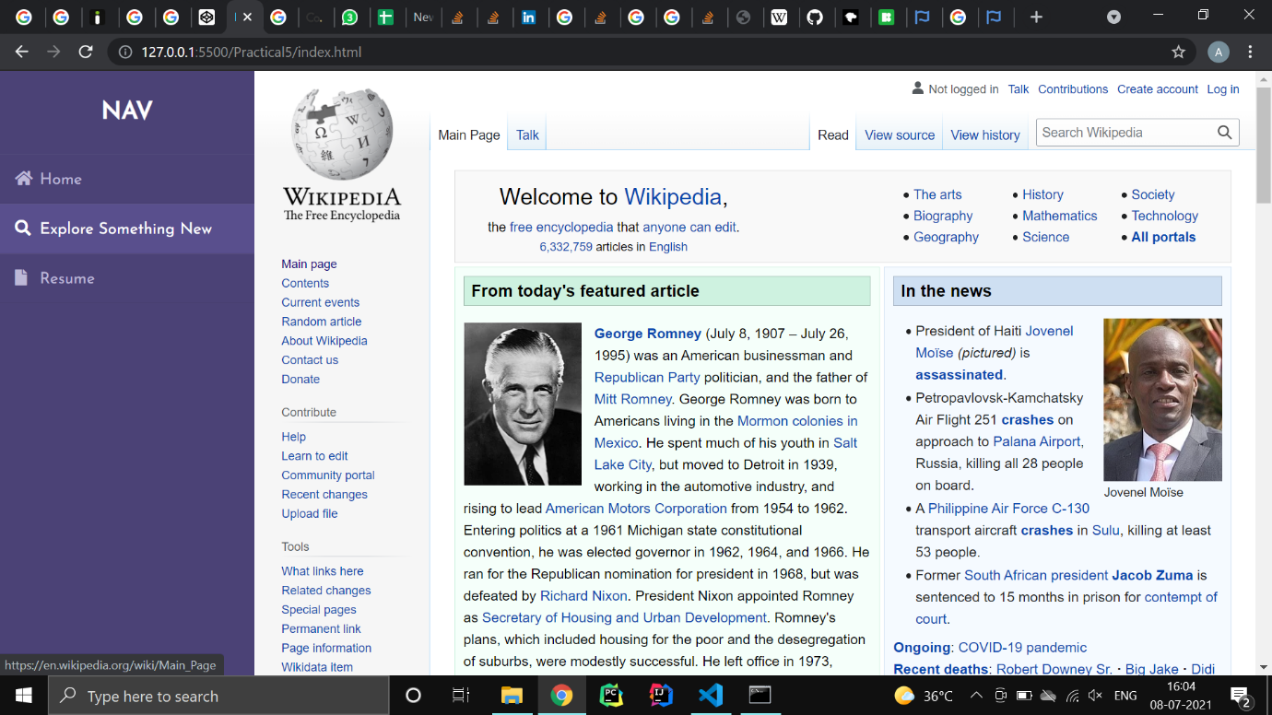

Practical 6

**Aim:**

Write html code to develop a webpage having two frames that divide the webpage into two equal rows and then divide the row into equal columns fill each frame with a different background color.

**Code:**

**Index.html**

<!DOCTYPE html>

<html lang="en">

  <head>

    <meta charset="UTF-8" />

    <meta http-equiv="X-UA-Compatible" content="IE=edge" />

    <meta name="viewport" content="width=device-width, initial-scale=1.0" />

    <title>Document</title>

    <style>

      * {

        margin: 0;

        padding: 0;

        box-sizing: border-box;

      }

    </style>

  </head>

  <body>

    <iframe

      src="top-iframe.html"

      frameborder="0"

      scrolling="yes"

      style="overflow: hidden; height: 50vh; width: 100%"

      name="top"

    >

    </iframe>

    <iframe

      src="bottom-iframe.html"

      frameborder="0"

      scrolling="yes"

      style="overflow: hidden; height: 50vh; width: 100%"

      name="bottom"

    >

    </iframe>

  </body>

</html>

**Top-iframe.html**

<!DOCTYPE html>

<html lang="en">

  <head>

    <meta charset="UTF-8" />

    <meta http-equiv="X-UA-Compatible" content="IE=edge" />

    <meta name="viewport" content="width=device-width, initial-scale=1.0" />

    <title>Document</title>

    <style>

      * {

        margin: 0;

        padding: 0;

        box-sizing: border-box;

      }

    </style>

  </head>

  <body>

    <iframe

      src="top-left.html"

      frameborder="0"

      scrolling="yes"

      style="overflow: hidden; height: 100vh; width: 50%; float: left"

      align="left"

    >

    </iframe>

    <iframe

      src="top-right.html"

      frameborder="0"

      scrolling="yes"

      style="overflow: hidden; height: 100vh; width: 50%"

      align="right"

      name="content"

    >

    </iframe>

  </body>

</html>

**Bottom-iframe.html**

<!DOCTYPE html>

<html lang="en">

  <head>

    <meta charset="UTF-8" />

    <meta http-equiv="X-UA-Compatible" content="IE=edge" />

    <meta name="viewport" content="width=device-width, initial-scale=1.0" />

    <title>Document</title>

    <style>

      * {

        margin: 0;

        padding: 0;

        box-sizing: border-box;

      }

    </style>

  </head>

  <body>

    <iframe

      src="bottom-left.html"

      frameborder="0"

      scrolling="yes"

      style="overflow: hidden; height: 100vh; width: 50%; float: left"

      align="left"

    >

    </iframe>

    <iframe

      src="bottom-right.html"

      frameborder="0"

      scrolling="yes"

      style="overflow: hidden; height: 100vh; width: 50%"

      align="right"

      name="content"

    ></iframe>

  </body>

</html>

**Top-left.html**

<!DOCTYPE html>

<html lang="en">

  <head>

    <meta charset="UTF-8" />

    <meta http-equiv="X-UA-Compatible" content="IE=edge" />

    <meta name="viewport" content="width=device-width, initial-scale=1.0" />

    <style>

      * {

        margin: 0;

        padding: 0;

        box-sizing: border-box;

        background-color: rgb(255, 255, 255);

      }

    </style>

  </head>

  <body></body>

</html>

**Top-right.html**

<!DOCTYPE html>

<html lang="en">

  <head>

    <meta charset="UTF-8" />

    <meta http-equiv="X-UA-Compatible" content="IE=edge" />

    <meta name="viewport" content="width=device-width, initial-scale=1.0" />

    <style>

      * {

        margin: 0;

        padding: 0;

        box-sizing: border-box;

        background-color: rgb(0, 136, 255);

      }

    </style>

  </head>

  <body></body>

</html>

**Bottom-left.html**

<!DOCTYPE html>

<html lang="en">

  <head>

    <meta charset="UTF-8" />

    <meta http-equiv="X-UA-Compatible" content="IE=edge" />

    <meta name="viewport" content="width=device-width, initial-scale=1.0" />

    <style>

      * {

        margin: 0;

        padding: 0;

        box-sizing: border-box;

        background-color: rgb(0, 56, 105);

      }

    </style>

  </head>

  <body></body>

</html>

**Bottom-right.html**

<!DOCTYPE html>

<html lang="en">

  <head>

    <meta charset="UTF-8" />

    <meta http-equiv="X-UA-Compatible" content="IE=edge" />

    <meta name="viewport" content="width=device-width, initial-scale=1.0" />

    <style>

      * {

        margin: 0;

        padding: 0;

        box-sizing: border-box;

        background-color: rgb(0, 0, 0);

      }

    </style>

  </head>

  <body></body>

</html>

**Screenshot:**

