Practical 7

**Aim:**

Design a web page of your home town with an attractive background color, text color, an Image, font etc. (use internal CSS).

**Code:**

**Index.html**

<!DOCTYPE html>

<html lang="en">

  <head>

    <meta charset="UTF-8" />

    <meta http-equiv="X-UA-Compatible" content="IE=edge" />

    <meta name="viewport" content="width=device-width, initial-scale=1.0" />

    <style>

      * {

        margin: 0;

        padding: 0;

        font-family: Arial, Helvetica, sans-serif;

      }

      img {

        margin: 0 auto;

        max-width: 80%;

        display: block;

      }

      nav ul {

        padding: 0.6rem;

        text-transform: capitalize;

        font-weight: bolder;

        font-size: 1.5rem;

      }

      section {

        padding: 0.5rem;

      }

      h1 {

        font-size: 3rem;

        text-align: center;

      }

      p,

      h2 {

        margin: 1.7rem 0;

      }

      h2 {

        font-size: 2rem;

        text-align: center;

      }

      /* nav */

      nav ul {

        list-style-type: none;

        overflow: hidden;

        background-color: #003975;

      }

      nav li {

        display: inline;

        float: left;

      }

      nav li a {

        display: block;

        color: white;

        text-align: center;

        padding: 14px 16px;

        text-decoration: none;

      }

      nav li a:hover,

      .active {

        background-color: #072f5a;

        font-weight: bold;

      }

      /* footer */

      .footer {

        padding: 14px 0;

        left: 0;

        bottom: 0;

        width: 100%;

        background-color: #003975;

        color: white;

        text-align: center;

      }

      /* card */

      .card {

        border-radius: 5px;

        box-shadow: 0px 30px 40px -20px hsl(229, 6%, 66%);

        padding: 30px;

        margin: 20px;

      }

      .card .container p {

        line-height: 2.3rem;

      }

      .card:hover {

        box-shadow: 0 8px 16px 0 rgba(0, 0, 0, 0.2);

      }

      .container {

        padding: 2px 16px;

      }

    </style>

    <title>Vadodara</title>

  </head>

  <body>

    <nav>

      <ul>

        <li>

          <a href="#"><h1>Vadodara</h1></a>

        </li>

      </ul>

    </nav>

    <div class="card">

      <div class="container">

        <section class="intro">

          <h2>Introduction</h2>

          <img src="img/Laxmi_Vilas_Palace.jpg" alt="Expert Lecture" />

          <p>

            Vadodara, also known as Baroda, is the second-largest city in the

            Indian state of Gujarat. It serves as the administrative

            headquarters of the Vadodara district and is situated on the banks

            of the Vishwamitri River, 141 kilometres (88 mi) from the state

            capital of Gandhinagar. The railway line and National Highway 8,

            which connect Delhi with Mumbai, pass through Vadodara. The city is

            named for its abundance of Banyan (Vad) plants. Vadodara is also

            locally referred to as the Sanskari Nagari (transl. 'Cultural City')

            and Kala Nagari (transl. 'City of Art')[6] of India.

          </p>

          <p>

            The city is prominent for landmarks such as the Laxmi Vilas Palace,

            which served as the residence of the Maratha royal Gaekwad dynasty,

            a that ruled over Baroda State. It is also the home of the Maharaja

            Sayajirao University of Baroda.[7]

          </p>

        </section>

        <section class="history">

          <h2>History</h2>

          <img src="img/Street_scene_in_Baroda.jpg" alt="" />

          <p>

            The city in one period was called Chandanavati after the rule of

            Chanda of the Dodiya Rajputs. The capital was also known as

            Virakshetra or Viravati (Land of Warriors). Later on, it was known

            as Vadpatraka or Vadodará, and according to tradition, is a corrupt

            form of the Sanskrit word vatodar, meaning "in the belly of the

            Banyan tree". It is, as of 2000, almost impossible to ascertain when

            the various changes in the name were made; early English travellers

            and merchants of the 18th century mention the town as Brodera,[8]

            and it is from this, that the name Baroda is derived; in 1974 (well

            after independence) the official name of the city was changed to

            Vadodara.

          </p>

        </section>

        <section class="geography">

          <h2>Geography</h2>

          <img src="img/vadodara-map.png" alt="" />

          <p>

            Vadodara is located at 22.30°N 73.19°E in western India at an

            elevation of 39 metres (128 ft). It is the 10th-largest city in

            India with an area of 400 square kilometres (150 sq mi) and a

            population of 3.5 million, according to the 2010–11 census. The city

            sits on the banks of the Vishwamitri River, in central Gujarat. The

            Vishwamitri frequently dries up in the summer, leaving only a small

            stream of water. The city is located on the fertile plain between

            the Mahi and Narmada Rivers. According to the Bureau of Indian

            Standards, the cosmopolis falls under seismic zone-III, on a scale

            of I to V (in order of increasing proneness to earthquakes).[9]

          </p>

        </section>

        <section class="transport">

          <h2>Transport</h2>

          <img src="img/NEW_BDQ_AIRPORT.jpg" alt="" />

          <p>

            Vadodara Airport (IATA: BDQ) is located north-east of the city.

            Vadodara has flight connections with Mumbai,New Delhi and Bangalore.

            Air India and IndiGo are currently operating their services from the

            airport. A new integrated international terminal has been

            constructed at the Vadodara airport and was inaugurated in October

            2016. Vadodara is the first Green Airport in Gujarat and Second

            Green Airport in India after Kochi.

          </p>

          <p>

            Vadodara was part of the historic Bombay, Baroda and Central India

            Railway (BBCI), which arrived in the city in January 1861.[68] On 5

            November 1951 the BBCI Railway was merged with the Saurashtra,

            Rajputana and Jaipur railways to create the Western Railway.

            Vadodara Railway Station now belongs to the Western Railway zone of

            Indian Railways and is a major junction on the Western Railway Main

            Line. The under-construction Mumbai–Ahmedabad high-speed rail

            corridor, India's first High-speed rail line will have a stop at the

            existing Vadodara Junction railway station. The station is planned

            for renovation to accommodate the new line.[69]

          </p>

        </section>

        <section class="religions-and-festivals">

          <h2>Religions and festivals</h2>

          <img src="img/festival.jpg" alt="" />

          <p>

            The most followed religion in the city is Hinduism, practiced by 85%

            of the population. The second most followed religion is Islam,

            followed by 11% of the population. All other religious groups make

            up the remaining 4% of the population.[70]

          </p>

        </section>

        <section class="education">

          <h2>Education</h2>

          <img src="img/MSU.jpg" alt="" />

          <p>

            The city houses many Schools and Colleges, including Baroda High

            School. Higher Education Institutions across various disciplines

            attract international students mainly from the African countries

            such as Ethiopia, Zimbabwe, Malawi, South Africa, and Kenya.

          </p>

        </section>

      </div>

    </div>

    <footer class="footer">

      <p>Vadodara &copy;2021</p>

    </footer>

  </body>

</html>

**Screenshot:**

**Introduction to Vadodara**

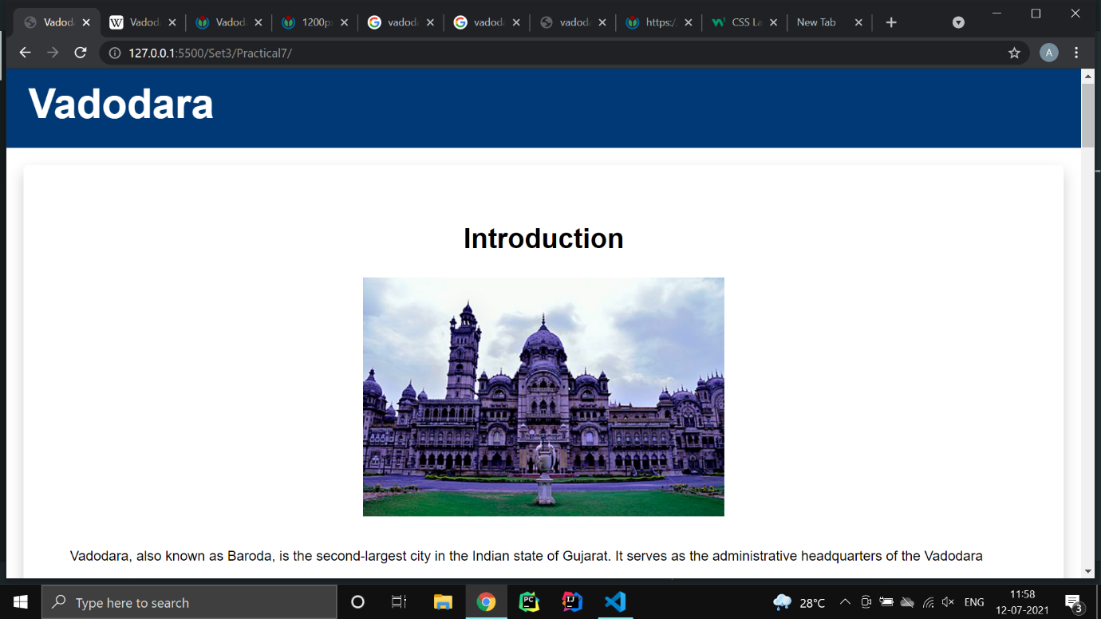

**History**

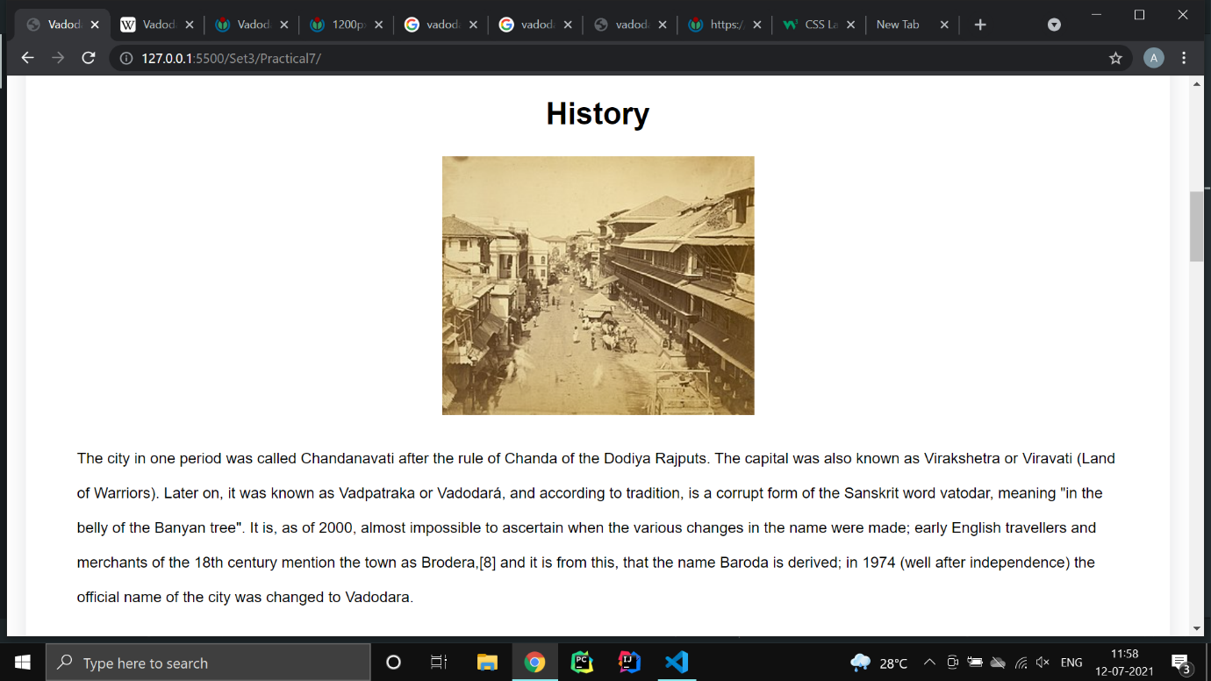

**Religions & Festivals**

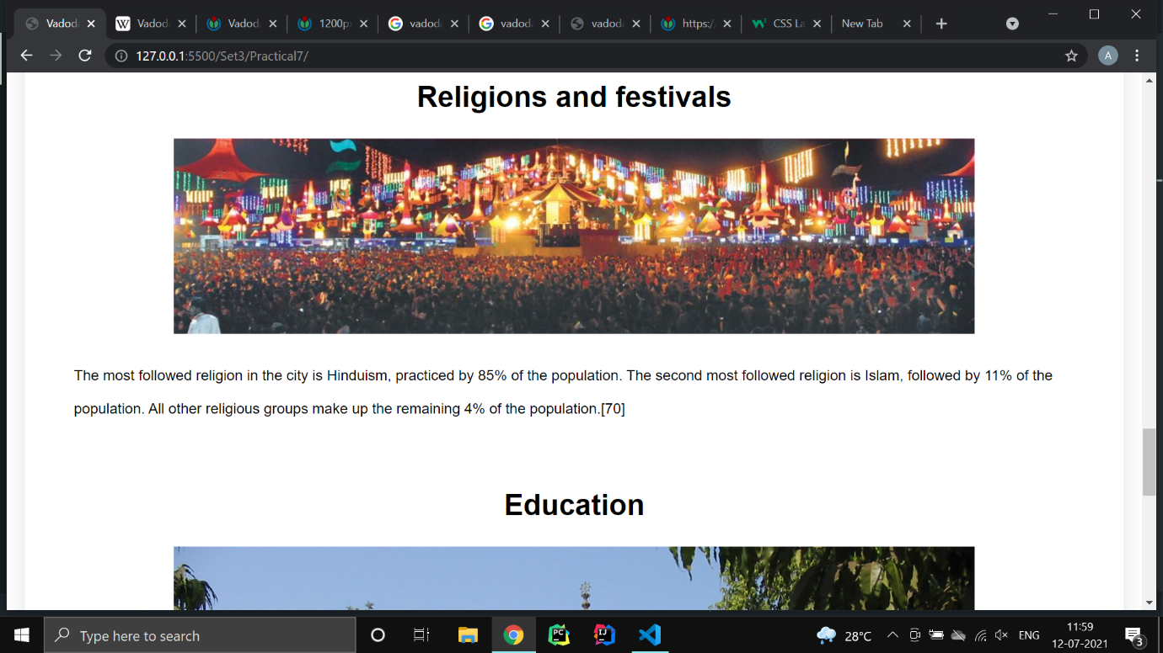

Practical 8

**Aim:**

Use Inline CSS to format your resume that you created in practical no 01.

**Code:**

**Index.html**

<!DOCTYPE html>

<html lang="en">

  <head>

    <meta charset="UTF-8" />

    <meta http-equiv="X-UA-Compatible" content="IE=edge" />

    <meta name="viewport" content="width=device-width, initial-scale=1.0" />

    <link

      href="https://fonts.googleapis.com/css?family=Lato:400,300,700"

      rel="stylesheet"

      type="text/css"

    />

    <style>

      * {

        margin: 0;

        padding: 0;

        box-sizing: border-box;

      }

      html {

        height: 100%;

      }

      body {

        min-height: 100%;

        background: #eee;

        font-family: "Lato", sans-serif;

        font-weight: 400;

        color: #222;

        font-size: 14px;

        line-height: 26px;

        padding-bottom: 50px;

      }

      .container {

        max-width: 700px;

        background: #fff;

        margin: 0px auto 0px;

        box-shadow: 1px 1px 2px #dad7d7;

        border-radius: 3px;

        padding: 40px;

        margin-top: 50px;

      }

      .header {

        margin-bottom: 30px;

      }

      .header .full-name {

        font-size: 40px;

        text-transform: uppercase;

        margin-bottom: 5px;

      }

      .header .first-name {

        font-weight: 700;

      }

      .header .last-name {

        font-weight: 300;

      }

      .header .contact-info {

        margin-bottom: 20px;

      }

      .header .email,

      .header .phone {

        color: #999;

        font-weight: 300;

      }

      .header .separator {

        height: 10px;

        display: inline-block;

        border-left: 2px solid #999;

        margin: 0px 10px;

      }

      .header .position {

        font-weight: bold;

        display: inline-block;

        margin-right: 10px;

        text-decoration: underline;

      }

      .details {

        line-height: 20px;

      }

      .details .section {

        margin-bottom: 40px;

      }

      .details .section:last-of-type {

        margin-bottom: 0px;

      }

      .details .section__title {

        letter-spacing: 2px;

        color: #54afe4;

        font-weight: bold;

        margin-bottom: 10px;

        text-transform: uppercase;

      }

      .details .section__list-item {

        margin-bottom: 40px;

      }

      .details .section__list-item:last-of-type {

        margin-bottom: 0;

      }

      .details .left,

      .details .right {

        vertical-align: top;

        display: inline-block;

      }

      .details .left {

        width: 60%;

      }

      .details .right {

        text-align: right;

        width: 39%;

      }

      .details .name {

        font-weight: bold;

      }

      .details a {

        text-decoration: none;

        color: #000;

        font-style: italic;

      }

      .details a:hover {

        text-decoration: underline;

        color: #000;

      }

      .details .skills__item {

        margin-bottom: 10px;

      }

      .details .skills__item .right input {

        display: none;

      }

      .details .skills__item .right label {

        display: inline-block;

        width: 20px;

        height: 20px;

        background: #c3def3;

        border-radius: 20px;

        margin-right: 3px;

      }

      .details .skills__item .right input:checked + label {

        background: #79a9ce;

      }

    </style>

    <title>Ankit Verma | Web Dev - Resume</title>

  </head>

  <body>

    <div class="container">

      <div class="header">

        <div class="full-name">

          <span class="first-name">Ankit</span>

          <span class="last-name">Verma</span>

        </div>

        <div class="contact-info">

          <span class="email">Email: </span>

          <span class="email-val">ankitverma209171@gmail.com</span>

          <span class="separator"></span>

          <span class="phone">Phone: </span>

          <span class="phone-val">932-711-4805</span>

        </div>

        <div class="about">

          <span class="position">Full-Stack Developer </span>

          <span class="desc">

            I am a full-stack developer with more than 1 years of experience

            writing html, css, and js for front-end and django as back-end. I'm

            motivated, result-focused and seeking a successful team-oriented

            company with opportunity to grow.

          </span>

        </div>

      </div>

      <div class="details">

        <div class="section">

          <div class="section__title">Experience</div>

          <div class="section__list">

            <div class="section__list-item">

              <div class="left">

                <div class="name">Freelancer</div>

                <div class="addr">Upwork</div>

                <div class="duration">July 2021 - Current</div>

              </div>

              <div class="right">

                <div class="name">Web Dev</div>

                <div class="desc">

                  Build Web Solutions with latest technologies in industry

                </div>

              </div>

            </div>

            <div class="section__list-item">

              <div class="left">

                <div class="name">Vision Web Solutions</div>

                <div class="addr">Ahmedabad, Gujarat, India</div>

                <div class="duration">Dec 2020 - Feb 2021</div>

              </div>

              <div class="right">

                <div class="name">Web Dev Intern</div>

                <div class="desc">

                  Build support APIs for BuuyIt (E-commerce solution)

                </div>

              </div>

            </div>

          </div>

        </div>

        <div class="section">

          <div class="section__title">Education</div>

          <div class="section__list">

            <div class="section__list-item">

              <div class="left">

                <div class="name">VGEC</div>

                <div class="addr">Ahmedabad, Gujarat, India</div>

                <div class="duration">Aug 2019 - Current</div>

              </div>

              <div class="right">

                <div class="name">Information Technology</div>

                <div class="desc">Bachelor of Engineering (CGPA - 8.75)</div>

              </div>

            </div>

            <div class="section__list-item">

              <div class="left">

                <div class="name">GSFC School</div>

                <div class="addr">Vadodara, Gujarat, India</div>

                <div class="duration">Jun 2017 - Mar 2019</div>

              </div>

              <div class="right">

                <div class="name">Science Stream</div>

                <div class="desc">GHSEB (89%)</div>

              </div>

            </div>

          </div>

        </div>

        <div class="section">

          <div class="section__title">Projects</div>

          <div class="section__list">

            <div class="section__list-item">

              <div class="name">Exam Shield</div>

              <div class="text">

                Exam Shield is an fool-proof examination system developed with

                rich features to conduct fair examinations and evaluations of

                the students online. <b>Technologies:</b> Django | CSS |

                Javascript

              </div>

            </div>

            <div class="section__list-item">

              <div class="name">Radhe Caterering Website</div>

              <div class="text">

                Radhe Caterering Website is a static website developed for

                creating business online presence and attract new customers

                online. <b>Technologies:</b> Django | CSS | Javascript

              </div>

            </div>

          </div>

        </div>

        <div class="section">

          <div class="section__title">Skills</div>

          <div class="skills">

            <div class="skills__item">

              <div class="left"><div class="name">Javascript</div></div>

              <div class="right">

                <input id="ck1" type="checkbox" checked />

                <label for="ck1"></label>

                <input id="ck2" type="checkbox" checked />

                <label for="ck2"></label>

                <input id="ck3" type="checkbox" checked />

                <label for="ck3"></label>

                <input id="ck4" type="checkbox" />

                <label for="ck4"></label>

                <input id="ck5" type="checkbox" />

                <label for="ck5"></label>

              </div>

            </div>

          </div>

          <div class="skills__item">

            <div class="left"><div class="name">CSS</div></div>

            <div class="right">

              <input id="ck1" type="checkbox" checked />

              <label for="ck1"></label>

              <input id="ck2" type="checkbox" checked />

              <label for="ck2"></label>

              <input id="ck3" type="checkbox" checked />

              <label for="ck3"></label>

              <input id="ck4" type="checkbox" checked />

              <label for="ck4"></label>

              <input id="ck5" type="checkbox" />

              <label for="ck5"></label>

            </div>

          </div>

          <div class="skills__item">

            <div class="left"><div class="name">Django</div></div>

            <div class="right">

              <input id="ck1" type="checkbox" checked />

              <label for="ck1"></label>

              <input id="ck2" type="checkbox" checked />

              <label for="ck2"></label>

              <input id="ck3" type="checkbox" checked />

              <label for="ck3"></label>

              <input id="ck4" type="checkbox" checked />

              <label for="ck4"></label>

              <input id="ck5" type="checkbox" checked />

              <label for="ck5"></label>

            </div>

          </div>

        </div>

        <div class="section">

          <div class="section__title">Interests</div>

          <div class="section__list">

            <div class="section__list-item">Reading, drawing, programming.</div>

          </div>

        </div>

      </div>

    </div>

  </body>

</html>

**Screenshot:**

**Index.html**

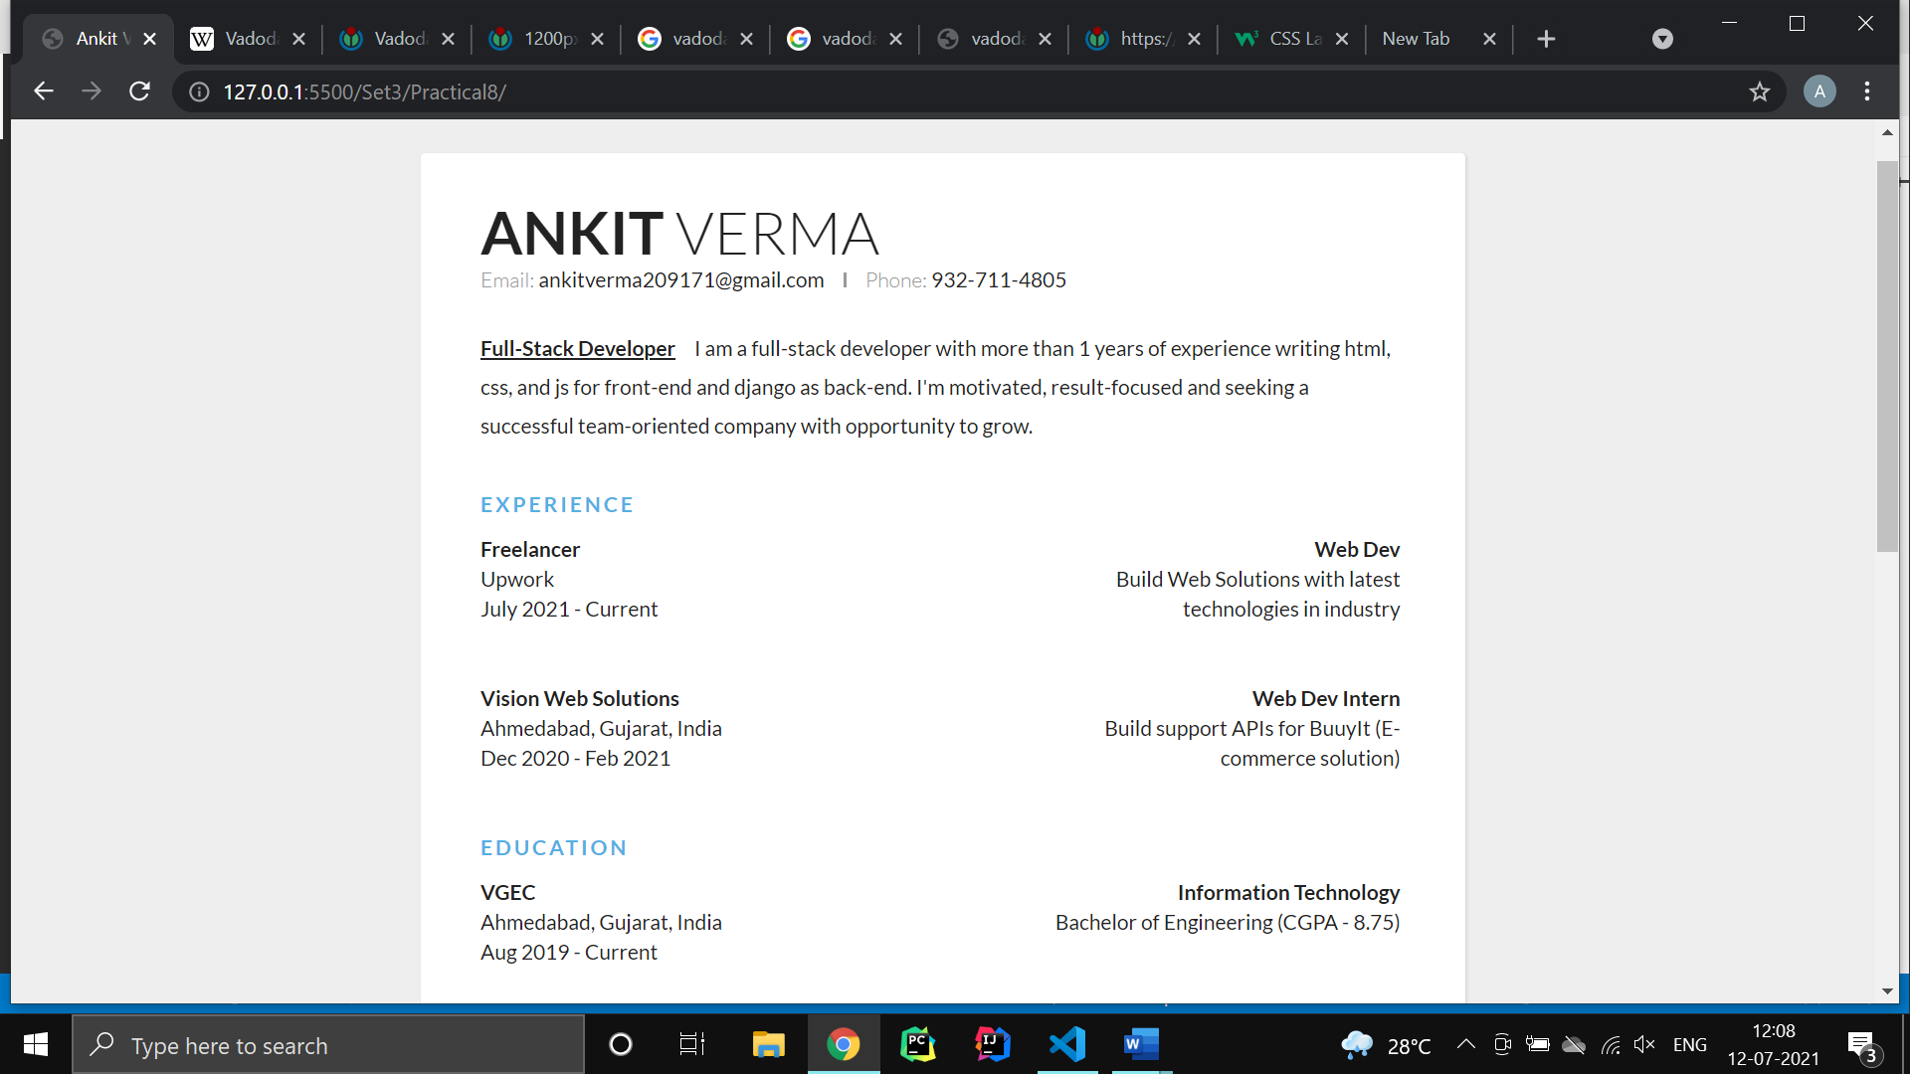

Practical 9

**Aim:**

Use External CSS to format your class timetable as you created in practical no 03.

**Code:**

**Index.html**

<!DOCTYPE html>

<html lang="en">

  <head>

    <meta charset="UTF-8" />

    <meta http-equiv="X-UA-Compatible" content="IE=edge" />

    <meta name="viewport" content="width=device-width, initial-scale=1.0" />

    <link rel="stylesheet" href="css/style.css" />

    <title>IT - Sem 5 | Time Table</title>

  </head>

  <body>

    <div>

      <table>

        <caption>

          VISHWAKARMA GOVERNMENT ENGG COLLEGE, CHANDKHEDA<br />

          INFORMATION TECHNOLOGY DEPARTMENT<br />

          Semester:V<br />

          ODD TERM 2021<br />

          WEF:- 07/06/2021<br />

        </caption>

        <thead>

          <tr>

            <th>Day</th>

            <th>10:30 TO 12:30</th>

            <th>1:00 TO 2:00</th>

            <th>2:00 TO 3:00</th>

            <th>3:15 TO 4:15</th>

            <th>4:15 TO 5:15</th>

            <th>5:15 TO 6:15</th>

          </tr>

        </thead>

        <tbody>

          <tr>

            <td></td>

            <td></td>

            <td></td>

            <td colspan="2">B201</td>

            <td colspan="2">B201</td>

          </tr>

          <tr>

            <th>Monday</th>

            <td>

              B1 - ADA (DCP) B206A<br />

              B3 - WD (CAP) B203B <br />

              B4 - CN (CGC) B206B

            </td>

            <td>ADA (DCP)</td>

            <td>CN (JHV)</td>

            <td>

              OOAD (NST)<br />

              WD (CAP) B103

            </td>

            <td>PE (DJV)</td>

            <td>

              B1 - DE - 2A (VDP)<br />

              B2 - DE - 2A (CAP)<br />

              B3 - DE - 2A (JRD)<br />

              B4 - DE - 2A (DCP)<br />

              B104

            </td>

          </tr>

          <tr>

            <th>Tuesday</th>

            <td>

              B1 - OOAD (NST) B203A<br />

              B2 - CN (CGC) B206B<br />

              B3 - ADA (DCP) B206A<br />

              B4 - WD (CAP) B203B

            </td>

            <td>ADA (DCP)</td>

            <td>CN (CGC)</td>

            <td>PE (DJV)</td>

            <td>ADA (VDP)</td>

            <td>

              B1 - DE - 2A (NST)<br />

              B2 - DE - 2A (CGC)<br />

              B3 - DE - 2A (JHV)<br />

              B4 - DE - 2A (DCP)<br />B104

            </td>

          </tr>

          <tr>

            <th>Wednesday</th>

            <td>

              B2 - ADA (DCP) B206A<br />

              B3 - CN (CGC) B206B

            </td>

            <td>ADA (DCP)</td>

            <td>CN (CGC)</td>

            <td>PE (DJV)</td>

            <td></td>

            <td></td>

          </tr>

          <tr>

            <th>Thursday</th>

            <td></td>

            <td></td>

            <td>

              IE-CS (JHV)<br />

              DS (SJM) B103

            </td>

            <td>CN (CGC)</td>

            <td>

              IE-CS (JHV)<br />

              DS (SJM) B103

            </td>

            <td></td>

          </tr>

          <tr>

            <th>Friday</th>

            <td>

              B1 - CN (JHV) B206B<br />

              B2 - WD (CAP) B203B<br />

              B4 - ADA (DCP) B206A

            </td>

            <td>IPDC (JRD)</td>

            <td>IPDC (JRD)</td>

            <td>

              OOAD (NST)<br />

              WD (CAP) B103

            </td>

            <td>

              OOAD (NST)<br />

              WD (CAP) B103

            </td>

            <td></td>

          </tr>

          <tr>

            <th>Saturday</th>

            <td colspan="2">

              10:00 TO 2:00 &nbsp B1-CS(JHV) &nbsp B3-DS(SJM) &nbsp B4-DS(NST)

            </td>

            <td colspan="4">2:00 TO 6:00 &nbsp B2-CS(JHV)</td>

          </tr>

        </tbody>

      </table>

      <br />

      <table>

        <thead>

          <tr>

            <th colspan="2">SUBJECT DETAILS</th>

            <th colspan="2">FACULTY DETAILS</th>

            <th colspan="2">FACULTY DETAILS</th>

          </tr>

        </thead>

        <tbody>

          <tr>

            <td>3150703</td>

            <td>Alalysis and Design of Algorithms (ADA)</td>

            <td>VDP</td>

            <td>Prof V D Patel</td>

            <td>NCG</td>

            <td>Prof N C Gamit</td>

          </tr>

          <tr>

            <td>3151604</td>

            <td>Object Oriented Analysis and Design (OOAD)</td>

            <td>CAP</td>

            <td>Prof C A Patel</td>

            <td>JRD</td>

            <td>Prof J R Dave</td>

          </tr>

          <tr>

            <td>3150005</td>

            <td>Integrated Personality Development Course (IPDC)</td>

            <td>SJM</td>

            <td>Prof S J Molia</td>

            <td>NST</td>

            <td>Prof N S Trivedi</td>

          </tr>

          <tr>

            <td>3150709</td>

            <td>Professional Ethics (PE)</td>

            <td>CGC</td>

            <td>Prof C G Chand</td>

            <td>DCP</td>

            <td>Prof D C Patel</td>

          </tr>

          <tr>

            <td>3150001</td>

            <td>Design Engineering - II A (DE2A)</td>

            <td>DJV</td>

            <td>Prof D J Varia</td>

            <td>JHV</td>

            <td>Prof J H Vania</td>

          </tr>

          <tr>

            <td>3150714</td>

            <td>Institute Elective - Cyber Security (CS)</td>

          </tr>

          <tr>

            <td>3150710</td>

            <td>Computer Networks (CN)</td>

          </tr>

          <tr>

            <td>3151606</td>

            <td>Web Developmennt (Professional Elective Course 1) (WD)</td>

          </tr>

          <tr>

            <td>3151608</td>

            <td>Institute Elective - Data Science (DS)</td>

          </tr>

        </tbody>

      </table>

    </div>

  </body>

</html>

**Style.css**

body {

  font-family: sans-serif;

}

table {

  border-collapse: collapse;

  border: 1px solid black;

  text-align: center;

  vertical-align: middle;

}

caption {

  text-align: center;

  padding: 1rem;

  font-weight: bold;

  font-size: 24px;

  color: #333;

}

thead {

  background-color: #333;

  color: white;

  font-size: 0.875rem;

  text-transform: uppercase;

  letter-spacing: 2%;

}

th,

td {

  padding: 1rem;

  border: 1px solid black;

}

thead th {

  width: 10%;

}

tbody tr:nth-child(odd) {

  background-color: #fff;

}

tbody tr:nth-child(even) {

  background-color: #eee;

}

**Screenshot:**

**Schedule**

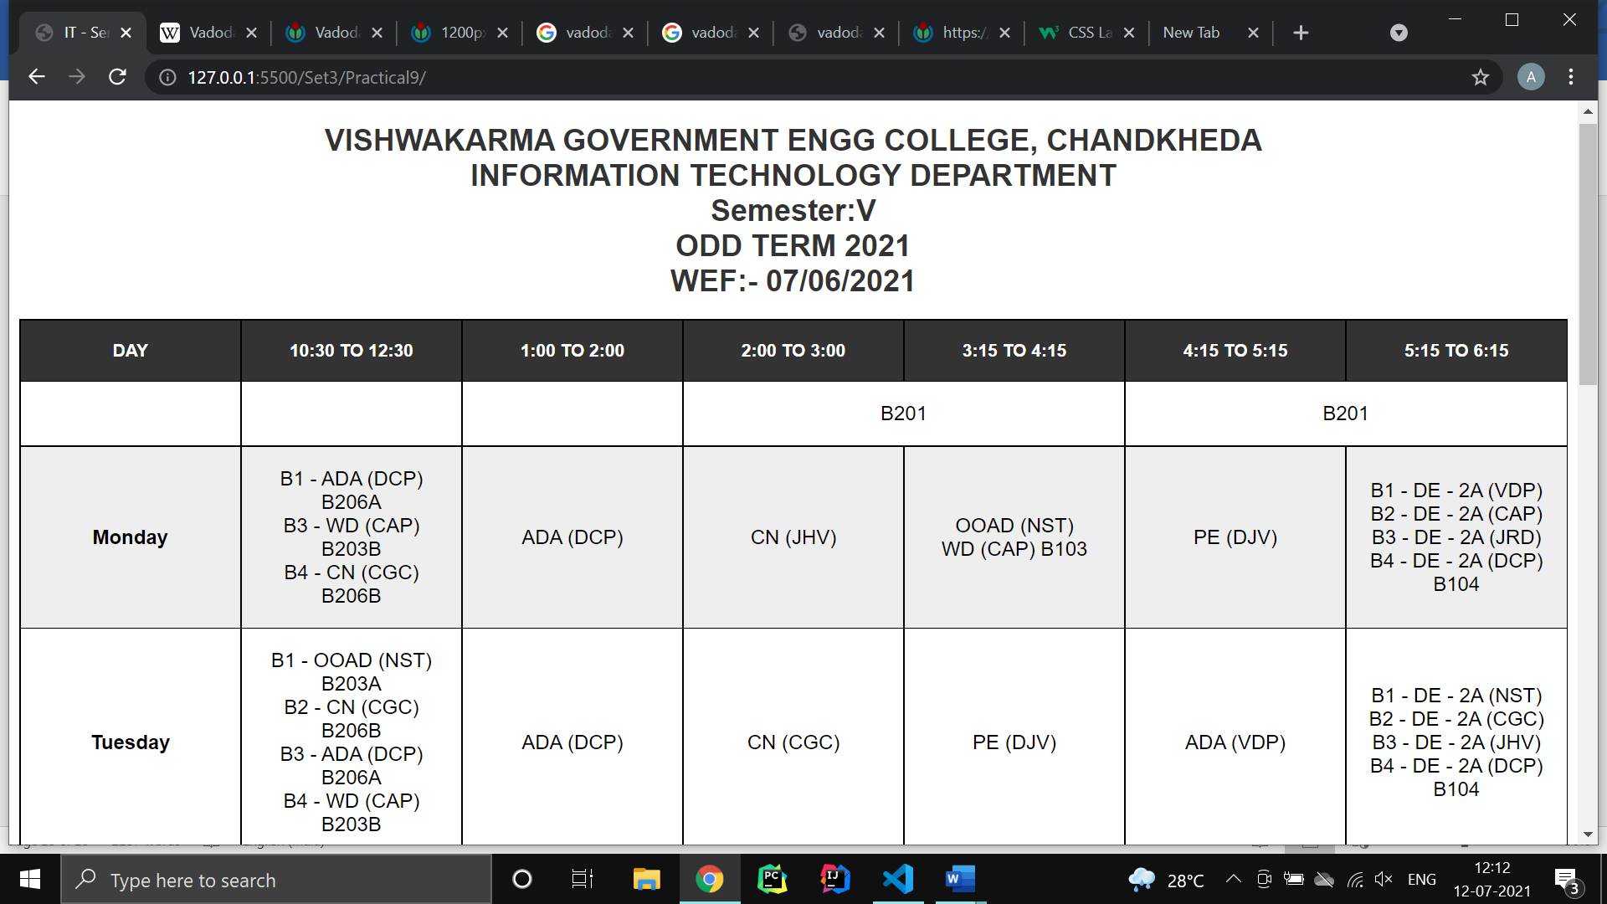

**Subject & Faculty Details**

