Project Title: PawFam
Name: Sudharshan R
Roll No: CB.SC.P2CSE25035

USE DATABASE COMMAND:
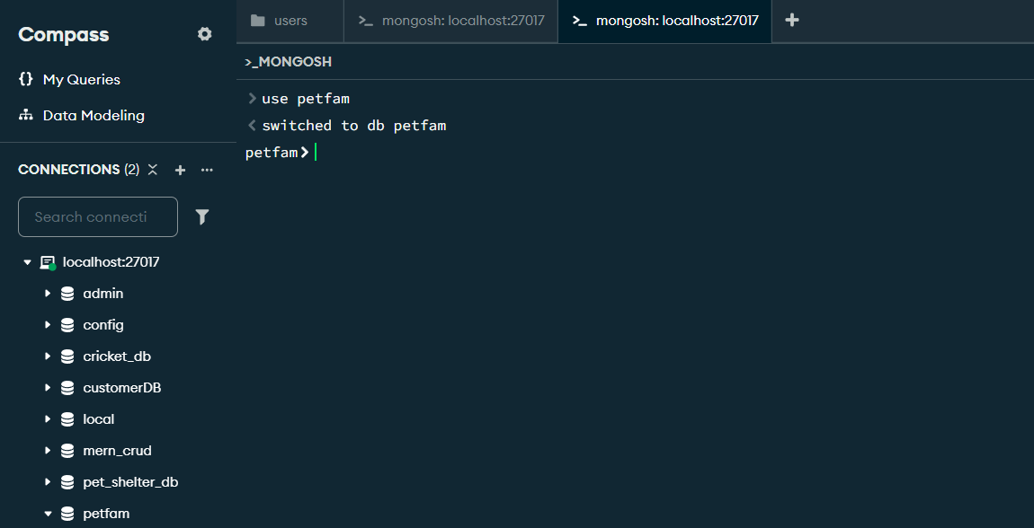

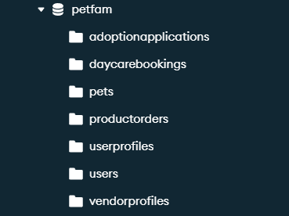

INSERT DATA:
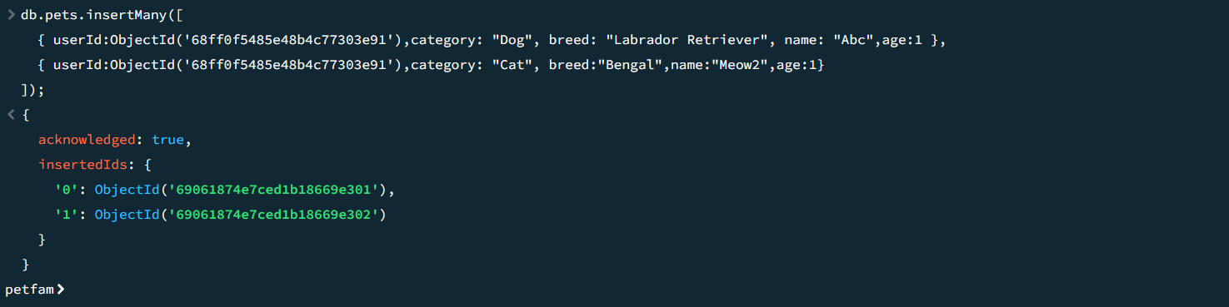

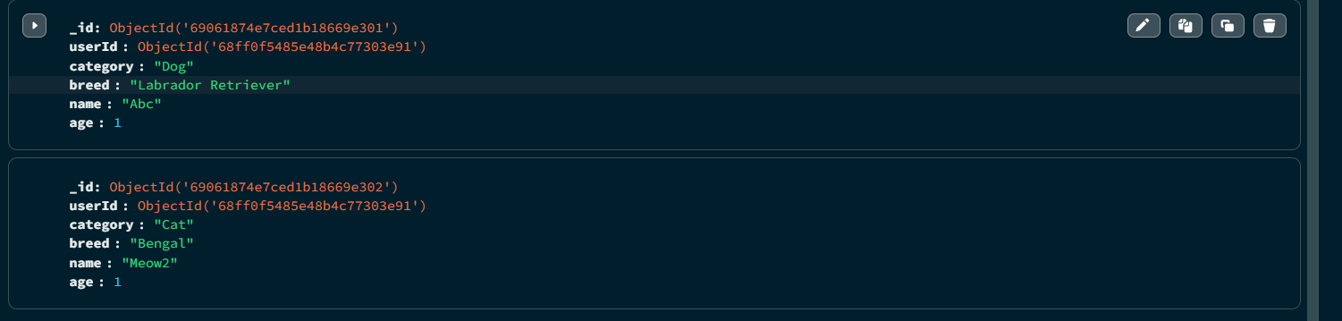

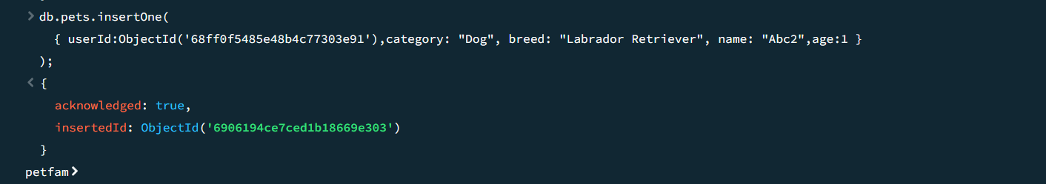

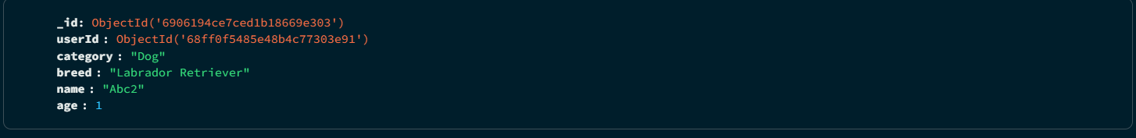

FIND DATA:
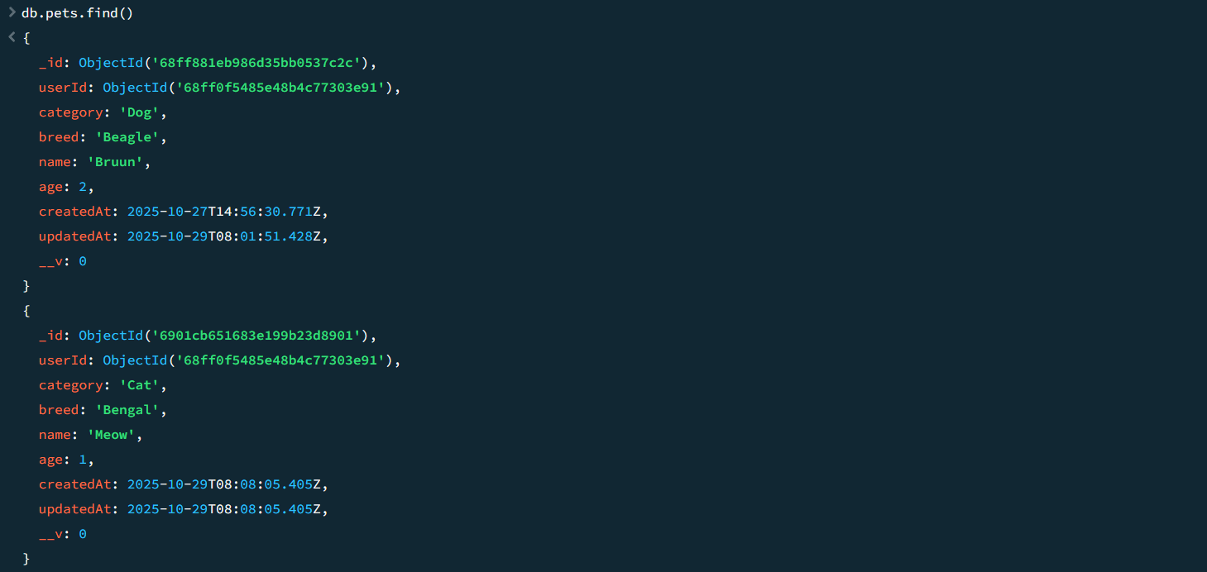

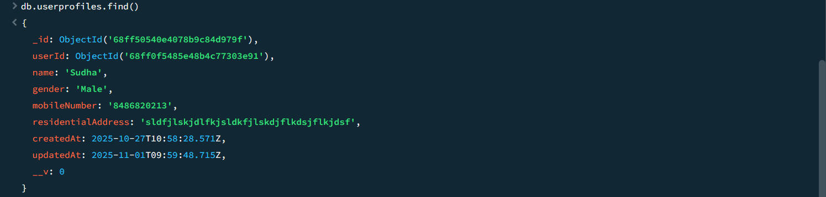
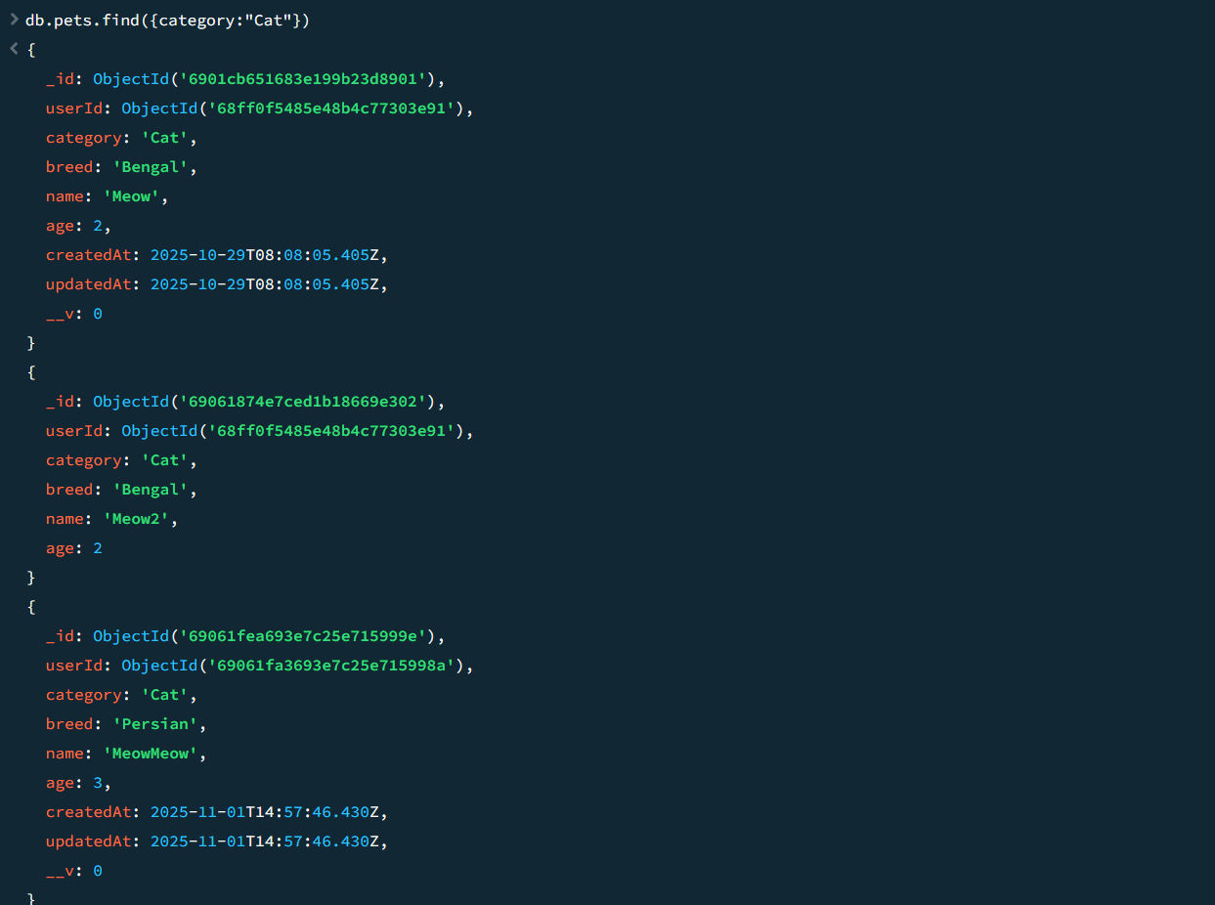

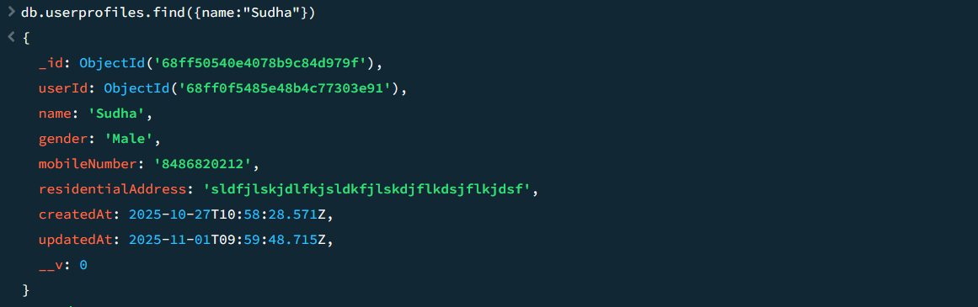

UPDATE DATA:
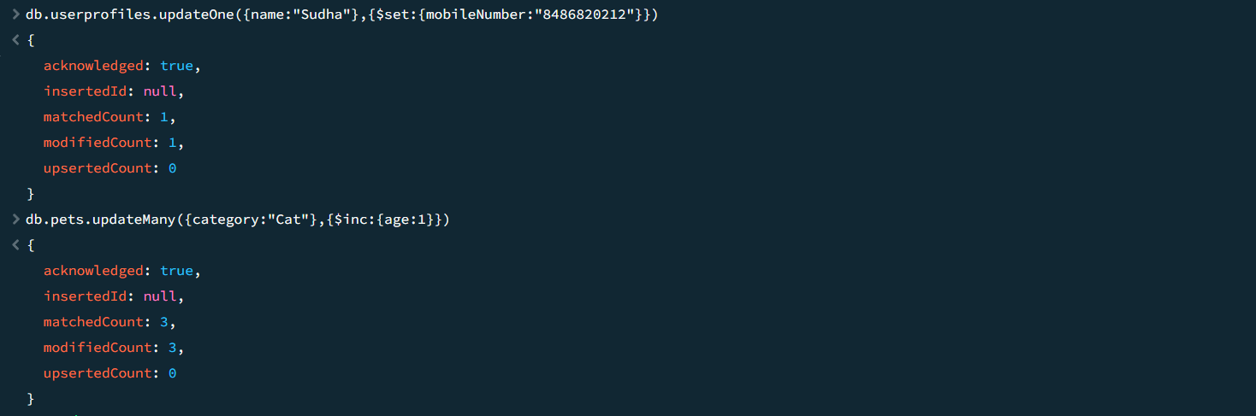

DELETE DATA:
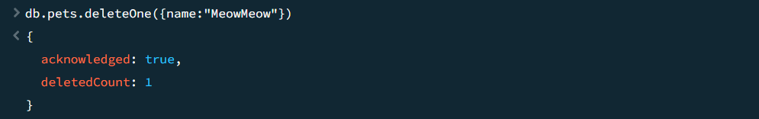

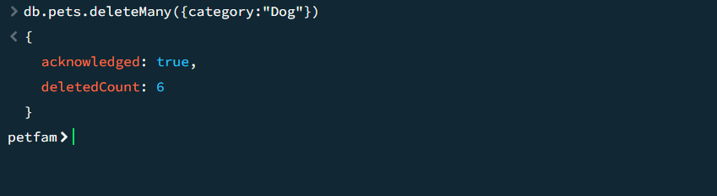

AGGREGATE (with MATCH, GROUP, AVG, MIN, MAX):
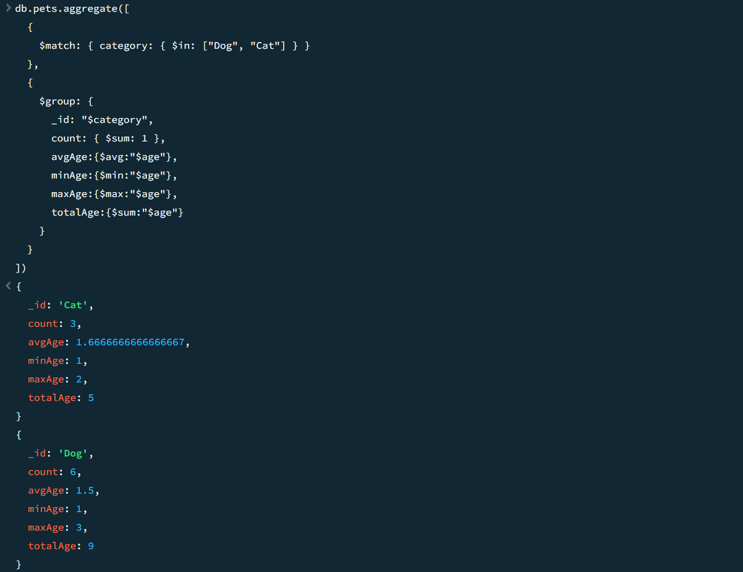
AGGREGATE with LOOKUP (Simulating Foreign Key Constraint)
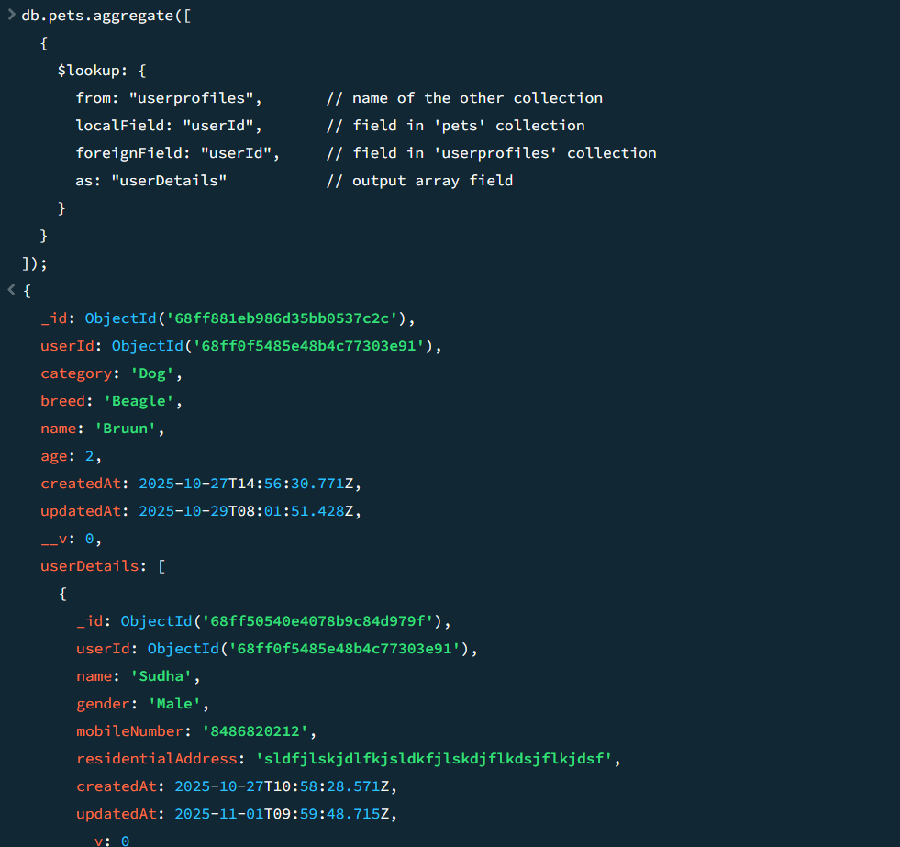

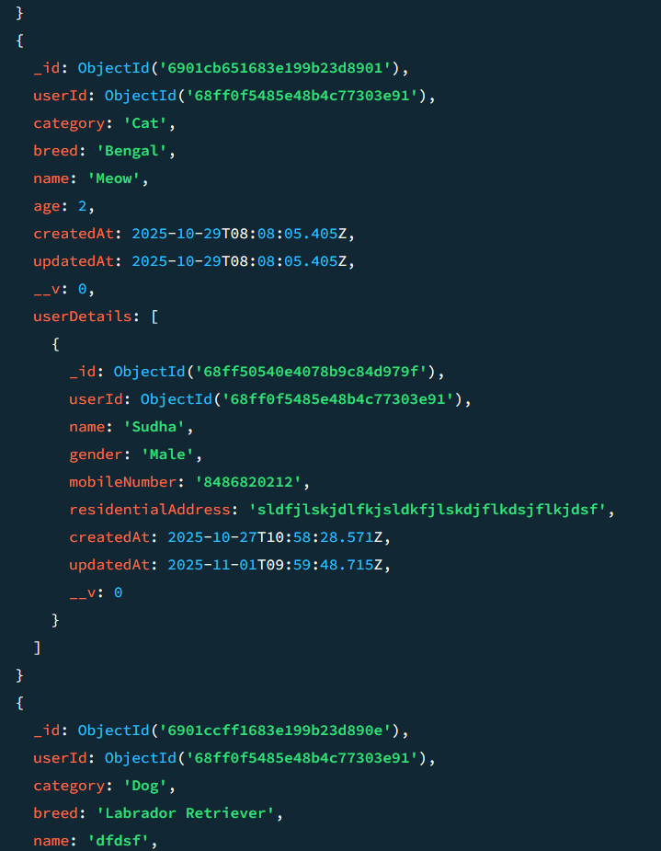

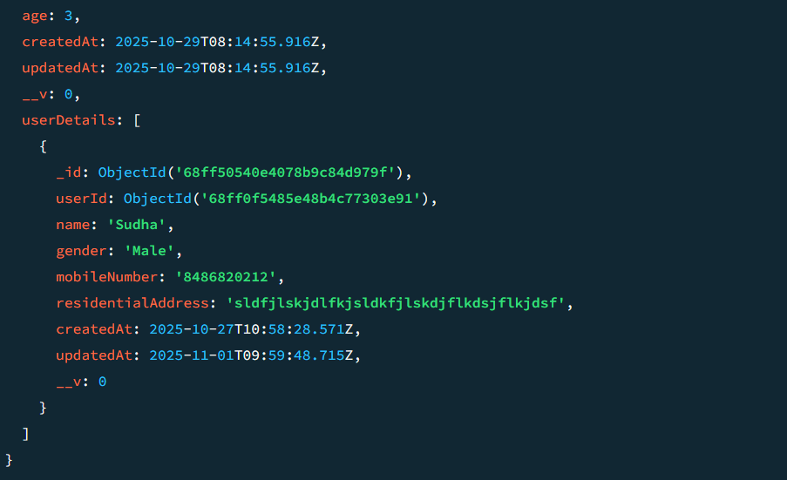

JOINS (Simulation using $lookup and $unwind, Master Table: userprofiles
Transaction Table: daycarebookings
)
