GHAREEB SECURE BANK
Console-Based Bank Management System in C++
Semester Project Report
Object-Oriented Programming Concepts in C++

Submitted by
PROFFESSER HAMZA RAZA
Class: B.S-CYS-2B | Student ID: 2520207
BS Cyber Security — Air University, Kamra Campus

1. Introduction
Ghareeb Secure Bank is a console-based bank management system developed in C++ as a semester project. The project simulates the core operations of a real bank — opening accounts, viewing account records, depositing and withdrawing money, and managing passwords — while demonstrating the four pillars of Object-Oriented Programming: Abstraction, Encapsulation, Inheritance, and Polymorphism. The application uses colored console output and simple text animations to make the terminal interface visually engaging, and stores all account data permanently in a text file so records persist between runs.

2. Objectives
- Design a class hierarchy that models real banking entities using proper OOP principles.
- Enforce real-world account-opening rules: a valid 13-digit CNIC, a valid phone number, and an age above 18.
- Support two account types — Savings and Current — each with its own withdrawal and interest rules.
- Persist all account data to a file so information is not lost when the program closes.
- Present a colorful, animated console menu inspired by real banking software.

3. Tools & Technologies
- Language: C++ (C++17)
- IDE / Compiler: Dev-C++ / Code::Blocks (MinGW g++)
- Libraries: <iostream>, <fstream>, <sstream>, <vector>, <string>, <windows.h> (console colors)
- Data storage: plain text file (accounts.txt), pipe-delimited records

4. Account Opening Requirements
Before an account can be created, the system validates three conditions, matching the real-world requirements given for this project:
- CNIC: must contain exactly 13 digits (dashes are optional and ignored during validation).
- Phone Number: must contain 10–11 digits.
- Age: must be strictly greater than 18 years.
If any condition fails, the system rejects the request with a clear error message and no account is created.

5. Class Diagram
The diagram below shows the class hierarchy: Person is the abstract root, Account inherits from Person and is itself abstract, and SavingsAccount / CurrentAccount are the concrete classes that implement the account-specific rules. The Bank class manages a collection of Account objects and handles file persistence.
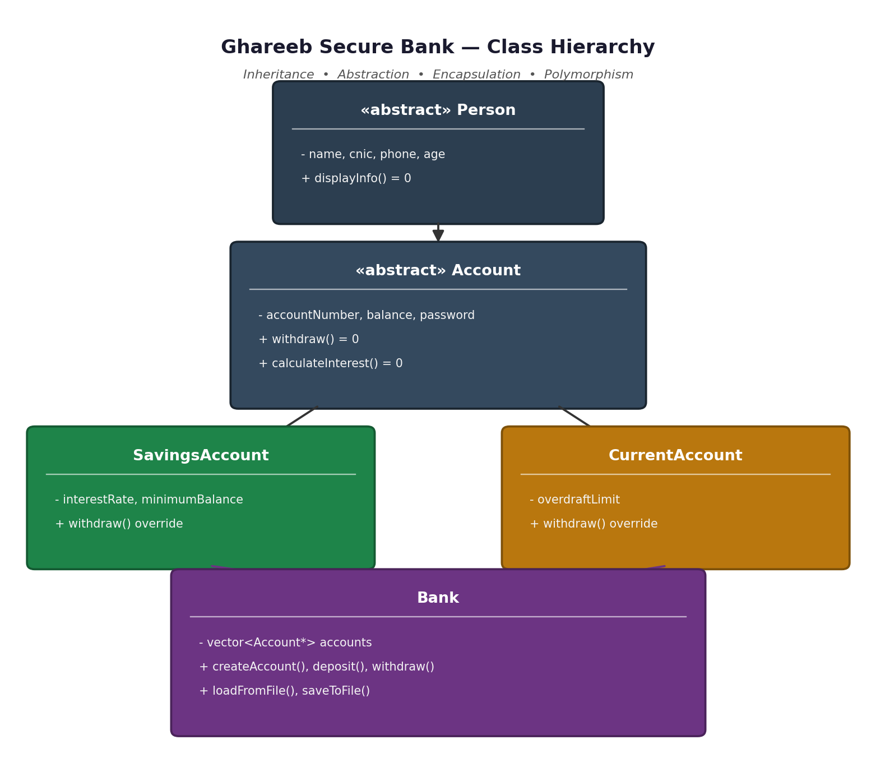

6. OOP Concepts Used
Each of the four core OOP concepts appears concretely in the source code, as summarized below:
Concept | Definition | How it's used in this project
Abstraction | Hiding implementation details and exposing only what's necessary, usually through abstract classes and pure virtual functions. | Person and Account are abstract classes. Person declares displayInfo() = 0, and Account declares withdraw() = 0 and calculateInterest() = 0 as pure virtual functions, so neither class can be instantiated directly — they only define a contract.
Encapsulation | Bundling data with the methods that operate on it, and restricting direct access to internal state. | All member variables (name, cnic, balance, password, etc.) are declared protected or private. They can only be read or changed through public getter/setter methods such as getBalance(), setPassword(), and checkPassword().
Inheritance | Creating new classes based on existing ones, reusing and extending their behavior. | Account inherits from Person, and both SavingsAccount and CurrentAccount inherit from Account. This forms a three-level hierarchy: Person → Account → {SavingsAccount, CurrentAccount}.
Polymorphism | Calling the same function on different object types and getting behavior specific to each type, resolved at runtime through virtual functions. | withdraw() and calculateInterest() are virtual in Account and overridden differently in SavingsAccount (minimum-balance rule, 5% interest) and CurrentAccount (overdraft limit, 0% interest). The Bank class stores accounts as vector<Account*> and calls acc->withdraw(amount) without knowing the exact derived type — the correct version runs automatically.

7. Key Code Snippets

7.1 Abstraction — pure virtual functions in Account
class Account : public Person {
protected:
string accountNumber, password;
double balance;
public:
virtual bool withdraw(double amount) = 0; // must be implemented
virtual double calculateInterest() const = 0; // by every derived class
};

7.2 Inheritance — three-level hierarchy
class Person { /* base: name, cnic, phone, age */ };
class Account : public Person { /* adds balance, password ... */ };
class SavingsAccount : public Account { /* adds interestRate */ };
class CurrentAccount : public Account { /* adds overdraftLimit */ };

7.3 Polymorphism — runtime-selected withdraw() rule
bool SavingsAccount::withdraw(double amount) {
if (balance - amount < minimumBalance) return false;
balance -= amount; return true;
}

bool CurrentAccount::withdraw(double amount) {
if (balance - amount < -overdraftLimit) return false;
balance -= amount; return true;
}

// Bank.cpp - the base-class pointer decides which version runs:
Account* acc = findAccount(accNo);
acc->withdraw(amount); // correct rule applied automatically

7.4 Encapsulation — controlled access
private:
string password;
public:
bool checkPassword(const string &p) const { return password == p; }
void setPassword(string p) { password = p; }
// password can never be read directly from outside the class

8. Menu Features
# | Menu Option | What it does
1 | Create Account | Collects name, CNIC, phone, age, password; validates CNIC (13 digits), phone (10-11 digits) and age (> 18); lets the user choose Savings or Current account
2 | View All Accounts | Displays a summary table of every account (number, name, type, balance)
3 | Display Full Account | Shows complete details of one account after password verification, plus its estimated annual interest
4 | Deposit Money | Adds funds to an account's balance
5 | Withdraw Money | Withdraws funds after password verification, enforcing the account type's own rule (minimum balance for Savings, overdraft limit for Current)
6 | Change Password | Updates an account's password after verifying the current one
7 | Exit | Saves all data to file and closes the program

9. File Handling & Data Persistence
Every account is serialized as a single pipe-delimited line — Type|Name|CNIC|Phone|Age|AccNo|Password|Balance — and written to accounts.txt. On startup, the Bank class reads this file line by line and reconstructs the correct object type (SavingsAccount or CurrentAccount) for each record, so all accounts, balances, and account numbers survive a program restart.

10. Console Colors & Animation
The interface uses the Windows SetConsoleTextAttribute() API to color menus, headings, success messages (green), and error messages (red) differently, matching the look of the reference bank menu image. A simple typing effect (character-by-character output with a short delay) animates the title banner, and a loading-bar animation plays during account creation, deposits, and withdrawals.

11. Conclusion
Ghareeb Secure Bank demonstrates all four core Object-Oriented Programming concepts in a practical, runnable console application. The abstract Person and Account classes define a clear contract, SavingsAccount and CurrentAccount extend that contract through inheritance, encapsulated data keeps account details safe, and polymorphic withdraw()/calculateInterest() calls let the same Bank code correctly handle every account type. Combined with file-based persistence and a colorful animated interface, the project fulfills both the technical OOP requirements and the visual presentation expected for the semester submission.

