Windows C# Final Project
Topic:

Book Search Library

Team Member:

Yan Liu (w0122904)
MinSu Lee (w0293156)
Paddy Vaughan (w0277831)
Joey Gilkie (w0295155)

Project Background:

Using the Open Library Search API, we will make an application that will allow the user to search for books in the Open Library database. Users will be able to select a book and find more information such as the title, the author, the first published year, and an image of the cover. The application will use a list view on the left side of the page which, after the search button is clicked, will fill with titles of different books that match the search terms within the Open Library database. Once the user selects a book title, its cover, title, author, and published year are listed on the right side of the page. The cover will be shown in an image view that takes up most of the content area. There will also be an about page which will list all the team members names as well as any other important information.

The Wire Frame looks as follows:

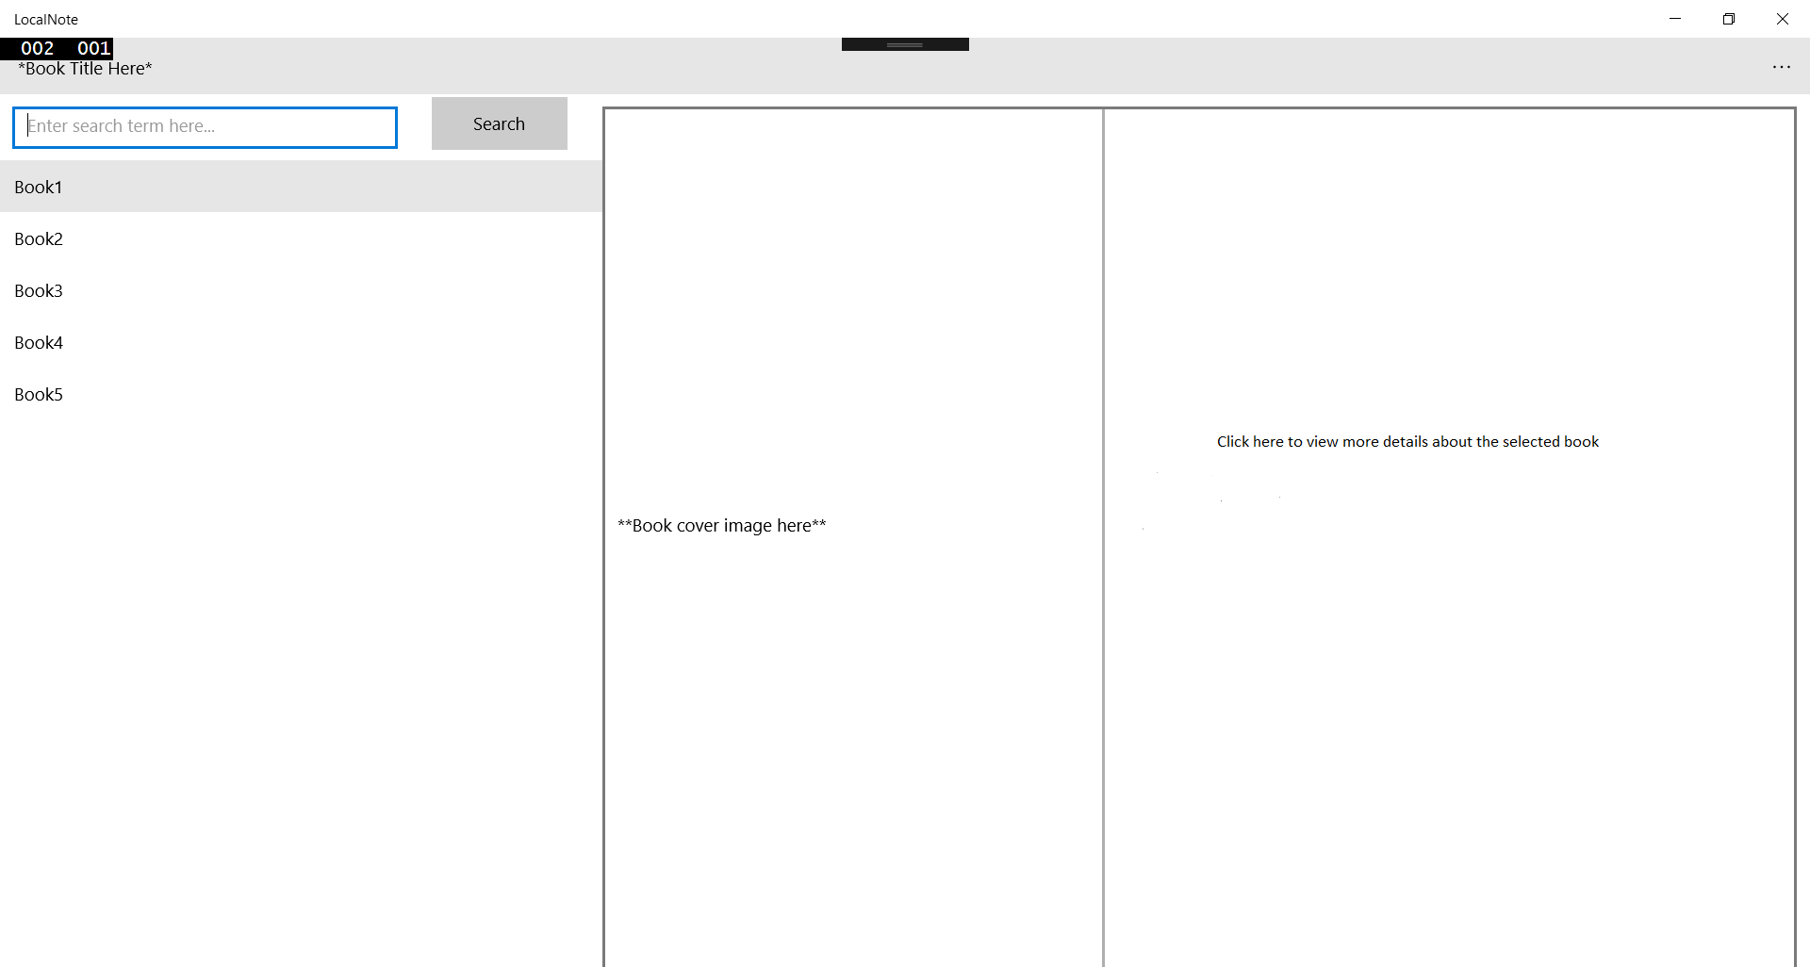

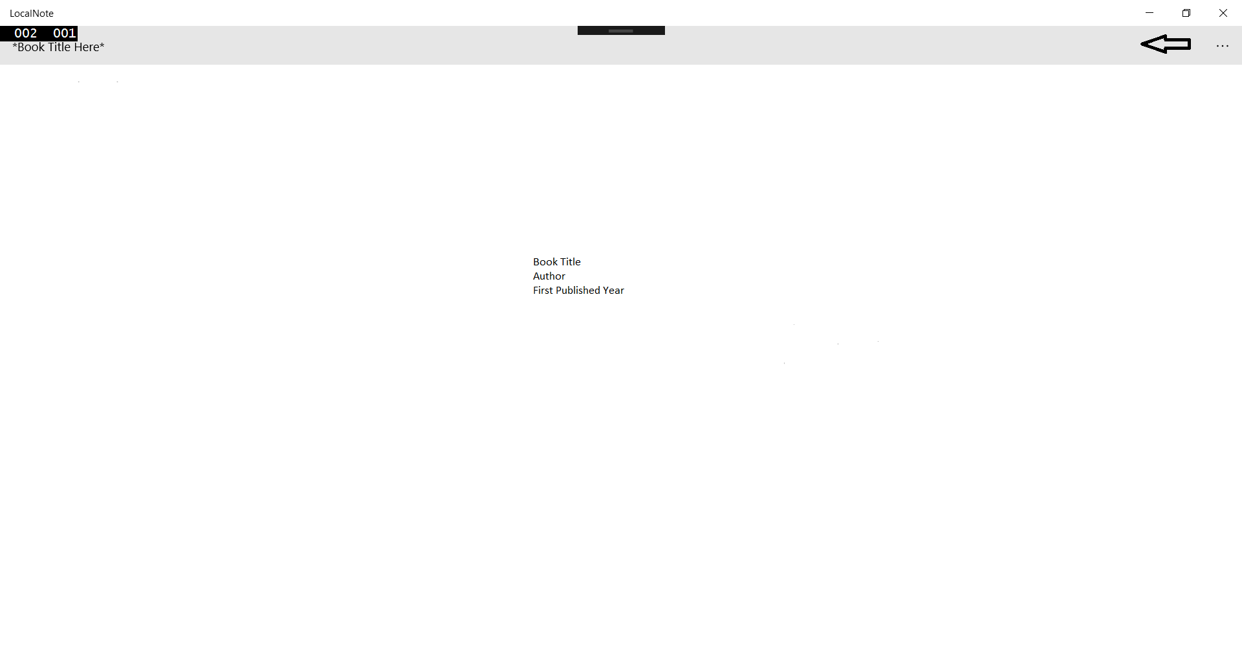

Objectives:
- To practice team collaboration, host the project on Github.
- To work on UWP application development
- To allow the application to consume data asynchronously from a data source
- List a summary of data and details section of selected data.
- To filter the available data
- Utilize UWP page navigation design and practice
- To practice complex control to display information.

Scope:
- Proposal and Project Design (wireframe of application).
- Journal of team collaboration and work done.
- Demonstrate to instructor of final application and success.

Schedule:
 | Description of Work | Start and End Dates
Phase One | Proposal and Project Design (Create wire frame, set up Github and assigned to every team member); Update Journal.  Approval by instructor | March 24 – March 28
Phase Two | Coding and Debug: Create the XAML design based on the Wire frame, research APl and populate the data. Search function. Update Journal. | March 28 – April 1
Phase Three | Finalize and Test: Display all data, Testing, and Update Journal. | April 1 – April 4
Team Organization:
Team Member | Yan Liu, MinSu Lee, Paddy, Joey
Project Manager | Yan Liu / Paddy
Instructor | Ronan
Monitoring and Evaluation:
Our team plans on meeting every Tuesday and Thursday. We will start each meeting by discussing what work has yet to be completed (following the project schedule), and to make sure the group understands their jobs. We will then discuss how our progress has been since our last meeting, and what issues we are facing. This allows the group members to gain input and assistance from one another. Then we will talk about what we will each be working on until the next group meeting. With this structure it allows more individuality, as we will be able to work from home if needed as long as the members make it to the meeting, then it doesn’t really matter where the group’s individuals do their work as long as the work is completed.
Using scrum minutes to record all the project progress, and document the team work step by step.
Approval Signatures
[Name], Project Members |  | [Name], Project Manager |  | [Name], Project Instructor

