Deenbandhu Chhotu Ram University of Science and Technology, Murthal
Department of Computer Science & Engineering
RepoShield
A Deterministic Verification and Control Layer for AI-Generated Code Changes
Submitted by | Prashant | Submitted to | Mrs. Neetu Verma
Roll No. | ______________ | Programme | B.Tech, Computer Science & Engineering (Final Year)
Document | Project Synopsis | Date | 04 October 2026

1. Abstract
AI coding assistants and autonomous agents now propose code changes faster than people can review them. Existing safeguards either run a fixed set of checks, miss effects that travel through shared modules, or rely on probabilistic AI reviewers whose opinions cannot be audited. RepoShield is a verification and control layer placed between an AI-generated change and the protected branch. For every change it (i) computes exactly what was modified, (ii) maintains an incrementally updated dependency graph of the code base and traces the files that may be affected, (iii) evaluates declarative policy rules and built-in checks, (iv) selects and runs only the tests that can be affected inside an isolated sandbox, and (v) returns one of three verdicts, PASS, REVIEW_REQUIRED or BLOCK, together with evidence and a tamper-evident audit trail. A working prototype has been built and evaluated: all ten simulated AI-agent pull requests received the designed verdict, and dependency-based test selection caught 12 of 12 seeded bugs while running 68.5% fewer test files.
2. Introduction and Problem Statement
Large-language-model agents can open dozens of pull requests per day. A reviewer looking at a 400-line diff cannot see which other modules depend on it, and a continuous-integration (CI) job only checks what someone remembered to configure. Observed failure modes of AI-generated changes include: (a) crossing an architectural boundary indirectly through a shared helper; (b) deleting, weakening or skipping a test so that the build turns green; (c) editing the policy or CI file that is supposed to judge the change; (d) leaking credentials or adding unreviewed dependencies; and (e) the cost trade-off that running every test is slow while running too few is unsafe.
Problem statement: design a system that decides, reproducibly and with evidence, whether an automatically generated change is safe to merge, without trusting the code, its author, or a language model.
3. Objectives
- Compute the exact blast radius of a change using a static dependency graph that is updated incrementally instead of rebuilt.
- Enforce project-specific rules (architecture boundaries, forbidden files and libraries, mandatory tests) read from a trusted source, never from the change being judged.
- Run only the tests that can be affected, falling back to the whole suite whenever the mapping is uncertain (safe test selection).
- Execute untrusted repository code only inside an isolated sandbox with resource limits and no network.
- Produce a deterministic verdict plus a hash-chained audit log so that every decision can be explained and verified later.
- Expose the engine as a command-line tool, a REST service with GitHub webhook integration, and a web dashboard.
4. Existing Approaches and the Gap
Approach | Strength | Limitation for AI-generated changes
CI pipeline / branch protection | Runs configured jobs on every push | Cannot tell which tests matter; its rules (workflow files) can be edited by the change under test
Human code review | Understands intent | Slow; misses transitive effects at agent-scale volume
LLM code-review assistants | Fast, flexible comments | Probabilistic and non-reproducible; verdict cannot be audited
Static analysis / SAST | Finds known vulnerability patterns | Does not know project-specific boundaries or test tampering
Regression test selection [1][2] | Fewer tests per revision | Selection only: no policy enforcement, no isolation, no verdict
RepoShield combines these ideas into a single pipeline specialised for agent-generated changes and makes unknown never equal to safe.
5. Proposed System and Architecture
RepoShield is implemented in Python (about 3,800 lines of source and 1,050 lines of tests). Requests arrive through the CLI, the REST API, or a signed GitHub webhook and are queued in SQLite. A worker calls the verification engine, whose six modules are shown in Fig. 1: a Git layer, a Python AST analyzer, the incremental dependency graph, the policy engine, built-in checks (secrets, test integrity, dependencies, syntax) and the test selector. Repository code is executed only in the sandbox, and every run writes reports, a hash-chained audit log, and a final commit status and pull-request comment.
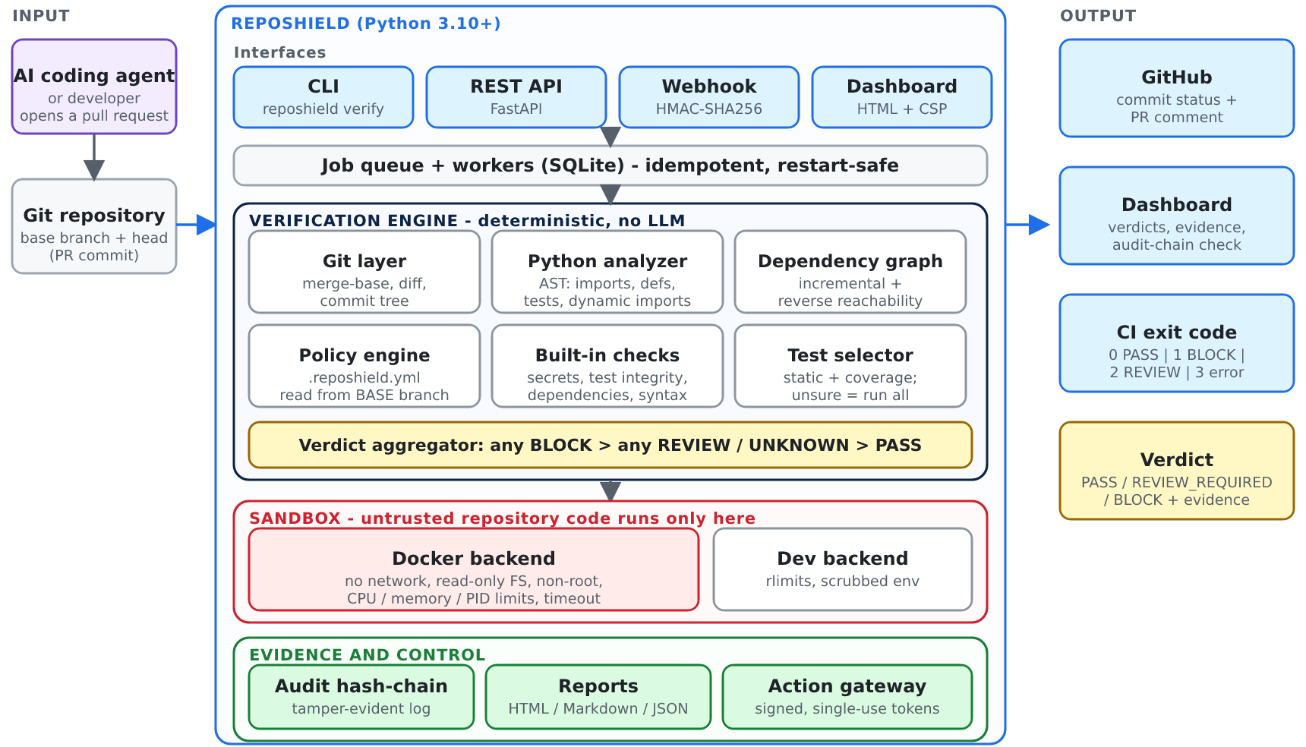
Fig. 1: System architecture of RepoShield (inputs, service, engine, sandbox, evidence store and outputs).
6. Methodology
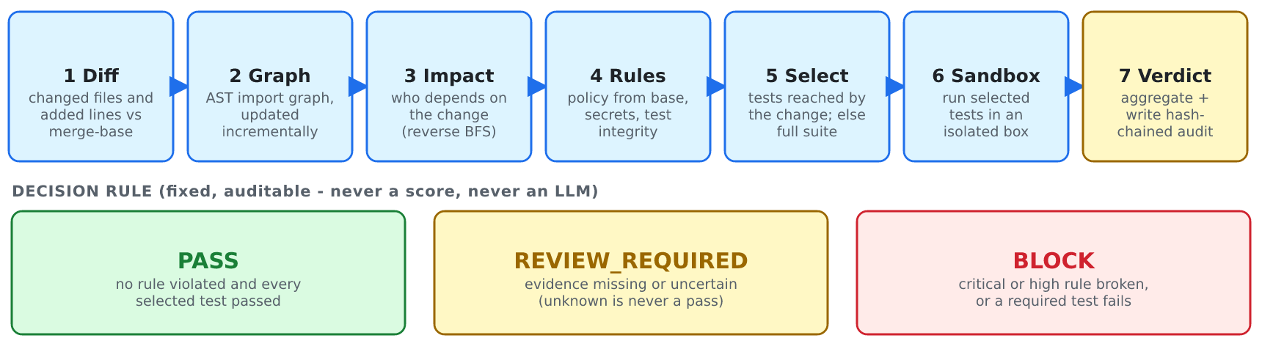
Fig. 2: Seven-stage verification pipeline and the fixed decision rule.
Incremental dependency graph. Python's ast module extracts absolute, relative and constant dynamic imports; edges point from importer to imported file. Parse results are cached by git blob hash, so for a new revision only changed files are re-parsed and edges are re-resolved. The impact set is the reverse breadth-first reachability from the changed files, each edge carrying a confidence value.
Safe test selection. Following the safety principle of Rothermel and Harrold [1], every test that can reach a changed file is selected. A changed configuration file, an unknown file type, or a source file that no test reaches triggers the full suite. An optional strategy prunes the set using a coverage map collected per test (one coverage context per test id).
Policy as code. A YAML file defines rules such as forbidden paths, forbidden imports (direct or transitive, repository paths or package names), required tests, size limits and mandatory review. The policy is read from the base branch, so a change cannot weaken its own judge, and only violations newly introduced (head minus base) are reported. Edits to the policy file are themselves flagged.
- id: payment-isolation - id: authentication-tests
severity: critical severity: high
rules: when: {changed: ["auth/**"]}
- type: forbidden_import rules:
from: "payments/**" - type: required_test
to: "analytics/**" paths: ["tests/auth/**"]
transitive: true
Listing: excerpt of .reposhield.yml (left: an architecture boundary; right: a mandatory-test rule).
AI-specific checks. The test-integrity check compares base and head ASTs to detect deleted tests, reduced assertions and newly skipped tests; the secret scan inspects only added lines and redacts matches in all output.
Fail-closed verdict and audit. Any finding with effect BLOCK yields BLOCK; otherwise any REVIEW or UNKNOWN yields REVIEW_REQUIRED; otherwise PASS. Each audit event stores H(i) = SHA-256( event(i) ‖ H(i−1) ), so modifying, deleting or reordering an event is detected [3]. An agent action gateway issues HMAC-signed, expiring, single-use tokens bound to the exact command, the policy hash and the workspace; everything not explicitly allowed is denied.
7. Technology Stack
Layer | Technology
Core and analysis | Python 3.10+, ast module, git command-line plumbing (diff, merge-base, ls-tree, archive), PyYAML for policies
Service | FastAPI [4], Uvicorn, SQLite job store, server-rendered dashboard with strict Content-Security-Policy
Testing and coverage | pytest [5] with an injected result plugin, coverage.py contexts for the test-to-code map
Isolation | Docker [6] (no network, read-only root file system, non-root user, CPU/memory/PID limits); POSIX rlimits for the development backend
Integration and security | GitHub webhooks and REST API (HMAC-SHA256 signature check, commit status, PR comments); SHA-256 hash chain; HMAC tokens
8. Implementation Status and Results
The prototype runs on Linux and Windows 10 under Python 3.10 and 3.12; its 112 automated tests pass on both interpreters. On the Windows machine, the Docker self-test confirmed an isolated network (loopback only), a read-only root file system, a non-root user, timeout kill and output capping. Ten pull requests that imitate typical agent behaviour were verified:
Simulated AI-agent action | Verdict | Deciding evidence
Adds an input guard to the refund module | PASS | All rules pass; 2 of 9 test files run (78% fewer)
Payments package imports analytics directly | BLOCK | payment-isolation: refund.py to analytics/client.py
Shared helper now imports analytics (indirect) | BLOCK | Path payments/refund.py, common/money.py, analytics/client.py
Hard-coded AWS key and a new CI workflow | BLOCK | Secret scan (redacted) and forbidden path .github/workflows
Removes a safety check and skips its test | REVIEW_REQUIRED | Test integrity: test newly skipped, although all tests pass
Deletes the token-expiry check | BLOCK | Required authentication test fails in the sandbox
Deletes the isolation rule from the policy, then breaks it | BLOCK | Policy taken from base branch; tampering flagged
README change only | PASS | No test can be affected; none run
Adds a new dependency | REVIEW_REQUIRED | Dependency manifest changed; full suite as fallback
Changes production configuration | REVIEW_REQUIRED | Policy requires manual review
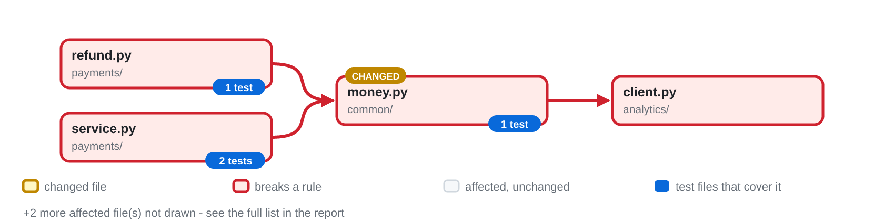
Fig. 3: Impact map generated by RepoShield for the indirect-leak change (red = dependency path that breaks a rule).
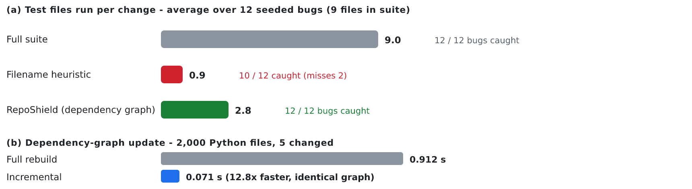
Fig. 4: Measured results from the reproducible benchmark (benchmark/bench.py).
9. Requirements and Work Plan
Software: Python 3.10 or newer, Git 2.x, a web browser, and Docker Desktop (optional, for the hardened sandbox). Hardware: an ordinary PC or laptop with 4 GB RAM or more; no GPU or special hardware is needed.
Phase | Scope | Status
1 | Core engine: Git layer, AST analyzer, incremental dependency graph, policy engine, built-in checks, test selector | Completed
2 | Sandbox backends, tamper-evident audit chain, agent action gateway, command-line interface | Completed
3 | REST service, GitHub webhook, job queue, web dashboard, visual impact-map reports | Completed (prototype)
4 | Hardening: Docker sandbox validated on Windows; evaluation on larger real repositories | In progress
5 | GitHub App with Check Runs, PostgreSQL queue, micro-VM isolation, pilot with a real team | Planned
10. Limitations and Future Scope
Limitations. Analysis is file-level and Python-only; reflection and non-constant dynamic imports are reported as UNKNOWN rather than resolved. The development sandbox is not a security boundary and Docker shares the host kernel. Test results originate inside the sandbox and could be forged by malicious test code; an out-of-sandbox reporter is needed. The results above come from a small demo application and must be validated on larger real repositories.
Future scope. (1) GitHub App with Check Runs and line annotations; (2) symbol-level impact analysis and per-test selection; (3) PostgreSQL and a distributed job queue; (4) micro-VM isolation (gVisor/Firecracker); (5) language adapters for TypeScript and Java; (6) an optional language-model explainer that summarises findings but can never change a verdict.
11. Conclusion
RepoShield shows that agent-generated changes can be gated by deterministic, explainable evidence instead of opinion: it traces a change's reach through the dependency graph, enforces rules the change cannot rewrite, runs only the necessary tests in isolation, and records a verifiable trail. The prototype meets its objectives on the evaluated scenarios and provides a base for production-grade hardening.
References
[1] G. Rothermel and M. J. Harrold, “A safe, efficient regression test selection technique,” ACM Trans. Softw. Eng. Methodol., vol. 6, no. 2, pp. 173–210, 1997.
[2] M. Gligoric, L. Eloussi and D. Marinov, “Practical regression test selection with dynamic file dependencies,” in Proc. ISSTA, 2015, doi:10.1145/2771783.2771784.
[3] B. Schneier and J. Kelsey, “Secure audit logs to support computer forensics,” ACM Trans. Inf. Syst. Secur., vol. 2, no. 2, pp. 159–176, 1999.
[4] FastAPI documentation, https://fastapi.tiangolo.com
[5] pytest documentation, https://docs.pytest.org
[6] Docker documentation, “Docker security” and “Resource constraints,” https://docs.docker.com
[7] GitHub Docs, “Validating webhook deliveries,” https://docs.github.com
[8] Python documentation, “ast — Abstract Syntax Trees,” https://docs.python.org/3/library/ast.html

