UNBANKED WOMEN: ECONOMIC EMPOWERMENT USING HALAQOH MODEL IN SHARIA MICRO FINANCIAL INSTITUTIONS IN INDONESIA
Rozalinda^{1,*}, Nurhasnah², Rizda Octaviani³
¹ Faculty of Islamic Economics and Business, State University of Imam Bonjol Padang, Indonesia, rozalinda@uinib.ac.id
²Sharia Faculty of the State Islamic University Imam Bonjol Padang, Indonesia
³Sharia Economics College Manna Wa Salwa, Padang Panjang, West Sumatra, Indonesia

Abstract
Empowering women with micro and small businesses requires support from Islamic Microfinance Institutions. Women cannot access financing from banks because they are considered unbanked or do not meet bank requirements. Therefore, this study aimed to elaborate on the empowerment model implemented by the Micro Waqf Bank (MWB) for poor, productive women around Islamic boarding schools. It used a qualitative approach on MWB in West Sumatra, Yogyakarta, and Central and East Java, Indonesia. Data were collected through interviews, observation, questionnaires, and documentation. The data sources comprised WMB leaders, assistants, and customers. All data were reviewed and analyzed qualitatively and descriptively. The results showed that WMB implements empowerment by providing training, financing, and assistance to productive potential poor women living around Islamic boarding schools. Women have been economically empowered through the Compulsory Group Training (CGT), financing, and assistance. All empowerment processes were carried out in the form of halaqoh. The customer and the companion sat cross-legged, facing each other to receive training and mentoring materials from the facilitator.
Additionally, assistance was provided after disbursing financing with the Weekly Halaqoh (WH) model. The study has implications for the government's ability to use MWB as a basis for the economic empowerment of unbanked women. Consequently, they can actively participate in economic activities and improve the welfare of their families. The results of this study can serve as inspiration for women micro and small entrepreneurs to continue fighting against marginalization in the financial aspect.
Keywords: Economic Empowerment, Halaqoh, Micro Waqf Bank, Unbanked, Women,

Introduction
Women's empowerment is an important issue in economic and social development, especially in developing countries such as Indonesia (Dalseg et al., 2018). Despite progress in financial inclusion, women still face significant access gaps compared to men. According to a survey conducted by SOFIA, only 42% of women in Indonesia use banking services, much lower than men (Sofia, 2017). In this context, Islamic microfinance institutions, especially Micro Waqf Bank (MWB), have emerged as innovative solutions to empower unbanked women. Through the Halaqoh model, MWB provides access to not only finance but also training and mentoring, which are needed to improve the skills and capacity of women entrepreneurs (Ade Soekadis, 2021).
This research focuses on understanding how MWB applies the Halaqoh model as a method of women's empowerment (Fitriatinnisa & Khoirunurrofik, 2021; IFC, 2021). What is already known is that Halaqoh functions as an interactive learning space where participants can share experiences and knowledge in a supportive atmosphere. However, much remains unknown, especially regarding the long-term impact of this program on the economic well-being of women and their families, as well as how MWB manages the risks associated with it (Fianto et al., 2019; Sulistiani, Siska Lis, Muhammad Yunus, 2019; Umar et al., 2019). Through a qualitative approach involving in-depth interviews, observations, and documentation analysis, this study aims to elaborate on the empowerment model applied by (Hasiba et al., 2021; and Paramita Prananingtyas, 2020). This study also aims to provide insight into the ways and reasons behind the success of this model in empowering marginalized women, as well as its implications for government policies and related institutions in supporting women's economic empowerment in Indonesia. Thus, the results of this study are expected to make a significant contribution to the literature on women's empowerment and financial access in the sharia context.
Research Method
This study was conducted at MWB in the Provinces of Yogyakarta, West Sumatra, as well as Central and East Java, Indonesia, as shown in Table 1.
Table 1. Study Location
Province | SMI MWB
West Sumatra | - SMI MWB Al Kausar Sari Lamak Kec. Harau, Lima Puluh Kota, West Sumatra
Yogyakarta | - SMI MWB Usaha Mandiri Sakinah, Aisyiyah University (UNISA) Yogyakarta
 | - SMI MWB Almuna Berkah Mandiri, Al Munawwir boarding school, Krapyak Yogyakarta
 | - SMI MWB Al Manshur Barokahing Gusti, Klaten Regency, Yogyakarta
 | - SMI Sharia Waqf Bank Alpansa, Klaten Regency, Yogyakarta
East Java | - SMI MWB Alfitrah Wafa Mandiri, As-Salafi Al-Fithrah Boarding School, Kewall Surabaya, East Java
 | - SMI MWB at Mambaul Maarif Boarding School, Denanyar, Jombang Regency, East Java
Central Java | - SMI MWB at Bahrul Ulum Islamic Boarding School, Tambak Beras
 | - SMI MWB at Tebuireng Boarding School, Central Java

During this study, MWBs were already established in forty-three Islamic boarding schools, thirty-four of which were spread across Java Island, seven in Sumatra, one in Kalimantan, one in Sulawesi, and one in Papua (BWM, 2019). Furthermore, Java Island was designated as the study location because it has the most significant number of MWB, followed by Sumatra.
This qualitative descriptive study analyzed data holistically to provide information (Thorne et al., 2017) about the model of women's economic empowerment. A descriptive qualitative approach was used in the framework of elaborating an in-depth model of women's economic empowerment at MWB toward productive poor women around Islamic boarding schools. Data were obtained from MWB customers, leaders, and assistants. Informants comprised parties directly involved with an important role in the empowerment. They understand MWB operations that contribute to women's economic empowerment. The empowerment model was obtained through interviews and observations. This study conducted observations on the mandatory group training and customer assistance processes during the WH meeting. Interviews were conducted with MWB leaders, assistants, and customers on the empowerment model that was carried out. Structured interviews were conducted naturally to build a friendly atmosphere for informants.

  - Socio-Demography
This study involved 95 women aged 30-39 (40%) and 40-49 (39%) to participate in in-depth interviews. Based on education level, 57% of respondents were Senior High School graduates, while only nine graduated from higher education. Most respondents (53%) have been in this business for 1-5 years, and only 6% for more than 15 years. Additionally, 27 respondents (29%) have an income of less than 1.9 million rupiahs, and 17 earn more than 4 million rupiahs, as shown in Table 1.
Table 1. Respondents’ Sociodemography
Education |  |  | Age |  |  | Business length |  |  | Income After Obtaining Financing
Education | Total | % | Age | Total | % | Business length | Total | % | Income | Total | %
Higher Education | 9 | 9% | >50 years | 13 | 14% | 1-5 years | 50 | 53% | <1.9 million rupiahs | 27 | 29%
Senior High School | 54 | 57% | 40-49 years | 37 | 39% | 6-10 years | 28 | 29% | 2 -2.9 million rupiahs | 21 | 23%
Junior High School | 19 | 20% | 30-39 years | 38 | 40% | 11-15 years | 11 | 12% | 3 -3.9 million rupiahs | 30 | 32%
Elementary School | 13 | 14% | 29 years | 7 | 7% | >15 years | 6 | 6% | >4 million rupiahs | 17 | 17%
 | 95 |  |  | 95 |  |  | 95 |  |  | 95

  - Data Analysis Procedure
This study used qualitative analysis with a thematic approach through data collection, reduction, interpretation, and display. During data collection, all information was recorded and transcribed. The reduction involves identifying and sorting the raw data before summarizing, coding, and categorizing them based on study questions (Patton, 2005). According to (Malik, 2013), thematic analysis reduces grouped data into more meaningful ones to obtain important themes by underlining, italicizing, or coding. An interpretation was performed based on the data category to get important patterns repeatedly appearing from the actual data. Therefore, thematic analysis requires more involvement and interpretation (Macqueen et al., 2005).
  - Credibility and Transferability
The findings' credibility, trustworthiness, transferability, and generalizability are significant in qualitative studies. To ensure credibility, this study recorded respondents’ explanations and reflected on the problem examined. Furthermore, the transferability of the results was ensured by presenting and expanding the existing data. The aim was to use the data applicable to the empowerment carried out by MWB for unbanked women. In-depth interviews with participants were also used to ensure the data’s validity and integrity. Written responses were read to interviewees to ensure the accuracy and confirmation of existing responses.

Results and Discussion
  - Stages of Women's Economic Empowerment in Sharia Microfinance Institutions Micro Waqf Banks (SMI MWB)
First, the identification of prospective customers was conducted to determine the suitability of program target criteria, such as distance of residence, type, and place of business. Second, the socialization of MWB to the community was carried out through recitation mothers, social gatherings, and Family Welfare Empowerment (FEW). The socialization aimed to disseminate information regarding the conception, stages of formation, participation requirements, and CBGIBSI activities. The third process was a survey of prospective customers. Fourth, a test was performed on the feasibility of prospective customers. Referring to the interviews with Dafril (2019) and Safitri (2019), Supervisor of MWB AlKautsar Payakumbuh and MWB UNISA Yogyakarta, the feasibility test clarifies the correctness of data on low-income families from identification activities and helps select prospective participants. The feasibility test involved a direct visit to the residence to see the house conditions and to obtain economic and business data.
Fifth, Group Compulsory Pre-Training (GCP) was performed before implementing CGT for prospective customers. Facilitators and prospective CBGIBSI members carried out the activities. The goal was to strengthen the group's determination and interest to participate in the MWB program, form a CBGIBSI, and introduce a financing distribution mechanism. This activity prepared the group to participate in the program implementation (BSM, 2017a). More details are shown in Figure 1.
Figure 1. Stages of Women's Empowerment in MWB

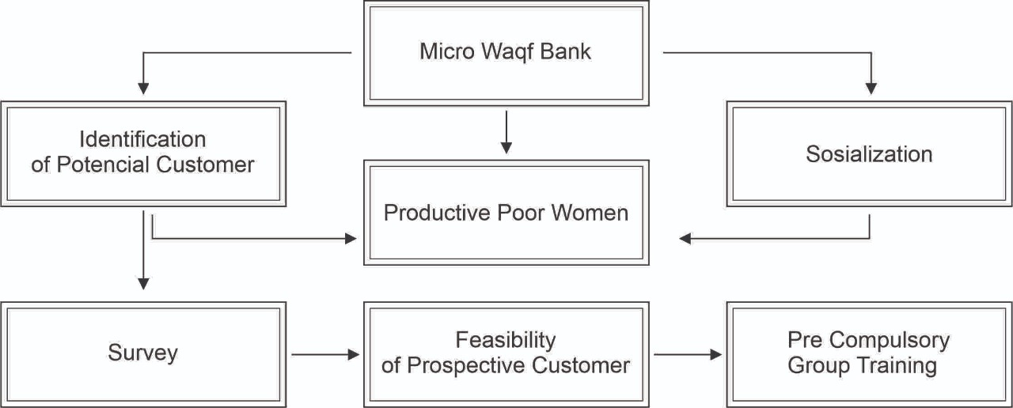

  - Women's Empowerment Model in Sharia Microfinance Institutions Micro Waqf Banks (SMI MWB)
Women are empowered through CGT, provision of financing, and customer assistance. First, CGT is the initial phase of the empowerment program conducted by MWB for unbanked women. The management emphasizes the character of prospective customers, including discipline, trust, responsibility, and caring for others. CGT is held after a minimum of three groups of five members are formed. It is carried out for 1 hour on five consecutive days (BSM, 2017a), as shown in Table 1:
Table 1. CGT Materials
Day | Material
First | 1) Explanation of CGT, 2) Introduction to MWB. 3) Introduction and principles of CBGIBSI membership, Introduction of CGT participants, 4) The introduction of the pledge, 5) Motivational material.
Second | 1) Reading of the pledge, 2) Capacity building materials, 6) Rights and obligations of members, 7) Election of the group leader and deputy leader, 8) Discussion of the responsibilities of the leader, secretary, and group members.
Third | 1) Reading of the pledge, 2) Introduction of contracts and financing procedures as well as installment payments, 3) Stories and how to create a business profile.
Fourth | 1) Reading of the pledge, 2) Giving the name and number of CBGIBSI, 3) Election of leader and deputy leader, 4) Discussion of the responsibilities of the leader, deputy leader, and members, and 5) discussion about WH.
Fifth | 1) Reading of the pledge, 2) Review of CGT materials, 3) CBGIBSI validation test.
Source: (BSM, 2017b)
The uniqueness of this training is the character testing of prospective customers. According to Sari (2019) and Dafril (2019), the participants of the Manager of MWB Al Kautsar Lima Puluh Kota of West Sumatra and MWB UNISA Yogyakarta collected small changes of IDR 2,000 on the first day. The supervisor recorded and entrusted the serial number to the participants sitting at the back. The following day, the supervisor asked for the money deposited to check the serial number. The participants were declared trustworthy when the serial number had not been changed, and vice versa. The supervisor emphasized the importance of trusting behavior. After the meeting on the second day, the supervisor collected small changes of IDR 2,000 and recorded the serial number. The number was left to the participants sitting in the penultimate row and the front.
All prospective customers were required to take the Group Validation Examination (GVE) conducted by the MWB supervisor on the fifth day. The prospective group members who understood the training material were declared to have passed and were confirmed as MWB customers, forming CBGIBSI (BSM, 2017b). Prospective customers are declared to have passed based on the indicators of a) Discipline, b) Cohesiveness, c) Trust, d) Ability to answer at least 50% of the statements, e) Get family support. Based on an interview with Puguh, Amalia (2019), Supervisor of MWB Alfitrah Wafa Mandiri As-Salafi Al-Fithrah Islamic Boarding School, Kewall Surabaya and MWB Tebu Ireng Jombang, the participants were ranked in the order of the most in need of receiving the first financing. The members who obtain the disbursement of financing first sit at the back. The leader sitting in the front receives the latest financing according to the arrangement shown in Figure 2.
Figure 2. Group Member Seating Order Model

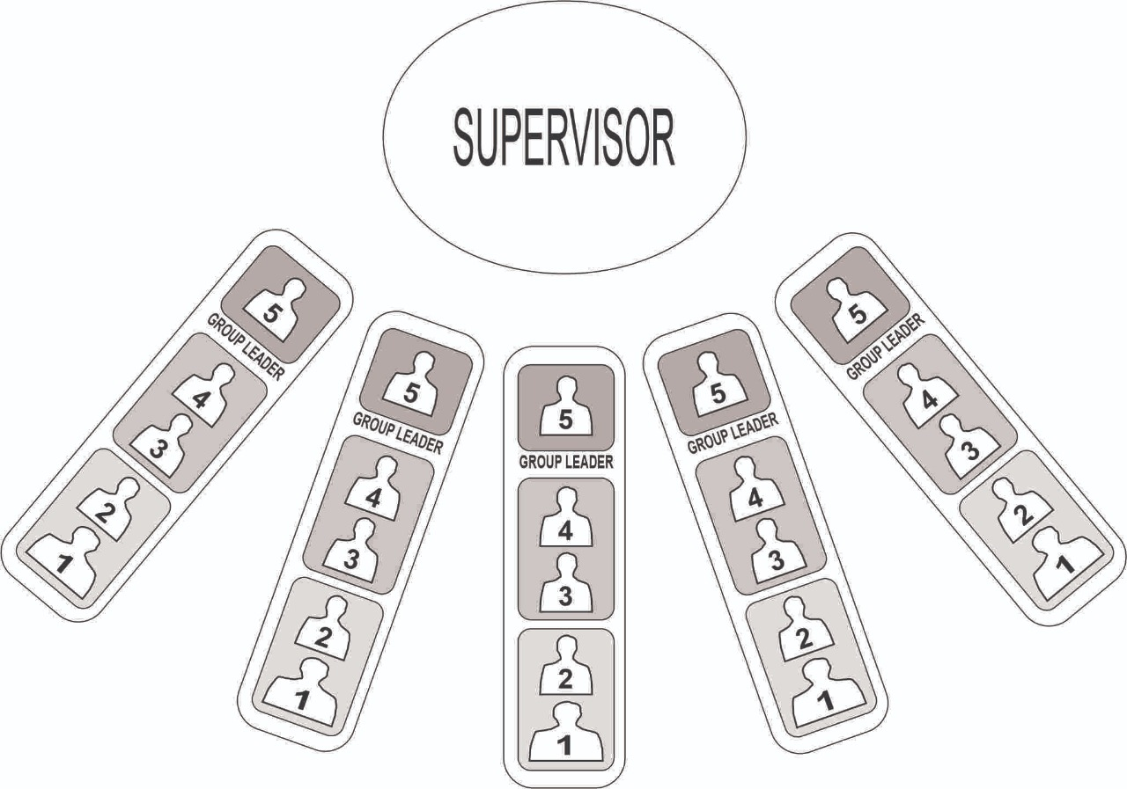
Source: The Micro Waqf Bank, 2019
The second step is the financing disbursement following the seating arrangement during GCT. As described by Sari and Umami (2019), Managers and Customers of MWB Mandiri Sakinah UNISA Yogyakarta and MWB Alpansa Klaten, financing is disbursed in three stages using a 2-2-1 pattern. This pattern is a model that teaches the caring attitude of fellow members. The financing disbursement was sorted by the urgency level, where the members most in need received it first. It was disbursed to the participants sitting at the back with serial numbers 5 and 4 in the first week of WH. The participants with serial numbers 3 and 2 received the financing in the second stage. The funding was disbursed in the second week of WH. The group leader will obtain the last disbursement opportunity to sit in the front. The financing was disbursed in the third week of WH. Third, customers’ assistance was provided after disbursing the financing during WH, as illustrated in Figure 3.
Figure 3: Implementation of Halaqoh in MWB
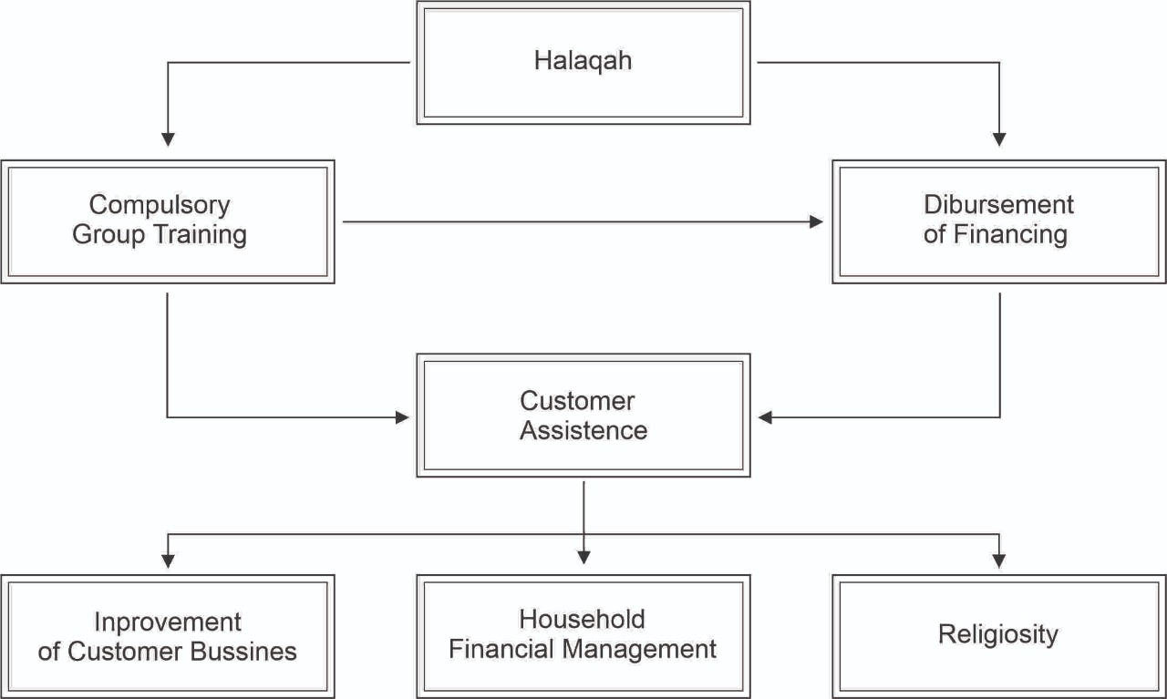

  - Halaqoh in SMI MWB
Each customer pays off the loan weekly at the WH meeting to qualify for further financing. The empowerment model applied to MWB in the form of WH is implemented at the home of the group leader or CBGIBSI. WH is a customer assistance activity where all participants and supervisors sit cross-legged on the floor. They comprise several CBGIBSI sitting in a row facing the supervisor. Puguh (2019), the manager of MWB Tebu Ireng Jombang, East Java, stated that the halaqoh model fosters the customers’ mental attitude. Halaqoh activity is performed regularly once a week and should be followed by every customer. This activity builds attitudes, a sense of togetherness, commitment, and customer discipline. It also builds an attitude of solidarity, responsibility, and group cooperation through joint responsibility in paying loan installments. Halaqoh is conducted for 1 hour accompanied by an MWB supervisor with an agenda, as described in Table 2.

Table 2. Halaqoh Agenda at MWB
No | Material
1 | Opening
2 | Pledge reading
3 | Member attendance report
4 | Disbursement of financing
5 | Customer Assistance
6 | Installment payments
7 | Prayer and closing
Source: (BSM, 2017a)

Assistance is provided directly by supervisors or external speakers through HALMI Akbar (Great WH). This was acknowledged by Zuhri (2019), the supervisor of MWB Alpansa Klaten Yogyakarta. Customers’ assistance is carried out through, First, religious spiritual guidance filled with studies by ustadz or ustazah from Islamic boarding schools. The second stage is household financial management. SMI provides assistance and family development through financial management to create a Sakinah family. Third, customers’ business development assistance is provided through mentoring and entrepreneurship help. This includes marketing management, bookkeeping training, services, and business expansion through food product packaging training and product quality improvement. Furthermore, MWB helps customers market their products online and guides them in creating online buying and selling accounts. It also helps customers sell products at certain events, as stated by Hayati (2019), the customer of MWB Al-Kausar Sari Lamak, Harau Lima Puluh Kota Sub-district.
MWB uses group-based financing, where the group determines loan approval and guarantees the payment of each member's financing. This group-based pattern uses a joint responsibility financing system, as confirmed by Eni (2019), Chairman of MWB Almuna Krapyak Yogyakarta. The groups guaranteed MWB that they were responsible for members with arrears in paying installments. Members help each other by donating and contributing to overcoming arrears. Therefore, they should have joint responsibility savings managed by the group leader. The savings are guaranteed by a group in case of arrears in installments from CBGIBSI members. The financing installments are taken from the group's joint responsibility savings to settle arrears. Members replace their arrears the following week at the halaqoh meeting with the group leader.

- Discussion
  - Women's Economic Empowerment in Sharia Microfinance Institutions Micro Waqf Banks (SMI MWB)
As SMI, MWB is a financial institution oriented towards improving the community welfare around Islamic boarding schools, specifically for poor, productive women (Sulistiani et al., 2020). It provides financing and assistance to micro and small business women (Soemitra et al., 2022). The SMI market segment is unbanked women or micro business actors with no access to financing from banks because they are considered unfit. This is because women are considered able to commit to discipline by attending regular WH meetings. They are also seen as more capable of managing family finances and business capital. Therefore, women could develop their businesses through the financial assistance of only IDR 1,000,000. (Rahman et al., 2017) Stated that microfinance programs target women because they have more problems obtaining credit. They have limited labor market access and higher loan repayment rates than men.
The financing program provided by MWB to group-based customers is run by 15 to 25 people. Muhammad Yunus applied the model through social entrepreneurship at the Grameen Bank in Bangladesh in 1983 (Nurhayati, 2016). According to (Ajja et al., 2020), women's empowerment through entrepreneurship has become an integral part of development in India. Women's entrepreneurship is a business or organization started by a woman or group of women. Self-help groups (SHGs) play a significant role in developing India's rural communities, whose members are predominantly women (Aggarwal et al., 2020). This empowerment program is implemented by a Doctor of Philosophy graduate at Vanderbilt University, Tennessee, United States. The graduate established the Grameen Bank by providing group-based microcredit for poor people with unsecured businesses. The recipient of the 2006 Nobel Peace Prize has programmed each loan applicant to form a group of five people. Group members cannot make credit in turn, while other members only make credit when the member that made first has shown discipline and honesty in paying the installments (Ashraful & Khan, 2016).
The financing in MWB is group-based, necessitating the pattern of joint responsibility known as kafalah in Islamic economics (Rozalinda, 2019). Members are mutually responsible for each other’s arrears financing installments. When a member cannot pay the installments, colleagues cover the arrears to ensure the financing installments to MWB remain smooth. Group-based loans could significantly reduce financing risk (Iwang Suwangsih et al., 2021; Prastyaningtyas et al., 2022). Muhammad Yunus also implemented a joint responsibility mechanism in the Mit Ghramr bank empowerment program. In this mechanism, group members jointly pay installments for colleagues experiencing difficulties (Yunus, 2005). (Hasiba et al., 2021) stated that this model significantly impacts poverty alleviation in Bangladesh, where loans are given to people experiencing poverty based on trust, not collateral or guarantor. Prospective borrowers should join a group of microfinance borrowers to receive a loan from Grameen Bank.
The Grameen Bank model has been replicated and modified in many Sharia microfinance programs in Indonesia, including Sharia micro waqf banks. Most Sharia microfinance is designed as ultra-micro financing as accomplished by Permodalan Nasional Madani (PNM) since 2015 (Musta’anah et al., 2021). Similarly, BTPN Syariah has focused on economically empowering productive, underprivileged women since 2010 (Fanggidae et al., 2020). These financial institution programs have specific characteristics, such as community empowerment and microfinance services. They are group-based and specifically aimed at women from poor or low-income families (Yaumidin et al., 2017). Muhammad Yunus stated that microfinance institutions that provide financial services to stimulate small businesses could empower women (Cabeza-García et al., 2019). Mit Ghramr Bank was founded for small business loans, and 97% of its customers are women (Yunus, 2005).

  - The Halaqoh Method In Women's Economic Empowerment
MWB uses the halaqoh method in women's economic empowerment activity around Islamic boarding schools (Rozalinda & Nurhasnah, 2022). The model has been running since prospective MWB customers started participating in GCT, which was held for five days (Anwar et al., 2023). Halaqoh activity is conducted once a week for financing disbursement and customers’ development activity (Soemitra et al., 2022). In the traditional learning system, the sitting positions of the teacher and students blend in to form a circle. (Yamin & Dalimunthe, 2020) Halaqoh activity is viewed as a bonding friendship among CBGIBSI members to strengthen women's determination and commitment to MWB rules (Ritonga et al., 2019). Therefore, it entails funding and assistance, friendship, and religious education. This finding proved that the halaqoh model motivates women to learn Islam, entrepreneurship, and the ability to manage household finances. Furthermore, it is the driving force for the emergence of women's micro-enterprises around Islamic boarding schools. As SMI, MWB has proven its role in realizing financial inclusion through micro-financing.
(Mukthar et al., 2023) The microcredit system contributes to the entrepreneurial spirit of rural women. (Nugroho & Hilal, 2019)Stated that MWB increases financial inclusion by enabling the community as well as micro small businesses to have easy capital. SMI is an alternative solution to the problems faced by people experiencing poverty (Zitouni & Ben Jedidia, 2022), precisely the ease of access to finance. According to (Rahman et al., 2017), microfinance programs have been an important development strategy worldwide for over three decades, specifically in developing countries. One goal of microfinance is to reduce poverty by providing more access to financial institutions to empower people experiencing poverty (Yaumidin et al., 2017). SMI has a role in economic, socio-cultural, and family empowerment (Islam, 2021). Involving women in microfinance improves their household position through independent access to income (Yaumidin et al., 2017).
Empowerment using the halaqoh model, a key to women's economic empowerment, is not entirely successful. Customers do not fully use the financing disbursed by MWB for business capital. The interviews with the group leader (AS, 2021) revealed that some customers used funds for consumptive purposes or to pay off debts (WT. 2021). This condition results in group members being in arrears in financing installments (R, 2021), which should be borne through group savings. It shows that the assistance provided by MWB is not only in the form of weekly halaqoh. Therefore, field assistance should involve supervising the customers’ place of business.

Conclusion
Empowerment is conducted by MWB through financing and assisting potentially productive but poor women living around Islamic boarding schools as their market segment. The loans are distributed using a group approach with a joint responsibility system. The empowerment model is implemented from the GCO GCT to mentoring using the halaqoh model. Participants sit cross-legged on the floor, facing the supervisor in a semi-circle. The participants most in need of financing first sit at the back, the group leader sits at the front, and those receiving funding come last.
The halaqoh model applied by MWB increases women's economic welfare through micro-financing. Women receive Sharia business character development in GCT based on their discipline, honesty, trustworthiness, concern for others, and financial responsibility. They also receive Islamic assistance, household financial management, and business development at regular halaqoh meetings.
The SMI MWB program could be replicated and expanded in the area of its establishment to enhance access to microfinance and empower women's economy. This study is expected to implicate government and non-government policies to promote women's empowerment through easy access to financial institutions. However, it only examined the women's empowerment model carried out by MWB, not the risk management side of group-based financing. This is an opportunity for future studies to examine financing risk management at MWB.
The new insight from this study is that the halaqoh model is very suitable for empowering unbanked women. At weekly halaqah meetings, fostering the mental attitude of customers, a sense of togetherness, commitment, discipline, building solidarity, responsibility, and group cooperation is seen as more effective. This study also offers some practical implications. Firstly, the government needs to make SMI MWB a basis for the economic empowerment of unbanked women who cannot access banking services. Hence, they can actively participate in economic activities and improve the welfare of their families. Secondly, the results of this study can inspire women micro and small entrepreneurs to continue fighting against marginalization in the financial aspect.

Acknowledgment
The authors are grateful to the leaders and mentors of the IA Scholar Foundation for providing direction in completing this study
References
Ade Soekadis. (2021). EMPOWERING INDONESIAN WOMEN’S ECONOMY THROUGH DIGITAL FINANCIAL INCLUSION Lessons from MFS and SWEET Programs for Women Micro-Entrepreneurs in East Java.
Aggarwal, S., Kumar, P., & Garg, V. (2020). Empowering SHGs Women through Micro-finance in Uttar Pradesh. International Journal of Law and Management, 62(6), 591–606. https://doi.org/10.1108/IJLMA-02-2020-0051/FULL/XML
Ajja, S. H., Samiti’, S., Arts, S. K. S. J., & Sheshgiri, S. M. (2020). Women Empowerment And Women Entrepreneurship: An Overview. Jurnal Universitas Arsitektur & Teknologi Xi’an, 12(3), 3843–3844.
Anwar, M. Z., Fathan, Warto, & Hidayati, O. N. (2023). TRANSFORMATION OF ECONOMIC THEOLOGY FOR COMMUNITY EMPOWERMENT A Case Study on Pesantren-Based Bank Wakaf Mikro. Journal of Indonesian Islam, 17(1), 76–99. https://doi.org/10.15642/JIIS.2023.17.1.76-99
Ashraful, M., & Khan, I. (2016). MICROCREDIT AND GRAMEEN BANK: A VIEW FROM THE GRASSROOTS. In Article in International Journal of Current Research.
BSM, L. (2017a). “SOP & SOM Standar Operasional Prosedure Dan Management Untuk LKM Syariah-Bank Wakaf Mikro (p. 8). LAZNAS BSM.
BSM, L. (2017b). Manajemen Lembaga Keuangan Mikro Syariah. LAZNAS BSM.
BWM. (2019). LKMS-BWM. Http://Www.Lkmsbwm.Id/.
Cabeza-García, L., Del Brio, E. B., & Oscanoa-Victorio, M. L. (2019). Female financial inclusion and its impacts on inclusive economic development. Women’s Studies International Forum, 77(October), 102300. https://doi.org/10.1016/j.wsif.2019.102300
Dalseg, S. K., Kuokkanen, R., Mills, S., & Simmons, D. (2018). Gendered Environmental Assessments in the Canadian North: Marginalization of Indigenous Women and Traditional Economies. Northern Review, 47(47), 135–166–135–166. https://doi.org/10.22584/NR47.2018.007
Fanggidae, R. E., Kurniawati, M., & Bahweres, H. (2020). The Effect of Workplace Spirituality and Employee Performance (Perspective of Islamic Work Ethics Case Study on BTPN Syariah, Kupang). Atlantes Press, 234–239. https://doi.org/10.2991/AEBMR.K.200522.045
Fianto, B. A., Maulida, H., & Laila, N. (2019). Determining factors of non-performing financing in Islamic microfinance institutions. Heliyon, 5(8), e02301. https://doi.org/10.1016/J.HELIYON.2019.E02301
Fitriatinnisa, D., & Khoirunurrofik, K. (2021). Financial Inclusion, Poverty, Inequality: Empirical Evidence from Provincial in Indonesia. Economics Development Analysis Journal, 10(2), 205–220. https://doi.org/10.15294/EDAJ.V10I2.44483
Hasiba, F. F., Mahmudah, S. N., & Puji Sucia Sukmaningrum, Shochrul Rohmatul Ajija, M. B. F. Z. (2021). The Strategies for Developing Micro Waqf Bank in Indonesia. Rigeo.Org, 11(4), 2021. https://doi.org/10.48047/rigeo.11.04.24
IFC. (2021). Mobile Banking in Indonesia Assessing the MArket PotentiAl for Mobile technology to extend bAnking to the UnbAnked And UnderbAnked.
Islam, M. S. (2021). Role of Islamic microfinance in women’s empowerment: evidence from Rural Development Scheme of Islami Bank Bangladesh Limited. ISRA International Journal of Islamic Finance, 13(1), 26–45. https://doi.org/10.1108/IJIF-11-2019-0174
Iwang Suwangsih, Nuzulul Fatimah, Noneng Rukayah Sukatmadiredja, & Emmywati. (2021). THE IMPACT OF IMPLEMENTATION OF A JOINT LIABILITY SYSTEM ON MEMBER BEHAVIOR. Journal of Islamic Economics Perspectives, 3(1), 88–100. https://doi.org/10.35719/JIEP.V3I1.41
Macqueen, K. M., Guest, G., & Namey, E. (2005). Qualitative Research Methods: A DATA COLLECTOR’S FIELD GUIDE NATASHA MACK • CYNTHIA WOODSONG.
Malik, R. S. (2013). QUALITATIVE RESEARCH METHODOLOGY IN EDUCATION. Jurnal Edubio Tropika, 1(2).
Mukthar, K. P. J., Asis, H. R., Vílchez-Vásquez, R., Huaman-Osorio, A., & Alvarado-Tolentino, J. (2023). Estimating Women Entrepreneurial Empowerment of Start-Up Business Through Micro Credit Model in Rural Areas. Lecture Notes in Networks and Systems, 495 LNNS, 86–94. https://doi.org/10.1007/978-3-031-08954-1_8/COVER
Musta’anah, A., Bina Buono, K., Atika, R., Noviarita, H., Islam, U., Raden, N., & Lampung, I. (2021). Analysis of Sharia Literacy Level and Sharia Financial Inclusion PNM Mekaar Sharia in Increasing Income Public (Study on the Fishing Community of Kuala Jaya Hamlet, South Lampung Regency). Journal of Islamic Business and Economic Review, 4(2), 97–101.
Nugroho, W., & Hilal, F. N. (2019). Micro Waqf Bank in Indonesia: Analysis of The Constitution Concept According to The Maqashid Sharia. Al-Iktisab: Journal of Islamic Economic Law, 3(1). https://doi.org/10.21111/AL-IKTISAB.V3I1.3905
Nurhayati. (2016). Social Entrepreneurship Muhammad Yunus“Grameen Bank". Jurnal Bisnis Manajemen & Perbankan, 2(1), 31–48.
Paramita, & Prananingtyas, H. S. D. (2020). Legal Consequences of Dualism Regulations on Micro Waqf Bank as a Sharia Microfinance Institutions in Indonesia. Varia Justicia, 16(1), 1–14. https://doi.org/10.31603/variajusticia.v16i1.3205
Patton, M. Q. (2005). Qualitative Research. Encyclopedia of Statistics in Behavioral Science. https://doi.org/10.1002/0470013192.BSA514
Prastyaningtyas, E. W., Widjaja, S. U. M., Wahyono, H., Andayani, E. S., & Rusdi, J. F. (2022). Methods for studying group loans, join responsibility, and women’s empowerment. MethodsX, 9, 101749. https://doi.org/10.1016/J.MEX.2022.101749
Rahman, M. M., Khanam, R., & Nghiem, S. (2017). The effects of microfinance on women’s empowerment: New evidence from Bangladesh. International Journal of Social Economics, 44(12), 1745–1757. https://doi.org/10.1108/IJSE-02-2016-0070/FULL/HTML
Ritonga, T., Ananda, A., Lanin, D., & Hasan, H. (2019). Practice to theory of learning: A lesson learned from islamic boarding school in South Tapanuli of Indonesia. Humanities and Social Sciences Reviews, 7(5), 1304–1310. https://doi.org/10.18510/hssr.2019.75169
Rozalinda. (2019). Fiqh Ekonomi Syariah Prinsip Dan Implementasinya Pada Sektor Keuangan Syariah (1st ed.). Raja Grafindo Persada.
Rozalinda, R., & Nurhasnah, N. (2022). Islamic Boarding School-Based Women’s Economic Empowerment and Its Impact on Increasing Home Industry Income. Annual International Conference on Islamic Economics and Business (AICIEB), 2(1), 432–448. https://doi.org/10.18326/AICIEB.V2I1.126
Soemitra, A., Kusmilawaty, & Rahma, T. I. F. (2022). The Role of Micro Waqf Bank in Women&rsquo;s Micro-Business Empowerment through Islamic Social Finance: Mixed-Method Evidence from Mawaridussalam Indonesia. Economies 2022, Vol. 10, Page 157, 10(7), 157. https://doi.org/10.3390/ECONOMIES10070157
Sofia. (2017). Survey on Financial Inclusion and Access (SOFIA) Implemented by Focus Note on Gender.
Sulistiani, Siska Lis, Muhammad Yunus, E. M. B. (2019). The Role and Legality of Micro Waqf Bank in Pesantren Based Poverty Alleviation in Indonesia. Jurnal Bimas Islam, 12(1), 1–26.
Sulistiani, S. L., Yunus, M., & Bayuni, E. M. (2020). Micro Waqf Bank: New Sharia Financial Instruments in Indonesia. Advances in Social Science, Education and Humanities Research, 409, 1–4. https://doi.org/10.2991/ASSEHR.K.200225.001
Thorne, S., Kirkham, S. R., & O’Flynn-Magee, K. (2017). The Analytic Challenge in Interpretive Description. International Journal of Qualitative Methods, 3(1), 1–11. https://doi.org/10.1177/160940690400300101
Umar, A., Ahmad, F., Fischer, J., Zulkhibri, M., Hassan, M. K., Asy’arie, M., Hidayah, N. N., Kayadibi, S., & Ghazanfar, S. M. (2019). Bank Wakaf Mikro and Creative Economics in Pesantren Buntet. Shirkah: Journal of Economics and Business, 4(2), 2503–4243. https://doi.org/10.22515/SHIRKAH.V4I2.269
Yamin, A., & Dalimunthe. (2020). Classic Islamic Education Heritage in Halaqah and Munazharah. 194.31.53.129, 6(2), 249–343. https://doi.org/10.24952/tazkir.v6i2.1315
Yaumidin, U. K., Suhodo, D. S., Yuniarti, P. I., & Hidayatina, A. (2017). Financial Inclusion for Women: Impact Evaluation on Islamic Microfinance to Women’s Empowerment in Indonesia. Financial Inclusion and Poverty Alleviation, 81–140. https://doi.org/10.1007/978-3-319-69799-4_3
Yunus, M. (2005). ELIMINATING POVERTY THROUGH MARKET-BASED SOCIAL ENTREPRENEURSHIP. In Global Urban Development (Vol. 1).
Zitouni, T., & Ben Jedidia, K. (2022). Does Islamic microfinance contribute to economic empowerment in Tunisia?: a case study of Zitouna Tamkeen. Journal of Business and Socio-Economic Development, 2(1), 67–81. https://doi.org/10.1108/JBSED-10-2021-0143/FULL/HTML

