UNBANKED WOMEN: ECONOMIC EMPOWERMENT USING HALAQOH MODEL IN SHARIA MICRO FINANCIAL INSTITUTIONS IN INDONESIA
Rozalinda¹, Irwan Abdullah², Zaenuddin Hudi Prasojo³, Nurhasnah⁴
¹Faculty of Islamic Economics and Business UIN Imam Bonjol Padang, Indonesia
²Faculty of Cultural Sciences Gadjah Mada University
³Institut Agama Islam Negeri (IAIN) Pontianak of West Borneo Indonesia
⁴Faculty of Sharia UIN Imam Bonjol Padang, Indonesia

Abstract (150-250 kata)
Background: Empowering women with micro and small businesses requires support from Islamic Microfinance Institutions. Women cannot access financing from banks because they are considered unbanked or do not meet bank requirements.
Aims: This study aims to outline the economic empowerment model used by MWB for poor, productive women
Research Methode: This study uses a qualitative approach to MWB in West Sumatra, Yogyakarta, and Central and East Java, Indonesia. Data was collected through interviews, observations, questionnaires, and documentation. The data source consists of WMB leaders, assistants, and customers. All data were reviewed and analyzed qualitatively and descriptively.
Results and Conclusion: The results of the study show that WMB implements empowerment by providing training, financing, and assistance to potentially productive poor women who live around Islamic boarding schools. Women have been economically empowered through Compulsory Group Training (CGT), financing, and assistance. The entire empowerment process is carried out in the form of halaqoh. Customers and companions sit cross-legged, facing each other to receive training materials and assistance from the facilitator. In addition, assistance is provided after financing is distributed using the Weekly Halaqoh (WH) model.
Contribution: This study has implications for the government's ability to use MWB as a basis for the economic empowerment of women who do not have bank accounts. As a result, they can actively participate in economic activities and improve the welfare of their families. The results of this research can inspire women micro and small entrepreneurs to continue to fight against marginalization in the financial aspect.
Keywords: Micro Waqf Bank, Halaqoh, Economic Empowerment, Women, Unbanked

Introduction
Financial inclusion is an important component of empowering unbanked women. Financial inclusion initiatives, such as those undertaken by BTPN Syariah in Indonesia, have shown that providing access to financial services, including savings and credit, for unbanked women can significantly increase their income and savings (Afrida et al., 2024). Financial inclusion not only helps economic empowerment but also increases social empowerment (Sohrab et al., 2024). Access to financial services, such as credit, savings, and insurance, has a positive impact on women's economic empowerment (Kodom et al., 2024).In Saudi Arabia, financial inclusion has been shown to significantly reduce women's financial worries, empowering them to make better decisions about their lives and improving their overall well-being and sense of security (Binsuwadan et al., 2024).
Women's empowerment is the key to the sustainability of MWB's business model. The study assumes that the empowerment of Islamic microfinance institutions can enable poor women to be economically productive. This argument was built to promote community empowerment, especially for lower-middle-income women with micro businesses. Therefore, support from microfinance institutions is needed (Alkhamees, 2013; Setyobudi et al., 2016). As a Sharia Microfinance Institution (SMI), MWB can overcome the limitations of people experiencing poverty around Islamic boarding schools in accessing financial services. This assumption reinforces (Zitouni & Ben Jedidia, 2022) The opinion that Sharia Microfinance Institutions are an alternative solution to the problems faced by people experiencing poverty related to access to finance.
The Halaqoh model helps in building supportive communities and ensures that women have easy access to financing and further assistance. Non-governmental groups (NGOs) provide women with access to savings and credit, which increases their economic independence and decision-making power (Abate & Amare, 2024). Community financing schemes such as 'Ajo' in Nigeria help women entrepreneurs by pooling and sharing financial resources, supported by prosocial actions of reciprocity, solidarity, and trust (Simba et al., 2023). Programs that use an intersectional approach, such as the one in Gujarat, India, address women's needs by incorporating their problems into the program's goals and strategies (Karan et al., 2021).
Increasing access to financing through Sharia MFIs has a positive impact on the income and savings of women household business actors. Increased access to financing through Sharia MFIs has been associated with increased income and savings among women entrepreneurs. For example, in West Sumatra, Indonesia, BTPN Syariah's financial inclusion model, which includes financial literacy and management training, has significantly increased the income and savings of women involved in home-based businesses (Afrida et al., 2024). Islamic microfinance plays an important role in empowering women economically. In Malaysia, Islamic microfinance has helped micro-entrepreneurs improve their financial well-being, which indirectly supports long-term economic development (Nik Azman et al., 2021). Sharia-based financing models such as musharakah have proven to be effective in empowering micro and small businesses through increasing business capital and expanding businesses (Hidayah et al., 2021). This has been seen in various regions, including Yogyakarta, Indonesia, where musharakah financing has helped entrepreneurs develop their businesses and increase the supply of goods.
Access to microfinance services also promotes social and political engagement among women, which is important for their overall empowerment. According to Anand & Karn (2023), Access to microfinance services often leads to increased social engagement among women. Women who access microfinance services often gain better knowledge about their voting rights and local governance, which can lead to increased political participation (Wulandari & Hj.Kassim, 2024). For example, a study in India found that microfinance initiatives help women understand and engage more in local politics despite the fact that their limited impact on candidacy is limited (Nawaz, 2014). Access to credit and savings services allows women to start or expand businesses, thus contributing to their economic stability and confidence (Jain, 2020; Okunlola et al., 2020).
Women are marginalized in various aspects of life, including finances. Indonesia still experiences a gender gap in access to finance, as the SOFIA survey shows that only 42% of women use banking services compared to more than 45% of men (Sofia, 2017). Although Indonesia's financial inclusion has made progress in recent years, there are still gaps and inequalities. In fact, the 2019 National Financial Literacy Survey (NFLS) shows that the level of financial inclusion in Indonesia reaches an index of 76.1% and is dominated by men (77.2%) rather than women (75.15%) (Ade Soekadis, 2021).
Women still have difficulty getting financing or credit from banks. While there is evidence that women-owned businesses face challenges in accessing credit, it is unclear whether these challenges are caused by systemic, non-economic discrimination or other factors (Stefani & Vacca, 2015). Women entrepreneurs often lack the necessary business skills and financial literacy, further hampering their ability to obtain credit (Altaf et al., 2024; TEIXEIRA & SHARIFU, 2017). Financial institutions show a reluctance to take risks in lending to women, often requiring higher collateral or implementing stricter loan requirements (Singh & Dash, 2021). In some regions, microfinance institutions (MFIs) and microcredit schemes have provided alternative financing options for women entrepreneurs (Altaf et al., 2024; Yahaya et al., 2024).
Barriers to sustainable financial access can prevent women from participating in economic activities and improve the well-being of their families. Financial institutions often have restrictive criteria that make it difficult for women to meet, especially in developing countries (Ufodike & Ally, 2022). Women often do not have the financial literacy necessary to manage the financial system effectively. This lack of knowledge can prevent them from accessing credit and other financial services (Ojo, 2024). Access to financial services allows women to start and grow businesses, which can increase household income and improve family well-being (Kumarasamy et al., 2023; Obodoechi et al., 2022). In addition to economic benefits, financial inclusion can improve health, education, and social status for women and their families (Bandara, 2024).
Many poor people are unable to access formal financial services in Indonesia. The high cost of financial services and the perception that they are not needed further hinder financial inclusion (Esquivias et al., 2021). Poor households often do not have enough valuable assets to use as collateral, limiting their ability to borrow from banks (‘Microfinance in Asia’, 2017). This government-developed Islamic microfinance institution offers affordable loan schemes and integrates theological and economic education, reaching many lower-class individuals (Anwar et al., 2023). Financial inclusion has been shown to reduce the likelihood of absolute poverty among households (Dawood et al., 2019). Strengthening the role of MFIs can bridge the financial access gap for low-income communities, providing the necessary capital for business development and community empowerment (Mulyati & Harieti, 2018).
Studies on MWBs primarily focus on formal juridical institutions. The World Bank's approach to legal and judicial reform has evolved to include a broader perspective, not only limited to formal institutions but also to include governance and public interest (Faundez, 2013). This shows a shift from a purely formalistic approach to a more comprehensive approach. The study of MWB and its influence on formal legal institutions has shown new advances in understanding multifaceted jurisprudence in addition to multifunctional school organizations embedded in a complex and interconnected network of subsystems (Bergh & Forsberg, 2024).
Poverty can lead to marginalization because poor women cannot access formal finance because they are considered unbanked. According to Normalisa, marginalization is fought by providing strength through education (Normalisa et al., 2020). Therefore, MWB focuses on the economic empowerment of productive poor women through training, financing, and mentoring. Because of this, it is crucial to research how women are economically empowered in Sharia microfinance institutions. Additionally, one of the best ways to enhance family welfare is to empower women through Sharia Microfinance Institutions (IKM). SMI provides poor women with easy access to finance, creates jobs, increases income and savings, and improves family living standards. MWB is trusted to carry out this function with the increasing trend of financial inclusion.
The customer does not fully use the financing disbursed by MWB for business capital. Misallocation of funds and pressure on the distribution of funds within households are significant factors that affect the full utilization of microfinance loans (Epstein & Yuthas, 2017; Riley, 2024). Delays in disbursing loans can cause borrowers to use the funds for unproductive ventures, affecting their ability to repay loans and make full use of the funds for business purposes (Jumpah et al., 2018). The high costs associated with microfinance services can discourage borrowers from taking full advantage of the loan for business purposes (Acclassato, 2008).
This research is important because there has been no research that examines women's empowerment using the halaqoh model in MWB. Therefore, the uniqueness of this research lies in the halaqah model in the process of women's economic empowerment in WMB. This elaboration is important because MWB is a Sharia Microfinance Institution that aims to empower poor women economically in Islamic boarding schools. It provides an empowerment model and process to make women strong and economically capable. This study aims to describe the economic empowerment model used by MWB for poor, productive women.
Research Method
This study uses descriptive qualitative research. This research was conducted in MWB in Yogyakarta Province, West Sumatra, and Central and East Java, Indonesia, as shown in Table 1.
Table 1. Study Location
Province | SMI MWB
West Sumatra | - SMI MWB Al Kausar Sari Lamak Kec. Harau, Lima Puluh Kota, West Sumatra
Yogyakarta | - SMI MWB Usaha Mandiri Sakinah, Aisyiyah University (UNISA) Yogyakarta
 | - SMI MWB Almuna Berkah Mandiri, Al Munawwir boarding school, Krapyak Yogyakarta
 | - SMI MWB Al Manshur Barokahing Gusti, Klaten Regency, Yogyakarta
 | - SMI Sharia Waqf Bank Alpansa, Klaten Regency, Yogyakarta
East Java | - SMI MWB Alfitrah Wafa Mandiri, As-Salafi Al-Fithrah Boarding School, Kewall Surabaya, East Java
 | - SMI MWB at Mambaul Maarif Boarding School, Denanyar, Jombang Regency, East Java
Central Java | - SMI MWB at Bahrul Ulum Islamic Boarding School, Tambak Beras
 | - SMI MWB at Tebuireng Boarding School, Central Java

During this study, MWB has been established in forty-three Islamic boarding schools, thirty-four of which are spread across the island of Java, seven in Sumatra, one in Kalimantan, one in Sulawesi, and one in Papua (BWM, 2019). Furthermore, Java Island was designated as the location of the study because it had the most significant number of MWBs, followed by Sumatra. A descriptive qualitative approach is used in order to elaborate in depth the model of women's economic empowerment in MWB for productive poor women around Islamic boarding schools. Data was obtained from MWB customers, leaders, and assistants. Informants consist of parties directly involved with an important role in empowerment. They understand that MWB's operations contribute to women's economic empowerment. The empowerment model was obtained through interviews and observations. This study observes the mandatory group training and customer mentoring process during WH meetings. Interviews were conducted with MWB leaders, assistants, and customers about the empowerment model conducted. Structured interviews are conducted naturally to establish a friendly atmosphere for informants. Data analysis in this study uses qualitative analysis with a thematic approach through data collection, reduction, interpretation, and display. During data collection, all information is recorded and transcribed. Reduction involves identifying and sorting raw data before summarizing, coding, and categorizing it based on the study question (Patton, 2005). According to (Malik, 2013), Thematic analysis reduces the grouped data into more meaningful data to get important themes by underlining, italicizing, or encoding. Interpretation is done based on data categories to get important patterns that repeatedly emerge from the actual data. Therefore, thematic analysis requires more involvement and interpretation (Macqueen et al., 2005).
Results and Discussion
Stages of Women's Economic Empowerment in Sharia Microfinance Institutions Micro Waqf Banks (SMI MWB)
First, the identification of prospective customers was carried out to assess the appropriateness of the program's target criteria, including location, kind, and business. Second, the socialization of MWB to the community was carried out through recitation mothers, social gatherings, and Family Welfare Empowerment (FEW). The socialization aimed to disseminate information regarding the conception, stages of formation, participation requirements, and CBGIBSI activities. The third process was a survey of prospective customers. Fourth, a test was performed on the feasibility of prospective customers. Referring to the interviews with Dafril (2019) and Safitri (2019), The feasibility test helps choose potential participants and confirms the accuracy of data on low-income households from identification operations, according to the supervisor of MWB AlKautsar Payakumbuh and MWB UNISA Yogyakarta. The feasibility test involved a direct visit to the residence to see the house conditions and to obtain economic and business data.
Fifth, Group Compulsory Pre-Training (GCP) was performed before implementing CGT for prospective customers. Facilitators and prospective CBGIBSI members carried out the activities. The goal was to strengthen the group's determination and interest to participate in the MWB program, form a CBGIBSI, and introduce a financing distribution mechanism. This activity prepared the group to participate in the program implementation (BSM, 2017a). More details are shown in Figure 1.
Figure 1. Stages of Women's Empowerment in MWB

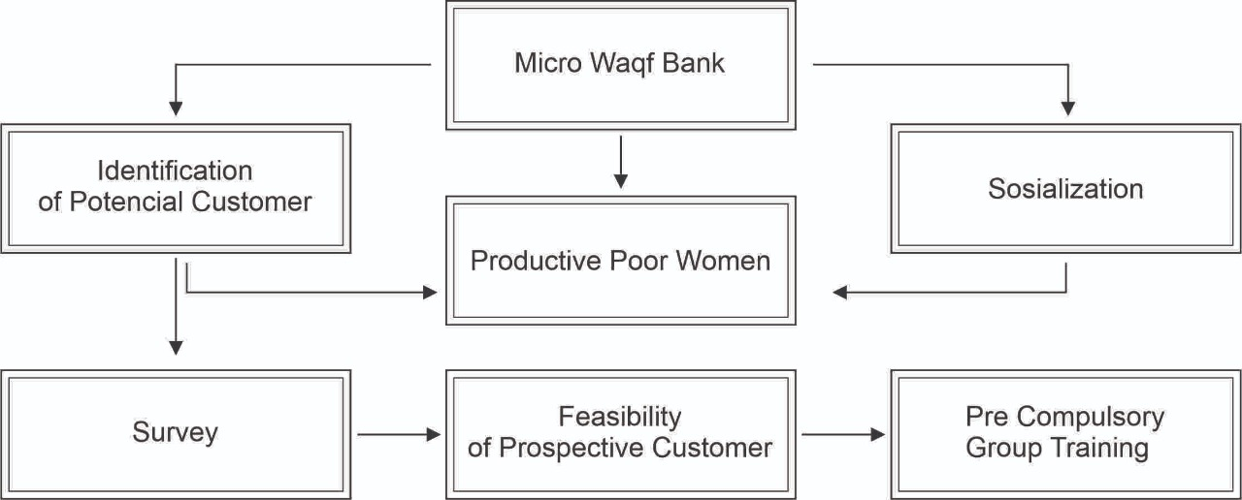

Women's Empowerment Model in Sharia Microfinance Institutions Micro Waqf Banks (SMI MWB)
Women are empowered through CGT, provision of financing, and customer assistance. First, CGT is the initial phase of the empowerment program conducted by MWB for unbanked women. The management emphasizes the character of prospective customers, including discipline, trust, responsibility, and caring for others. CGT is held after a minimum of three groups of five members are formed. It is carried out for 1 hour on five consecutive days (BSM, 2017a), as shown in Table 1:
Table 1. CGT Materials
Day | Material
First | 1) Explanation of CGT, 2) Introduction to MWB. 3) Introduction and principles of CBGIBSI membership, Introduction of CGT participants, 4) The introduction of the pledge, 5) Motivational material.
Second | 1) Reading of the pledge, 2) Capacity building materials, 6) Rights and obligations of members, 7) Election of the group leader and deputy leader, 8) Discussion of the responsibilities of the leader, secretary, and group members.
Third | 1) Reading of the pledge, 2) Introduction of contracts and financing procedures as well as installment payments, 3) Stories and how to create a business profile.
Fourth | 1) Reading of the pledge, 2) Giving the name and number of CBGIBSI, 3) Election of leader and deputy leader, 4) Discussion of the responsibilities of the leader, deputy leader, and members, and 5) discussion about WH.
Fifth | 1) Reading of the pledge, 2) Review of CGT materials, 3) CBGIBSI validation test.
Source: (BSM, 2017b)
The uniqueness of this training is the character testing of prospective customers. According to Sari (2019) and Dafril (2019), the participants of the Manager of MWB Al Kautsar Lima Puluh Kota of West Sumatra and MWB UNISA Yogyakarta collected small changes of IDR 2,000 on the first day. The supervisor recorded and entrusted the serial number to the participants sitting at the back. The following day, the supervisor asked for the money deposited to check the serial number. The participants were declared trustworthy when the serial number had not been changed, and vice versa. The supervisor emphasized the importance of trusting behavior. After the meeting on the second day, the supervisor collected small changes of IDR 2,000 and recorded the serial number. The number was left to the participants sitting in the penultimate row and the front.
All prospective customers were required to take the Group Validation Examination (GVE) conducted by the MWB supervisor on the fifth day. The prospective group members who understood the training material were declared to have passed and were confirmed as MWB customers, forming CBGIBSI (BSM, 2017b). Prospective customers are declared to have passed based on the indicators of a) Discipline, b) Cohesiveness, c) Trust, d) Ability to answer at least 50% of the statements, e) Get family support. Based on an interview with Puguh, Amalia (2019), Supervisor of MWB Alfitrah Wafa Mandiri As-Salafi Al-Fithrah Islamic Boarding School, Kewall Surabaya and MWB Tebu Ireng Jombang, the participants were ranked in the order of the most in need of receiving the first financing. The members who obtain the disbursement of financing first sit at the back. The leader sitting in the front receives the latest financing according to the arrangement shown in Figure 2.
Figure 2. Group Member Seating Order Model

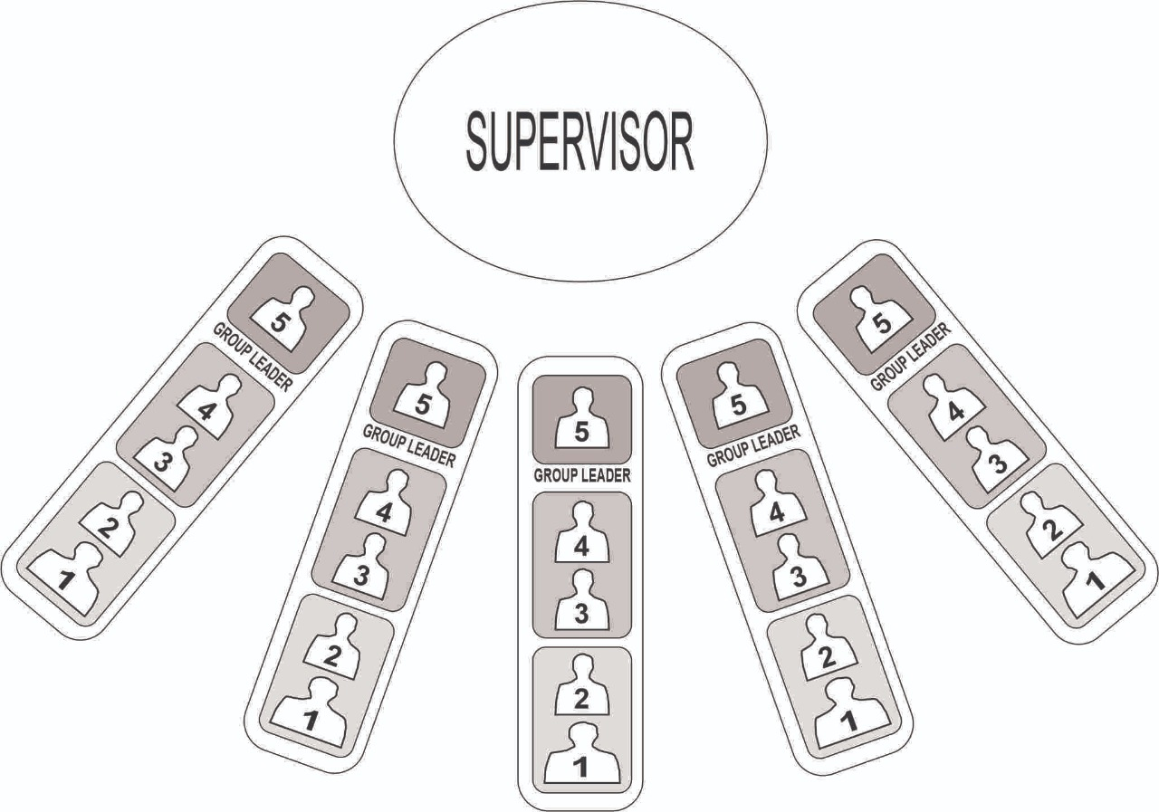
Source: The Micro Waqf Bank, 2019
The second step is the financing disbursement following the seating arrangement during GCT. As described by Sari and Umami (2019), Managers and Customers of MWB Mandiri Sakinah UNISA Yogyakarta and MWB Alpansa Klaten, financing is disbursed in three stages using a 2-2-1 pattern. This pattern is a model that teaches the caring attitude of fellow members. The financing disbursement was sorted by the urgency level, where the members most in need received it first. It was disbursed to the participants sitting at the back with serial numbers 5 and 4 in the first week of WH. The participants with serial numbers 3 and 2 received the financing in the second stage. The funding was disbursed in the second week of WH. The group leader will obtain the last disbursement opportunity to sit in the front. The financing was disbursed in the third week of WH. Third, customers’ assistance was provided after disbursing the financing during WH, as illustrated in Figure 3.
Figure 3: Implementation of Halaqoh in MWB
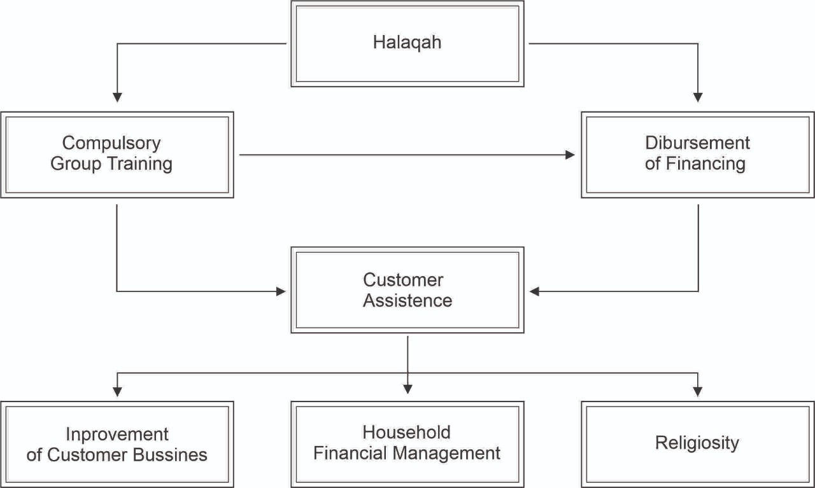

  - Halaqoh in SMI MWB
Each customer pays off the loan weekly at the WH meeting to qualify for further financing. The empowerment model applied to MWB in the form of WH is implemented at the home of the group leader or CBGIBSI. WH is a customer assistance activity where all participants and supervisors sit cross-legged on the floor. They comprise several CBGIBSI sitting in a row facing the supervisor. Puguh (2019), the manager of MWB Tebu Ireng Jombang, East Java, stated that the halaqoh model fosters the customers’ mental attitude. Halaqoh activity is performed regularly once a week and should be followed by every customer. Through this activity, attitudes, a sense of community, dedication, and customer discipline are developed. Through shared accountability for loan payments, it also fosters a mindset of solidarity, accountability, and teamwork. Halaqoh is conducted for 1 hour accompanied by an MWB supervisor with an agenda, as described in Table 2.
Table 2. Halaqoh Agenda at MWB
No | Material
1 | Opening
2 | Pledge reading
3 | Member attendance report
4 | Disbursement of financing
5 | Customer Assistance
6 | Installment payments
7 | Prayer and closing
Source: (BSM, 2017a)
Assistance is provided directly by supervisors or external speakers through HALMI Akbar (Great WH). This was acknowledged by Zuhri (2019), the supervisor of MWB Alpansa Klaten Yogyakarta. Customers’ assistance is carried out through, First, religious spiritual guidance filled with studies by ustadz or ustazah from Islamic boarding schools. The second stage is household financial management. SMI provides assistance and family development through financial management to create a Sakinah family. Third, customers’ business development assistance is provided through mentoring and entrepreneurship help. This includes marketing management, bookkeeping training, services, and business expansion through food product packaging training and product quality improvement. Furthermore, MWB helps customers market their products online and guides them in creating online buying and selling accounts. It also helps customers sell products at certain events, as stated by Hayati (2019), the customer of MWB Al-Kausar Sari Lamak, Harau Lima Puluh Kota Sub-district.
MWB uses group-based financing, where the group determines loan approval and guarantees the payment of each member's financing. This group-based pattern uses a joint responsibility financing system, as confirmed by Eni (2019), Chairman of MWB Almuna Krapyak Yogyakarta. The groups guaranteed MWB that they were responsible for members with arrears in paying installments. Members help each other by donating and contributing to overcoming arrears. Therefore, they should have joint responsibility savings managed by the group leader. The savings are guaranteed by a group in case of arrears in installments from CBGIBSI members. The financing installments are taken from the group's joint responsibility savings to settle arrears. Members replace their arrears the following week at the halaqoh meeting with the group leader.

As SMI, MWB is a financial institution oriented towards improving the community welfare around Islamic boarding schools, specifically for poor, productive women (Sulistiani et al., 2020). It provides financing and assistance to micro and small business women (Soemitra et al., 2022). The SMI market segment is unbanked women or micro business actors with no access to financing from banks because they are considered unfit. This is because women are considered able to commit to discipline by attending regular WH meetings. They are also seen as more capable of managing family finances and business capital. Therefore, women could develop their businesses through the financial assistance of only IDR 1,000,000. (Rahman et al., 2017) Stated that microfinance programs target women because they have more problems obtaining credit. They have limited labor market access and higher loan repayment rates than men.
The financing program provided by MWB to group-based customers is run by 15 to 25 people. Muhammad Yunus applied the model through social entrepreneurship at the Grameen Bank in Bangladesh in 1983 (Nurhayati, 2016). According to (Ajja et al., 2020), women's empowerment through entrepreneurship has become an integral part of development in India. Women's entrepreneurship is a business or organization started by a woman or group of women. Self-help groups (SHGs) play a significant role in developing India's rural communities, whose members are predominantly women (Aggarwal et al., 2020). A doctor of philosophy graduate from Vanderbilt University in Tennessee, USA, oversees this empowerment initiative. By offering group-based microcredit to underprivileged individuals with unsecured companies, the graduate founded the Grameen Bank. Each loan application has been assigned to a group of five by the 2006 Nobel Peace Prize winner. Members of the group are not allowed to take credit in turn, and other members can only take credit when the original creator has demonstrated self-control and integrity in making the monthly payments (Ashraful & Khan, 2016).
The financing in MWB is group-based, necessitating the pattern of joint responsibility known as kafalah in Islamic economics (Rozalinda, 2019). Members are mutually responsible for each other’s arrears financing installments. When a member cannot pay the installments, colleagues cover the arrears to ensure the financing installments to MWB remain smooth. Group-based loans could significantly reduce financing risk (Iwang Suwangsih et al., 2021; Prastyaningtyas et al., 2022). Muhammad Yunus also implemented a joint responsibility mechanism in the Mit Ghramr bank empowerment program. In this mechanism, group members jointly pay installments for colleagues experiencing difficulties (Yunus, 2005). (Hasiba et al., 2021) claimed that because loans are granted to those in need based on trust rather than collateral or guarantors, this model has a significant influence on reducing poverty in Bangladesh. To obtain a loan from Grameen Bank, potential borrowers must join a group of microfinance borrowers.
The Grameen Bank model has been replicated and modified in many Sharia microfinance programs in Indonesia, including Sharia micro waqf banks. Most Sharia microfinance is designed as ultra-micro financing as accomplished by Permodalan Nasional Madani (PNM) since 2015 (Musta’anah et al., 2021). Similarly, BTPN Syariah has focused on economically empowering productive, underprivileged women since 2010 (Fanggidae et al., 2020). These financial institution programs have specific characteristics, such as community empowerment and microfinance services. They are group-based and specifically aimed at women from poor or low-income families (Yaumidin et al., 2017). Muhammad Yunus stated that microfinance institutions that provide financial services to stimulate small businesses could empower women (Cabeza-García et al., 2019). 97% of Mit Ghramr Bank's clients are women, and the bank was established to provide small company loans (Yunus, 2005).
MWB uses the halaqoh method in women's economic empowerment activity around Islamic boarding schools (Rozalinda & Nurhasnah, 2022). The model has been running since prospective MWB customers started participating in GCT, which was held for five days (Anwar et al., 2023). Halaqoh activity is conducted once a week for financing disbursement and customers’ development activity (Soemitra et al., 2022). In the traditional learning system, the sitting positions of the teacher and students blend in to form a circle. (Yamin & Dalimunthe, 2020) Halaqoh activity is viewed as a bonding friendship among CBGIBSI members to strengthen women's determination and commitment to MWB rules (Ritonga et al., 2019). Therefore, it entails funding and assistance, friendship, and religious education. This finding proved that the halaqoh model motivates women to learn Islam, entrepreneurship, and the ability to manage household finances. Furthermore, it is the driving force for the emergence of women's micro-enterprises around Islamic boarding schools. As SMI, MWB has proven its role in realizing financial inclusion through micro-financing.
(Mukthar et al., 2023) The microcredit system contributes to the entrepreneurial spirit of rural women. (Nugroho & Hilal, 2019) Stated that MWB increases financial inclusion by enabling the community as well as micro, small, and businesses to have easy capital. SMI is an alternative solution to the problems faced by people experiencing poverty (Zitouni & Ben Jedidia, 2022), precisely the ease of access to finance. According to (Rahman et al., 2017), microfinance programs have been an important development strategy worldwide for over three decades, specifically in developing countries. One goal of microfinance is to reduce poverty by providing more access to financial institutions to empower people experiencing poverty (Yaumidin et al., 2017). SMI has a role in economic, socio-cultural, and family empowerment (Islam, 2021). Involving women in microfinance improves their household position through independent access to income (Yaumidin et al., 2017).
Empowerment using the halaqoh model, a key to women's economic empowerment, is not entirely successful. Customers do not fully use the financing disbursed by MWB for business capital. The interviews with the group leader (AS, 2021) revealed that some customers used funds for consumptive purposes or to pay off debts (WT. 2021). This condition results in group members being in arrears in financing installments (R, 2021), which should be borne through group savings. It shows that the assistance provided by MWB is not only in the form of weekly halaqoh. Therefore, field assistance should involve supervising the customers’ place of business.

Conclusion
Empowerment is conducted by MWB through financing and assisting potentially productive but poor women living around Islamic boarding schools as their market segment. The loans are distributed using a group approach with a joint responsibility system. The empowerment model is implemented from the GCO and GCT for mentoring using the halaqoh model. Participants sit cross-legged on the floor, facing the supervisor in a semi-circle. The participants most in need of financing first sit at the back, the group leader sits at the front, and those receiving funding come last.
The halaqoh model applied by MWB increases women's economic welfare through micro-financing. Women receive Sharia business character development in GCT based on their discipline, honesty, trustworthiness, concern for others, and financial responsibility. They also receive Islamic assistance, household financial management, and business development at regular halaqoh meetings.
The SMI MWB program could be replicated and expanded in the area of its establishment to enhance access to microfinance and empower women's economy. This study is expected to implicate government and non-government policies to promote women's empowerment through easy access to financial institutions. However, it only examined the women's empowerment model carried out by MWB, not the risk management side of group-based financing. This is an opportunity for future studies to examine financing risk management at MWB.
The new insight from this study is that the halaqoh model is very suitable for empowering unbanked women. At weekly halaqah meetings, fostering the mental attitude of customers, a sense of togetherness, commitment, discipline, building solidarity, responsibility, and group cooperation is seen as more effective. This study also offers some practical implications. Firstly, the government needs to make SMI MWB a basis for the economic empowerment of unbanked women who cannot access banking services. Hence, they can actively participate in economic activities and improve the welfare of their families. Secondly, the results of this study can inspire women micro and small entrepreneurs to continue fighting against marginalization in the financial aspect.
This study was limited to in-depth interviews on the empowerment conducted by MWB for unbanked women through training, disbursement of financing, and assistance to customers. It did not cover the management of financing risk at SMI. Therefore, this is an opportunity for future studies to examine the topic more deeply.

Acknowledgment
The authors are grateful to the leaders and mentors of the IA Scholar Foundation for providing direction in completing this study.
References
Abate, D. S., & Amare, H. G. (2024). The activities, benefits, and challenges of Awada women’s self-help groups in empowering women in sidama region, Southern Ethiopia. In Saving and Being Safe Away from Home: Savings and Insurance Associations in Ethiopia and Its Diaspora (pp. 71–89).
Acclassato, D. H. (2008). Global interest rate, financial viability and microcredit to small business: Evidence from Benin. Annals of Public and Cooperative Economics, 79(1), 161–195. https://doi.org/10.1111/j.1467-8292.2007.00355.x
Ade Soekadis. (2021). Empowering Indonesian Women’s Economy Through Digital Financial Inclusion Lessons From Mfs And Sweet Programs For Women Micro-Entrepreneurs In East Java.
Afrida, Y., Abdullah, I., Prasojo, Z. H., Ulfah, M., Saka, P. A., & Nelli, J. (2024). Economic empowerment of unbanked women through financial inclusion in Indonesia. Cogent Business and Management, 11(1). https://doi.org/10.1080/23311975.2024.2407921
Aggarwal, S., Kumar, P., & Garg, V. (2020). Empowering SHGs Women through Micro-finance in Uttar Pradesh. International Journal of Law and Management, 62(6), 591–606. https://doi.org/10.1108/IJLMA-02-2020-0051/FULL/XML
Ajja, S. H., Samiti’, S., Arts, S. K. S. J., & Sheshgiri, S. M. (2020). Women Empowerment And Women Entrepreneurship: An Overview. Jurnal Universitas Arsitektur & Teknologi Xi’an, 12(3), 3843–3844.
Alkhamees, A. (2013). The impact of Shari’ah governance practices on Shari’ah compliance in contemporary Islamic finance. Journal of Banking Regulation, 14(2), 134–163. https://doi.org/10.1057/jbr.2012.12
Altaf, M., Ullah, K., & Atiq, M. (2024). Women-owned businesses and access to finance in Pakistan: a study of perceptions, experiences and behaviors. Qualitative Research in Financial Markets. https://doi.org/10.1108/QRFM-08-2023-0189
Anand, A., & Karn, A. (2023). The role of microfinance in women empowerment. In Empowering Women Through Microfinance in Developing Countries (pp. 192–212). https://doi.org/10.4018/978-1-6684-8979-6.ch011
Anwar, M. Z., Fathan, Warto, & Hidayati, O. N. (2023). Transformation Of Economic Theology For Community Empowerment A Case Study On Pesantren-Based Bank Wakaf Mikro. Journal of Indonesian Islam, 17(1), 76–99. https://doi.org/10.15642/JIIS.2023.17.1.76-99
Ashraful, M., & Khan, I. (2016). MICROCREDIT AND GRAMEEN BANK: A VIEW FROM THE GRASSROOTS. In Article in International Journal of Current Research.
Bandara, S. H. (2024). Unveiling the Prospects, Impacts, and Constraints of Women’s Microfinancing Initiatives in South Asia: A Systematic Review. Social Sciences, 13(8). https://doi.org/10.3390/socsci13080428
Bergh, A., & Forsberg, E. (2024). Differentiation of education through juridification. Journal of Curriculum Studies, 56(2), 146–159. https://doi.org/10.1080/00220272.2023.2261991
Binsuwadan, J., Elhaj, M., Bousrih, J., Mabrouk, F., & Alofaysan, H. (2024). The Relationship between Financial Inclusion and Women’s Financial Worries: Evidence from Saudi Arabia. Sustainability (Switzerland), 16(19). https://doi.org/10.3390/su16198317
BSM, L. (2017a). “SOP & SOM Standar Operasional Prosedure Dan Management Untuk LKM Syariah-Bank Wakaf Mikro (p. 8). LAZNAS BSM.
BSM, L. (2017b). Manajemen Lembaga Keuangan Mikro Syariah. LAZNAS BSM.
BWM. (2019). LKMS-BWM. Http://Www.Lkmsbwm.Id/.
Cabeza-García, L., Del Brio, E. B., & Oscanoa-Victorio, M. L. (2019). Female financial inclusion and its impacts on inclusive economic development. Women’s Studies International Forum, 77(October), 102300. https://doi.org/10.1016/j.wsif.2019.102300
Dawood, T. C., Pratama, H., Masbar, R., & Effendi, R. (2019). Does financial inclusion alleviate household poverty? Empirical evidence from Indonesia. Economics and Sociology, 12(2), 235–252. https://doi.org/10.14254/2071-789X.2019/12-2/14
Epstein, M. J., & Yuthas, K. (2017). Cash Flow Training and Improved Microfinance Outcomes. Journal of International Development, 29(1), 106–116. https://doi.org/10.1002/jid.2918
Esquivias, M. A., Sethi, N., Ramandha, M. D., & Jayanti, A. D. (2021). Financial inclusion dynamics in Southeast Asia: An empirical investigation on three countries. Business Strategy and Development, 4(2), 203–215. https://doi.org/10.1002/bsd2.139
Fanggidae, R. E., Kurniawati, M., & Bahweres, H. (2020). The Effect of Workplace Spirituality and Employee Performance (Perspective of Islamic Work Ethics Case Study on BTPN Syariah, Kupang). Atlantes Press, 234–239. https://doi.org/10.2991/AEBMR.K.200522.045
Faundez, J. (2013). Searching for a ‘good struggle’: Comments on ‘The justice-security- development nexus: Theory and practice in fragile and conflict-affected states’ by Doug Porter, Deborah Isser & Louis-Alexandre Berg. Hague Journal on the Rule of Law, 5(2), 334–339. https://doi.org/10.1017/S1876404512001182
Hasiba, F. F., Mahmudah, S. N., & Puji Sucia Sukmaningrum, Shochrul Rohmatul Ajija, M. B. F. Z. (2021). The Strategies for Developing Micro Waqf Bank in Indonesia. Rigeo.Org, 11(4), 2021. https://doi.org/10.48047/rigeo.11.04.24
Hidayah, K., Daud, D., Zainal, N., & Ibrahim, S. S. (2021). Effectiveness of musharakah financing in empowering small micro enterprises. Estudios de Economia Aplicada, 39(10). https://doi.org/10.25115/eea.v39i10.5847
Islam, M. S. (2021). Role of Islamic microfinance in women’s empowerment: evidence from Rural Development Scheme of Islami Bank Bangladesh Limited. ISRA International Journal of Islamic Finance, 13(1), 26–45. https://doi.org/10.1108/IJIF-11-2019-0174/FULL/HTML
Iwang Suwangsih, Nuzulul Fatimah, Noneng Rukayah Sukatmadiredja, & Emmywati. (2021). The Impact Of Implementation Of A Joint Liability System On Member Behavior. Journal of Islamic Economics Perspectives, 3(1), 88–100. https://doi.org/10.35719/JIEP.V3I1.41
Jain, B. K. (2020). Microfinance Services and Women Empowerment in Biratnagar Metropolitan, Nepal. Journal of Underrepresented and Minority Progress, 4(2), 251–270. https://doi.org/10.32674/jump.v4i2.2399
Jumpah, E. T., Tetteh, E. K., & Adams, A. (2018). Microcredit repayment among smallholder farmers: What microfinance institutions need to know. Asian Journal of Agriculture and Rural Development, 8(2), 74–91. https://doi.org/10.18488/JOURNAL.1005/2018.8.2/1005.2.74.91
Karan, P., Lee, J.-S., & Hugman, R. (2021). Combatting Gender Oppression: Applying Intersectionality in Microfinance Self-help Groups. European Journal of Development Research, 33(6), 1649–1665. https://doi.org/10.1057/s41287-020-00309-5
Kodom, M., Osarfo, D., & Quartey, P. (2024). Digital Financial Inclusion and Women’s Economic Empowerment in Northern Ghana: The Experience of Rural Women in the Shea Value Chain. In Sustainable Development Goals Series: Vol. Part F3578 (pp. 179–200). https://doi.org/10.1007/978-981-97-6132-6_8
Kumarasamy, D., Singh, P., & Kaur, S. (2023). Women Entrepreneurship, Demand Side Heterogeneity and Financial Inclusion in Rural India. Vision. https://doi.org/10.1177/09722629231204756
Macqueen, K. M., Guest, G., & Namey, E. (2005). Qualitative Research Methods: A DATA COLLECTOR’S FIELD GUIDE NATASHA MACK • CYNTHIA WOODSONG.
Malik, R. S. (2013). Qualitative Research Methodology In Education. Jurnal Edubio Tropika, 1(2).
Microfinance in Asia. (2017). In Microfinance In Asia. https://doi.org/10.1142/10233
Mukthar, K. P. J., Asis, H. R., Vílchez-Vásquez, R., Huaman-Osorio, A., & Alvarado-Tolentino, J. (2023). Estimating Women Entrepreneurial Empowerment of Start-Up Business Through Micro Credit Model in Rural Areas. Lecture Notes in Networks and Systems, 495 LNNS, 86–94. https://doi.org/10.1007/978-3-031-08954-1_8/COVER
Mulyati, E., & Harieti, N. (2018). Model of business activities of microfinance institutions in Indonesia. IOP Conference Series: Earth and Environmental Science, 175(1). https://doi.org/10.1088/1755-1315/175/1/012194
Musta’anah, A., Bina Buono, K., Atika, R., Noviarita, H., Islam, U., Raden, N., & Lampung, I. (2021). Analysis of Sharia Literacy Level and Sharia Financial Inclusion PNM Mekaar Sharia in Increasing Income Public (Study on the Fishing Community of Kuala Jaya Hamlet, South Lampung Regency). Journal of Islamic Business and Economic Review, 4(2), 97–101.
Nawaz, F. (2014). Can women travel to the policy-making level in Bangladesh? Rural women’s political representation, participation and empowerment in the context of microfinance. Pertanika Journal of Social Sciences and Humanities, 22(2), 633–648.
Nik Azman, N. H., Md Zabri, M. Z., & Zull Kepili, E. I. (2021). Nexus between Islamic microfinancing and financial wellbeing of micro-entrepreneurs during the COVID-19 pandemic in Malaysia. Jurnal Ekonomi Malaysia, 55(1). https://doi.org/10.17576/JEM-2021-5501-10
Normalisa, D., ¶½í, & Rosyidi, M. I. (2020). Resistance to Marginalization in America as Reflected in Kathryn Stockett’s ‘The Help’. Rainbow : Journal of Literature, Linguistics and Culture Studies, 9(1), 10–18. https://doi.org/10.15294/RAINBOW.V9I1.37683
Nugroho, W., & Hilal, F. N. (2019). Micro Waqf Bank in Indonesia: Analysis of The Constitution Concept According to The Maqashid Sharia. Al-Iktisab: Journal of Islamic Economic Law, 3(1). https://doi.org/10.21111/AL-IKTISAB.V3I1.3905
Nurhayati. (2016). Social Entrepreneurship Muhammad Yunus“Grameen Bank". Jurnal Bisnis Manajemen & Perbankan, 2(1), 31–48.
Obodoechi, D. N., Omeje, A. N., Nwokolo, C. C., Urama, C. E., Asogwa, H. T., Agu, C. V, & Ukwueze, E. R. (2022). Women and Entrepreneurship in Nigeria: What Role Does Social Inclusion Play? Journal of International Women’s Studies, 23(5), 41–62.
Ojo, T. A. (2024). Gendered Finance: Inclusion and Transformation. In Sustainable Development Goals Series: Vol. Part F2834 (pp. 1–10). https://doi.org/10.1007/978-3-031-53337-2_1
Okunlola, F. A., Babajide, A., & Isibor, A. (2020). Empowering women through micro finance: Empirical evidence from Ibadan, Oyo state, Nigeria. Academy of Entrepreneurship Journal, 26(1), 1–12.
Patton, M. Q. (2005). Qualitative Research. Encyclopedia of Statistics in Behavioral Science. https://doi.org/10.1002/0470013192.BSA514
Prastyaningtyas, E. W., Widjaja, S. U. M., Wahyono, H., Andayani, E. S., & Rusdi, J. F. (2022). Methods for studying group loans, join responsibility, and women’s empowerment. MethodsX, 9, 101749. https://doi.org/10.1016/J.MEX.2022.101749
Rahman, M. M., Khanam, R., & Nghiem, S. (2017). The effects of microfinance on women’s empowerment: New evidence from Bangladesh. International Journal of Social Economics, 44(12), 1745–1757. https://doi.org/10.1108/IJSE-02-2016-0070/FULL/HTML
Riley, E. (2024). Resisting Social Pressure in the Household Using Mobile Money: Experimental Evidence on Microenterprise Investment in Uganda†. American Economic Review, 114(5), 1415–1447. https://doi.org/10.1257/aer.20220717
Ritonga, T., Ananda, A., Lanin, D., & Hasan, H. (2019). Practice to theory of learning: A lesson learned from islamic boarding school in South Tapanuli of Indonesia. Humanities and Social Sciences Reviews, 7(5), 1304–1310. https://doi.org/10.18510/hssr.2019.75169
Rozalinda. (2019). Fiqh Ekonomi Syariah Prinsip Dan Implementasinya Pada Sektor Keuangan Syariah (1st ed.). Raja Grafindo Persada.
Rozalinda, R., & Nurhasnah, N. (2022). Islamic Boarding School-Based Women’s Economic Empowerment and Its Impact on Increasing Home Industry Income. Annual International Conference on Islamic Economics and Business (AICIEB), 2(1), 432–448. https://doi.org/10.18326/AICIEB.V2I1.126
Setyobudi, W. T., Wiryono, S. K., Nasution, R. A., & Purwanegara, M. S. (2016). The efficacy of the model of goal directed behavior in explaining Islamic bank saving. Journal of Islamic Marketing, 7(4), 405–422. https://doi.org/10.1108/JIMA-12-2014-0080
Simba, A., Martins Ogundana, O., Braune, E., & Dana, L.-P. (2023). Community financing in entrepreneurship: A focus on women entrepreneurs in the developing world. Journal of Business Research, 163. https://doi.org/10.1016/j.jbusres.2023.113962
Singh, S., & Dash, B. M. (2021). Gender Discrimination in Accessing Finance by Women-Owned Businesses: A Review. Journal of International Women’s Studies, 22(9), 381–399.
Soemitra, A., Kusmilawaty, & Rahma, T. I. F. (2022). The Role of Micro Waqf Bank in Women&rsquo;s Micro-Business Empowerment through Islamic Social Finance: Mixed-Method Evidence from Mawaridussalam Indonesia. Economies 2022, Vol. 10, Page 157, 10(7), 157. https://doi.org/10.3390/ECONOMIES10070157
Sofia. (2017). Survey on Financial Inclusion and Access (SOFIA) Implemented by Focus Note on Gender.
Sohrab, T., Idris, F., & Sulaiman, N. (2024). The relationship between financial inclusion and women’s empowerment in rural Bangladesh: The moderating effect of agent banking. Environment and Social Psychology, 9(1). https://doi.org/10.54517/esp.v9i1.1955
Stefani, M. L., & Vacca, V. (2015). Small Firms’ Credit Access in the Euro Area: Does Gender Matter? CESifo Economic Studies, 61(1), 165–201. https://doi.org/10.1093/cesifo/ifu031
Sulistiani, S. L., Yunus, M., & Bayuni, E. M. (2020). Micro Waqf Bank: New Sharia Financial Instruments in Indonesia. Advances in Social Science, Education and Humanities Research, 409, 1–4. https://doi.org/10.2991/ASSEHR.K.200225.001
TEIXEIRA, A. A. C., & SHARIFU, H. A. (2017). Female Entrepreneurship And Access To Bank Loans In Tanzania: A Double-Hurdle Model Approach. Journal of Developmental Entrepreneurship, 22(03), 1750019. https://doi.org/10.1142/S1084946717500194
Ufodike, A., & Ally, S. (2022). Enhancing Gender-Responsive Financing in Africa: A Sustainable Development Perspective. In Sustainable Development in Post-Pandemic Africa: Effective Strategies for Resource Mobilization (pp. 48–67). https://doi.org/10.4324/9781003185062-4
Wulandari, P., & Hj.Kassim, S. (2024). Empowering female entrepreneurs through access to digital microfinance services. International Journal of Gender and Entrepreneurship. https://doi.org/10.1108/IJGE-04-2024-0130
Yahaya, S., Hamid, C. K., Abdullah, S. R., Hassan, M. S. H., & Yasin, Y. F. (2024). Gender-based Acceptance of Ar-Rahnu Among Muslim Micro-Entrepreneurs. Global Journal Al-Thaqafah, JULY 2024(SPECIAL ISSUE), 130–145. https://doi.org/10.7187/GJATSI072024-9
Yamin, A., & Dalimunthe. (2020). Classic Islamic Education Heritage in Halaqah and Munazharah. 194.31.53.129, 6(2), 249–343. https://doi.org/10.24952/tazkir.v6i2.1315
Yaumidin, U. K., Suhodo, D. S., Yuniarti, P. I., & Hidayatina, A. (2017). Financial Inclusion for Women: Impact Evaluation on Islamic Microfinance to Women’s Empowerment in Indonesia. Financial Inclusion and Poverty Alleviation, 81–140. https://doi.org/10.1007/978-3-319-69799-4_3
Yunus, M. (2005). Eliminating Poverty Through Market-Based Social Entrepreneurship. In Global Urban Development (Vol. 1).
Zitouni, T., & Ben Jedidia, K. (2022). Does Islamic microfinance contribute to economic empowerment in Tunisia?: a case study of Zitouna Tamkeen. Journal of Business and Socio-Economic Development, 2(1), 67–81. https://doi.org/10.1108/JBSED-10-2021-0143/FULL/HTML

