Pemberdayaan Perempuan Miskin Untuk Meningkatkan Ekonomi Keuangan Mikro Syariah Di Indonesia
Name Satu^{1*}, Nama Dua², Nama Tiga³
¹Deapartment, Institusi, Kota, Kode pos, Negara, Email, Orcid
²Deapartment, Institusi, Kota, Kode pos, Negara, Email, Orcid
³Deapartment, Institusi, Kota, Kode pos, Negara, Email, Orcid

Abstract
background:
Purpose:
Method: (Metode dasar, Respondent, penarikan sampel, Instrument, Procedure, analisis data)
Result and Conclusion: Harus menjawab tujuan
Contribution:

Keywords: Keywords1, Keywords2, Keywords3, Keywords4, Keywords5

Introduction
Women in Indonesia experience a gender gap in access to finance, with only 42% using banking services. In this context, the development of the Financial Inclusion Index emphasizes the vital role of digital services in improving financial access for women (Tripathi & Rajeev, 2023a). The index shows a positive relationship between digital financial inclusion and the gender development index, meaning countries with higher levels of digital financial inclusion tend to achieve better gender equality outcomes. Thus, increasing digital financial inclusion can be an important step in overcoming inequality in financial access for women. According to Demir et al. (2022), The development of the Financial Inclusion Index is critical to improving financial access for women, especially in lower-middle-income countries such as Indonesia, where the gender gap in financial access is still significant. Differences in access to health services in different regions, such as those in the healthcare sector, reflect the challenges faced in financial inclusion (Rizkianti et al., 2021). This is evident as women living in rural and remote areas have more limited access to financial services.
The Micro Waqf Bank (MWB) was established to provide financial access for poor women, especially those based in Islamic boarding schools. Financial inclusion plays an important role in achieving gender equality and women's empowerment by providing access to financial products and services needed to meet business and household needs. This is a strategic step in supporting women in improving their living standards (Tripathi & Rajeev, 2023b). One form of this is microfinance initiatives, such as MWB, which have a positive impact on society by allowing women to form self-help groups and gain access to loans (Ojha et al., 2020). This model has proven to be effective in improving the economic conditions and social status of women in marginalized communities. However, access to finance is still a significant barrier for women in rural areas and marginalized groups, so initiatives such as MWB seek to address this issue by offering tailor-made financial products without the need for traditional collateral (Senou & Manda, 2022). The gender gap in financial access is an ongoing problem, and research shows that women often face more challenges than men, emphasizing the importance of targeted interventions such as MWB. Thus, MWB serves as a solution to overcome the challenges faced by women in accessing financial resources.
However, there has been no research that specifically examines the model of women's empowerment through halaqoh in MWB. Although studies show that economic empowerment is a key factor in improving the status of women, as seen in a study in rural Kenya that emphasized the importance of income diversification for female-led households—which face unique challenges compared to male-led households—there are still gaps in research on the application of this model (Vimefall & Levin, 2023a). On the other hand, although financial inclusion through digital services is recognized as a way to empower women by providing better access, there is not enough evidence regarding its effectiveness in the context of halaqoh in MWB. In addition, social bonds and cultural norms that should have a crucial role in women's empowerment often do not function properly. In collectivist societies, weak social relationships can actually hinder women's entrepreneurship and empowerment activities (Bastian et al., 2023). Although digital financial inclusion is considered an important element in empowering women by providing access to financial services, which is expected to increase their economic participation and decision-making abilities, the effectiveness of these services has varied. It has not always been consistent across different regions and contexts (Mabrouk et al., 2023a).
The effectiveness of the halaqah model in the process of economic empowerment of poor women has not been explored in depth. While digital financial services should be proven to significantly improve women's economic empowerment by providing easier access to financial products, which are indispensable for meeting business and household needs, the reality is that this has not been the case consistently (Mabrouk et al., 2023b; Tripathi & Rajeev, 2023c). According to Su et al. (2021) Moreover, despite the theoretical benefits of digital financial services, many women, especially in low- and middle-income countries, are unable to access such services due to the significant barriers they face. These barriers include limited access to mobile phones and the internet, which is crucial for taking advantage of digital financial services. In addition, gender norms in many societies hinder women's financial independence and decision-making power, hindering women's participation in digital financial services and causing financial decisions to be made by male family members (Plouffe et al., 2020).
Women's economic empowerment through Sharia microfinance institutions can improve family welfare and create jobs. Although in many developing countries, there are challenges from patriarchal norms and gender inequality, there are opportunities to overcome these barriers and encourage women's active participation in economic activities. With ttheprproperwomen can be empowered to make financial decisions independently, thereby maximizing the benefits of microfinance (Danquah et al., 2021; Jaim, 2021). Studies show that microfinance can improve several aspects of women's lives, such as mobility and savings, and has the potential to support broader empowerment as well as improved well-being, including efforts to reduce violence and depression in intimate relationships (Gibbs et al., 2020). In addition, microfinance can offer quick financial assistance, but there is an opportunity to address further economic barriers faced by women, such as access to quality jobs and education (Desai et al., 2021a). By addressing these systemic issues, the impact of microfinance on job creation and family well-being can become more significant.
Women's empowerment is the key to the sustainability of MWB's business model and can enable poor women to be more economically productive. With microfinance activities that have proven to have a positive impact, women get the financial resources they need to participate in entrepreneurial activities (Sethy & Jana, 2022). This participation not only allows them to use funds productively but also helps them get out of poverty and achieve economic independence. In addition, psychological empowerment, which includes autonomy, independence, and control over business decisions, is essential to the success of Women entrepreneurs (Fuad et al., 2022). Research shows there is a significant positive relationship between psychological empowerment and entrepreneurial success, which contributes to sustainable business practices. In addition, education plays a crucial role in empowering women by providing them with the skills and confidence necessary to engage in economic activities (Kumari, 2022). Women who get an education are more likely to become independent entrepreneurs, thus contributing to the financial independence of their families and the development of society as a whole.
The long-term impact of women's empowerment through MWB on the welfare of families and communities around Islamic boarding schools has not been measured. In addition, empowerment programs often face challenges due to deep-seated social norms, which not only reduce their effectiveness but also make it difficult to measure their long-term impact (Hoop et al., 2010). There is a lack of studies that do not specifically evaluate the long-term impact of women's empowerment through MWB on families and communities (Desai et al., 2021b). In addition, the impact of empowerment cannot be determined to differ significantly depending on cultural, economic, and social contexts, making it difficult to generalize findings across different settings, such as Islamic boarding schools, without specific studies focusing on those contexts (Vásquez-Vera et al., 2022).
The training, financing, and mentoring provided by MWB cannot be optimized to produce better outcomes for poor women if there is no integration between performance-based financing and equity sizing. Without such integration, resources will not reach the most vulnerable groups (Mwase et al., 2020). In addition, without encouraging the use of digital financial services, financial inclusion for women will not increase, and they will not have better access to financial products and services, which are essential for economic empowerment and growth (Tripathi & Rajeev, perceived-based programs cannot effectively even with carefully managed, and the quality of the data used to evaluate the interventions will not support how effective the programs are perceived.is an aistremexcusemexcessthattlyomaandheperceived this seventyteventt event gap in financial theeventiveventherththe even of women use banking services compared to more than 45% of men? With a focus on the economic empowerment of productive poor women, this study explains how Islamic Microfinance Institutions (MWBs) can improve their well-being through training, financing, and men's approach to the introduction of the halaqah model as an empowerment method that has not been widely researched before, as well as the emphasis on women groups that are often the quality approach-din-depths in-depth depth-depth depthiiinsightshalltheengaengageswomen face in accessing financial services. The main objective of this study is to outline the empowerment model implemented by MWB, analyze the effectiveness of existing programs, and provide recommendations for the government and related institutions to increase support for women's economic empowerment through Microfinance Institutions.
Research Method
This study uses a qualitative descriptive method to analyze women's economic empowerment, which was developed by Islamic Microfinance Institutions (MWB) in Yogyakarta, West Sumatra, and Central Java and East Java Provinces. The respondents in this study consisted of those whose selections were carried out purposefully, with a purposive number that had relevant exempowerment carried out by MWB.
Data collection was carried out through in-depth interviews and observations. Structured interviews were conducted with MWB leaders, companions, and customers to explore information about the operations and empowerment models implemented. In addition, observations were made on mandatory group training and the customer mentoring process during weekly meetings. This method allows researchers to gain a comprehensive perspective on the challenges and successes faced by women in accessing financial services.
Table 1. Sociodemographics of respondents
Education |  |  | Age |  |  | Length of business |  |  | Income After Earning Financing
Education | Total | % | Age | Total | % | Length of business | Total | % | Income | Total | %
Higher education | 9 | 9% | >50 year | 13 | 14% | 1-5 year | 50 | 53% | <1,9 million rupiah | 27 | 29%
High School | 54 | 57% | 40-49 year | 37 | 39% | 6-10 year | 28 | 29% | 2 -2,9 million rupiah | 21 | 23%
Junior High School | 19 | 20% | 30-39 year | 38 | 40% | 11-15 year | 11 | 12% | 3 -3,9 million rupiah | 30 | 32%
Primary school | 13 | 14% | 29 year | 7 | 7% | >15 year | 6 | 6% | >4 million rupiah | 17 | 17%
 | 95 |  |  | 95 |  |  | 95 |  |  | 95
With this approach, the research aims to provide a clear picture of the impact and effectiveness of MWB programs in women's empowerment, as well as to identify the key factors that influence their success in accessing financial services.
Results and Discussion
The results of the study show that the stages of women's economic empowerment in the Sharia Microfinance Institution of Bank Waqf Mikro (SMI MWB) consist of several systematic steps. First, the identification of potential customers is carried out to ensure compliance with the target criteria of the program, such as the distance of residence, type of business, and business location. After that, MWB socialization to the community was carried out through various groups, such as womenWomenecitRecitationFamily Welfare Empowerment (PKK), to disseminate information about the program. The next stage includes surveys to prospective customers and feasibility testing, where direct visits are conducted to assess home conditions and economic data. After going through this process, prospective customers take part in the Pre-Compulsory Group Training (PK, Phchic h, aiwhich mstwhichhen their motvation andwhicwhichtowhichogram.
The program model determines motivation through) stage, in which the initial process notimesinitiaprogram fortthosedoesanager assesses the initialed of that customer, including discipline and responsibility. Illinois proves that those are required to take the Group Validation Exam (GVE) after the training, which determines their eligibility to become a customer. The distribution of financing is carried out in three stages based on the level of urgency, with a 2-2-1 pattern, which prioritizes a caring attitude between group members. Furthermore, Halaqoh activities at SMI MWB are an important part of customer assistance. Every week, customers are required to pay off their loans in a Halaqoh meeting held at the house of the group chairman. This activity not only serveservesveslsoent but aservesstudentsernes, commas-serves, and responsibility between members. Tcommas-service is carried out by a supervisor who provides religious guidance and training on household financial management. In addition, MWB also supports customer business development through entrepreneurship training and online product marketing. With a group-based financing model, customers help each other in installment payments, creating solidarity and responsibility among them. Overall, the results of the study show that SMI MWB has succeeded in creating an effective empowerment model for productive productive, with productiveproductiveniy-productiv,productivepcommuniproductiveproductiveniy-based approachcial access, bprovidekillsprovidesdprovidessoliprovideson g customers, thereby contributing to among their economic landing.
contributes Stages of Women's Empowerment in MWB
This figure illustrates the systematic stages in the process of women's empowerment at SM, I MWB. Every step from a potential customer I, potentiation, socialization, potential, feacustomeIy potentiationainisurveysfeasibilitynsurveyshw how MWB prepares women to become active customers. This image provides a clear visual representation of the process that potential customers must go through before they can gain access to finance.
Table 1. CGT Material
Day | Material
First | 1) Explanation of CGT, 2) Introduction to MWB. 3) Introduction and principles of CBGIBSI membership, Introduction of CGT participants, 4) Introduction of pledges, 5) Motivational materials.
Second | 1) Reading material, 2) Coaching materials, 6) Rights and obligations of members, 7) ElecReadf, the chairman and vice chairman of the group, and 8) Discussion of the duties of the chairman, secretary, and group members.
Third | 1) Remmbersf the promise, 2) Introduction of the contract and financing procedures and installment payments, 3) Stories and how to create a business profile.
Fourth | 1)profile of the pledge, 2) Giving the names and serial numbers of the CBGIBSI management, 3) Election of leaders and deputy leaders, 4) Discussion of the duties of leaders, deputy leaders, and members, and 5) Discussion of WH.
Fifth | 1) Reading of promises, 2) Review of CGT materials, 3) CBGIBSI validation test.
Source: (BSM, 2017a)
This table details the materials covered during the Cinta Group Training (CGT) session. Each day has a specific agenda, from introduction to the reading of the pledge and validation test. This table helps to understand the training structure designed to prepare prospective clients to be ready for the enablement program.
Table 2. Halaqah Agenda at MWB
NO | Material
1 | Unveiling
2 | Promise reading
3 | Member Attendance Report
4 | Disbursement of financing
5 | Customer Support
6 | Installment payments
7 | Prayer and Closing
Source: (BSM, 2017b)
This table shows the agenda followed during the Halaqoh activities at MWB. Each session includes openings, attendance reports, and other important activities such as financing disbursements and installment payments. This reflects MWB's commitment to maintaining transparency and accountability among customers.

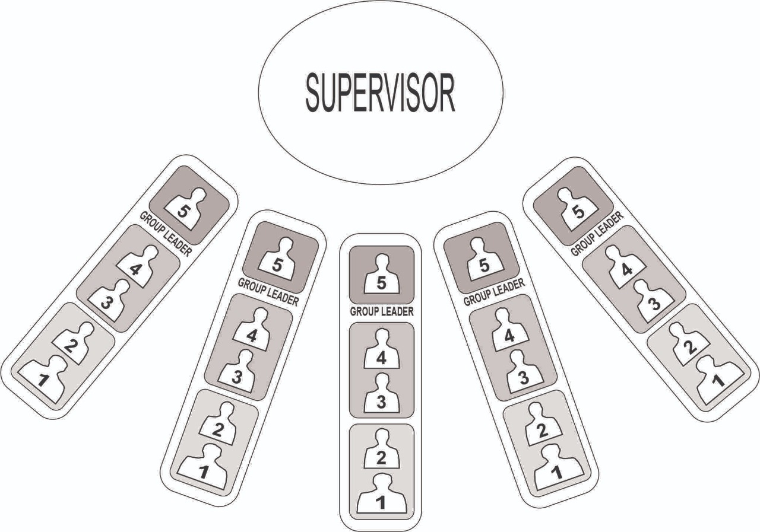
Figure 2. Group Member Seating Order Model
Source: Bank Wakaf Mikro , 2019
This image depicts a model of the seating order of group members during the Halaqoh session. The placement of members in order of priority to receive financing demonstrates a fair and transparent approach to the distribution of resources. It also emphasizes the importance of mutual support among group members.

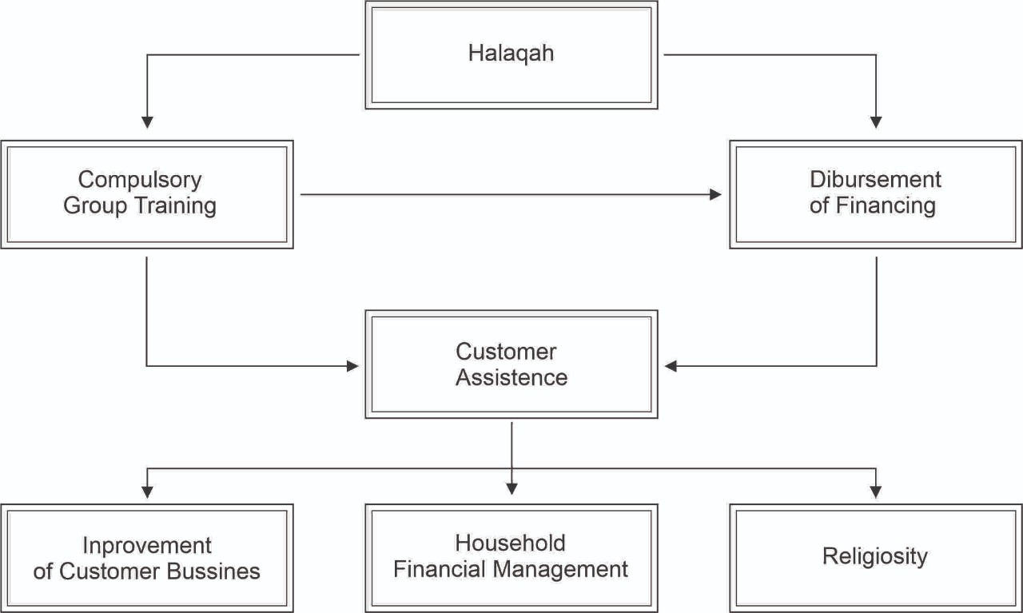

Figure 3: Implementation of Halaqoh at MWB
This image shows the atmosphere of the implementation of Halaqoh at MWB, where customers gather to pay off loans and get assistance. The act of sitting cross-legged on the floor reflects simplicity and egalitarianism in the interaction between the client and the mentor. This image is important to depict the nuances of togetherness and solidarity built in the community. Thus, this study provides in-depth insight into the effectiveness of the empowerment program implemented by SMI MWB and its impact on productive poor women.
To address the lack of research examining the model of women's empowerment through halaqoh in MWB, it is necessary to conduct qualitative research and in-depth case studies so that it can explore customer experiences, analyze impacts, and develop a comprehensive theoretical framework on the effectiveness of the xplorewerment model. In addition, digital financial inclusion initiatives also show significant potential in empowering women by providing them with access to financial resources, which is a key element in the empowerment process (Tripathi & Rajeev, 2023e). However, many women, especially in low-income and rural areas, experience difficulties in accessing digital financial services due to limited internet connectivity and lack of digital literacy (Udenigwe & Yaya, 2022). This digital divide can exacerbate existing inequalities and prevent women from benefiting from digital financial inclusion.
To explore the effectiveness of the halaqah model in the economic empowerment of poor women, more in-depth research, including qualitative and quantitative analysis, is needed, which can identify key factors, challenges, and outcomes achieved through participation in halaqah programs. This is becoming even more relevant given that women in rural areas face unique challenges in diversifying their sources of income, often especially challenged agricultural activities (Vimefall & Levin, 2023b). Therefore, understanding these barriers is essential for designing effective empowerment. The integration of gender perspectives in program evaluations is often inadequate, hindering understanding of their effectiveness (Morgan et al., 2022). Thus, a comprehensive evaluation framework, which includes gender analysis, can provide deeper insights into the success of the halaqah model.
To measure the long-term impact of women's empowerment through MWB on the welfare of families and communities around Islamic boarding schools, it is necessary to conduct longitudinal research that includes regular data collection, as well as evaluation of social and economic changes that occur over a specific time. At this time, the concept has many dimensions, including physical mobility power in decision-periodonomic resources (Mehra et al., 2023). Therefore, in order to accurately measure these aspects over time, comprehensive and sensitive tools are needed, which are often difficult to apply in longitudinal research. In addition, economic empowerment can have a varied impact on mental health. On the one hand, financial results. Ence is often associated with a decrease in mental health disorders, while on the other hand, the stress that arises from managing new economic responsibilities can also have a negative effect on health (Essel-Gaisey et al., 2023).
To optimize the training and mentoring provided by MWB for poor women, it is important to integrate a performance-based financing system with a precise equity measure so as to ensure that the results are fairer and more sustainable and meet the specific needs of clients. On the other hand, economic empowerment ensures that those processes during public health emergencies have the potential to support gender equality; nonetheless, these programs can also have adverse effects, such as an increase in domestic violence, which support carefully managed (Steinert et al., 2021). In addition, a review of interventioadversearly childhood development in low- and middle-income countries shows that although many interventions have been successful in improving equity, the integration of equity aspects in economic evaluation is still limited, indicating the need for a more holistic approach to ensure equitable outcomes (Baek et al., 2023).
Conclusion
The empowerment program carried out by MWB through the halaqah model has proven effective in improving the economic welfare of unbanked women by providing microfinance and assistance based on Sharia principles. Through a group approach and business character development, women are able to develop financial skills and build solid skills in their communities. Not only does this program have the potential to be replicated and expanded, but it can also serve as a basis for government and non-government policies to improve access to financial institutions. Thus, this study provides new insights into the importance of the halaqah model in women's empowerment and encourages women micro and small entrepreneurs to fight marginalization in financial aspects.
Acknowledgment
Ucapan terimakasih kepada pihak yang memberikan dana, institusi dan dan afiliasi. Missal, peneliti mengucapkan terimakasih atas dukungan dll, jika ada pendaan maka sebutkan nomor surat dan tanggal surat dan dari mana asalanya.
References
Baek, Y., Ademi, Z., Fisher, J., Tran, T., & Owen, A. (2023). Equity in Economic Evaluations of Early Childhood Development Interventions in Low-and Middle-Income Countries: Scoping Review. Maternal and Child Health Journal, 27(6), 1009–1029. https://doi.org/10.1007/s10995-023-03650-3
Bastian, B. L., Wood, B. P., & Ng, P. Y. (2023). The role of strong ties in empowering women entrepreneurs in collectivist contexts. International Journal of Gender and Entrepreneurship, 15(1), 122–146. https://doi.org/10.1108/IJGE-10-2021-0171
BSM, L. (2017a). Manajemen Lembaga Keuangan Mikro Syariah. LAZNAS BSM.
BSM, L. (2017b). “SOP & SOM Standar Operasional Prosedure Dan Management Untuk LKM Syariah-Bank Wakaf Mikro (p. 8). LAZNAS BSM.
Danquah, M., Iddrisu, A. M., Boakye, E. O., & Owusu, S. (2021). Do gender wage differences within households influence women’s empowerment and welfare? Evidence from Ghana. Journal of Economic Behavior & Organization, 188, 916–932. https://doi.org/10.1016/j.jebo.2021.06.014
Demir, A., Pesqué-Cela, V., Altunbas, Y., & Murinde, V. (2022). Fintech, financial inclusion, and income inequality: a quantile regression approach. The European Journal of Finance, 28(1), 86–107. https://doi.org/10.1080/1351847X.2020.1772335
Desai, S., Mehta, K. M., Singh, R. J., Westley, A. K., Dirisu, O., Wong, C., De Hoop, T., & Darmstadt, G. L. (2021a). Effects of integrated economic and health interventions with women’s groups on health-related knowledge, behaviors and outcomes in low-income and middle-income countries: a systematic review protocol. BMJ Open, 11(7), e046856. https://doi.org/10.1136/bmjopen-2020-046856
Desai, S., Mehta, K. M., Singh, R. J., Westley, A. K., Dirisu, O., Wong, C., De Hoop, T., & Darmstadt, G. L. (2021b). Effects of integrated economic and health interventions with women’s groups on health-related knowledge, behaviours and outcomes in low-income and middle-income countries: a systematic review protocol. BMJ Open, 11(7), e046856. https://doi.org/10.1136/bmjopen-2020-046856
Essel-Gaisey, F., Okyere, M. A., Forson, R., & Chiang, T.-F. (2023). The road to recovery: Financial resilience and mental health in post-apartheid South Africa. SSM - Population Health, 23, 101455. https://doi.org/10.1016/j.ssmph.2023.101455
Fuad, N., Tuan Lonik, K. A., & Dahalan@Omar, N. (2022). THE INFLUENCE OF PSYCHOLOGICAL WOMEN EMPOWERMENT ON MICRO ENTERPRISE SUSTAINABILITY. International Journal of Education, Psychology and Counseling, 7(46), 449–461. https://doi.org/10.35631/IJEPC.746034
Gibbs, A., Corboz, J., Chirwa, E., Mann, C., Karim, F., Shafiq, M., Mecagni, A., Maxwell-Jones, C., Noble, E., & Jewkes, R. (2020). The impacts of combined social and economic empowerment training on intimate partner violence, depression, gender norms and livelihoods among women: an individually randomised controlled trial and qualitative study in Afghanistan. BMJ Global Health, 5(3), e001946. https://doi.org/10.1136/bmjgh-2019-001946
Hoop, D., Kempen, V., & Eerdewijk, V. (2010). Munich Personal RePEc Archive Women’s Autonomy and Subjective Well-Being in India: How Village Norms Shape the Impact of Self-Help Groups.
Jaim, J. (2021). Exist or exit? Women business‐owners in Bangladesh during COVID‐19. Gender, Work & Organization, 28(S1), 209–226. https://doi.org/10.1111/gwao.12546
Kumari, Dr. P. (2022). Role of Women Empowerment in achieving social transformation and sustainable development. International Journal of Multidisciplinary Research and Growth Evaluation, 134–138. https://doi.org/10.54660/anfo.2022.3.6.5
Mabrouk, F., Bousrih, J., Elhaj, M., Binsuwadan, J., & Alofaysan, H. (2023a). Empowering Women through Digital Financial Inclusion: Comparative Study before and after COVID-19. Sustainability, 15(12), 9154. https://doi.org/10.3390/su15129154
Mabrouk, F., Bousrih, J., Elhaj, M., Binsuwadan, J., & Alofaysan, H. (2023b). Empowering Women through Digital Financial Inclusion: Comparative Study before and after COVID-19. Sustainability, 15(12), 9154. https://doi.org/10.3390/su15129154
Mehra, D., Srivastava, S., Chandra, M., Srivastava, N., Laaksonen, M., Saarinen, H. E., & Mehra, S. (2023). Effect of physical mobility, decision making and economic empowerment on gender-based violence among married youth in India-SAWERA project. BMC Public Health, 23(1), 548. https://doi.org/10.1186/s12889-023-15421-4
Morgan, R., Garrison-Desany, H., Hobbs, A. J., & Wilson, E. (2022). Strengthening effectiveness evaluations through gender integration to improve programs for women, newborn, child, and adolescent health. Global Health Action, 15(sup1). https://doi.org/10.1080/16549716.2021.2006420
Mwase, T., Lohmann, J., Hamadou, S., Brenner, S., Somda, S. M. A., Hien, H., Hillebrecht, M., & De Allegri, M. (2020). Can Combining Performance-Based Financing With Equity Measures Result in Greater Equity in Utilization of Maternal Care Services? Evidence From Burkina Faso. International Journal of Health Policy and Management. https://doi.org/10.34172/ijhpm.2020.121
Ojha, S., Szatkowski, L., Sinha, R., Yaron, G., Fogarty, A., Allen, S. J., Choudhary, S., & Smyth, A. R. (2020). Rojiroti microfinance and child nutrition: a cluster randomised trial. Archives of Disease in Childhood, 105(3), 229–235. https://doi.org/10.1136/archdischild-2018-316471
Plouffe, V., Bicaba, F., Bicaba, A., & Druetz, T. (2020). User fee policies and women’s empowerment: a systematic scoping review. BMC Health Services Research, 20(1), 982. https://doi.org/10.1186/s12913-020-05835-w
Rizkianti, A., Saptarini, I., & Rachmalina, R. (2021). Perceived Barriers in Accessing Health Care and the Risk of Pregnancy Complications in Indonesia. International Journal of Women’s Health, Volume 13, 761–772. https://doi.org/10.2147/IJWH.S310850
Senou, M. M., & Manda, J. (2022). Access to finance and rural youth entrepreneurship in Benin: Is there a gender gap? African Development Review, 34(1), 29–41. https://doi.org/10.1111/1467-8268.12623
Sethy, S., & Jana, C. (2022). Economic Empowerment Analysis of Women in West Bengal Using Multivariate Techniques. Journal of Rural Development, 40(4), 548. https://doi.org/10.25175/jrd/2021/v40/i4/144217
Steinert, J. I., Alacevich, C., Steele, B., Hennegan, J., & Yakubovich, A. R. (2021). Response strategies for promoting gender equality in public health emergencies: a rapid scoping review. BMJ Open, 11(8), e048292. https://doi.org/10.1136/bmjopen-2020-048292
Su, L., Peng, Y., Kong, R., & Chen, Q. (2021). Impact of E-Commerce Adoption on Farmers’ Participation in the Digital Financial Market: Evidence from Rural China. Journal of Theoretical and Applied Electronic Commerce Research, 16(5), 1434–1457. https://doi.org/10.3390/jtaer16050081
Tripathi, S., & Rajeev, M. (2023a). Gender-Inclusive Development through Fintech: Studying Gender-Based Digital Financial Inclusion in a Cross-Country Setting. Sustainability, 15(13), 10253. https://doi.org/10.3390/su151310253
Tripathi, S., & Rajeev, M. (2023b). Gender-Inclusive Development through Fintech: Studying Gender-Based Digital Financial Inclusion in a Cross-Country Setting. Sustainability, 15(13), 10253. https://doi.org/10.3390/su151310253
Tripathi, S., & Rajeev, M. (2023c). Gender-Inclusive Development through Fintech: Studying Gender-Based Digital Financial Inclusion in a Cross-Country Setting. Sustainability, 15(13), 10253. https://doi.org/10.3390/su151310253
Tripathi, S., & Rajeev, M. (2023d). Gender-Inclusive Development through Fintech: Studying Gender-Based Digital Financial Inclusion in a Cross-Country Setting. Sustainability, 15(13), 10253. https://doi.,org/10.3390/su151310253
Tripathi, S., & Rajeev, M. (2023e). Gender-Inclusive Development through Fintech: Studying Gender-Based Digital Financial Inclusion in a Cross-Country Setting. Sustainability, 15(13), 10253. https://doi.org/10.3390/su151310253
Udenigwe, O., & Yaya, S. (2022). Leaving no woman or girl behind? Inclusion and participation in digital maternal health programs in sub-Saharan Africa. Reproductive Health, 19(1), 54. https://doi.org/10.1186/s12978-022-01358-1
Vásquez-Vera, C., Fernández, A., & Borrell, C. (2022). Gender-based inequalities in the effects of housing on health: A critical review. SSM - Population Health, 17, 101068. https://doi.org/10.1016/j.ssmph.2022.101068
Vimefall, E., & Levin, J. (2023a). Income Diversification Among Farming Households Headed by Women in Rural Kenya. Feminist Economics, 29(2), 219–251. https://doi.org/10.1080/13545701.2022.2159056
Vimefall, E., & Levin, J. (2023b). Income Diversification Among Farming Households Headed by Women in Rural Kenya. Feminist Economics, 29(2), 219–251. https://doi.org/10.1080/13545701.2022.2159056

