UNBANKED WOMEN: ECONOMIC EMPOWERMENT USING HALAQOH MODEL IN SHARIA MICRO FINANCIAL INSTITUTIONS IN INDONESIA
Rozalinda^{1*}, Nurhasnah², Rizda Octaviani³
¹Faculty of Islamic Economics and Business, Imam Bonjol Padang State University, Indonesia.
²Faculty of Sharia, Imam Bonjol State Islamic University, Padang, Indonesia.
³Manna Wa Salwa College of Sharia Economics, Padang Panjang, West Sumatra, Indonesia.
*Corresponding Author: Rozalinda, rozalinda@uinib.ac.id

Abstract
This study explores the women's economic empowerment model applied by Bank Waqf Mikro (BWM), a Sharia microfinance institution in Indonesia established in 2017 to provide financial access for poor women around Islamic boarding schools. Using a descriptive qualitative approach, data was collected through in-depth interviews and observations of BWM customers, leaders, and assistants in several provinces, such as Yogyakarta, West Sumatra, Central Java, and East Java. BWM applies an empowerment model through group training, funding, and mentoring with the halaqoh method, which means "circle" and is a traditional learning method in Islam. The empowerment process begins with potential customer identification, socialization, surveys, feasibility tests, and pre-group training, followed by funding and mentoring through weekly halaqoh meetings. This model has proven effective in improving women's economic well-being by providing access to capital, entrepreneurship training, and household financial management. However, challenges such as improper use of funds for consumptive purposes or debt payments are still encountered, which lead to delays in instalment payments. The study concludes that the BWM model has the potential to be replicated and expanded to improve women's financial inclusion and economic empowerment, especially for those who do not have access to formal banking services. The practical implications of this study are the need for the government and non-governmental institutions to utilize the BWM model as a basic framework for women's economic empowerment and encourage women's active participation in economic activities to improve family welfare. The study also opens up opportunities for further research on risk management in group-based funding at BWM.
Keywords: Women's Economic Empowerment, Micro Waqf Bank (BWM), Halaqoh, Financial Inclusion, Sharia Microfinance Institutions
Introduction
Women face significant financial marginalization in various aspects of life, which is influenced by a combination of systemic, cultural, and socioeconomic factors. Gender discrimination is a significant barrier to financial inclusion for women in Indonesia. Studies show that men have easier access to funds from family, banks, and angel investors than women (Lueg & Ni, 2020). This gender gap affects significant economic vulnerability, especially during personal or family crises and economic shocks (Ackah et al., 2024). Programs such as microfinance and digital financial services have shown promise in empowering women by providing easier access to financial products (Tripathi & Rajeev, 2023).
A lack of access to formal finance often causes the marginalization faced by poor women. According to Rana et al. (2024), Education is one way to empower women and fight marginalization. MWB focuses on the economic empowerment of productive women through training, financing, and mentoring. This makes studying women's economic empowerment in Sharia Microfinance Institutions very important.
Women's empowerment through SMEs is an effective strategy to improve family welfare (Andari et al., 2023; Senapati & Ojha, 2019). MWB provides easy access to finance, creates jobs, increases income, and improves family living standards. With the increasing trend of financial inclusion, MWB is expected to carry out this function effectively (Niaz, 2022).
Women-owned micro and small businesses face difficulties in obtaining financing or credit from banks because they are considered to have no bank accounts (Darwis et al., 2023). These barriers can prevent women from participating in economic activities and improve family well-being (Zogning, 2023). Many poor people in Indonesia are also unable to access formal financial services. In the face of this situation, the Financial Services Authority established the Micro Waqf Bank (MWB) in 2017 to provide financial access for poor women. (Hamzah & Yudiawan, 2023).
This study aims to examine the economic empowerment model applied by MWB to support productive women who are in poor conditions. This study's uniqueness lies in applying the halaqah model in women's economic empowerment in MWB, which is expected to significantly contribute to overcoming the marginalization of women in the financial sector. By understanding how MWB empowers women through training, financing, and mentoring, it is hoped that this research can provide new insights into effective economic empowerment strategies in the context of Sharia Microfinance Institutions.
Literature Review
Halaqoh
In the context of Islam, halaqoh refers to religious gatherings that aim to study Islam and the Qur'an. Halaqoh means "circle" (Santoso & Khisbiyah, 2021). According to Sibbald et al. (2022), This term can be interpreted as a 'circle of knowledge' or 'learning community'. This learning community includes interaction between two or more people who discuss Islamic science (Zengin Arslan, 2020). In halaqoh, participants usually sit in a circle to communicate with each other. Halaqoh is a gathering place for people to learn about Islam (Fathorrahman et al., 2024). Therefore, halaqoh serves as a means of education for small groups of Murabbi (teachers) and several mutarabbis (guided students). This educational process is carried out clearly and regularly. Halaqoh is often held in mosques or prayer rooms. At the Al-Haram Mosque in Makkah and Medina, halaqoh is held daily and guided by the Masses (Handoko et al., 2024).
Muslims also hold halaqoh in various places, such as at home or in the park. In this system, the speaker sits in the middle of the forum, surrounded by other members (F. Ahmed, 2019). This format is a method commonly used in Islamic boarding schools and has been applied in the archipelago since the arrival of Islam, categorized as a traditional learning system. Halaqoh is a place to discuss religion and self-reflect (Ismail et al., 2024). Although halaqoh is a traditional learning model, it shapes students' beliefs, morals, worship character, and scientific insights (Taja et al., 2021).
Women's Empowerment
Empowerment means creating strength within individuals by promoting, motivating, and increasing awareness of their potential and development (Back & Keys, 2020). The goal is to give strength to those who are less fortunate. The term includes planning, processes, and efforts to strengthen weak individuals (Richey et al., 2022). Empowerment is related to improving the ability of a person, family, or group towards better conditions. These efforts involve individual change that includes increased willpower and capacity across multiple dimensions, including economic, socio-cultural, family, legal, political, and psychological (Earle et al., 2022). Women's empowerment is essential for national growth and development. According to Eggers del Campo & Steinert (2022), Women's social and economic development contributes to overall economic development.
Empowering women means improving their abilities and skills in the social, economic, and political fields (Lavy et al., 2022). This empowerment program involves productive economic, health, and educational activities (Bapolisi et al., 2020; Coan et al., 2020). In the context of economic development, women's empowerment includes the ability to 1) earn, spend, and save income; 2) buy, own, and sell assets; 3) start and manage a business; 4) open a bank account or get credit; and 5) participate in or lead trade unions and other economic activities. Therefore, empowerment aims to enable women to participate, contribute, and benefit from the development process by respecting their values and dignity (Pizzamiglio & Kovacs, 2021). It also increases women's self-awareness and ability to be independent.
Sharia Microfinance Institution Bank Waqf Mikro (SMI MWB)
MWB is a Sharia microfinance institution that aims to provide microfinance to the community (Nurasyiah et al., 2024). The government is committed to expanding financial access for people in Islamic boarding schools that are not connected to formal financial institutions (Hasiba et al., 2021). MWB does not collect or manage public savings funds (Non-Deposit Taking). According to Sharia principles, this institution only provides assistance and financing to poor women who have productive potential around Islamic boarding schools. Financing distribution is carried out with a group approach and a shared responsibility system (Rozalinda, 2020).
MWB was established with several objectives, namely: 1) improving the welfare of the community around the pesantren through assistance and training for customers, 2) improving the living standards of the productive poor, 3) maximizing the role of the pesantren as an educational institution adjacent to socio-religious life to empower women through the Weekly Halaqoh (WH) for each group member, and 4) building and strengthening professional socio-economic institutions, accountable, and independent by growing Community Business Groups around Islamic Boarding Schools in Indonesia (CBGIBSI). Institutionally, MWB is a cooperative legal entity (Paramita & Prananingtyas, 2020) which operates as a sharia microfinance institution licensed and supervised by the Financial Services Authority (OJK) (Nugroho et al., 2019; Widyanti, 2020). Since its launch nationwide in 2017 until March 31, 2019, MWB has established 43 units throughout Indonesia, with a total of Rp 18,543,680,000 in financing disbursed and a total of 15,236 customers registered in 10,003 CBGIBSI (BWM, 2019).
Research Method
This research was conducted in MWB in Yogyakarta Province, West Sumatra, and Central and East Java, Indonesia, as shown in Table 1.
Table 1. Study Location
Province | SMI MWB
West Sumatra | - SMI MWB Al Kausar Sari Lamak Kec. Harau, Lima Puluh Kota, West Sumatra
Yogyakarta | - SMI MWB Usaha Mandiri Sakinah, Aisyiyah University (UNISA) Yogyakarta
 | - SMI MWB Almuna Berkah Mandiri, Al Munawwir Islamic Boarding School, Krapyak Yogyakarta
 | - SMI MWB Al Manshur Barokahing Gusti, Klaten Regency, Yogyakarta
 | - SMI Bank Waqf Syariah Alpansa, Klaten Regency, Yogyakarta
East Java | - SMI MWB Alfitrah Wafa Mandiri, As-Salafi Al-Fithrah Islamic Boarding School, Kewall Surabaya, East Java
 | - SMI MWB at Mambaul Maarif Islamic Boarding School, Denanyar, Jombang Regency, East Java
Central Java | - SMI MWB at Bahrul Ulum Islamic Boarding School, Rice Farm
 | - SMI MWB at Tebuireng Islamic Boarding School, Central Java

During this study, Micro Waqf Banks (MWB) have been established in forty-three Islamic boarding schools, of which thirty-four are located on the island of Java, seven in Sumatra, one in Kalimantan, one in Sulawesi, and one in Papua (BWM, 2019). Java Island was chosen as the location of the study because it has the most significant number of MWBs, followed by Sumatra.
This study uses a qualitative descriptive method to analyze the data thoroughly and provide information about the women's economic empowerment model. A qualitative descriptive approach is applied to explore the women's economic empowerment model in MWB aimed at productive poor women around Islamic boarding schools. Data is collected from MWB customers, leaders, and assistants. Informants consist of directly involved individuals who have an important role in the empowerment process. They deeply understand MWB's operations and its contribution to women's economic empowerment. The empowerment model was obtained through interviews and observations. This study also observes the required group training and customer mentoring process during the Halaqoh Weekly (WH) meeting. Interviews were conducted with MWB leaders, assistants, and customers to explore the empowered model applied. Structured interviews are conducted in a comfortable atmosphere to build good relationships with informants.
Socio-Demographic
The study involved 95 women aged 30-39 (40%) and 40-49 (39%) to participate in in-depth interviews. Based on education level, 57% of respondents are high school graduates, while only nine are college graduates. Most respondents (53%) have been in the business for 1-5 years and only 6% for over 15 years. In addition, 27 respondents (29%) had an income of less than 1.9 million rupiah, and 17 respondents had an income of more than 4 million rupiah, as shown in Table 1.

Table 1. Sociodemographics of respondents
Education |  |  | Age |  |  | Length of business |  |  | Income After Getting Financing
Education | Entire | % | Age | Entire | % | Length of business | Entire | % | Income | Entire | %
Higher Education | 9 | 9% | >50 years | 13 | 14% | 1-5 years | 50 | 53% | <1.9 million rupiah | 27 | 29%
High School | 54 | 57% | 40-49 years old | 37 | 39% | 6-10 years | 28 | 29% | 2 -2.9 million rupiah | 21 | 23%
Junior High School | 19 | 20% | 30-39 years old | 38 | 40% | 11-15 years | 11 | 12% | 3 -3.9 million rupiah | 30 | 32%
Sd | 13 | 14% | 29 years | 7 | 7% | >15 years | 6 | 6% | >4 million rupiah | 17 | 17%
 | 95 |  |  | 95 |  |  | 95 |  |  | 95

Data Analysis Procedure
This research uses a qualitative analytical framework that utilizes thematic methodologies through data collection, reduction, interpretation, and presentation. In data collection, all relevant information is carefully documented and transcribed. The reduction phase includes identifying and organising the raw data before summarizing, coding, and categorizing this data according to the research question. Thematic analysis filters the grouped data into more significant forms to extract critical themes by emphasizing, italicizing, or encoding relevant information. Interpretive insights are drawn from categorized data to distinguish significant patterns that consistently emerge from empirical data. As a result, thematic analysis requires a high level of engagement and interpretive effort.
Credibility and Transferability
The credibility, trustworthiness, transferability, and generalization of findings are essential in qualitative studies. To ensure credibility, the study recorded the respondents' explanations and reflected on the issues examined. Furthermore, the transferability of the results is ensured by presenting and expanding the existing data. The goal is to use the applicable data for empowerment carried out by MWB for women who do not have bank accounts. In-depth interviews with participants are also used to ensure the validity and integrity of the data. Written responses are read to the interviewee to ensure the accuracy and confirmation of the existing responses.
Results and Discussion
Results
First, prospective customers are identified to ensure compliance with the program's target criteria, such as distance of residence, type of business, and business location. Second, socialization about MWB is carried out in the community through maternal recitation activities, social gatherings, and Family Welfare Empowerment (FEW). This socialisation aims to disseminate information about the concept, stages of formation, participation requirements, and CBGIBSI activities. The third process involves surveying potential customers. In the fourth stage, the feasibility test of prospective customers is carried out. Based on interviews with Dafril (2019) and Safitri (2019), who are the Trustees of MWB AlKautsar Payakumbuh and MWB UNISA Yogyakarta, the feasibility test aims to ensure the correctness of poor family data from the identification results and assist in the selection of prospective participants. This feasibility study includes direct visits to the residences of prospective customers to assess the condition of the homes and collect economic and business data.

Fifth, Group Mandatory Pre-Training (GCP) is carried out before CGT is implemented for prospective customers. This activity was carried out by facilitators with prospective CBGIBSI members. The goal is to strengthen the group's intention and interest in participating in the MWB program, establish CBGIBSI, and introduce financing distribution mechanisms. This activity prepares the group to participate in the implementation of the program (BSM, 2017a). Further details can be seen in Figure 1.
Figure 1. Stages of Women's Empowerment in MWB

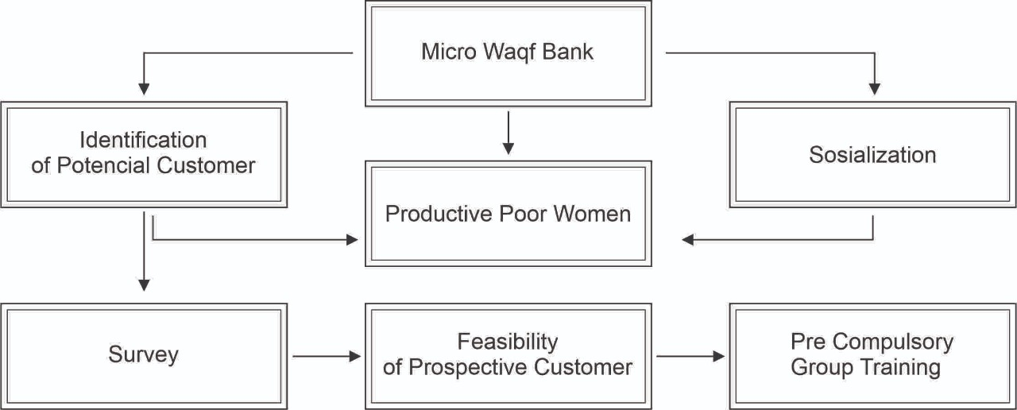

Women's empowerment is facilitated through Community Group Training (CGT), allocation of financial resources, and customer support services. Initially, CGT served as the introductory phase of the empowerment initiatives implemented by MWB aimed at women who do not have access to banking services. Administration underlines the importance of specific attributes in prospective clients, which include discipline, trust, accountability, and mutual care. The CGT session begins after forming at least three groups, each consisting of five members. This process is carried out for one hour over five consecutive days (BSM, 2017a), as illustrated in Table 1:
Table 1. CGT Material
Day | Material
First | 1) Explanation of CGT, 2) Introduction to MWB. 3) Introduction and principles of CBGIBSI membership, Introduction of CGT participants, 4) Introduction of pledges, 5) Motivational materials.
Second | 1) Reading of the pledge, 2) Capacity building materials, 6) Rights and obligations of members, 7) Election of group leaders and deputy leaders, 8) Discussion of the responsibilities of leaders, secretaries, and group members.
Third | 1) Reading of guarantees, 2) Introduction of contracts and financing procedures and instalment payments, 3) Stories and how to create a business profile.
Fourth | 1) Reading of the pledge, 2) Giving the name and number of CBGIBSI, 3) Election of leaders and deputy leaders, 4) Discussion of the responsibilities of leaders, deputy leaders, and members, and 5) discussion of WH.
Fifth | 1) Reading the pledge, 2) Review of CGT material, 3) CBGIBSI validation test.
Source: (BSM, 2017b)
The hallmark of this instructional program is the assessment of the character traits shown by the prospective client. As Sari (2019) and Dafril (2019) stated, participants from MWB Al Kautsar Five Forty in West Sumatra and MWB UNISA Yogyakarta collected a nominal amount of Rp 2,000 during the initial session. The supervising academician documents and allocates the serial number to the participant in the back. The next day, the supervisor requested a withdrawal of the deposited funds to verify the serial number. Participants are considered trustworthy if the serial number remains unchanged, and vice versa, it is not. The supervisor underlines the critical nature of showing trust. After the meeting on the second day, the supervising academics took an additional nominal amount of Rp 2,000 and carefully recorded the sequence number. This amount is then given to participants who sit in the second and last rows.

All prospective clients must take the Group Validation Exam (GVE) organized by MWB supervisors on the fifth day. Prospective group members who fully understand the training material are declared competent and affirmed as MWB clients, thus forming CBGIBSI (BSM, 2017b). Prospective clients are judged to have passed based on the following criteria: a) Discipline, b) Cohesion, c) Trust, d) Ability to respond accurately to at least 50% of questions, and e) Secure family support. According to an interview with Puguh, Amalia (2019), a lecturer from the MWB Alfitrah Wafa Mandiri As-Salafi Al-Fithrah Islamic Boarding School, Kewall Surabaya, and MWB Tebu Ireng Jombang, participants were ranked according to their needs to receive initial financial support. Members who are prioritized for financial disbursement are positioned at the back. Sitting at the front, the leader is allocated the latest financial support according to the arrangement depicted in Figure 2.
Figure 2. Group Member Seating Order Model

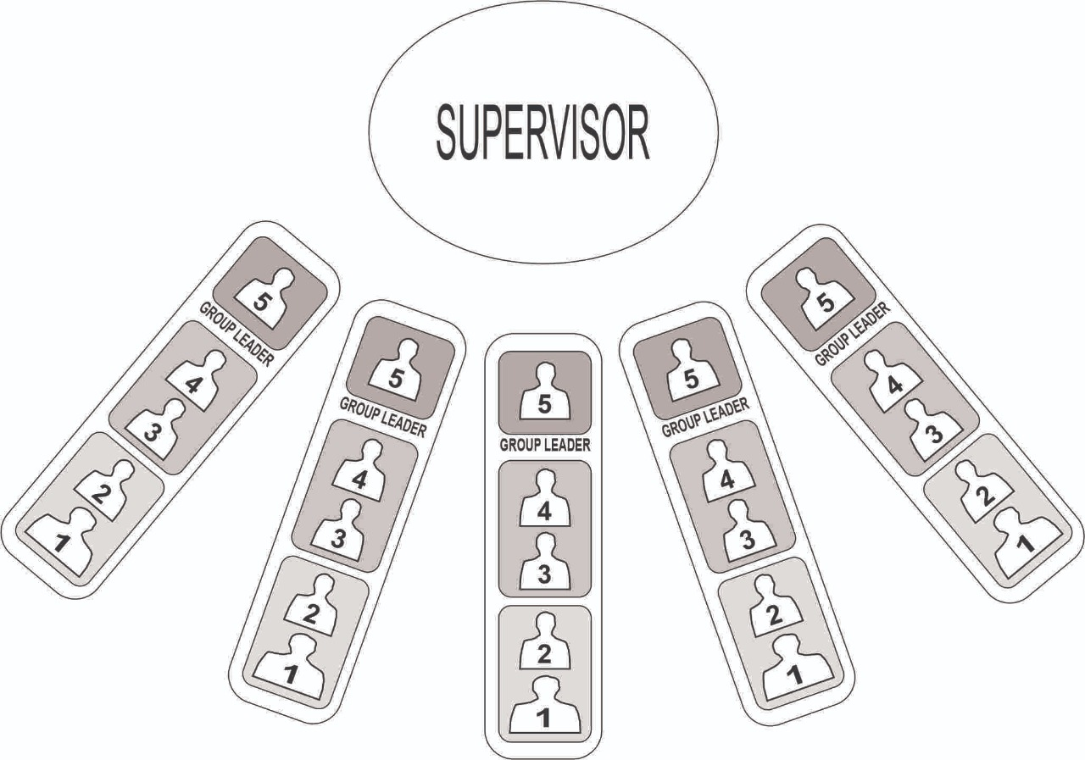
Source: Micro Waqf Bank, 2019
The next phase involves allocating financial resources after seating arrangements during GCT. Sari and Umami (2019) stated that Managers and Customers of MWB Mandiri Sakinah UNISA Yogyakarta and MWB Alpansa Klaten indicated that financing is allocated in three stages following a 2-2-1 distribution model. This model exemplifies an educational framework that fosters an empathetic attitude among members. The allocation of financial resources is prioritized based on the level of urgency, ensuring that those most in need are taken care of first. During the first week of WH, funds are distributed to participants sitting in the back, specifically those with sequence numbers 5 and 4. In the next phase, participants who were given serial numbers 3 and 2 were given financing. This second allocation occurred during the second week of WH. The group leader was given the last chance to occupy the position at the front. The financing allocation was carried out in the third week of WH. Finally, customer support is provided following the distribution of financing across WH, as depicted in Figure 3.
Figure 3: Implementation of Halaqoh in MWB
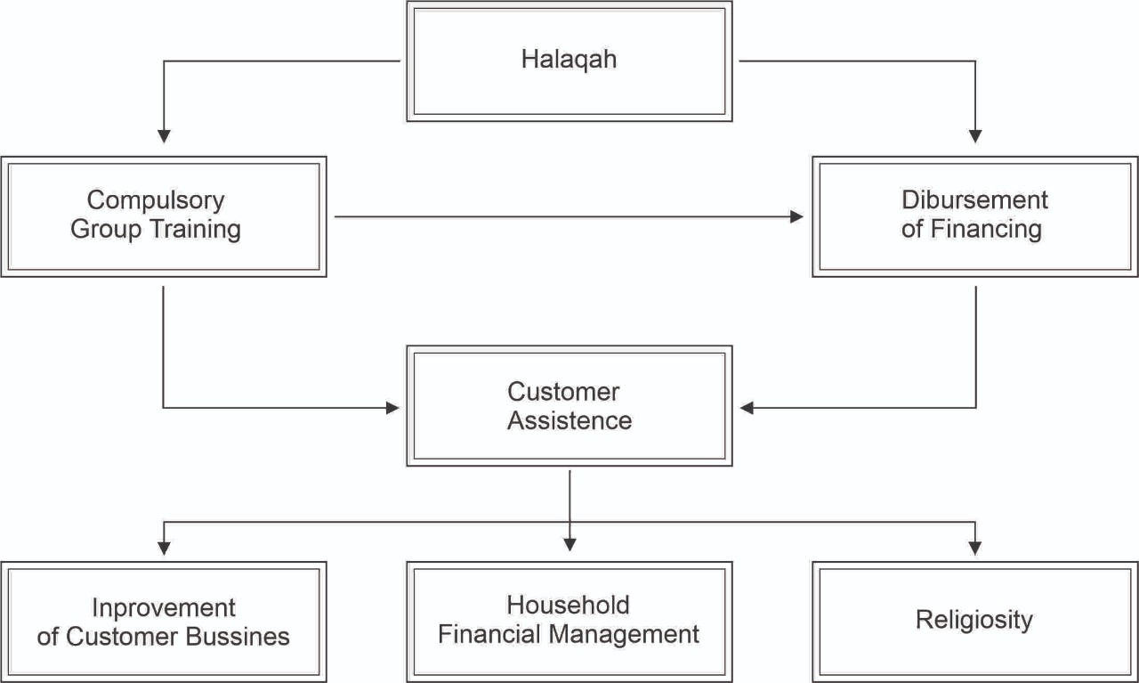

Each client fulfils their payment obligations weekly during WH meetings in order to qualify for the next financing opportunity. The empowerment framework used in MWB, manifested in the WH format, is implemented within the domicile of the group leader or CBGIBSI. WH is a customer mentorship initiative where all participants and supervisory academics sit cross-legged on the ground. Participants consist of several CBGIBSI individuals arranged in a linear formation directed to the supervisor. Puguh (2019), MWB Tebu Ireng Jombang manager in East Java, articulated that the halaqoh model fosters a customer's psychological disposition. Halaqoh involvement is carried out systematically every week and must be attended to by all clients. This initiative fosters customer attitudes, a sense of unity, commitment, and discipline. Additionally, it promotes an ethos of solidarity, accountability, and collaborative efforts within the group through collective responsibility to deliver loan payments. The Halaqoh session was held for one hour, accompanied by MWB supervisors, presenting a structured agenda as depicted in Table 2.
Table 2. Halaqoh Agenda at MWB
Not | Material
1 | Mouth
2 | Reading of the pledge
3 | Member attendance reports
4 | Disbursement of financing
5 | Customer Support
6 | Installment payment
7 | Prayer and closing
Source: (BSM, 2017a)
The assistance was delivered directly by the supervisor or an external entity such as HALMI Akbar (WH Agung). This was admitted by Zuhri (2019), a supervisory lecturer at MWB Alpansa Klaten Yogyakarta. Client assistance is carried out through the initial phase of religious and spiritual guidance, which is complemented by scientific instruction from the ustadz or ustazah of the boarding house. The next phase involves household financial management. SMI offers family assistance and development through financial management strategies to grow the Sainah family. The third phase includes assistance in customer business development through mentoring and entrepreneurial support. This includes training in marketing management, bookkeeping, service provision, and business expansion through food product packaging and product quality improvement training. Furthermore, MWB helps customers market their products through online platforms and guides them in building an online buying and selling account. It also assists customers in selling products during certain events.

MWB uses a group-based financing model, where the group collectively determines loan approval and guarantees the financing payment of each member. This group-centric paradigm uses a shared responsibility financing system. The groups assured MWB of their accountability for members who failed to pay instalments. Members support each other by contributing and donating to reduce arrears. As a result, they must maintain a shared responsibility for savings supervised by the group leader. These savings serve as a collective guarantee in the case of instalment arrears from CBGIBSI members. Financing instalments are deducted from the group's joint responsibility savings to overcome unpaid arrears. Members are expected to make up their arrears during a halaqoh meeting with the group leader the following week.

Discussion
Women's Economic Empowerment in Sharia Microfinance Institutions of Micro Waqf Banks (SMI MWB)
As a Social Microfinance Institution (SMI), MWB functions as a financial entity that aims to improve the socio-economic welfare of the community around boarding schools, with a special emphasis on economically disadvantaged productive women (Sulistiani et al., 2020). It offers financial assistance and support for women's micro and small businesses (Soemitra et al., 2022). SMI's target demographic includes women who do not have bank accounts or micro-entrepreneurs who cannot secure bank financing due to perceptions of inadequacy. This perception arises from believing that women are more likely to show discipline by consistently attending Women's Health (WH) meetings. In addition, women are considered superior in managing household finances and entrepreneurial capital. As a result, women are given the opportunity to expand their businesses through financial support of only Rp 1,000,000. According to Adetiloye et al. (2020) Microfinance initiatives are specifically aimed at women, as they face greater challenges in obtaining credit. They experience limited access to the labor market and show higher rates of loan repayment compared to their male counterparts.
The financing initiative provided by MWB to group-based clients operates with participation ranging from 15 to 25 individuals (Zhao et al., 2022). Ajja et al. (2020) explained that women's empowerment through entrepreneurship has emerged as an important component of development efforts in India. Women's entrepreneurship refers to a business venture or organization initiated by a woman or a women's collective. Self-help groups (SHGs) are crucial in encouraging the development of rural communities in India, mostly made up of women members (Aggarwal et al., 2020). Alumni of the Doctor of Philosophy program at Vanderbilt University, Tennessee, USA, carried out this empowerment initiative. The graduate founded Grameen Bank, which provides group-based microcredit to poor individuals with unsecured companies. The 2006 Nobel Peace Prize recipient designed a program that required each loan applicant to organize into groups of five individuals. Within this framework, group members cannot access credits in order. In contrast, granting credit to other members is contingent on the discipline and integrity demonstrated by the original borrower in meeting payment obligations (Gaganis et al., 2023; Xu et al., 2020).
The financing model used by MWB is essentially group-based, requiring a collective responsibility structure known as kafalah in Islamic economics (H. Ahmed & Aassouli, 2022). Members share accountability for financing instalment payments with each other. In cases where members cannot meet their payment obligations, fellow group members are responsible for arrears, thus ensuring the continuity of financing payments to MWB. Group-based loans have the potential to reduce financing risk significantly (Iwang Suwangsih et al., 2021; Prastyaningtyas et al., 2022). Hasiba et al. (2021) affirmed that this model profoundly impacts poverty alleviation in Bangladesh, where loans are given to the economically disadvantaged based on trust rather than guarantees or guarantees. Prospective borrowers must be part of a group of microfinance borrowers to qualify for a loan from Grameen Bank.
Grameen Bank's operational framework has been imitated and adopted in various Sharia-compliant microfinance initiatives in Indonesia, mainly including the Micro Sharia Waqaf Bank. Most Sharia microfinance initiatives are built as ultra-micro financing, a paradigm set by Permodalan Nasional Madani (PNM) since 2015 (Musta’anah et al., 2021). In the same vein, BTPN Syariah has focused its efforts on the economic empowerment of women who are less able to achieve productivity since 2010 (Fanggidae et al., 2020). These financial institution initiatives show different characteristics, such as community empowerment and the provision of microfinance services. These services are organized in groups and specifically targeted at women from poor or low-income backgrounds. Muhammad Yunus emphasized that Microfinance Institutions, which provide financial services designed to stimulate small businesses, can empower women (Cabeza-García et al., 2019). Bank Mit Ghramr was founded to provide loans to small businesses, and 97% of its clients are women.

Halaqoh Method in Women's Economic Empowerment
MWB uses the halaqah methodology in its initiative, which aims to increase women's economic empowerment around boarding schools (Rozalinda & Nurhasnah, 2022). The framework has operated since the start of prospective MWB clients participating in the five-day GCT (Anwar et al., 2023). Halaqoh sessions take place every week, facilitating the disbursement of financial resources along with customer development initiatives (Soemitra et al., 2022). In the conventional educational paradigm, the seating arrangement of the instructor and the learner combine to form a circular configuration (Yamin & Dalimunthe, 2020). Halaqoh activities encourage interpersonal relationships among CBGIBSI members to strengthen women's determination and loyalty to MWB regulations (Ritonga et al., 2019). As a result, financial support, collaborative relationships, and religious instruction are required. These findings prove that the halaqoh framework inspires women to acquire knowledge of Islam, entrepreneurship, and domestic financial management. In addition, it catalyzes the proliferation of women's micro-enterprises in the boarding school environment. As a Small Micro Industry (SMI), MWB has proven its significance in achieving financial inclusion through microfinance.
Mukthar et al. (2023) identified that microcredit frameworks significantly increase rural women's entrepreneurial aspirations. MWB increases financial inclusion by facilitating access to capital for the community and micro, small and medium enterprises (Zhang et al., 2023). SMI presents a viable alternative to the challenges faced by poor populations (Zitouni & Ben Jedidia, 2022), especially regarding the accessibility of financial resources. The main goal of microfinance is to reduce poverty by increasing access to financial institutions to empower economically disadvantaged individuals. SMI is important in economic, socio-cultural, and family empowerment (Islam, 2021). Involving women in microfinance improves their domestic standing through self-sufficiency income opportunities.
Empowerment facilitated through the halaqoh model, central to women's economic progress, has not achieved complete success. The client did not fully utilize the financing allocated by MWB for working capital. Discussions with group leaders indicate that some clients allocate funds for consumptive expenses or to pay off existing debts. This situation has caused group members to delay the payment of financing instalments, which should have been handled through group savings. This illustrates that the assistance provided by MWB goes beyond the boundaries of weekly halaqoh. Therefore, field assistance should include oversight of the customer's business operations.
Conclusion
MWB implements empowerment initiatives through the provision of financial resources and guidance directed to economically disadvantaged but potentially productive women who live near boarding schools, which serve as their targeted market demographics. Loan disbursement follows a collective approach characterized by a shared accountability system. Various operational empowerment frameworks, including GCO, GCT, and mentoring, use the halaqoh model. Participants are positioned on the floor in a cross-sectional, facilitator-oriented manner in a semicircular setting. Individuals who need financial assistance the most occupy the back position, with group leaders at the forefront, while those who have received funds are in the last position.
The halaqoh model MWB uses significantly improves women's economic welfare through microfinance mechanisms. Women are involved in developing Sharia-compliant business characteristics within the GCT framework, which emphasizes the principles of discipline, integrity, trust, concern for others, and fiscal responsibility. In addition, they benefit from Islamic guidance, household financial management, and business development during regular halaqoh sessions.
SMI's MWB program has the potential for replication and expansion in its initial areas to facilitate increased access to microfinance and to improve women's economic empowerment. It is anticipated that this investigation will involve government and non-government policies to encourage women's empowerment through increased access to financial institutions. Nevertheless, the study focuses exclusively on the empowerment model run by MWB, omitting the exploration of the risk management dimension associated with group-based financing. This presents a valuable opportunity for further research to evaluate risk management practices in financing in MWB.
A prominent observation made from this study is that the Halaqoh model is particularly advantageous for empowering women who do not have access to bank accounts. In the context of weekly halaqah meetings, maintaining the mental attitude of participants and fostering a sense of togetherness, commitment, discipline, solidarity, responsibility, and cooperative group dynamics are considered more effective. The findings of this study also produce several practical implications. First, the government must utilize SMI MWB as a basic framework for the economic empowerment of unbanked women, thus enabling their active participation in economic activities and improving the well-being of their families. Second, the results of this study can be a source of inspiration for women involved in micro and small businesses, encouraging them to persevere in the fight against financial marginalization.
Acknowledgement
The authors are grateful to the leaders and mentors of the IA Scholar Foundation for providing direction in completing this study.
References
Ackah, C., Torvikey, G. D., Obeng Adomaa, F., & Asante, K. T. (2024). “You cannot rely on bank loans to expand your business”: aversion to formal credit among female micro-entrepreneurs in Ghana. International Journal of Social Economics, 51(7), 870–883. https://doi.org/10.1108/IJSE-02-2023-0090
Adetiloye, K. A., Adegboye, F. B., & Akinjare, V. A. (2020). Sustainable financial access for female entrepreneurs in the micro, small and medium enterprises sector in Nigeria. Cogent Social Sciences, 6(1). https://doi.org/10.1080/23311886.2020.1823600
Aggarwal, S., Kumar, P., & Garg, V. (2020). Empowering SHGs Women through Micro-finance in Uttar Pradesh. International Journal of Law and Management, 62(6), 591–606. https://doi.org/10.1108/IJLMA-02-2020-0051/FULL/XML
Ahmed, F. (2019). The potential of halaqah to be a transformative Islamic dialogic pedagogy. In The Routledge International Handbook of Research on Dialogic Education (pp. 647–659). Routledge. https://doi.org/10.4324/9780429441677-53
Ahmed, H., & Aassouli, D. (2022). Entrepreneurial finance, agency problems and Islamic ethics: complementarities and constraints. Venture Capital, 24(1), 25–46. https://doi.org/10.1080/13691066.2022.2067017
Ajja, S. H., Samiti’, S., Arts, S. K. S. J., & Sheshgiri, S. M. (2020). Women Empowerment And Women Entrepreneurship: An Overview. Jurnal Universitas Arsitektur & Teknologi Xi’an, 12(3), 3843–3844.
Andari, S., Yusuf, H., Kuntjorowati, E., Purnama, A., Listyawati, L., Febriyandi Y. S., F., Martino, M., & Murdiyanto, M. (2023). Empowerment and mobility of women from domestic to public spaces in improving family welfare. Multidisciplinary Science Journal, 5, 2023031. https://doi.org/10.31893/multiscience.2023031
Anwar, M. Z., Fathan, Warto, & Hidayati, O. N. (2023). TRANSFORMATION OF ECONOMIC THEOLOGY FOR COMMUNITY EMPOWERMENT A Case Study on Pesantren-Based Bank Wakaf Mikro. Journal of Indonesian Islam, 17(1), 76–99. https://doi.org/10.15642/JIIS.2023.17.1.76-99
Back, L. T., & Keys, C. B. (2020). Developing and testing the College Student Empowerment Scales for Racial/Ethnic Minorities. Journal of Community Psychology, 48(2), 482–502. https://doi.org/10.1002/jcop.22257
Bapolisi, W. A., Ferrari, G., Blampain, C., Makelele, J., Kono-Tange, L., Bisimwa, G., & Merten, S. (2020). Impact of a complex gender-transformative intervention on maternal and child health outcomes in the eastern Democratic Republic of Congo: protocol of a longitudinal parallel mixed-methods study. BMC Public Health, 20(1), 51. https://doi.org/10.1186/s12889-019-8084-3
BSM, L. (2017a). “SOP & SOM Standar Operasional Prosedure Dan Management Untuk LKM Syariah-Bank Wakaf Mikro (p. 8). LAZNAS BSM.
BSM, L. (2017b). Manajemen Lembaga Keuangan Mikro Syariah. LAZNAS BSM.
BWM. (2019). LKMS-BWM. Http://Www.Lkmsbwm.Id/.
Cabeza-García, L., Del Brio, E. B., & Oscanoa-Victorio, M. L. (2019). Female financial inclusion and its impacts on inclusive economic development. Women’s Studies International Forum, 77(October), 102300. https://doi.org/10.1016/j.wsif.2019.102300
Coan, S., Woodward, J., South, J., Bagnall, A., Southby, K., Button, D., & Trigwell, J. (2020). Can a community empowerment intervention improve health and wellbeing in a post-industrial UK town? European Journal of Public Health, 30(Supplement_5). https://doi.org/10.1093/eurpub/ckaa165.229
Darwis, V., Rachmawati, R. R., Muslim, C., Chanifah, Sembiring, A., Ilham, N., Mufidah, L., Suhartini, S. H., Basuki, R. S., Rina, Y., Suharyon, Nurdin, M., Dahya, Damanik, M., & Dewi, D. O. (2023). Transformation of financial institutions grants from the government to inclusive financial institutions in Indonesia. PLOS ONE, 18(6), e0286482. https://doi.org/10.1371/journal.pone.0286482
Earle, R., Littlewood, R., Nalatu, S., & Walker, J. (2022). Empowerment Approaches in Childhood Weight Management: A Systematic Review. Childhood Obesity, 18(1), 2–30. https://doi.org/10.1089/chi.2021.0049
Eggers del Campo, I., & Steinert, J. I. (2022). The Effect of Female Economic Empowerment Interventions on the Risk of Intimate Partner Violence: A Systematic Review and Meta-Analysis. Trauma, Violence, & Abuse, 23(3), 810–826. https://doi.org/10.1177/1524838020976088
Fanggidae, R. E., Kurniawati, M., & Bahweres, H. (2020). The Effect of Workplace Spirituality and Employee Performance (Perspective of Islamic Work Ethics Case Study on BTPN Syariah, Kupang). Atlantes Press, 234–239. https://doi.org/10.2991/AEBMR.K.200522.045
Fathorrahman, A Hashfi Luthfi, Riyanta, & Ach Fatayillah Mursyidi. (2024). Dynamics of Thought in the Fiqh of Civilization Halaqah at Pesantren Affiliated with Nahdlatul Ulama (NU) in Yogyakarta. Ijtihad : Jurnal Wacana Hukum Islam Dan Kemanusiaan, 24(1), 71–95. https://doi.org/10.18326/ijtihad.v24i1.71-95
Gaganis, C., Papadimitri, P., Pasiouras, F., & Tasiou, M. (2023). Social traits and credit card default: a two-stage prediction framework. Annals of Operations Research, 325(2), 1231–1253. https://doi.org/10.1007/s10479-022-04859-1
Hamzah, H., & Yudiawan, A. (2023). The contribution of infaq funds to socio-economic resilience during COVID-19 pandemic: An Islamic economics insight from Indonesia. HTS Teologiese Studies / Theological Studies, 79(1). https://doi.org/10.4102/hts.v79i1.8213
Handoko, W., Nasution, I. P., Wahyudi, W. R., Yogaswara, H., Subair, M., Kholis, N., Massoweang, K., Firmanto, A., & Akbar, A. (2024). The Relationship of Islam and Locality in the Architecture of the Wapauwe Ancient Mosque in Maluku. Journal of Islamic Architecture, 8(1), 184–198. https://doi.org/10.18860/jia.v8i1.21729
Hasiba, F. F., Mahmudah, S. N., & Puji Sucia Sukmaningrum, Shochrul Rohmatul Ajija, M. B. F. Z. (2021). The Strategies for Developing Micro Waqf Bank in Indonesia. Rigeo.Org, 11(4), 2021. https://doi.org/10.48047/rigeo.11.04.24
Islam, M. S. (2021). Role of Islamic microfinance in women’s empowerment: evidence from Rural Development Scheme of Islami Bank Bangladesh Limited. ISRA International Journal of Islamic Finance, 13(1), 26–45. https://doi.org/10.1108/IJIF-11-2019-0174/FULL/HTML
Ismail, S., Sabri, H., Asari, H., Yamin, M., & Yunus, M. M. (2024). Fostering Emotional and Moral Development in Islamic Boarding Schools: The Impact of TalaqqÃ® and á¸¤alaqa Traditions. Jurnal Pendidikan Islam, 10(1), 13–24. https://doi.org/10.15575/jpi.v0i0.35124
Iwang Suwangsih, Nuzulul Fatimah, Noneng Rukayah Sukatmadiredja, & Emmywati. (2021). THE IMPACT OF IMPLEMENTATION OF A JOINT LIABILITY SYSTEM ON MEMBER BEHAVIOR. Journal of Islamic Economics Perspectives, 3(1), 88–100. https://doi.org/10.35719/JIEP.V3I1.41
Lavy, V., Lotti, G., & Yan, Z. (2022). Empowering Mothers and Enhancing Early Childhood Investment. Journal of Human Resources, 57(3), 821–867. https://doi.org/10.3368/jhr.57.3.0917-9083R2
Lueg, K., & Ni, A. (2020). Female Entrepreneurs and Access to Financial Capital. Asian Journal of Social Science, 48(1–2), 15–43. https://doi.org/10.1163/15685314-04801003
Mukthar, K. P. J., Asis, H. R., Vílchez-Vásquez, R., Huaman-Osorio, A., & Alvarado-Tolentino, J. (2023). Estimating Women Entrepreneurial Empowerment of Start-Up Business Through Micro Credit Model in Rural Areas. Lecture Notes in Networks and Systems, 495 LNNS, 86–94. https://doi.org/10.1007/978-3-031-08954-1_8/COVER
Musta’anah, A., Bina Buono, K., Atika, R., Noviarita, H., Islam, U., Raden, N., & Lampung, I. (2021). Analysis of Sharia Literacy Level and Sharia Financial Inclusion PNM Mekaar Sharia in Increasing Income Public (Study on the Fishing Community of Kuala Jaya Hamlet, South Lampung Regency). Journal of Islamic Business and Economic Review, 4(2), 97–101.
Niaz, M. U. (2022). Socio-Economic development and sustainable development goals: a roadmap from vulnerability to sustainability through financial inclusion. Economic Research-Ekonomska Istraživanja, 35(1), 3243–3275. https://doi.org/10.1080/1331677X.2021.1989319
Nugroho, W., Islamic, F. H.-A.-I. J. of, & 2019, undefined. (2019). Micro Waqf Bank in Indonesia: Analysis of The Constitution Concept According to The Maqashid Sharia. Ejournal.Unida.Gontor.Ac.Id, 3(1).
Nurasyiah, A., Syamputri, D., Al Adawiyah, R. A., Mahri, A. J. W., & Ismail, A. G. (2024). Islamic wealth management: ensuring the prosperity of Muslim households of MSMEs during Covid-19. International Journal of Ethics and Systems, 40(1), 189–211. https://doi.org/10.1108/IJOES-09-2021-0165
Paramita, & Prananingtyas, H. S. D. (2020). Legal Consequences of Dualism Regulations on Micro Waqf Bank as a Sharia Microfinance Institutions in Indonesia. Varia Justicia, 16(1), 1–14. https://doi.org/10.31603/variajusticia.v16i1.3205
Pizzamiglio, R., & Kovacs, P. (2021). Accelerating Women’s Empowerment Through Legal Empowerment and Social Accountability Strategies. Journal of Human Development and Capabilities, 22(3), 517–526. https://doi.org/10.1080/19452829.2021.1890005
Prastyaningtyas, E. W., Widjaja, S. U. M., Wahyono, H., Andayani, E. S., & Rusdi, J. F. (2022). Methods for studying group loans, join responsibility, and women’s empowerment. MethodsX, 9, 101749. https://doi.org/10.1016/J.MEX.2022.101749
Rana, M. Q., Lee, A., Rodrigues Bezerra, J. F., & Villas Boas, G. H. (2024). Empowerment and Sustainability: Investigating Barriers to Women’s Transition from Higher Education to Empowerment in Brazil. Societies, 14(11), 234. https://doi.org/10.3390/soc14110234
Richey, M., Brooks, J., & Ravishankar, M. N. (2022). Building self-determination of disadvantaged groups: insights from an entrepreneurship focused program for refugees. International Journal of Entrepreneurial Behavior & Research, 28(7), 1828–1850. https://doi.org/10.1108/IJEBR-10-2021-0806
Ritonga, T., Ananda, A., Lanin, D., & Hasan, H. (2019). Practice to theory of learning: A lesson learned from islamic boarding school in South Tapanuli of Indonesia. Humanities and Social Sciences Reviews, 7(5), 1304–1310. https://doi.org/10.18510/hssr.2019.75169
Rozalinda. (2020). Bank Wakaf Mikro: Its Operations and Its Role in Empowering Communities Surrounding Islamic Boarding Schools in Indonesia. Islam Realitas: Journal of Islamic and Social Studies, 6(1), 47–60.
Rozalinda, R., & Nurhasnah, N. (2022). Islamic Boarding School-Based Women’s Economic Empowerment and Its Impact on Increasing Home Industry Income. Annual International Conference on Islamic Economics and Business (AICIEB), 2(1), 432–448. https://doi.org/10.18326/AICIEB.V2I1.126
Santoso, M. A. F., & Khisbiyah, Y. (2021). Islam-based peace education: values, program, reflection and implication. Indonesian Journal of Islam and Muslim Societies, 11(1), 185–207. https://doi.org/10.18326/ijims.v11i1.185-207
Senapati, A. K., & Ojha, K. (2019). Socio-economic Empowerment of Women Through Micro-entrepreneurship: Evidence from Odisha, India. International Journal of Rural Management, 15(2), 159–184. https://doi.org/10.1177/0973005219866588
Sibbald, S. L., Burnet, M. L., Callery, B., & Mitchell, J. I. (2022). Building a virtual community of practice: experience from the Canadian foundation for healthcare improvement’s policy circle. Health Research Policy and Systems, 20(1), 95. https://doi.org/10.1186/s12961-022-00897-0
Soemitra, A., Kusmilawaty, & Rahma, T. I. F. (2022). The Role of Micro Waqf Bank in Women&rsquo;s Micro-Business Empowerment through Islamic Social Finance: Mixed-Method Evidence from Mawaridussalam Indonesia. Economies 2022, Vol. 10, Page 157, 10(7), 157. https://doi.org/10.3390/ECONOMIES10070157
Sulistiani, S. L., Yunus, M., & Bayuni, E. M. (2020). Micro Waqf Bank: New Sharia Financial Instruments in Indonesia. Advances in Social Science, Education and Humanities Research, 409, 1–4. https://doi.org/10.2991/ASSEHR.K.200225.001
Taja, N., Nurdin, E. S., Kosasih, A., Suresman, E., & Supriyadi, T. (2021). Character Education in the Pandemic Era: A Religious Ethical Learning Model through Islamic Education. International Journal of Learning, Teaching and Educational Research, 20(11), 132–153. https://doi.org/10.26803/ijlter.20.11.8
Tripathi, S., & Rajeev, M. (2023). Gender-Inclusive Development through Fintech: Studying Gender-Based Digital Financial Inclusion in a Cross-Country Setting. Sustainability, 15(13), 10253. https://doi.org/10.3390/su151310253
Widyanti, A. (2020). STRATEGY MARKETING OF SHARIA BANKS OF MICRO SHARIA WAKAF IN INCREASING THE NUMBER OF CUSTOMERS (Case Study: Typical Islamic Micro Waqf Bank Kempek Cirebon). Journal of Social Science, 1(1), 1–9. https://doi.org/10.46799/JSS.V1I1.2
Xu, Y., Cheng, W., & Zhang, L. (2020). Switching from Group Lending to Individual Lending: The Experience at China’s Largest Microfinance Institution. Emerging Markets Finance and Trade, 56(9), 1989–2006. https://doi.org/10.1080/1540496X.2019.1636228
Yamin, A., & Dalimunthe. (2020). Classic Islamic Education Heritage in Halaqah and Munazharah. 194.31.53.129, 6(2), 249–343. https://doi.org/10.24952/tazkir.v6i2.1315
Zengin Arslan, B. (2020). Reading the Universe with Heart and Practicing Science as Religious Ethics: Reconciling Islam and Science in Contemporary Turkey. Social Epistemology, 34(3), 265–280. https://doi.org/10.1080/02691728.2019.1672824
Zhang, L., Chen, J., Liu, Z., & Hao, Z. (2023). Digital Inclusive Finance, Financing Constraints, and Technological Innovation of SMEs—Differences in the Effects of Financial Regulation and Government Subsidies. Sustainability, 15(9), 7144. https://doi.org/10.3390/su15097144
Zhao, H., Liu, X., Zhang, X., Wei, Y., & Liu, C. (2022). The effects of person-organization fit on lending behaviors: Empirical evidence from Kiva. Journal of Management Science and Engineering, 7(1), 133–145. https://doi.org/10.1016/j.jmse.2021.09.004
Zitouni, T., & Ben Jedidia, K. (2022). Does Islamic microfinance contribute to economic empowerment in Tunisia?: a case study of Zitouna Tamkeen. Journal of Business and Socio-Economic Development, 2(1), 67–81. https://doi.org/10.1108/JBSED-10-2021-0143/FULL/HTML
Zogning, F. (2023). Inclusion financière, entrepreneuriat inclusif et modèles alternatifs de financement. Journal of Small Business & Entrepreneurship, 35(1), 1–7. https://doi.org/10.1080/08276331.2022.2121517

