HRPUB Manuscript Template for Manuscripts Preparation
First Author¹, Second Author^{2,*}, Third Author³
¹College of Engineering, Boston University, Boston, 02215, Massachusetts, United States
²Chemistry & Chemical Engineering Faculty, California Institute of Technology, Pasadena, 91125, California, United States
³College of Arts and Sciences, University of Pennsylvania, Philadelphia, 19104, Pennsylvania, United States
*Corresponding Author: Second Author@gmail.com
Copyright©2021 by authors, all rights reserved. Authors agree that this article remains permanently open access under the terms of the Creative Commons Attribution License 4.0 International License

Abstract The instruction for the preparation of the full manuscript is detailed in this template file. The template is intended as a tool to assist you in the layout of your manuscript. It is encouraged that this template can be used for submission of manuscripts. Use of the template will save time during production and expedite publication.
Keywords Table, Figure, Manuscript Format

1. Introduction
This template is formatted according to advice of some experts. All settings about fonts, point sizes and line spacing have been defined in the styles menu. (Figure 1) Use this document as a template if you are using Microsoft Word 2003 or higher. The Manuscript length should contain 5 pages at least. It should be in a two-column format. In general, a full manuscript consists of "Introduction", "Objectives", "Methods", "Results", "Discussion" and "Conclusions". English is treated as the only written language throughout the text.
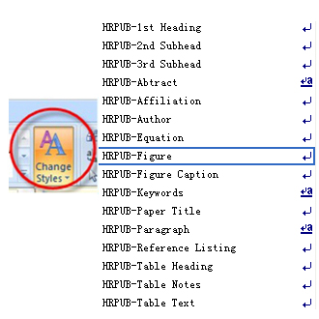
Figure 1. Change Styles→Styles Menu
For personal preference, you may import styles into your own manuscript. The process is divided into 4 steps:
Step 1: Click Show the Styles window (Figure 2);
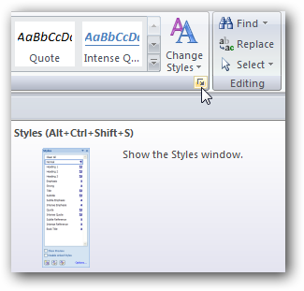
Figure 2. Show the Styles window
Step 2: Click Manage Styles, find Import/Export at the bottom (Figure 3)
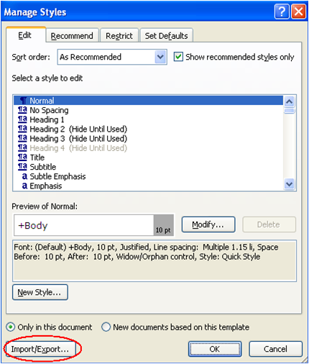
Figure 3. Manage Styles→Import/Export
Step 3: Copy all styles entitled with HRPUB to the Normal.dotm and close the Organizer (Figure 4)
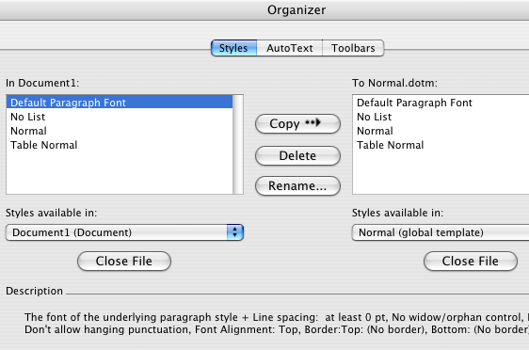
Figure 4. Copy all styles entitled with HRPUB to the Normal.dotm
Step 4: Open your own manuscript file, repeat Step 1-3 and copy all styles entitled with HRPUB to your own manuscript file.

2. Materials and Methods
Present the research design, research type, research duration, inclusion/exclusion criteria, choice of subjects, etc. Describe the methodology completely, including sample collection, processing, lab analysis, statistical tests used for data analysis etc. Use section headings/subheadings in a logical order to entitle each category or method. A maximum of three levels of headings may be used. Usually, headings are numbered with Arabic numerals (1., 2.; 1.1., 1.2.; 1.1.1., 1.2.1….). It’s preferred to illustrate with tables and figures.
2.1. Paper Title
A paper should have a short, straightforward title directed at general readers in no more than 20 words.
2.2. Authorship
List the first and last names of all authors. Provide the full affiliation for each author including Department, University, City, Zip Code, State, Country. If any of the co-authors are from different organizations, their affiliation should be numbered with different Arabic numerals. Email address is compulsory for the corresponding author.
e.g. Josh Jacobus¹, Garrett Elleithy², Jamal Ghaly³
¹College of Engineering, Boston University, Boston, 02215, Massachusetts, United States
²Chemistry & Chemical Engineering Faculty, California Institute of Technology, Pasadena, 91125, California, United States
³College of Arts and Sciences, University of Pennsylvania, Philadelphia, 19104, Pennsylvania, United States
2.3. Abstract & Keywords
The abstract should concisely state the purpose of the investigation and summarize the important conclusions. It should be a single paragraph of generally no more than 200 words.
Immediately after the abstract, 3-8 words or short phrases should be included for online searching (e.g. Keywords Table, Figure, Manuscript Format)
2.4. Figures
2.4.1. Figures Caption
Each figure should have a caption. The caption should be concise and typed separately, not on the figure area; If figures have parts (for example, A and B), make sure all parts are explained in the caption.
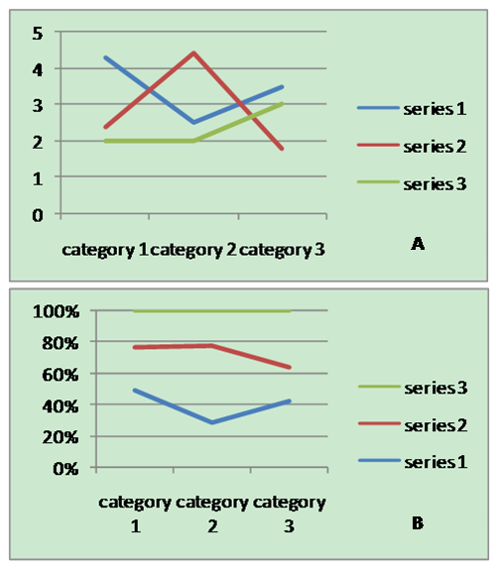
Figure 5. Part A and Part B
2.4.2. Figures Numbering & Citation
All figures are to be sequentially numbered with Arabic numerals. Figures should always be cited in consecutive numerical order. (Figure 5) Parts in a figure can be identified by A, B, C etc. and cited as Fig. 2A, Fig. 2B, Fig. 2C. For larger figures or tables (8.4cm≤Width≤17cm), you may put them in one column. (Figure 6 & Table 1)
2.4.3. Figures Resolution
Figures must be created at a minimum resolution of 300 dpi to avoid bad printing quality. For fuzzy or jagged figures, authors are required to replace it or send the original figure file to us for reproduction.

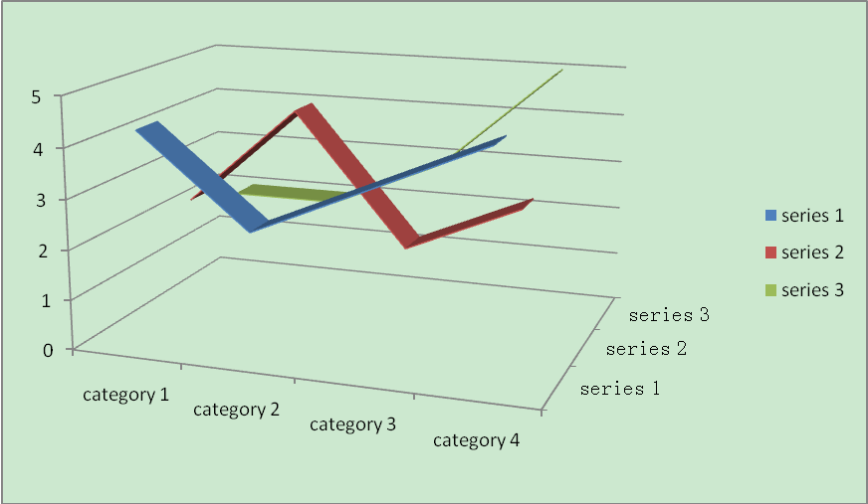
Figure 6. A large figure in one column
Table 1. Specific data of Column/Row
 | Column Header 1 | Column Header 2
Row Header 1 | X | X
Row Header 2 | X | X

2.5. Tables
2.5.1. Tables Title
Every table must have a unique title placed at the top. Titles should be clear and concise, and they should not be complete sentences.
2.5.2. Tables Format
Table tools in Microsoft Word are recommended for inserting a table. It’s necessary to avoid tables created with the tab key.
2.5.3. Tables Numbering & Citation
Tables in the main body of the text should be numbered consecutively according to its appearance in the text. Cite each table in numerical order.
2.6. Equation
2.6.1. Equation Format
The equation number should be placed in parentheses to the right of the equation. Do not create equations as pictures. Use MathType or insert symbols as normal text.
Equation as normal text:
E=MC² (1)
Equation created by MathType:
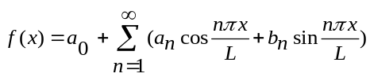 (2)
2.6.2. Equation Numbering & Citation
Equations should be numbered consecutively with Arabic numerals to avoid ambiguities, if they will be referred to in text. Citation for an equation should be made by using “(1),” not “Eq. (1)” or “equation (1),” except at the beginning of a sentence: “Equation (1) is…”
2.7. Appendix
An appendix may be included (and is often helpful) in mathematical or computational modeling.
2.8. Reference Style
All sources cited in text must appear in the reference list, and all items in the reference list must be cited in text. With the numerical system, references are arranged in the reference list so that they match the order in which they are cited in the text.
2.8.1. Reference in-Text Citation Format
References are simply cited with the consistent reference number in square brackets. Do not set references number as superscript number. Do not use “Ref. [3]” or “Reference [3]” except at the beginning of a sentence, e.g. “Reference [3] shows …”
A. Single Reference
If the author's name appears in the text, place the reference number immediately after the name.
E.g. Peter[10] found an innovative scientific phenomenon.
B. Multiple References
1) Put two or four numbers in numerical order and separate them by commas but no spaces.
E.g.: [2,3]
2) Indicate three or more consecutive reference numbers by giving the first and last numbers separated by a hyphen.
E.g.: [3-5]
2.8.2. List of References
Authors are requested to check all references for completeness, including author names, paper title, publisher, journal heading, Volume, Number., pages for journal citations, Year.
Books
All author names, Book title, Publisher, Country, Year.
e.g. R. F. Voss, J. Clarke. Algorithmic Musical Composition, Silver Burdett Press, Londyn, 1986.
Journals
All author names, Title, Publisher, Journal title, Vol, No, pp, Year
e.g. W. Zabierowski, A. Napieralski. Chords classification in tonal music, Journal of Environment Studies, Vol.10, No.5, 50-53.

Conference Papers
All author names, Title, Conference title, pp, Year.
e.g. A. Abiewskiro,. Z. Moplskiiera. The Problem Of Grammar Choice For Verification, TCSET of the International Conference, House of Lviv Polytechnic National University, 19-23, 2008.
Websites
Online Available: http:// e.g.: Farquhar C, Protein and DNA Music, Online available from http://www.hrpub.com

3. Conclusion
Any comments and suggestions are welcomed so that we can constantly improve this template to satisfy all authors’ research needs.

Acknowledgements
We are very grateful to experts for their appropriate and constructive suggestions to improve this template.

REFERENCES
- R. F. Voss, J. Clarke. Algorithmic Musical Composition, Silver Burdett Press, Londyn, 1986.
- W. Zabierowski, A. Napieralski. Chords classification in tonal music, Journal of Environment Studies, Vol.10, No.5, 50-53.
- A. Abiewskiro,. Z. Moplskiiera. The Problem Of Grammar Choice For Verification, TCSET of the International Conference , House of Lviv Polytechnic National University, 19-23, 2008.
- Farquhar C, Protein and DNA Music, Online available from http://www.hrpub.org

