MCQ Questions
- The triple representation is given below.
Which of the following represents the correct expression?
- a = b*-c+b*-c
- a = -c*b+ -c*b
- a = -c*b +b*-c
- a = b*-c+-c*b

- The syntax-directed definition
Translates the assignment statement a = b + - c , into the which of the following three-address code sequence.

- t1=minus c
t2=b+t1
a=t2
- t1=minus b
t2=c+t1
a=t1

- t1=minus t
t2=a+t1
a=t
- t2=minus b
t2=c+a
a=t1

- The translation scheme for the Boolean expression B -> El re1 E2 is
- { B, truelist = Bl . truelist;
B. falselist = Bl .falselist; )

(b) { B.truelist = makelist(nextinstr);
B. falselist = makelist(nextinstr + 1);
emit('if’ El.addr rel.op E2.addr 'goto –I’);
emit('goto –I’); )

(c) { backpatch(B1.truelist,M.instr);
B. truelist = B2 . truelist;
B.f alselist = merge(Bl.f alselist, B2.falselist); }

(d) { backpatch(B1.falselistM, .instr);
B.t ruelist = merge(B1t.r uelist,B 2.t ruelist);
B.f alselist = B2.falselist; }

- Match the following

- Temporaries - storing temporary values generated in procedure
Control link - point to callers activation record
Access link - refer to non-local data of other activation record
Returned value – used by caller procedure to send return value
Saved machine status - storing program counter value, machine
register value
Actual parameters - used by calling program to give parameters
to called procedure

- Temporaries - point to callers activation record
Control link - storing temporary values generated in procedure
Access link - used by caller procedure to send return value
Returned value – refer to non-local data of other activation record
Saved machine status - used by calling program to give parameters to called procedure Actual parameters - storing program counter value, machine register value

(c) Temporaries -used by calling program to give parameters to called procedure
Control link - refer to non-local data of other activation record
Access link - storing program counter value, machine register value
Returned value – point to callers activation record
Saved machine status - used by caller procedure to send return value
Actual parameters - storing temporary values generated in procedure

- The Activation Tree is given below
The activation record for the above tree is

(c)

(d)

- The optimization technique used in the below basic block is
- Strength Reduction
- Common subexpression elimination
- Constant Folding
- Dead code elimination

- The gen and kill equations for the basic block B1 is
(a)

(b) gen B1={d4,d5,d6,d7}
kill B1={d1,d2,d3}
(c) gen B1={d4,d5}
kill B1={d1,d2,d7}
(d) gen B1={d7}
kill B1={d1,d4}

- The next use information of temporary variable t7 in line no. 9 for the following code is
- t7=D
- t7=L(0)
- t7=L(2)
- t7=L(9)
Note: L means Line number

- The DAG representation for the following three address code is
S1:= 4 * i
S2:= a[S1]
S3:= 4 * i
S4:= b[S3]
S5:= s2 * S4
S6:= prod + S5
Prod:= s6
S7:= i+1
i := S7
if i<= 20 goto (1)

- 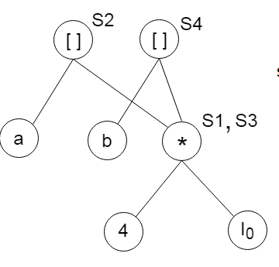

- 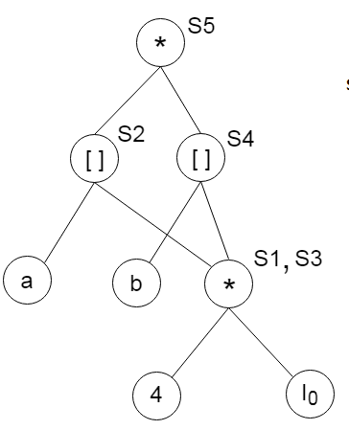

- 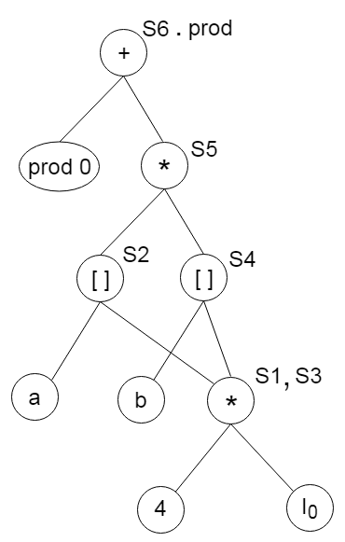

(d)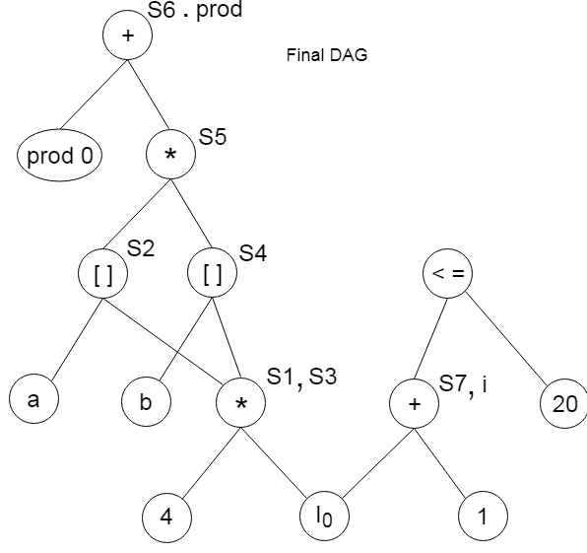

- The loop optimization technique used in the below code is
while (i<10)
{
j= 3 * i+1;
a[j]=a[j]-2;
i=i+2;
}

s= 3*i+1;
while (i<10)
{ j=s;
a[j]= a[j]-2;
i=i+2;
s=s+6;
}

- Strength Reduction
- Dead code elimination
- Constant Folding
- Common subexpression elimination

11) Annotated parse tree means
a) Parse tree with attributes
b) Code generated
c) Correct parse tree
d) None of the given options

12) Which of the following comment about peephole optimization is true?
A) It is applied to a small part of the code and applied repeatedly
B) It can be used to optimize intermediate code
C) It can be applied to a portion of the code that is not contiguous
D) It is applied in the symbol table to optimize the memory requirements.

13) Which of the following class of statement usually produces no executable code when compiled?
A) Declaration
B) Assignment statements
C) Input and output statements
D) Structural statements

14) Substitution of values for names (whose values are constants) is done in
A) Local optimization
B) Loop optimization
C) Constant folding
D) Strength reduction

15) In compiler terminology reduction in strength means
A) Replacing run time computation by compile time computation
B) Removing loop invariant computation
C) Removing common subexpressions
D) Replacing a costly operation by a relatively cheaper one

16) Which of the following statements about peephole optimization is False?
A) It is applied to a small part of the code
B) It can be used to optimize intermediate code
C) To get the best out of this, it has to be applied repeatedly
D) It can be applied to the portion of the code that is not contiguous

17) The graph that shows basic blocks and their successor relationship is called:
A) DAG
B) Control graph
C) Flow graph
D) Hamiltonian graph

18) In compiler optimization, operator strength reduction uses mathematical identities to replace slow math operations with faster operations. Which of the following code replacements is an illustration of operator strength reduction ?
A) Replace P + P by 2 * P or Replace 3 + 4 by 7.
B) Replace P * 32 by P << 5
C) Replace P * 0 by 0
D) Replace (P << 4) – P by P * 15

Explanation: In option (B), Multiplication operation is replaced with Shift Operator. It reduce the operator strength because shift operator is less expensive than multiplication operation. So option (B) is correct.

19) Some code optimizations are carried out on the intermediate code because
A) They enhance the portability of the compiler to other target processors
B) Program analysis is more accurate on intermediate code than on machine code
C) The information from dataflow analysis cannot otherwise be used for optimization
D) The information from the front end cannot otherwise be used for optimization
Ans: A and B

20) Which one of the following is FALSE?
A)A basic block is a sequence of instructions where control enters the sequence at the beginning and exits at the end.
B) Available expression analysis can be used for common sub expression elimination.
C) Live variable analysis can be used for dead code elimination.
D) x = 4 ∗ 5 => x = 20 is an example of common subexpression elimination.

21) Consider the basic block given below.
A = b + c
c = a + d
d = b + c
e = d - b
a = e + b
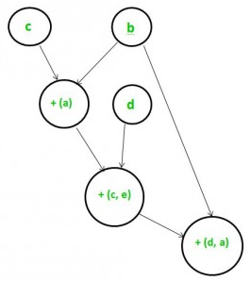
The minimum number of nodes and edges present in the DAG representation of the above basic block respectively are
(A) 6 and 6
(B) 8 and 10
(C) 9 and 12
(D) 4 and 4
Explanation: Simplifying the given equations:
d = b + c (given) e = d – b (given)
=> d = b + c and e = c
e = d – b (given) a = e + b (given)
=> a = d
Thus, the given DAG has 6 nodes and 6 edges.

22) Consider the following Syntax Directed Translation Scheme (SDTS), with non-terminals {S, A} and terminals {a,b}. S→aA{print1} S→a{print2} A→Sb{print3}
Using the above SDTS, the output printed by a bottom-up parser, for the input aab is:
(A) 1 3 2
(B) 2 2 3
(C) 2 3 1
(D) syntax error

