## D3_92712_Prashantkumar:

## Assignment –1:: Creating sample tables and inserting values.

Create the following tables with the given structures and insert sample data as specified: -

A) SALESPEOPLE

Snum int(4)

Sname varchar(10)

City varchar(10)

Comm float(3,2)

B) CUSTOMERS

Cnum int(4)

Cname varchar(10)

City varchar(10)

Rating int(4)

Snum int(4)

C) ORDERS

Onum int(4)

Amt float(7,2)

Odate date

Cnum int(4)

Snum int(4)

A)

Cmd: create table salespeople(

-> Snum int(4),

-> Sname varchar(10),

-> City varchar(10),

-> Comm float(3,2));

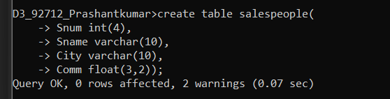

Insert cmd: insert into salespeople(snum,sname,city,comm)

-> values (1001,'Peel','London',.12);

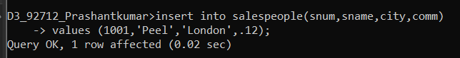

Cmd: insert into salespeople(snum,sname,city,comm)

-> values (1002,'Serres','San Jose',.13);

insert into salespeople(snum,sname,city,comm)

-> values (1004,'Motika','London',.11);

insert into salespeople(snum,sname,city,comm)

-> values (1007,'Rifkin','Barcelona',.15);

insert into salespeople(snum,sname,city,comm)

-> values (1003,'Axelrod','New York',.10);

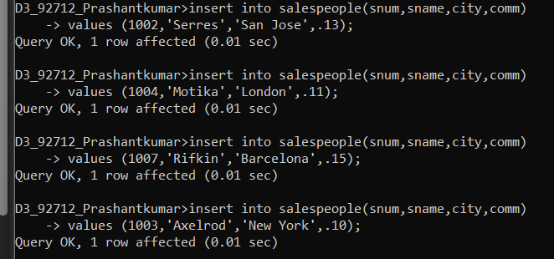

B)

Cmd: create table customers(

-> Cnum int(4),

-> Cname varchar(10),

-> City varchar(10),

-> Rating int(4),

-> Snum int(4));

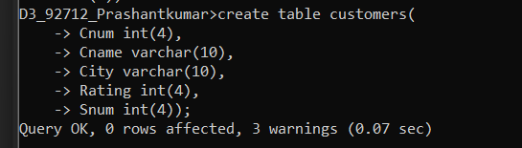

Insert cmd: insert into customers(cnum,cname,city,rating,snum)

-> values (2001,'Hoffman','London',100,1001),

-> (2002,'Giovanni','Rome',200,1003),

-> (2003,'Liu','San Jose',200,1002),

-> (2004,'Grass','Berlin',300,1002),

-> (2006,'Clemens','London',100,1001),

-> (2008,'Cisneros','San Jose',300,1007),

-> (2007,'Pereira','Rome',100,1004);

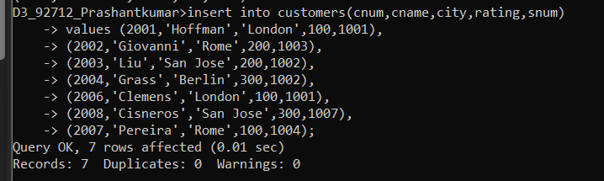

C)

Cmd: create table orders(

-> Onum int(4),

-> Amt float(7,2),

-> Odate date,

-> Cnum int(4),

-> Snum int(4));

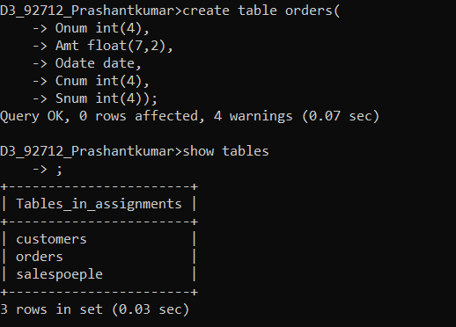

Insert cmd: insert into orders(onum,amt,odate,cnum,snum) values

-> (3001,18.69,'1990-10-03',2008,1007),

-> (3003,767.19,'1990-10-03',2001,1001),

-> (3002,1900.10,'1990-10-03',2007,1004),

-> (3005,5160.45,'1990-10-03',2003,1002),

-> (3006,1098.16,'1990-10-03',2008,1007),

-> (3009,1713.23,'1990-10-04',2002,1003),

-> (3007,73.75,'1990-10-04',2004,1002),

-> (3008,4723.00,'1990-10-05',2006,1001),

-> (3010,1309.95,'1990-10-06',2004,1002),

-> (3011,9891.88,'1990-10-06',2006,1001);

