# Assignment 4: Retrieving Information from Tables

1. Write a select command that produces the order number, amount and date for all rows in the Orders table.

* Select onum,amt,odate from orders;

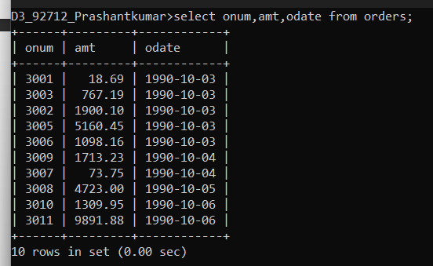

1. Write a query that produces all rows from the Customer table for which the salespersons number is 1001.

* Select * from customers where snum = 1001;

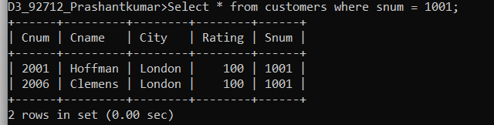

1. Write a query that displays the Salespeople table with the column in the following order: city,sname,snum,comm.

* Select city,sname,snum,comm from salespeople;

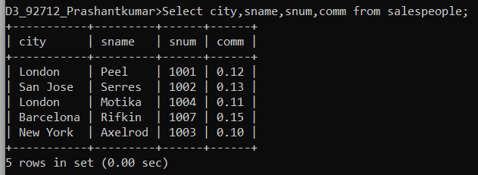

1. Write a select command that produces the rating followed by the name of each customer in San Jose.

* Select rating, cname from customers;

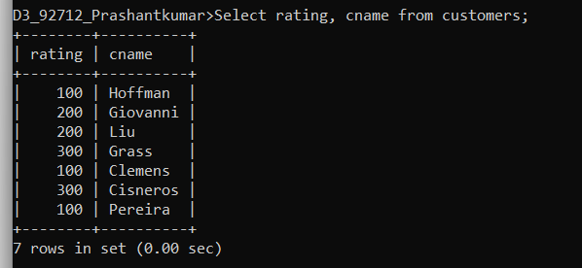

1. Write a query that will produce the snum values of all salespeople (suppress the duplicates) with orders in the Orders table.

* Select distinct snum,onum from orders;

