# Assignment5: Relational and Logical Operators

1. Write a query that will give you all orders for more than 1000 rs.

* Select onum Order_num,amt Order_Amout,odate Order_Date,cnum Customer_Name,snum Salesperson_Name

from orders where amt>1000;

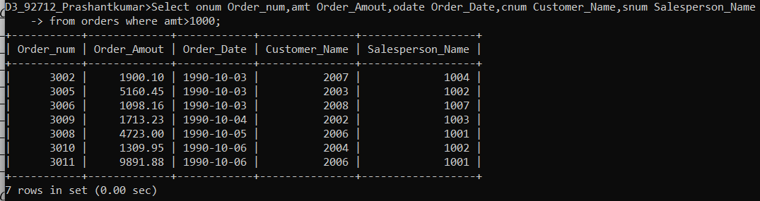

1. Write a query that will give you the names and cities of all salespeople in London with a commission above .10.

* Select sname,city from salespeople

where city = 'London' and comm>0.10;

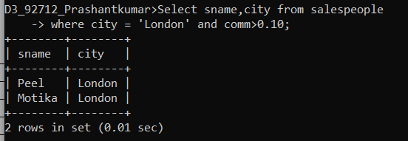

1. Write a query on the Customers table whose output will exclude all customers with a rating <= 100, unless they are located in Rome.

* Select * from customers

Where city = ‘Rome’ or not(rating<=100);

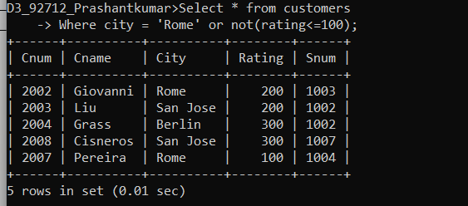

1. What will be the output from the following query?

Select * from Orders

where (amt < 1000 OR NOT (odate = ‘1990-10-03’ AND cnum > 2003));

* It will display all columns of rows which has order amount less than 1000,

And also those rows which don’t have order date 3 oct 1990 with cnum greater than 2003.

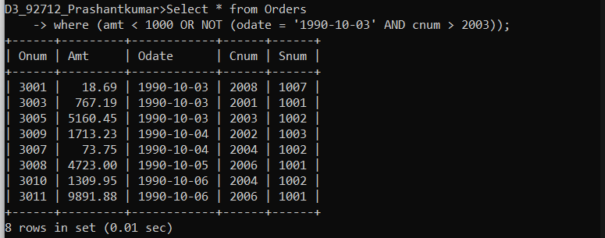

1. What will be the output of the following query?

Select * from Orders

where NOT ((odate = ‘1990-10-03’ OR snum >1006) AND amt >= 1500);

* It will display all column of rows excluding those who have order amount greater than 1499, either having date 3 oct 1990 or have snum grater than 1006.

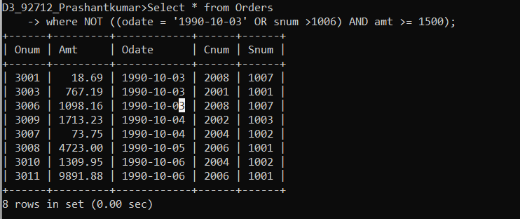

1. What is a simpler way to write this query?

Select snum, sname, city, comm From Salespeople where (comm > .12 OR comm <.14);

* It will display all fields of Salesperson with all rows. Because it will return all comm values i.e. greater than 0.12 and lesser than 0.14.

