# Assignment6: Using special operators in conditions

1. Write two different queries that would produce all orders taken on October 3rd or 4th, 1990.

* Select * from orders where odate between ‘1990-10-03’ and ‘1990-10-04’;

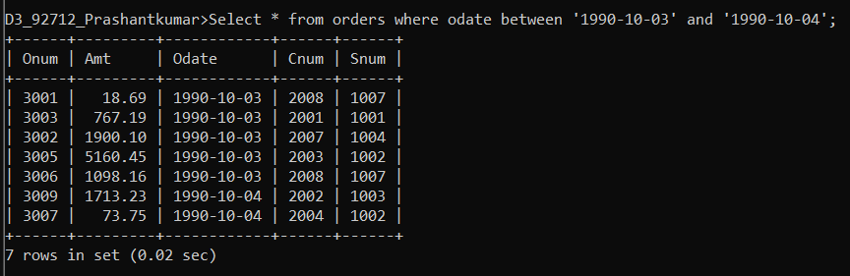

* Select * from orders where odate= ‘1990-10-03’ or odate= ‘1990-10-04’;

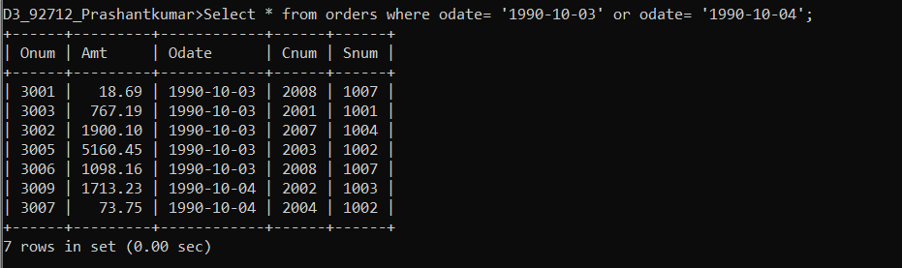

1. Write a query that selects all of the customers serviced by Peel or Motika.

* Select * from customers where snum in(select snum from salespeople where sname = ‘Peel’ or sname = ‘Motika’);

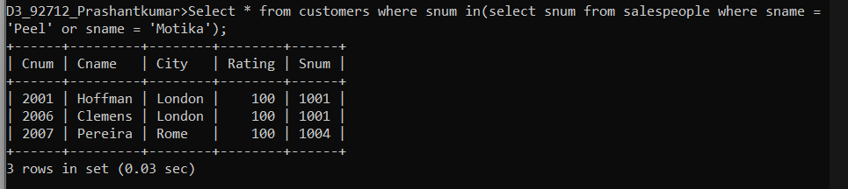

1. Write a query that will produce all the customers whose names begin with a letter from ‘A’ to ‘G’.

* Select * from customers where cname >= ‘A’ and cname <= ‘H’ ;

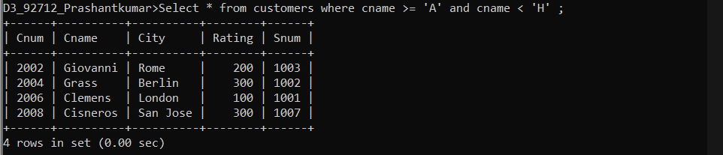

1. Write a query that selects all customers whose names begin with the letter ‘C’.

* Select * from customers where cname like ‘C%’;

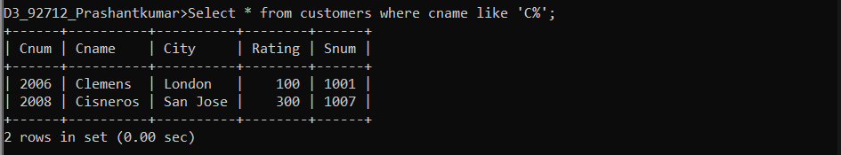

1. Write a query that selects all orders except those with zeroes or NULLs in the amt field.

* Select * from orders where amt like ‘%’ or not (amt=00);

