# Assignment7: Summarizing Data with Aggregate Function

1. Write a query that counts all orders for October 3.

* Select count(onum) from orders where odate = ‘1990-10-03’;

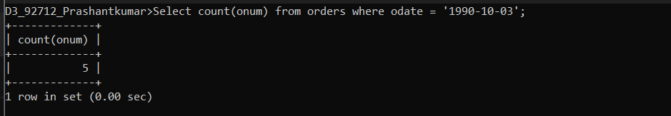

1. Write a query that counts the number of different non-NULL city values in the

Customers table.

* Select count(distinct city) from customers where city like ‘%’;

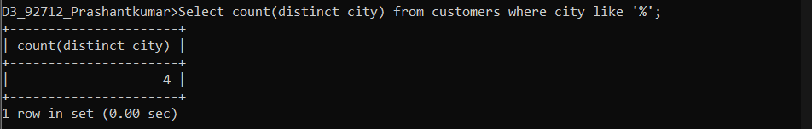

1. Write a query that selects each customer’s smallest order.

* Select cname,min(amt) from orders group by cnum;

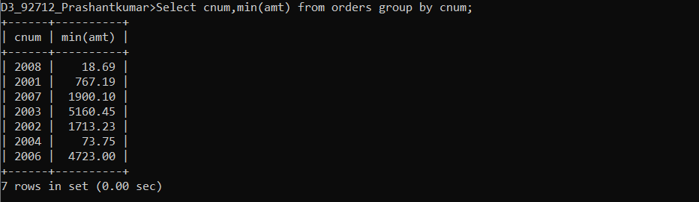

1. Write a query that selects the first customer, in alphabetical order, whose name

begins with G.

* Select min(cname) from customers where cname like ‘G%’;
* Select min(cname) from customers where cname>=’G’;

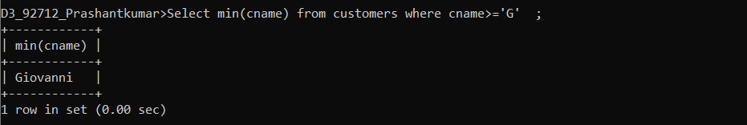

1. Write a query that selects the highest rating in each city.

* Select city, max(rating) from customers group by city;

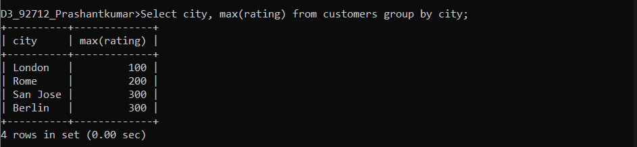

1. Write a query that counts the number of salespeople registering orders for each day. (If a salesperson has more than one order on a given day, he or she should be counted only once.).

* Select odate ,count(distinct snum) No_of_salespeople from orders group by odate;

