# Assignment –8: Formatting Query Output

1. Assume each salesperson has a 12% commission. Write a query on the orders

table that will produce the order number, the salesperson number, and the amount

of the salesperson’s commission for that order.

* Select onum “Order_Number”,snum “Salesperson_Number”, amt*0.12 “Commission” from orders;

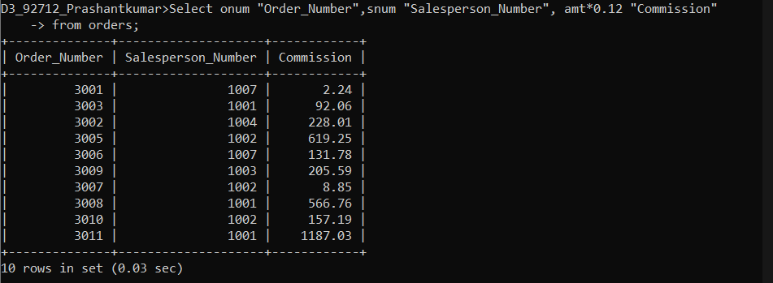

1. Write a query on the Customers table that will find the highest rating in each city.

Put the output in this form:

For the city (city), the highest rating is : (rating).

* select concat("For the city ",city," the highest rating is ",max(rating)) "Question 2 Required Output " from customers group by city;

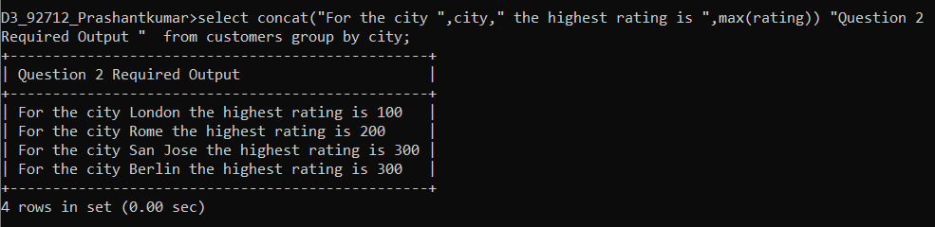

1. Write a query that lists customers in descending order of rating. Output the rating

field first, followed by the customer’s name and number.

* select rating,cname "Customer_Name",cnum "Customer_Number" from customers

order by 1 desc;

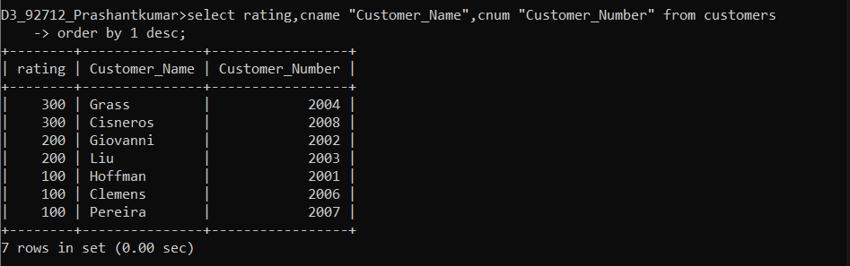

1. Write a query that totals the orders for each day and places the results in

descending order.

* select odate "OrderDate",sum(onum) "Total orders"

-> from orders

-> group by odate

-> order by 2 desc;

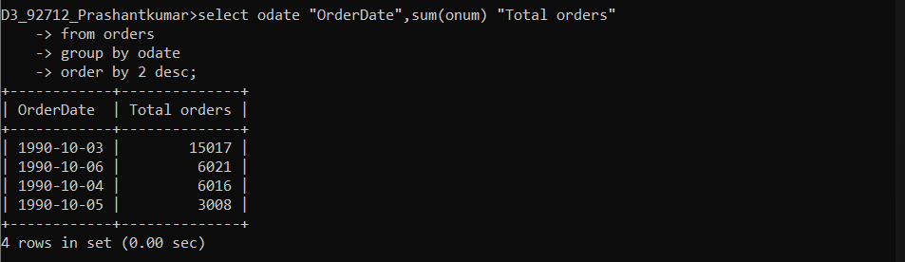

If we order it by date then :-

