

Table of Contents

1. Introduction .............................................
2. Business Objective ...................................
3. Scope of Application .................................
4. User Roles & Access .................................
5. Home Page Overview ................................
6. Registration Process ................................
7. Login Process ...........................................
7.1 Investor Login
7.2 Vendor (Lender) Login
8. Investor Dashboard ................................
9. Investment Plans .......................................
10. Investment Calculation & Verification ....
11. Terms & Conditions ................................
12. Payment Gateway Process .....................
13. Investment Confirmation .........................
14. Bond Generation .....................................
15. Notifications & Communication ..............
16. Post-Investment Access ........................
17. Business Summary & Benefits .................

1. Introduction

The Investment Application is a digital platform designed to provide investors with a secure, transparent, and structured way to invest funds across multiple investment plans. The system ensures compliance, traceability, and automated communication throughout the investment lifecycle.

This document explains the complete Investor journey, from entry into the platform to investment completion and bond issuance.



2. Business Objective

The primary objectives of the application are:
To provide a simple and secure investment onboarding process
To support multiple investment tenures and plans
To offer transparent profit calculations before payment
To automate confirmations, notifications, and bond generation
To build trust through documented and verifiable investment records

3. Scope of Application
In Scope
Investor registration and login
Investment plan selection
Profit calculation
Payment gateway integration
Investment confirmation
Digital bond generation
Email and SMS notifications
Out of Scope
Vendor (Lender) internal operational workflows (covered separately)

4. User Roles & Access
Investor
Registers on the platform
Logs in using Investor credentials
Invests money in available plans
Receives confirmation and bond
Vendor (Lender)
Separate login and access
Vendor-specific operations handled independently

5. Home Page Overview
The Home Page serves as the primary entry point for users and includes:
About the Company
Investment Offerings
Plan Highlights
Terms & Policies
Contact Information
Login / Register buttons
The Home Page guides users toward secure login and registration.

6. Registration Process (One-Time)
Registration is mandatory and required only once.
User Details Required
Full Name
Email Address
Mobile Number
Verification Process
Email verification (OTP or link)
Mobile number verification (OTP)
Once verification is successful, the user can proceed to login.

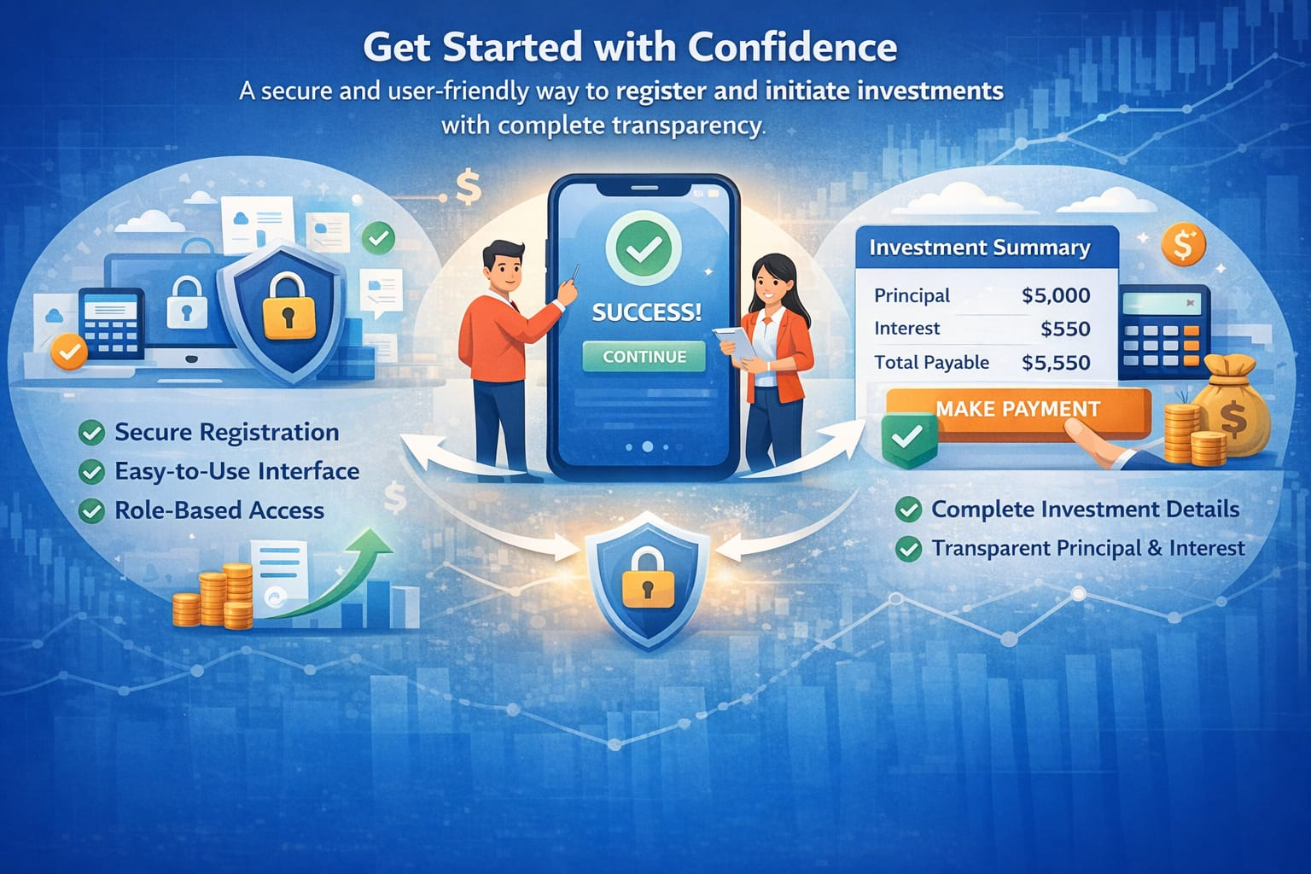

7. Login Process
At login, the user must choose the role:
7.1 Investor Login
System generates a Unique Customer ID
Format: I + 4 digits (Example: I1234)
Credentials Communication
Sent to registered email and mobile:
Welcome message
Customer ID
Username (same as registered name)
Password
The Customer ID is the primary access identifier.

8. Investor Dashboard
After login, the investor is redirected to the dashboard, where they can:
View all available investment plans
Enter investment amount
Select tenure
Review profit and returns
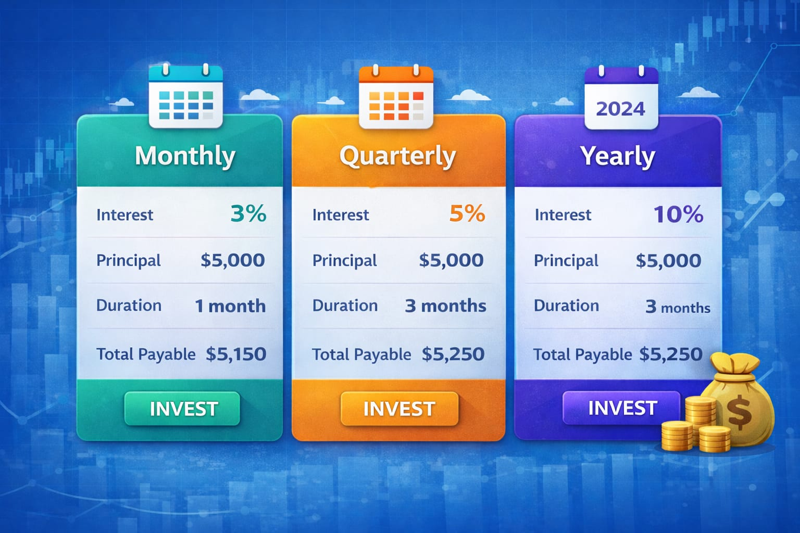
9. Investment Plans

Short-Term Plans
1 Month
3 Months
6 Months
Long-Term Plans
Above 1 Year
Plan Types
Monthly Plan (specific percentage)
Quarterly Plan (specific percentage)
Yearly Plan (specific percentage)
Each plan displays complete project and return details.

10. Investment Calculation & Verification
Based on user input, the system automatically calculates:
Principal Amount
Interest Amount
Total Amount
All details are displayed clearly before proceeding.

11. Terms & Conditions
Investor must accept Terms & Conditions
Checkbox is mandatory to continue
This ensures legal and regulatory compliance.

12. Payment Gateway Process
Supported payment options include:
Other secure gateways
Payment is redirected securely and credited to the company account.

13. Investment Confirmation
After successful payment:
Unique Investment ID is generated
Investment date, time, and tenure are recorded
Confirmation is sent via email and SMS.

14. Bond Generation
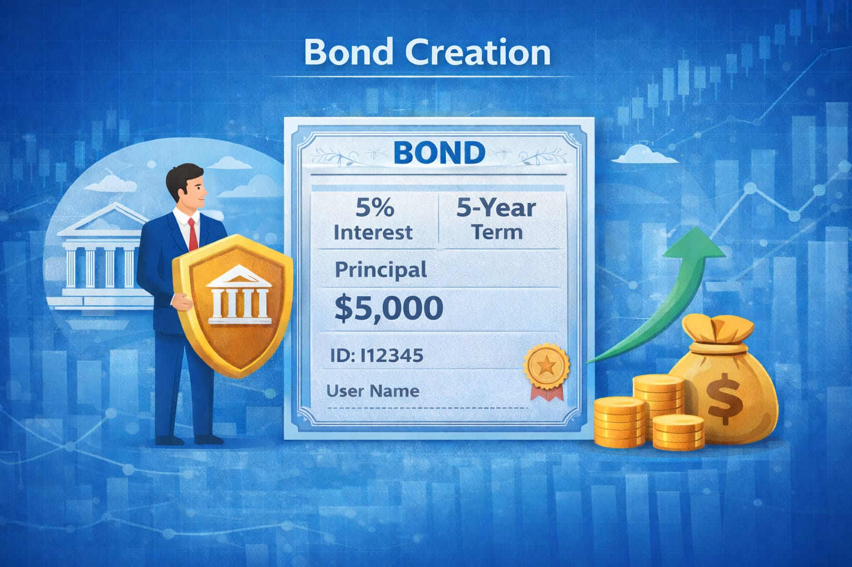
An automatic digital bond is generated containing:
Username
INFRC Number
Investment ID
Amount
GST details
Tenure
Bond is sent via email and available for download.

15. Notifications & Communication
Notifications are sent for:
Registration success
Investment success
Bond issuance

Channels:
Email
SMS

16. Post-Investment Access
Investor can view:
Principal amount
Active investments
Bond documents
Investment history

