# Frequently Asked Questions

Q: What version of Flash do I need?  Where do I need to go to get Flash?

A:  Application Browser currently supports the Pepper Flash Plugin (PPAPI) for Chrome/Chromium.   This can be downloaded from [https://get.adobe.com/flashplayer/otherversions](https://get.adobe.com/flashplayer/otherversions/).

For use of Flash beyond 2020, please see Adobe's website on enterprise end of life - <https://www.adobe.com/products/flashplayer/enterprise-end-of-life.html>

Q: How do I get the application browser install?

A:  The Windows installation can be downloaded from <https://github.com/PROSPricing/application-browser>

Q: How do I get notified of new releases?

A: There is a watch feature on the GitHub site (<https://github.com/PROSPricing/application-browser>).  From this feature, you can select the option - Releases Only to be notified when a new release is created.

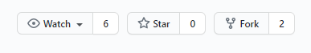

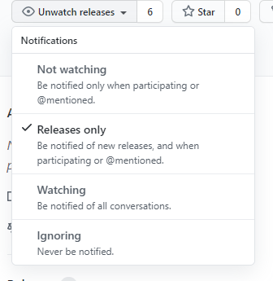

Q: How do I get support for issues that I encounter while using Deal Optimizer, Sales Optimizer, or Signal Demand with Application Browser?

A:  You can submit Deal Optimizer, Sales Optimizer, and Signal Demand issues through the regular support process.  If the issue is related to Application Browser, PROS will do its best to resolve the issue within a reasonable time frame.  If an update to Application Browser is necessary, we have the ability to contribute code to the Application Browser project on GitHub and provide a new release.

Q: How do I request new features for Application Browser?

A:  These requests can be entered through the PROS User Voice site that is accessible through PROS Connect.

Q: Is Application Browser covered by my current Sales Optimizer/Deal Optimizer maintenance contract?

A: No, Application Browser is an open source tool governed by a separate license agreement governed by the GPL-3.0 License - <https://github.com/PROSPricing/application-browser/blob/master/LICENSE>.  See our message on GitHub for our commitment related to Application Browser.

Q: How do I get maintenance and support for any issues with Flash?

A: For the remainder of 2020, maintenance and support will be provided by Adobe for any Flash related issues.  After 2020, Adobe has an agreement with Harman (<https://www.harman.com/>) to provide distributions/support/maintenance for Flash.  You can contact these companies directly for anything Flash related.

Q: If our company does not want to use the Application Browser solution to continue to use Sales Optimizer/Deal Optimizer, is there an alternative?

A: Yes, Harman also provide solutions for customers that have a need to continue to use a Flash based Enterprise application.  Please contact them directly for more information (<https://www.harman.com/>)

Q:  Can PROS make changes to the install to incorporate enhancements based on what my IT group needs?

A:  A basic install is provided with Application Browser.  Any additional enhancements needed for deployment will need to be made by each customer's individual IT groups.

Q: How do I deploy the configuration file for the Application Browser?

A: The deployment of the configuration file will need to be done by the customer's IT deployment process/tool.  The file will need to be copied to the appropriate directory and made read-only in order for the Application Browser to work properly.

Q: How does Application Browser prevent access to non-Sales Optimizer/Deal Optimizer/Signal Demand URLs?

A: Application Browser uses a configuration file that allows the customer to include a set of white listed sites.  Application Browser will only allow the user to access the white list sites.  In general, our recommendation is to allow the user to only access Sales Optimizer/Deal Optimizer/Signal Demand URLs.

Q: Does Adobe plan to support Flash past end of the year?

A: To understand Adobe's plan around Flash, please go here:  
<https://www.adobe.com/products/flashplayer/enterprise-end-of-life.html>