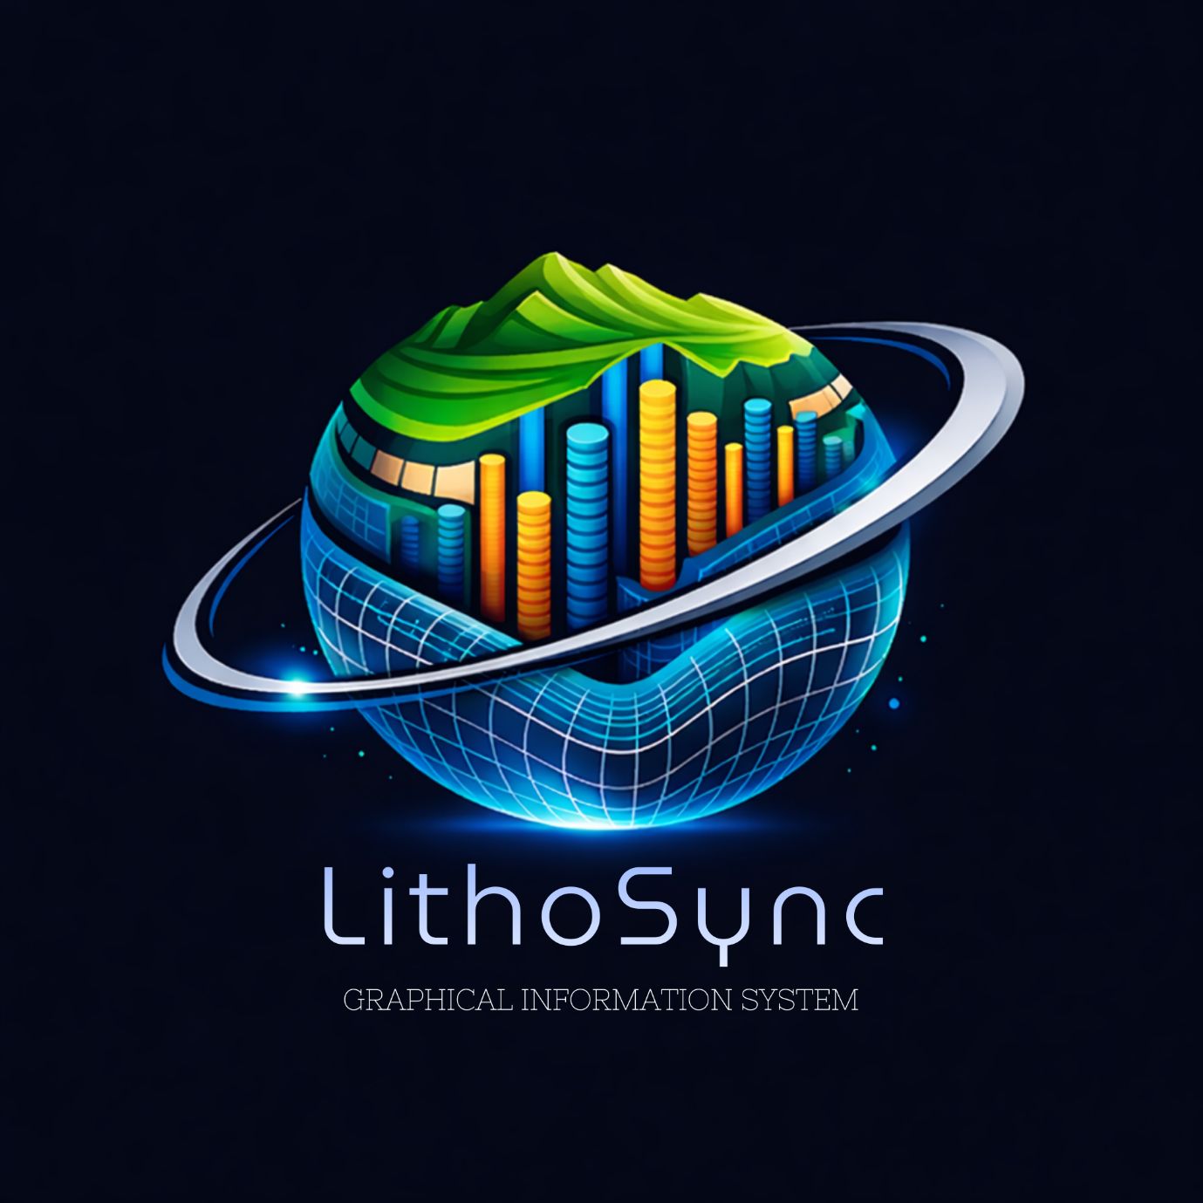

LithoSync
LithoSync Graphical Information System is a browser-based geospatial platform built for visualizing, uploading, and analyzing borehole lithology data on an interactive map. It bridges traditional geological field data with modern web GIS technology, enabling engineers and geoscientists to explore subsurface stratigraphic data in real time — including live 3D borehole visualization.

Features
🗺 Map Interface
The core map is powered by the ArcGIS JS API and renders in full-screen with a dark ocean basemap as default. All UI panels float over the map using a glassmorphism design system with backdrop blur and semi-transparent surfaces.
📂 Data Upload & Processing
Users can drag and drop .xlsx or .csv borehole data files directly onto the upload panel. The system auto-detects coordinate formats — supporting both decimal degrees (lat/lon) and UTM easting/northing — and plots borehole markers on the map in real time.
🧭 Search Places
The search bar supports place name queries and direct coordinate input (lat, lon). It uses the ArcGIS geocoding service to suggest and navigate to locations, with dropdown autocomplete for fast access.
⚡ Overlay Layers
Eight scientific raster and vector layers sourced from NOAA and USGS can be toggled independently:
- Bathymetry Hillshade, ETOPO1 Bedrock, Magnetic Anomaly, GEBCO Contours (NOAA)
- Plate Boundaries, Fault Lines (USGS)
- Multibeam Sonar, Coastlines (NOAA)
🗺 Base Maps
Eight ArcGIS basemaps are available via a visual thumbnail grid: Oceans, Satellite, Topo, Dark Gray, Light Gray, Streets, National Geographic, and Terrain.
📋 Borehole Info Panel
Clicking any borehole marker slides in a 40vw detail panel from the right. It displays:
- Core metrics (max depth, water depth, layer count) as visual cards
- Location fields (borehole ID, lat/lon, UTM coordinates)
- Full stratigraphic table with depth ranges and descriptions
📊 Log Pipeline & 3D Visualization
Uploading a logData.xlsx triggers the backend rule engine (ruleScript.py) which classifies each stratigraphic layer by soil type (Clay, Sand, Calcareous, etc.) and assigns colours. A processed output workbook is generated for download. Each processed borehole then shows a live 3D stratigraphic column rendered via Three.js inside an iframe panel.
🔗 Cross-Panel Hover Interaction
Hovering over a layer in the 3D view sends a postMessage to the parent window, which highlights the corresponding row in the stratigraphy table — and vice versa. This cross-panel synchronisation allows engineers to correlate visual depth with raw log data instantly.

Dashboard Overview
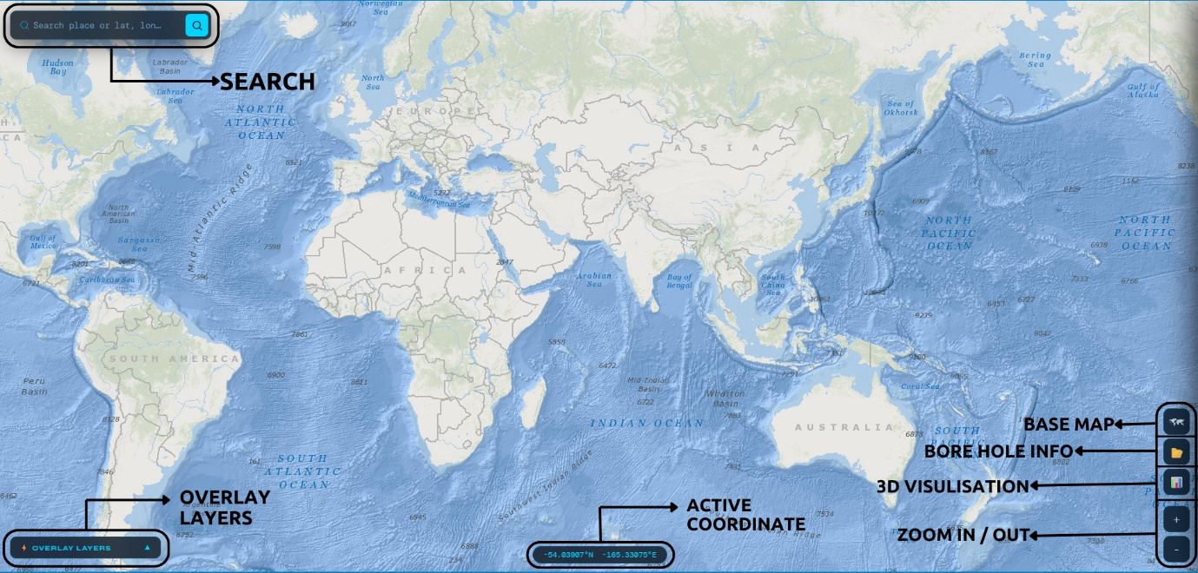
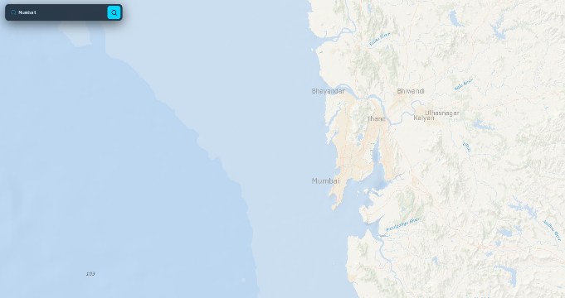
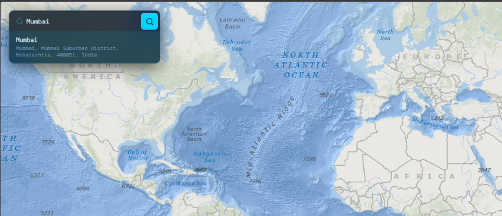
Search Places

Overlay Layers
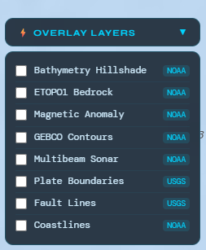
Bathymetry Hillshade | 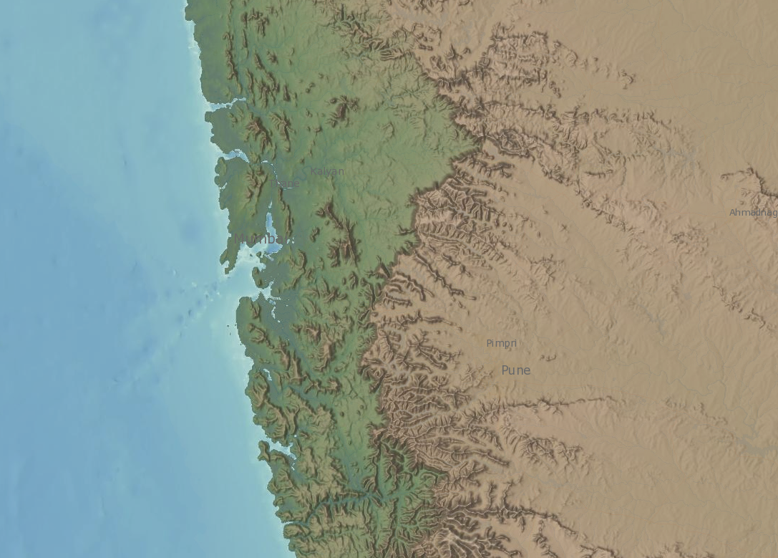
ETOPO1 Bedrock | 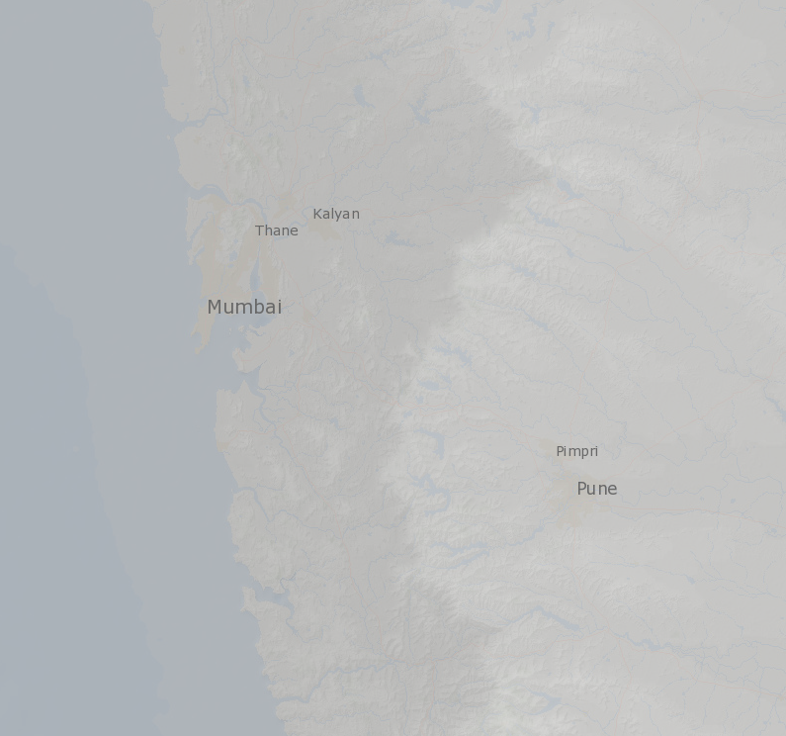
Magnetic Anomaly | 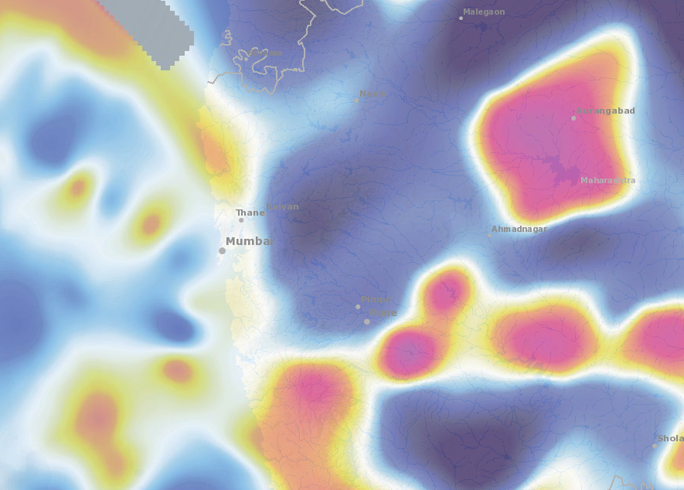
Plate Boundaries | 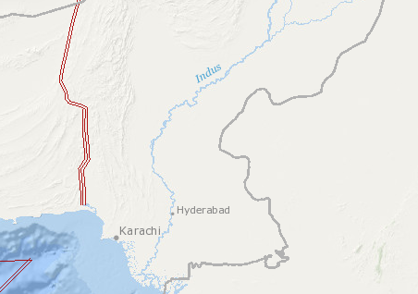
Coastlines | 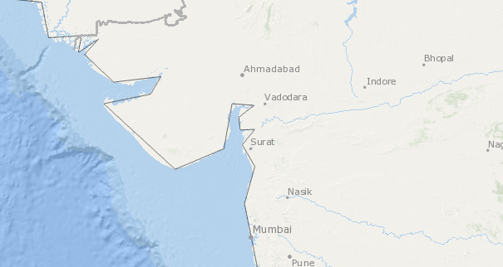

Base Map
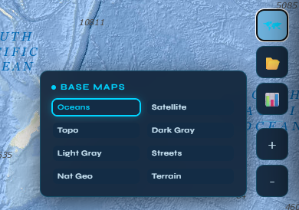
Oceans | 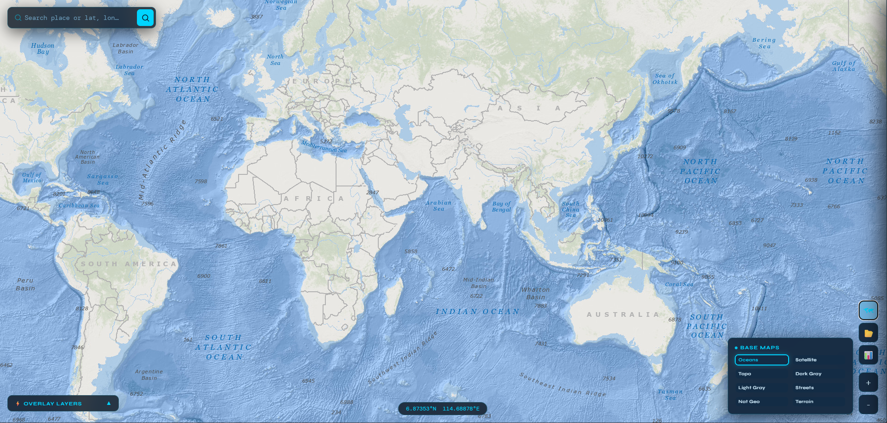
Topo | 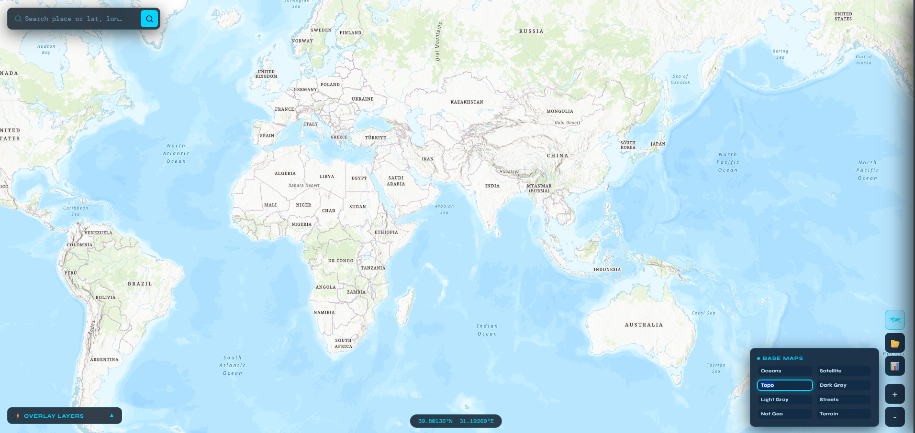
Light Grey | 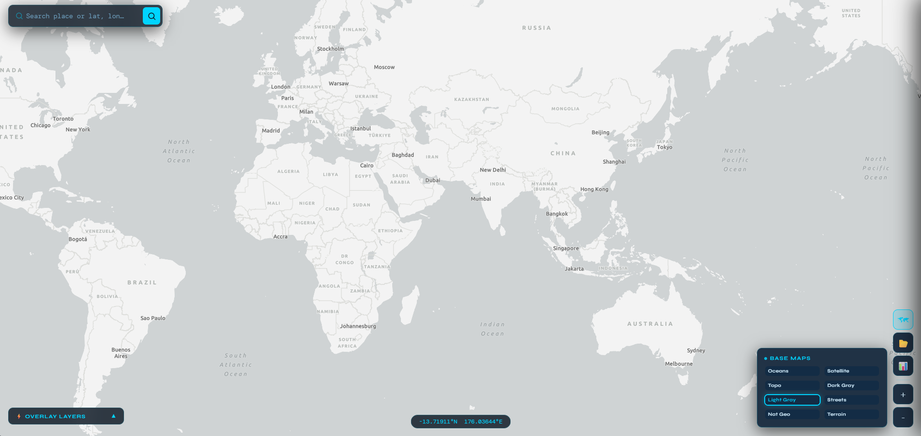
Satellite | 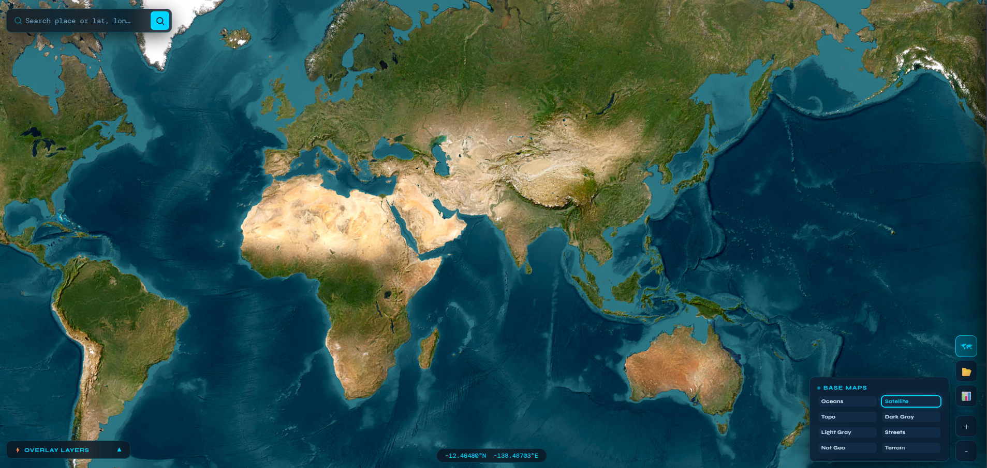
Dark Gray | 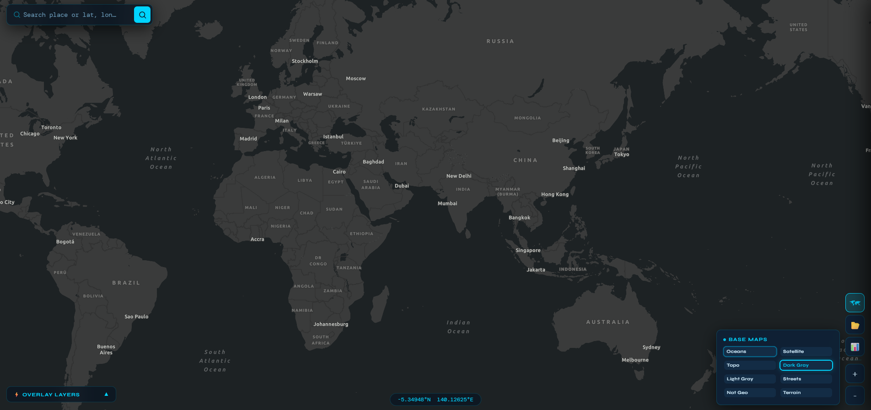
Streets | 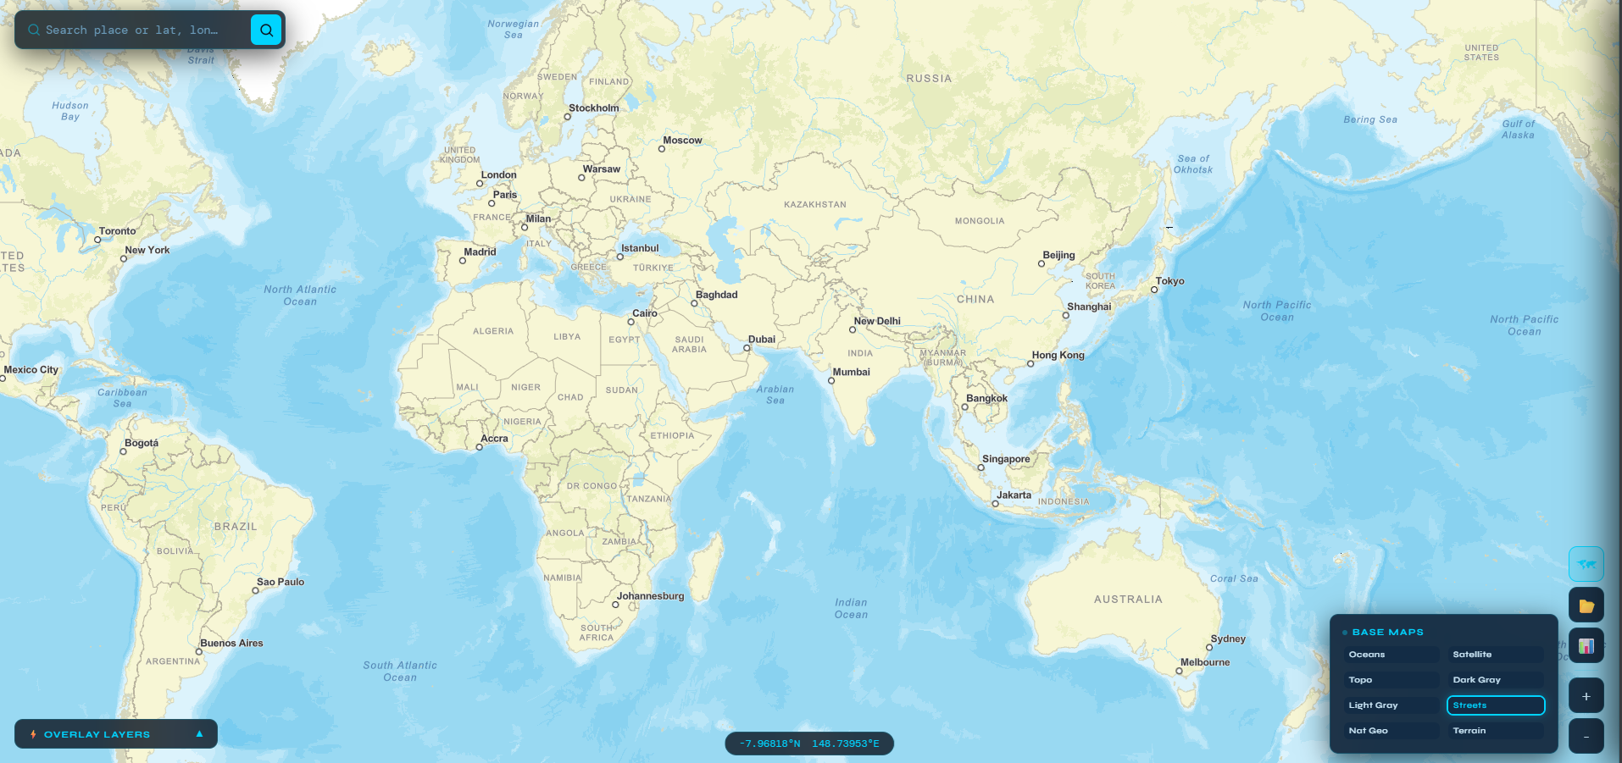
Terrain | 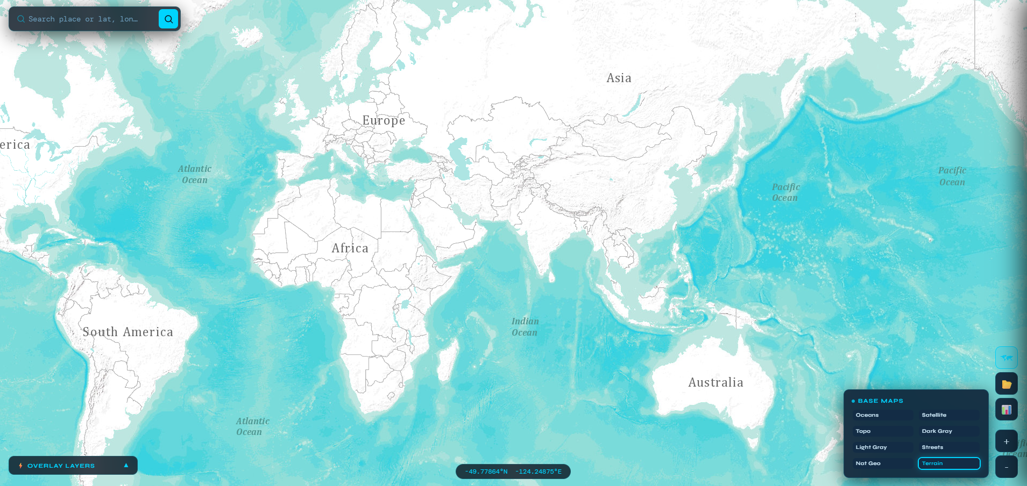

Borehole Info
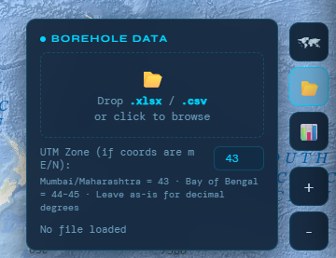

Zoom In / Out
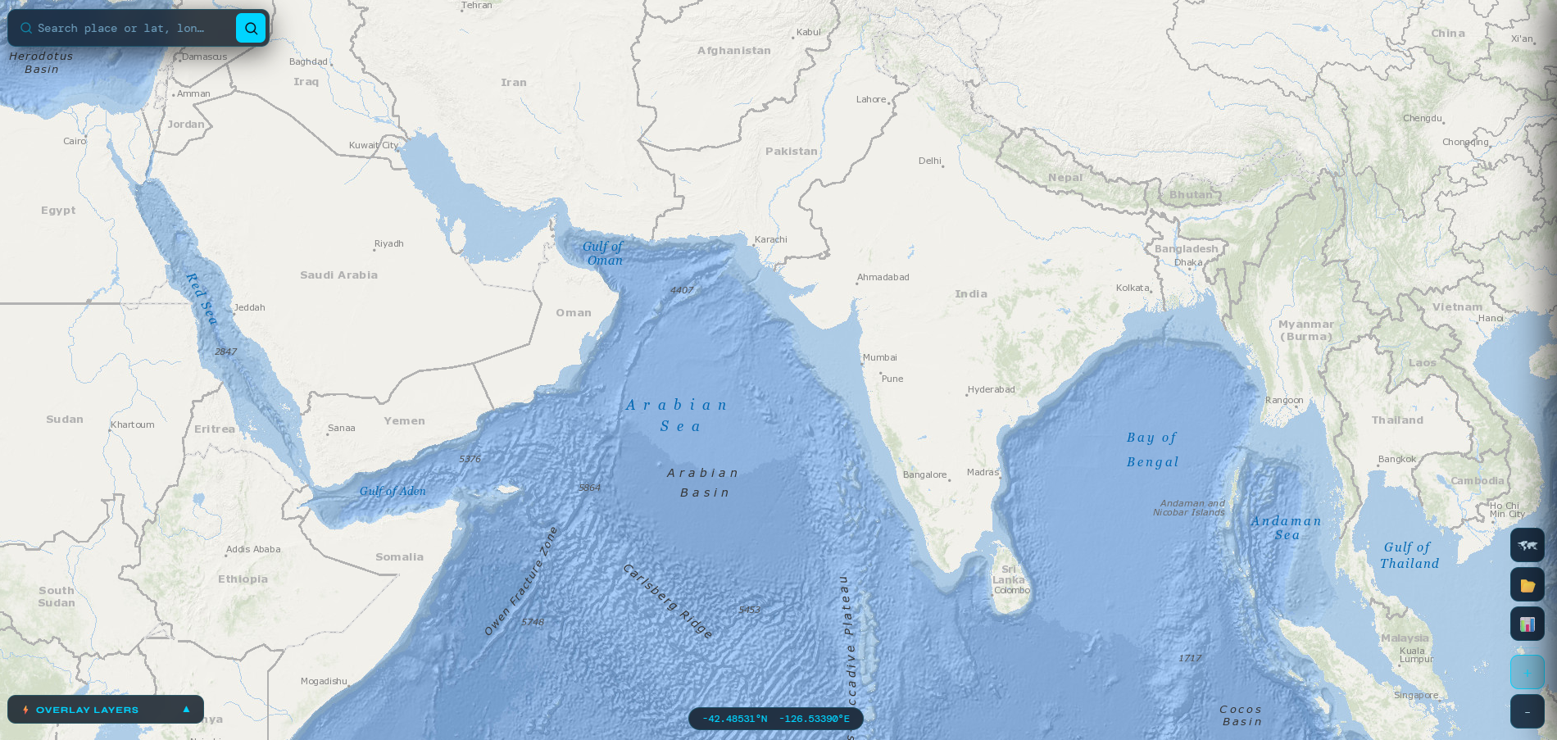
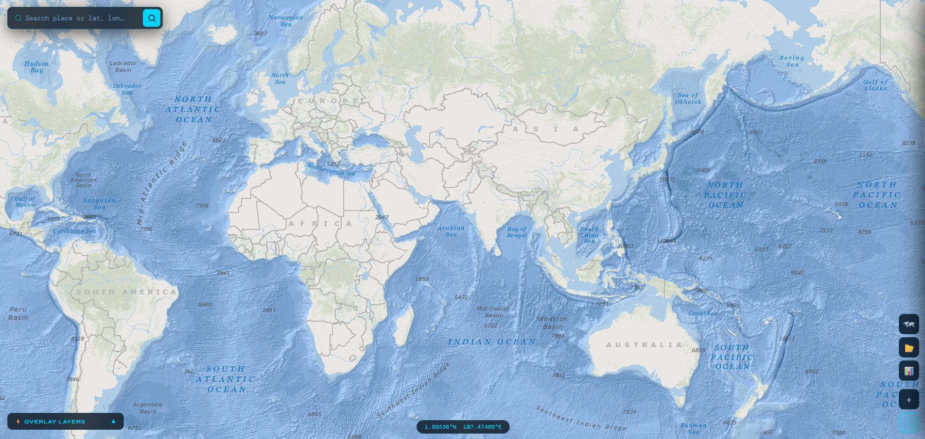

3d Borehole Visualization
