AI
Parameters considered
- Sensitivity of data
- Transmission medium
- HSMs

Just as an example
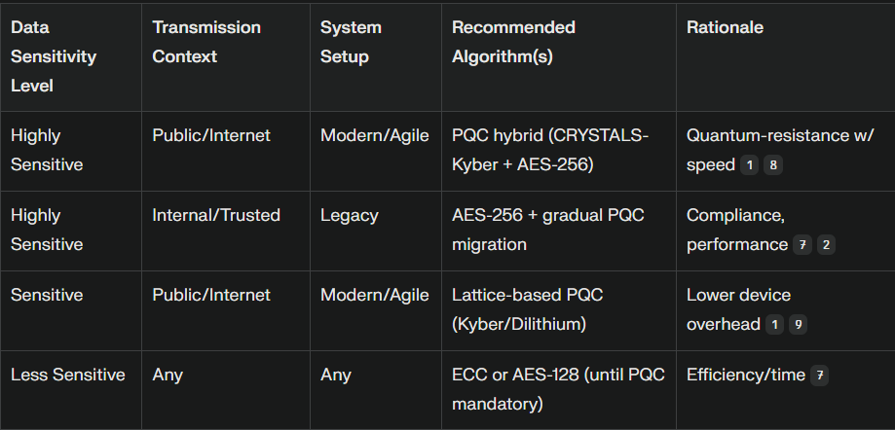

How things will work
- Take benchmark scores form shruti avani research, then this will be used by my aiml model to filter data and choose the best model.
- Input: Type of data to encrypt, data flow mapping, and system infrastructure.
- Analysis: Sensitivity scoring → channel risk rating → compatibility checks.
- Output: Cryptographic recommendation (primary and fallback), with steps for integration.
Key PQC and Crypto-Agile Recommendations
- PQC Choices: Lattice-based algorithms like CRYSTALS-Kyber (encryption) and Dilithium (signatures) are early NIST picks for post-quantum resistance.
- Hybrid Crypto: Use PQC combined with classical crypto (RSA, ECC) during the transition phase to ensure both classical and quantum security and regulatory compliance.
- Crypto-Agility: Design modular encryption stacks so algorithms can be replaced without rewriting entire app logic—this is essential for banking in a quantum future.
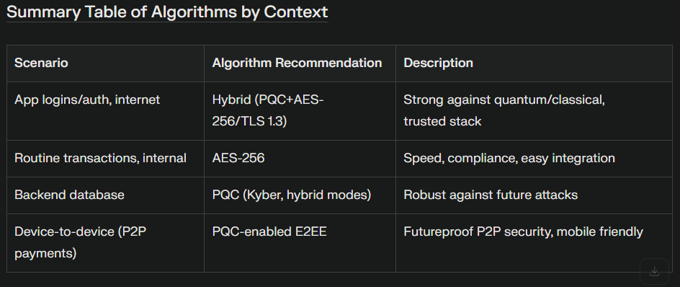

Training Your AI Model for Crypto-Agile PQC Banking Solutions
1. Define Model Objectives and Output
- Input: Data sensitivity level, transmission route, system setup.
- Output: Recommended cryptographic algorithms, rationale, possible fallback options.
2. Curate and Annotate a High-Quality Training Dataset
Data Sources:
- Banking system architectures.
- Data classification labels (highly sensitive, sensitive, low sensitivity).
- Transmission contexts (internal, external, third-party).
- System setups (legacy, modern, with/without crypto-agility).
Annotations:
- Map each scenario to appropriate cryptographic recommendations based on guidelines and current standards (classical, hybrid, PQC).

Recommended Approaches:
- Structured Logic or Rule-Based Model: For initial prototyping, use decision trees or rule-based classifiers reflecting expert cryptographic logic.
- Supervised Machine Learning: For scalability, consider gradient boosting, random forests, or neural networks fed by annotated historical scenarios.

