CONCLUSION:

In this paper, various machine learning algorithms has been applied on the dataset. The classification has been done using many algorithms in which random forest gives highest accuracy of 89.35%. After hyperparameter tuning 88.42%. This model enhance the accuracy of diabetes prediction with this dataset compared to pre existing dataset. Further this work can be improved to find how likely non-diabetic people can have diabetes in the following years.

****DECISION TREE****

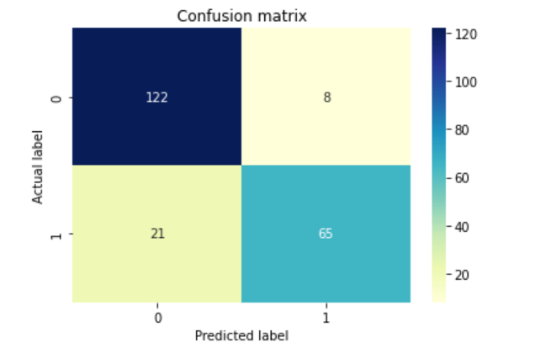

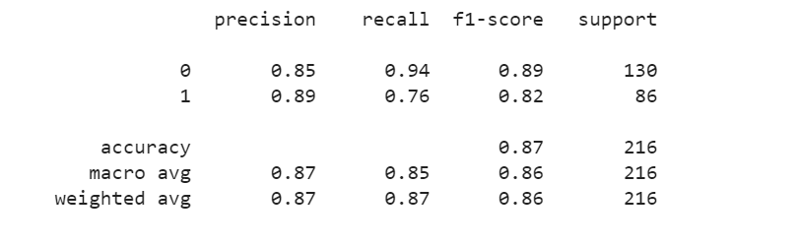

****KNN****

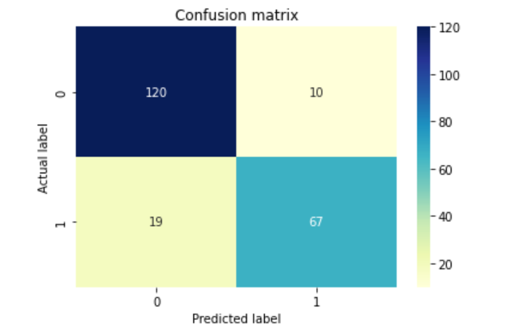

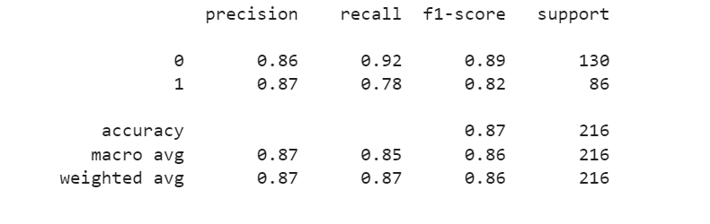

****LOGISTIC REGRESSION****

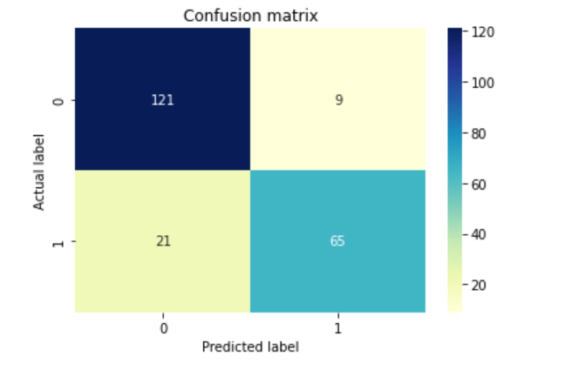

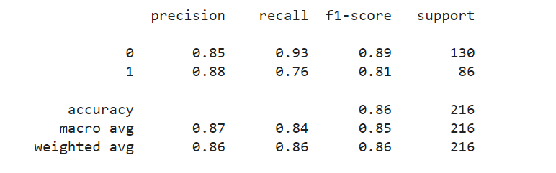

****NAIVE BAYES****

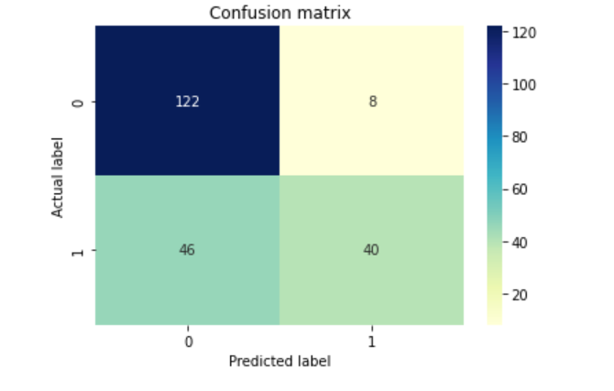

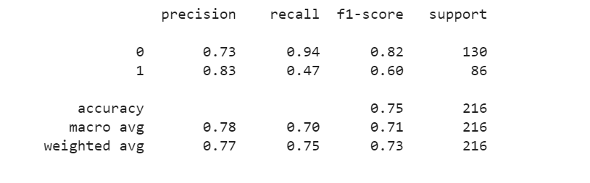

****RANDOM FOREST****

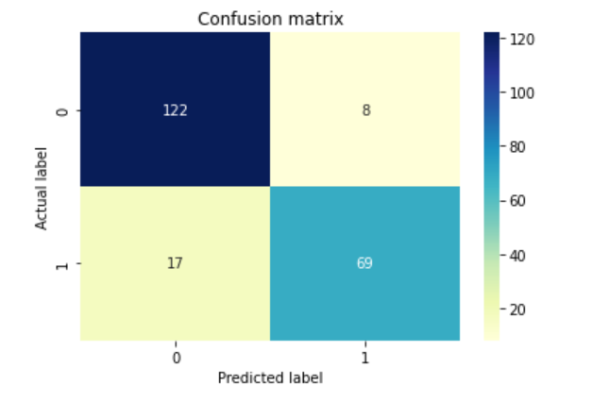



****SVM****

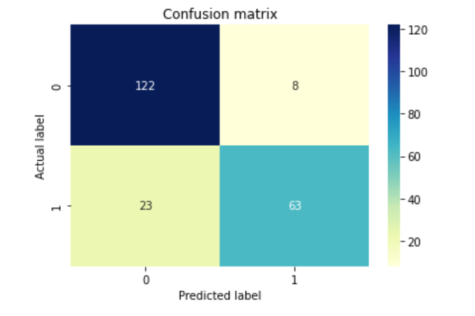

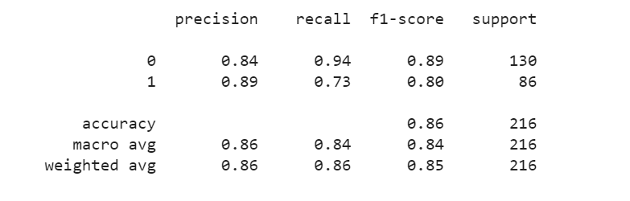

REFERENCE:

* <https://ieeexplore.ieee.org/abstract/document/8965556>
* <https://d1wqtxts1xzle7.cloudfront.net/54976577/IRJET-V4I1077-with-cover-page-v2.pdf?Expires=1632653395&Signature=gXunJwptESA9IF5fjGIycv4lG71EIRjLsb~-ksoq-9NvONQAHWXtTI9y9zIhoFgfJA-sB9kY5ir0rKz9~yaMKywI~sxvawi97o2BrLX3FoUHcltiY5mEhCdk5EuFseRaSHMeRRAtLzxUckI9~ti6zxzmL60NSMlSTrDIR-w5Ks~3XGFEeogRPunFXS0sUKUUVsz2V0oAbQLqU9XFYIzwkwjIjg6-fEtxy0-pjOs8VzVDlt467syENSpU3hRKbWWqsJug17aC~kRtU9r0NHTZao9CJA8jkNELU3n6>
* <https://www.sciencedirect.com/science/article/pii/S1877050920300557>
* <https://ieeexplore.ieee.org/abstract/document/8614871>