**ELECTION ALGORITHMS IMPLEMTATION IN DISTRIBUTED SYSTEMS**

**Name : A S Pruthiev**

**Roll No : 2019506067**

**IMPLEMENTATION PLATFORM : Java**

**AIM:**

To implement the bully and ring election algorithms

**BULLY ALGORITHM:**

**Algorithm:**

* Read the number of process, process initiated election and process that crashed from the user.
* Initiate a boolean array that maintains all the process that were choosen to give out the election chance.
* Store the process that is not creahed and has priority higher than the choosen process in an arraylist
* Print the process that is choosen
* Recursively call for the stored process one by one untill all the stored process are visited
* Choose the process which has higher priority as the new coordinator
* Inform all the process about the new coordinator

**Code:**

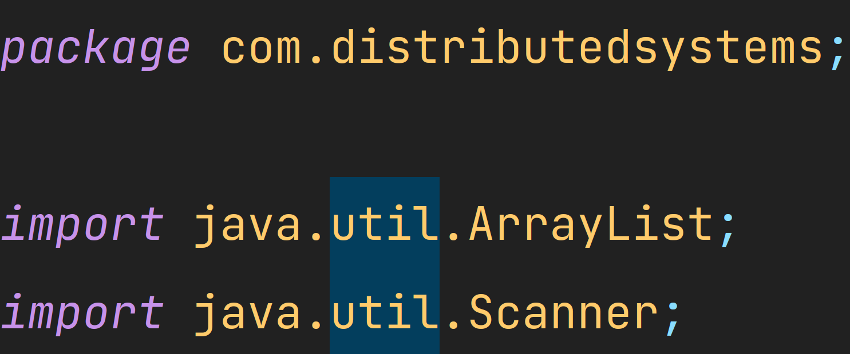

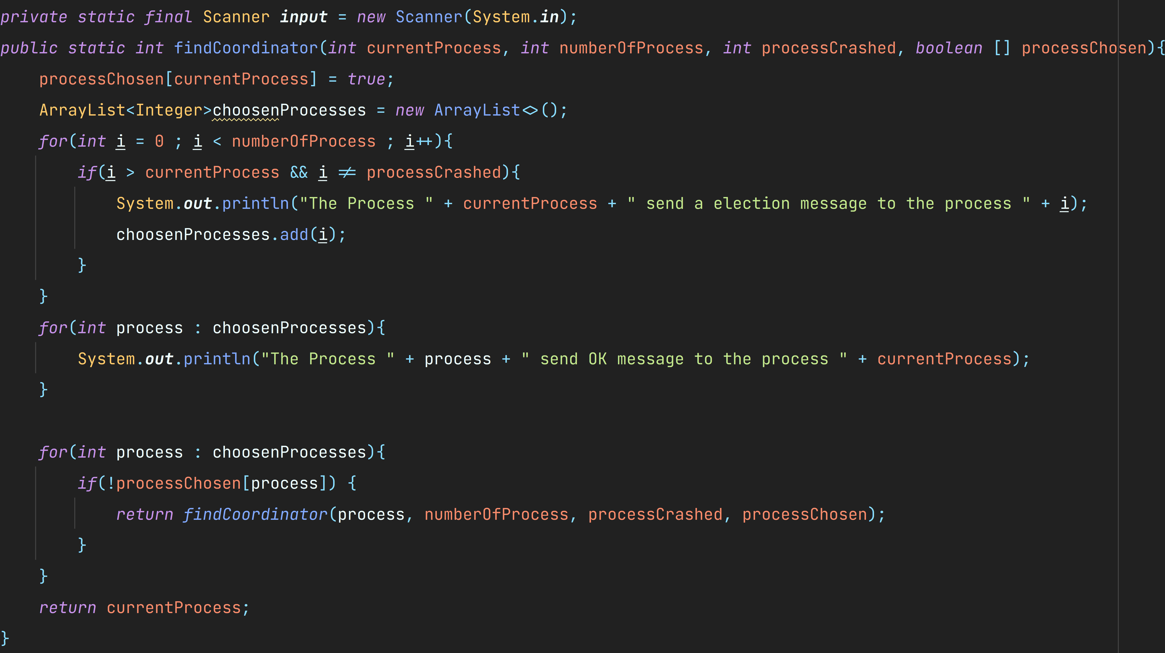

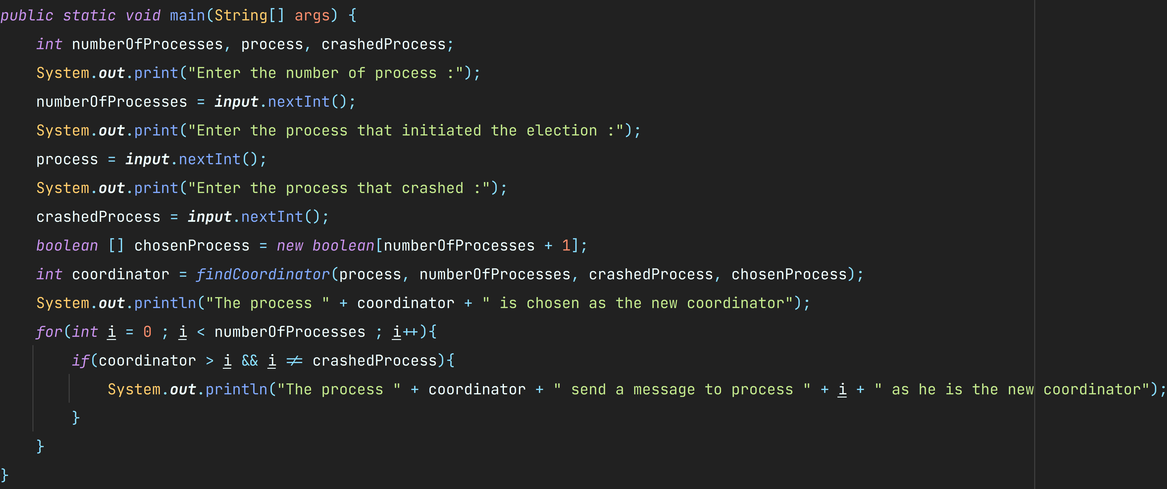

**OUTPUT :**

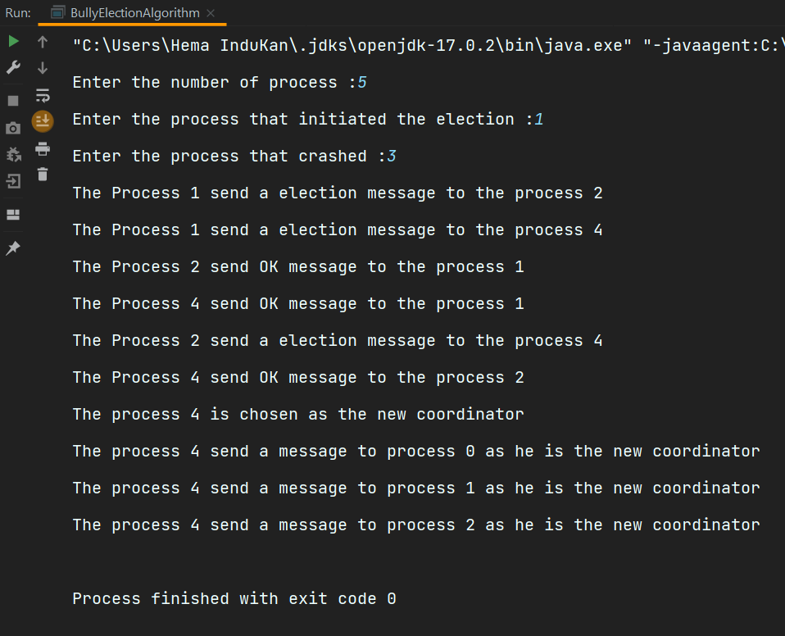

**2)**

**ALGORITHM:**

* Read the number of process, process initiated election and process that crashed from the user.
* Read the process cycle that is the process order
* Choose the process that hasn’t crashed and has highest priority by traversing the cycle.

**CODE:**

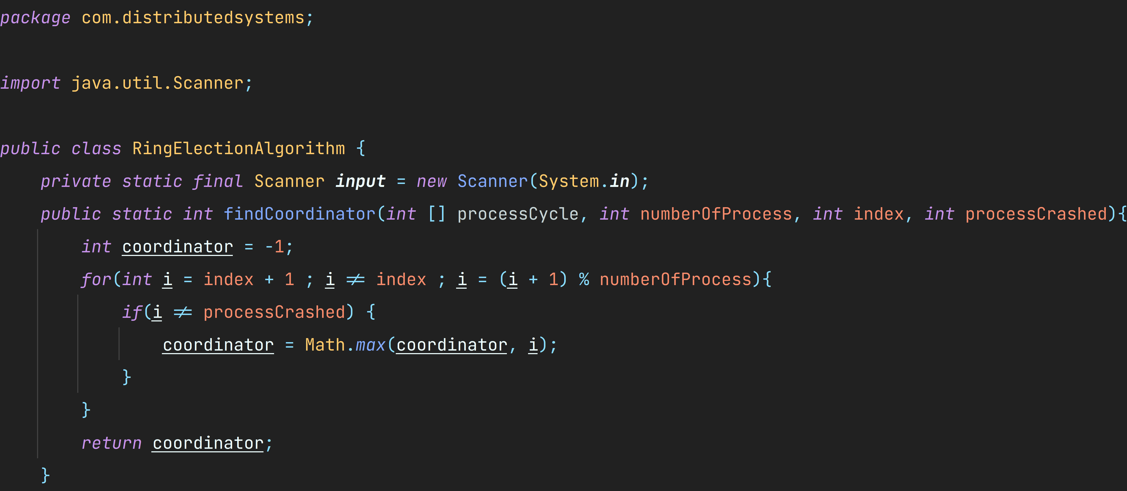

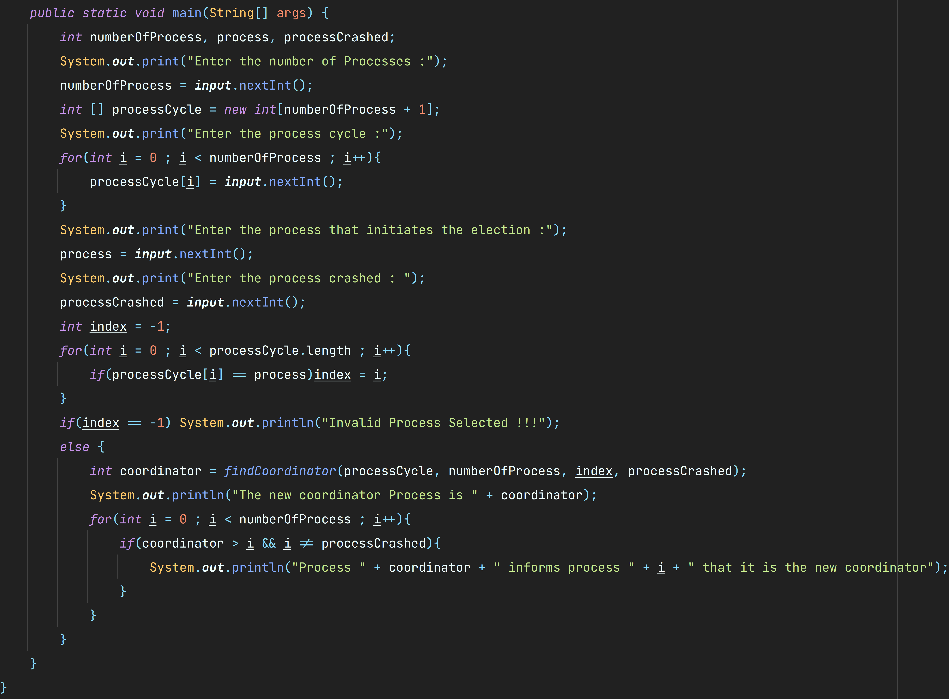

**OUTPUT:**

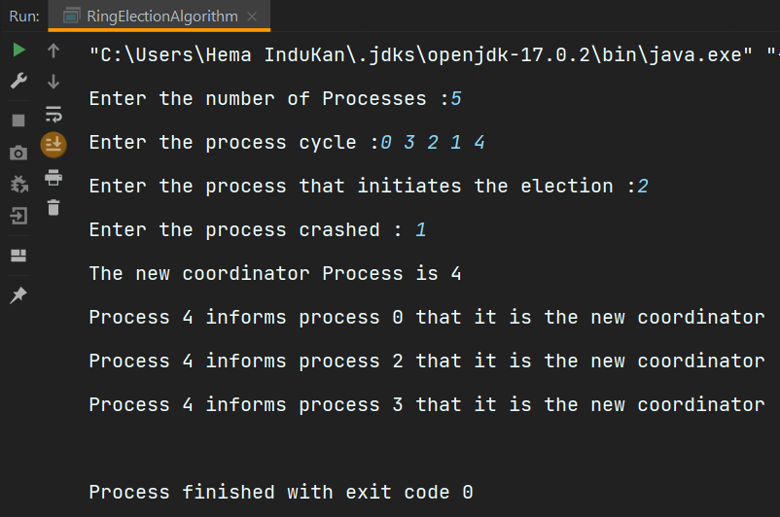

**RESULT:**

Thus both the election algorithms Bully and Ring are implemented successfully.