**IT5512- WEB TECHNOLOGY LAB-SESSION-8**

**DATE: 25/10/2021**

**NAME: A.S. PRUTHIEV**

**REG NO.2019506067**

**SIMPLE GUI USING APPLET**

**1)AIM:**

To write a Java Program to create a calculator using applets

**PROGRAM CODE:**

package com.webtech.appletapp;

import java.awt.*;

import java.applet.*;

import java.awt.event.*;

public class lab4a extends Applet implements ActionListener{

TextField inp;

public void init(){

setBackground(Color.white); setLayout(null);

int i;

inp = new TextField();

inp.setBounds(150,100,270,50);

this.add(inp);

Button button[] = new Button[10];

for(i=0;i<10;i++){

button[i] = new Button(String.valueOf(9-i));

button[i].setBounds(150+((i%3)*50),150+((i/3)*50),50,50);

this.add(button[i]);

button[i].addActionListener(this);

}

Button dec=new Button(".");

dec.setBounds(200,300,50,50);

this.add(dec);

dec.addActionListener(this);

Button clr=new Button("C");

clr.setBounds(250,300,50,50);

this.add(clr);

clr.addActionListener(this);

Button operator[] = new Button[5];

operator[0]=new Button("/"); operator[1]=new Button("*");

operator[2]=new Button("-"); operator[3]=new Button("+");

operator[4]=new Button("=");

for(i=0;i<4;i++){

operator[i].setBounds(300,150+(i*50),50,50);

this.add(operator[i]);

operator[i].addActionListener(this);

}

operator[4].setBounds(350,300,70,50);

this.add(operator[4]);

operator[4].addActionListener(this);

}

String num1="";

String op="";

String num2="";

//Function to calculate the expression

public void actionPerformed(ActionEvent e){

String button = e.getActionCommand();

char ch = button.charAt(0);

if(ch>='0' && ch<='9'|| ch=='.') {

if (!op.equals("")) num2 = num2 + button;

else num1 = num1 + button;

inp.setText(num1+op+num2);

}else if(ch=='C'){

num1 = op = num2 = "";

inp.setText("");

}else if (ch =='=') {

if(!num1.equals("") && !num2.equals("")){

double temp;

double n1=Double.parseDouble(num1);

double n2=Double.parseDouble(num2);

if(n2==0 && op.equals("/")){

inp.setText(num1+op+num2+" = Zero Division Error");

num1 = op = num2 = "";

}else{

if (op.equals("+")) temp = n1 + n2;

else if (op.equals("-")) temp = n1 - n2;

else if (op.equals("/")) temp = n1/n2;

else temp = n1*n2;

inp.setText(num1+op+num2+" = "+temp);

num1 = Double.toString(temp);

op = num2 = "";

}

}else{

num1 = op = num2 = "";

inp.setText("");

}

}else {

if (op.equals("") || num2.equals("")) op = button;

else {

double temp;

double n1=Double.parseDouble(num1);

double n2=Double.parseDouble(num2);

if(n2==0 && op.equals("/")){

inp.setText(num1+op+num2+" = Zero Division Error");

num1 = op = num2 = "";

}else{

if (op.equals("+")) temp = n1 + n2;

else if (op.equals("-")) temp = n1 - n2;

else if (op.equals("/")) temp = n1/n2;

else temp = n1*n2;

num1 = Double.toString(temp);

op = button;

num2 = "";

}

}

inp.setText(num1+op+num2);

}

}

}

**OUTPUT:**

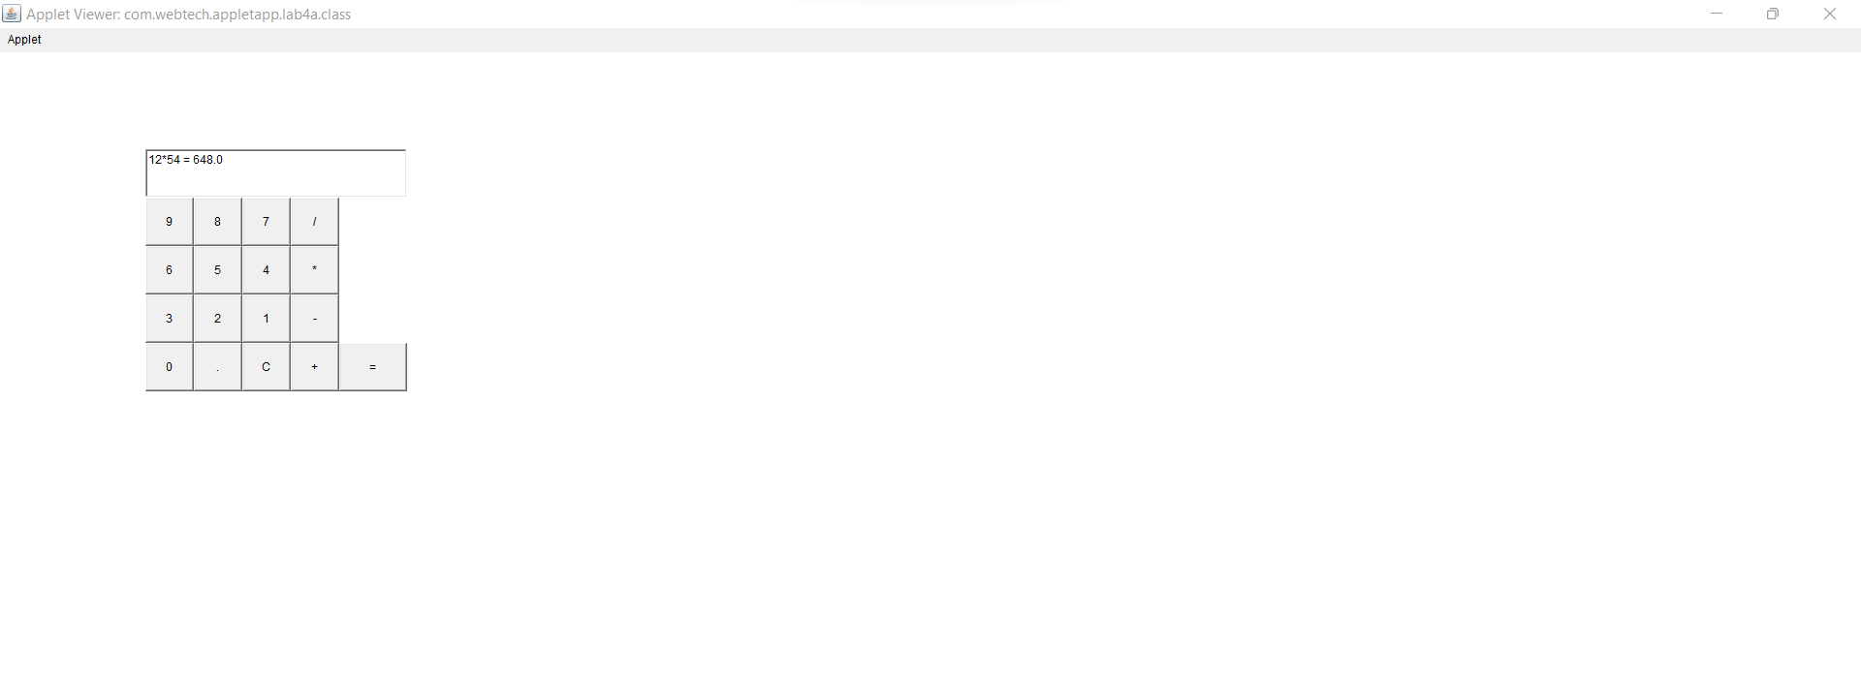

**RESULT :**

Thus the program has been executed successfully.