**IT5512- WEB TECHNOLOGY LAB-SESSION-10**

**DATE: 01/11/2021**

**NAME: A.S. PRUTHIEV**

**REG NO.2019506067**

**IMPLEMENT MULTITHREADED PROGRAMS USING PRIORITY AND SYNCHRONIZE**

**1)AIM:**

To write a Java multithreaded Program to print the pattern by prioritizing the threads

**PROGRAM CODE:**

package Java.Lab.lab9;

import java.util.Scanner;

public class ThreadPriorities{

private static final Scanner input = new Scanner(System.in);

public static void printTopPattern(int n){

for(int i = n-1,k = 0 ; i >= 0 ; i--,k++){

for(int j = 0 ; j < i ; j++){

System.out.print(" ");

}

for(int l = 0 ; l <= k ; l++){

System.out.print("* ");

}

System.out.println();

}

}

public static void printBottomPattern(int n){

for(int i = n-1,k = 0 ; i >=0 ; i --,k ++){

for(int j = n-1 ; j > i ; j--){

System.out.print(" ");

}

for(int l = 0 ; l <= i ; l++){

System.out.print("* ");

}

System.out.println();

}

}

public static void main(String[] args) {

int n;

System.out.print("Enter a number :");

n = input.nextInt();

Thread t1 = new Thread(() -> {

printTopPattern(n);

});

Thread t2 = new Thread(() -> {

printBottomPattern(n);

});

t1.setPriority(10);

t2.setPriority(9);

t1.start();

t2.start();

}

}

**OUTPUT :**

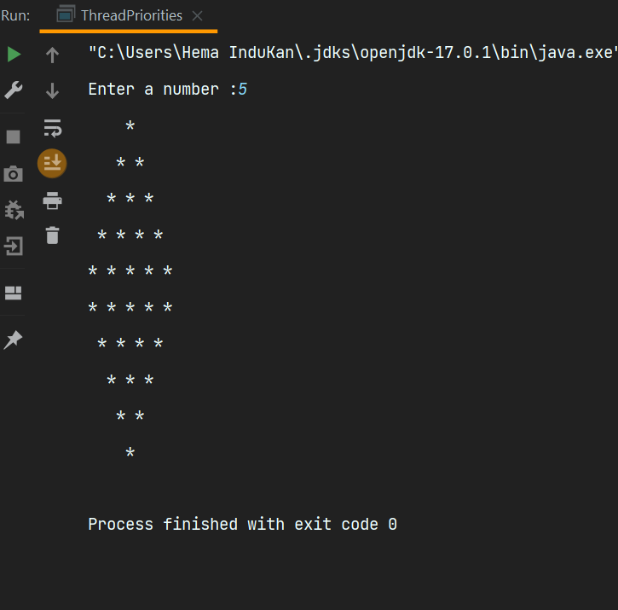

**RESULT :** Thus the program has been executed successfully.

**2)AIM:**

To write a Java multithreaded Program for producer and consumer problem using synchronized keyword

**PROGRAM CODE:**

package Java.Lab.lab9;

import java.util.LinkedList;

import java.util.Scanner;

class SetGetItem1 {

private int capacity;

private LinkedList<Integer> values = new LinkedList<>();

SetGetItem1(int capacity) {

this.capacity = capacity;

}

public int getCapacity() {

return capacity;

}

public synchronized void setItem(int item) {

while (values.size() == capacity) {

try {

wait();

} catch (Exception e) {

System.out.println(e.getMessage());

}

}

values.add(item);

notifyAll();

}

public synchronized int getItem() {

while (values.isEmpty()) {

try {

wait();

} catch (Exception e) {

System.out.println(e.getMessage());

}

}

notify();

return values.pollFirst();

}

}

class Producer1 implements Runnable {

private SetGetItem1 setGetItem;

private int item;

public Producer1(int item, SetGetItem1 setGetItem) {

this.item = item;

this.setGetItem = setGetItem;

}

@Override

public void run() {

while (true) {

System.out.println("Set :" + item);

setGetItem.setItem(item++);

try {

Thread.sleep(1000);

} catch (Exception e) {

System.out.println(e.getMessage());

}

}

}

}

class Consumer1 implements Runnable {

private SetGetItem1 setGetItem;

public Consumer1(SetGetItem1 setGetItem) {

this.setGetItem = setGetItem;

}

@Override

public void run() {

while (true) {

int Get = setGetItem.getItem();

System.out.println("Get :" + Get);

try {

Thread.sleep(1000);

} catch (Exception e) {

System.out.println(e.getMessage());

}

}

}

}

public class ProducerConsumer {

private static final Scanner input = new Scanner(System.in);

public static void main(String[] args) {

System.out.print("Enter the starting items and capacity of the buffer: ");

int number = input.nextInt();

int cap = input.nextInt();

SetGetItem1 setGetItem = new SetGetItem1(cap);

new Thread(new Producer1(number, setGetItem)).start();

new Thread(new Consumer1(setGetItem)).start();

}

}

**OUTPUT :**

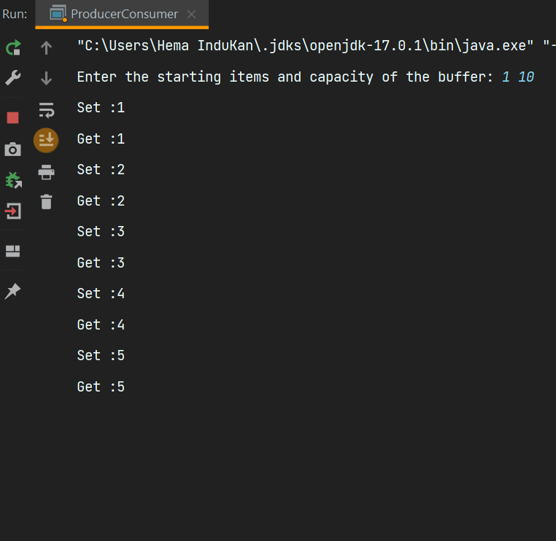

**RESULT :** Thus the program has been executed successfully.