**IT5512- WEB TECHNOLOGY LAB-SESSION-9**

**DATE: 01/11/2021**

**NAME: A.S. PRUTHIEV**

**REG NO.2019506067**

**IMPLEMENT MULTITHREADED PROGRAMS**

**1)AIM:**

To write a Java multithreaded Program to perform matrix addition

**PROGRAM CODE:**

package Java.Lab.lab9;

import java.util.Scanner;

public class MatrixAddition {

private static final Scanner input = new Scanner(System.in);

public static void readInput(int [][]mat,int row,int col){

System.out.println("Enter the elements in the matrix :");

for(int i = 0 ; i < row ; i ++){

for(int j = 0 ; j < col ; j++){

mat[i][j] = input.nextInt();

}

}

}

public static void add(int [][]res,int [][]mat1,int [][]mat2,int row,int col){

for(int i = 0 ; i < col ; i++){

res[row][i] = mat1[row][i] + mat2[row][i];

}

System.out.println("The " + row + " row's sum is calculated using " + Thread.currentThread().getName());

}

public static void printArray(int [][]res,int row,int col){

System.out.println("The matrix after addition :");

for(int i = 0 ; i < row ; i++){

for(int j = 0 ; j < col; j ++){

System.out.print(res[i][j] + " ");

}

System.out.println();

}

}

public static void main(String[] args) {

int row,col;

System.out.print("Enter the number of rows :");

row = input.nextInt();

System.out.print("Enter the number of cols :");

col = input.nextInt();

int [][]mat1 = new int[row][col];

int [][]mat2 = new int[row][col];

int [][]res = new int[row][col];

Thread [] threads = new Thread[row];

readInput(mat1,row,col);

readInput(mat2,row,col);

for(int i = 0 ; i < row ; i++){

int finalI = i;

threads[i] = new Thread(() -> {

add(res,mat1,mat2,finalI,col);

});

threads[i].setName("Thread " + i);

threads[i].start();

}

for(int i = 0 ; i < row ; i++){

try{

threads[i].join();

}

catch(InterruptedException exception){

exception.printStackTrace();

}

}

printArray(res,row,col);

}

}

**OUTPUT :**

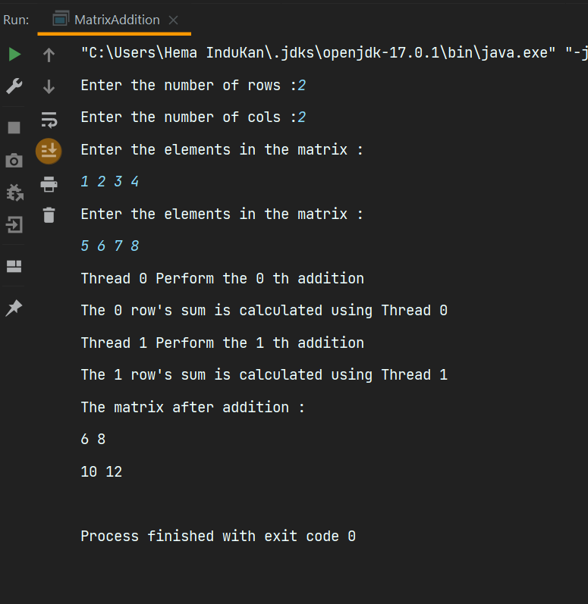

**RESULT :**

Thus the output of the program has been successfully executed

**2)AIM:**

To write a Java multithreaded Program to perform matrix subtraction

**PROGRAM CODE:**

package Java.Lab.lab9;

import java.util.Scanner;

public class MatrixSubtraction{

private static final Scanner input = new Scanner(System.in);

public static void readInput(int [][]mat,int row,int col){

System.out.println("Enter the elements in the matrix :");

for(int i = 0 ; i < row ; i ++){

for(int j = 0 ; j < col ; j++){

mat[i][j] = input.nextInt();

}

}

}

public static void add(int [][]res,int [][]mat1,int [][]mat2,int row,int col){

for(int i = 0 ; i < col ; i++){

res[row][i] = mat1[row][i] - mat2[row][i];

}

System.out.println("The " + row + " row's sub is calculated using " + Thread.currentThread().getName());

}

public static void printArray(int [][]res,int row,int col){

System.out.println("The matrix after subtraction :");

for(int i = 0 ; i < row ; i++){

for(int j = 0 ; j < col; j ++){

System.out.print(res[i][j] + " ");

}

System.out.println();

}

}

public static void main(String[] args) {

int row,col;

System.out.print("Enter the number of rows :");

row = input.nextInt();

System.out.print("Enter the number of cols :");

col = input.nextInt();

int [][]mat1 = new int[row][col];

int [][]mat2 = new int[row][col];

int [][]res = new int[row][col];

Thread [] threads = new Thread[row];

readInput(mat1,row,col);

readInput(mat2,row,col);

for(int i = 0 ; i < row ; i++){

int finalI = i;

threads[i] = new Thread(() -> {

add(res,mat1,mat2,finalI,col);

});

threads[i].setName("Thread " + i);

threads[i].start();

}

for(int i = 0 ; i < row ; i++){

try{

threads[i].join();

}

catch(InterruptedException exception){

exception.printStackTrace();

}

}

printArray(res,row,col);

}

}

**OUTPUT :**

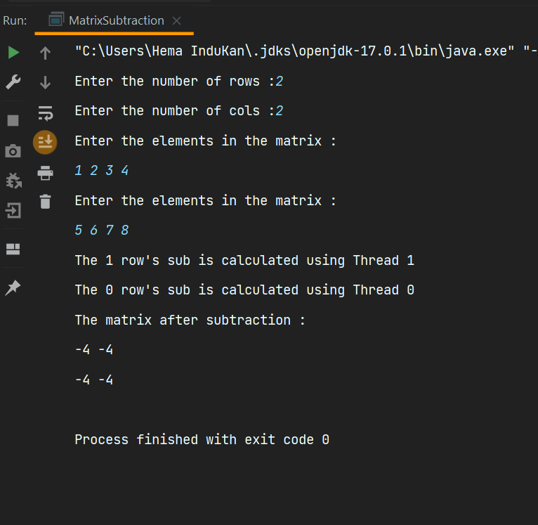

**RESULT :**Thus the output of the program has been successfully executed

**3)AIM:**

To write a Java multithreaded Program to sort the even elements in one thread,odd elements in second thread , find the even average using third thread and find the odd average using fourth thread

**PROGRAM CODE:**

package Java.Lab.lab9;

import java.util.*;

class SortArrayEven implements Comparator<Integer>{

@Override

public int compare(Integer o1, Integer o2) {

if (o1 % 2 == 0 && o2 % 2 == 0) {

return o1 - o2;

}

else if(o1 % 2 == 0 && o2 % 2 == 1)return -1;

else if(o1 % 2 == 1 && o2 % 2 == 0)return 1;

else return o1 - o2;

}

}

public class OddEvenSeparate {

private static final Scanner input = new Scanner(System.in);

public static void readInput(Integer []arr,int n){

System.out.print("Enter the elements :");

for(int i = 0 ; i < n ; i++){

arr[i] = input.nextInt();

}

}

public static void sortEvenOddNumbers(Integer []arr,int n){

Arrays.sort(arr,new SortArrayEven());

System.out.println("The array is sorted using " + Thread.currentThread().getName());

}

public static void calAvgEvenNumbers(Integer []arr,double []avg,int n){

double evenAvg = 0.00;

for(int i = 0 ; i < n ; i ++){

if(arr[i] % 2 == 0)evenAvg += arr[i];

}

avg[0] = evenAvg / n;

System.out.println("The average of even numbers are calculated using " + Thread.currentThread().getName());

}

public static void calAvgOddNumbers(Integer []arr,double []avg , int n){

double oddAvg = 0.00;

for(int i = 0 ; i < n ; i ++){

if(arr[i] % 2 == 1)oddAvg += arr[i];

}

avg[1] = oddAvg / n;

System.out.println("The average of odd numbers are calculated using " + Thread.currentThread().getName());

}

public static void main(String[] args) {

int n;

System.out.print("Enter the number of elements :");

n = input.nextInt();

Integer []arr = new Integer[n];

readInput(arr,n);

double [] avg = new double[2];

Thread []thread = new Thread[3];

(thread[0] = new Thread(() -> {

sortEvenOddNumbers(arr,n);

})).start();

(thread[1] = new Thread(() -> {

calAvgEvenNumbers(arr,avg,n);

})).start();

(thread[2] = new Thread(() -> {

calAvgOddNumbers(arr,avg,n);

})).start();

for(int i = 0 ; i < 3 ; i ++){

try{

thread[i].join();

}

catch(InterruptedException exception){

exception.printStackTrace();

}

}

System.out.println("The array after separating even and odd numbers :");

for(int i = 0 ; i < n ; i++){

System.out.print(arr[i] + " ");

}

System.out.println("\nThe even average is " + avg[0]);

System.out.println("The Odd average is :" + avg[1]);

}

}

**OUTPUT :**

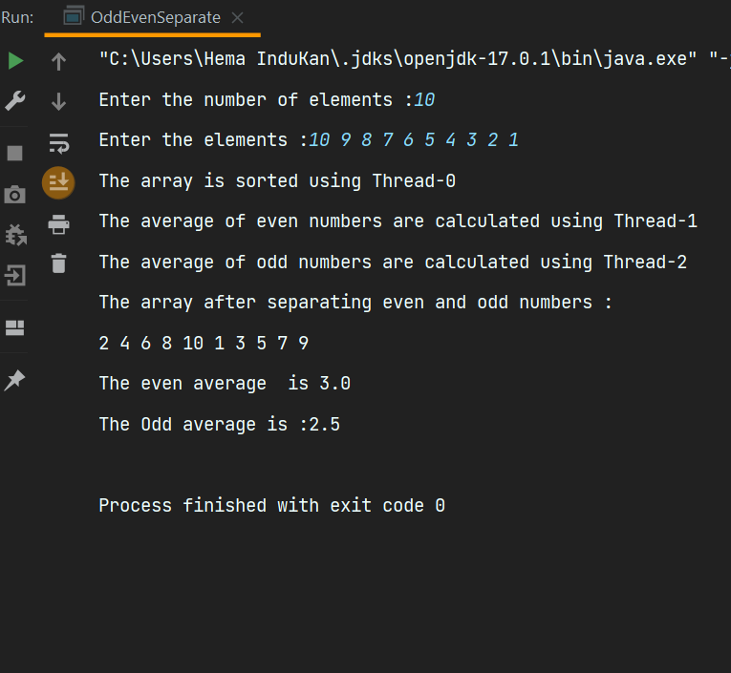

**RESULT :**Thus the output of the program has been successfully executed