­

Practical Lab_01

Adv.JAVA

Name:- Praveer Kishore

Enrollment No.:- A45349521001

Cousre:- BCA+MCA (Dual)

Semester:- 6th ‘B’

Submitted By :-

Crud Operation using JDBC

**About Our Project:-**

Telecom Management System

The Telecom Management System is a Java-based console application that provides functionalities for managing customer information in a telecom database. The system utilizes MySQL as the backend database for storing and retrieving customer details. Users interact with the system through a text-based interface, entering information and executing various operations on the telecom database.

Key Features:

1. **Insert Customer Information:**

Users can input customer details such as ID, name, phone number, telecom company name, plan price, and data usage. The entered information is then stored in the telecom database.

1. **Display Telecom Information:**

The system allows users to view the entire telecom database, displaying details like customer ID, name, phone number, telecom company, plan price, and data usage for each customer.

1. **Update Customer Information:**

Users can update customer details by providing the phone number of the customer and entering the new customer name.

This operation is useful for updating information when a customer's phone number is transferred.

1. **Remove Customer Record:**

Users can delete a customer record from the telecom database by specifying the customer ID.

This operation is useful for removing outdated or irrelevant customer information.

1. **Display Important Information:**

The system provides an option to display essential customer information, including customer name, phone number, and the telecom company they are associated with.

1. **Display Data Based on Telecom Company Name:**

Users can retrieve and display customer data based on the telecom company's name, providing a targeted view of customer information.

1. **Display Data Based on Customer Name Alphabet:**

Users can obtain and display customer data based on the initial letter or character of the customer's name.

1. **Display Number of Customers:**

The system offers a feature to display the total number of customers present in the telecom database.

1. **Display Highest Plan by a Customer:**

Users can view details of the customer with the highest data usage plan, aiding in identifying high-data users.

10.**Display Data Based on Rank Order of Data:**

Users have the option to view customer data based on the rank order of data usage. This utilizes the RANK() function in SQL to provide a ranked list of customers.

**Tech Stack Used in the Telecom Management System:-**

1. **Integrated Development Environment (IDE):**

Eclipse: The project is developed using the Eclipse IDE, providing a robust and user-friendly development environment for Java applications.

1. **Database Management System:**

MySQL Workbench: MySQL Workbench is used as the database management system to design, model, create, and manage the MySQL database that stores customer information.

1. **Programming Language:**

Java: The entire application is written in Java, a versatile and platform-independent programming language. Java is used for its object-oriented principles, extensive libraries, and wide industry adoption.

1. **Java Database Connectivity (JDBC) Architecture:**

JDBC is employed for database connectivity, allowing Java applications to interact with relational databases like MySQL. The JDBC architecture is utilized to establish connections, execute SQL queries, and manage data retrieval and updates.

**PoJo of Telecom Management System:-**

|  |
| --- |
| Telecom |
| * Customer ID: Int * Customer Name: String * Phone Number: Int * Telecom Company: String * Plan Price: Int * Data (Gb): Double |
| + telecom()  + telecom(Id: Int, Name: String, Phone: Int, Telecomname: String, Plan: int, Data: Double) |
| +getId(): Int  +setId(Id:int):void  +getName(): String  +setName(Name:string):void  +getPhone(): Int  +setPhone(Phone:int):void  +getTelecomname(): String  +setTelecomname (Telecomname:string):void  +getPlan(): Int  +setPlan(Plan:int):void  +getData(): Double  +setData(Data:double):void  +toString(): String |

**My sql Workbench (Queries):-**

**1. CREATE SCHEMA `lab` ;**

**2. use lab**

**3. CREATE TABLE `telecom` (**

`id` INT NOT NULL,

`name` VARCHAR(45) NULL,

`phone` BIGINT(10) NULL,

`telecom_name` VARCHAR(45) NULL,

`plan` INT NULL,

`Data` DOUBLE NULL,

PRIMARY KEY (`id`));

PRIMARY KEY (`Id`));

1. **Desc telecom**

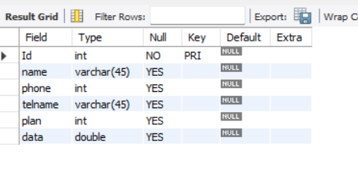

**5. INSERT** INTO `lab`.`telecom` (`Id`, `name`, `phone`, `telecom_name`, `plan`, `data`) VALUES ('4001', 'Aman', '9568214753', 'Airtel', '249', '24');

INSERT INTO `lab`.`telecom` (`Id`, `name`, `phone`, `telecom_name`, `plan`, `data`) VALUES ('4008', 'Ayush', '9875632145', 'Airtel', '379', '45');

INSERT INTO `lab`.`telecom` (`Id`, `name`, `phone`, `telecom_name`, `plan`, `data`) VALUES ('4010', 'Akbar', '9756278965', 'Airtel', '749', '85.6');

INSERT INTO `lab`.`telecom` (`Id`, `name`, `phone`, `telecom_name`, `plan`, `data`) VALUES ('6102', 'Nahid', '8745369852', 'Jio', '199', '28');

INSERT INTO `lab`.`telecom` (`Id`, `name`, `phone`, `telecom_name`, `plan`, `data`) VALUES ('6245', 'Mohan', '8745698521', 'Jio', '799', '95.5');

INSERT INTO `lab`.`telecom` (`Id`, `name`, `phone`, `telecom_name`, `plan`, `data`) VALUES ('6751', 'Sahid', '7589632541', 'Jio', '1799', '241.5');

INSERT INTO `lab`.`telecom` (`Id`, `name`, `phone`, `telecom_name`, `plan`, `data`) VALUES ('7458', 'Dhruv', '6325874153', 'VI', '449', '65.2');

INSERT INTO `lab`.`telecom` (`Id`, `name`, `phone`, `telecom_name`, `plan`, `data`) VALUES ('7210', 'Gaurav', '7524136985', 'VI', '3499', '365');

INSERT INTO `lab`.`telecom` (`Id`, `name`, `phone`, `telecom_name`, `plan`, `data`) VALUES ('8210', 'Harshit', '8532469874', 'VI', '179', '24');

1. **select * from telecom**

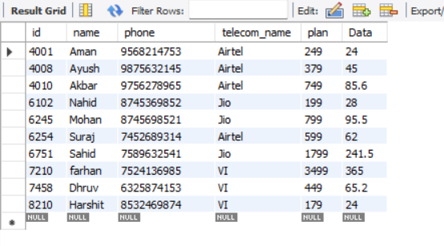

**Project in Eclipse:-**

Telecom.java :-

package Telecom.pojo;

import java.sql.Connection;

import java.sql.ResultSet;

import java.sql.SQLException;

import java.sql.Statement;

import java.util.Scanner;

public class Telecom {

public Telecom() {

super();

}

// Inserting information in the table

public void insertTelecom(Connection con, Scanner sc) throws SQLException {

Statement st = con.createStatement();

System.***out***.println("Enter Customer Id: ");

int id = sc.nextInt();

System.***out***.println("Enter Customer Name: ");

String name = sc.next();

System.***out***.println("Enter Phone Number: ");

String phoneStr = sc.next();

long phone = Long.*parseLong*(phoneStr);

System.***out***.println("Enter Tel-Company Name: ");

String telecom_name = sc.next();

System.***out***.println("Enter Plan price: ");

int plan = sc.nextInt();

System.***out***.println("Enter Data(gb): ");

double data = sc.nextDouble();

String query = String.*format*("INSERT INTO telecom VALUES(%d, '%s', %d, '%s', %d, %f)", id, name, phone, telecom_name, plan, data);

int rowsAffected = st.executeUpdate(query);

System.***out***.println(rowsAffected + " Information successfully stored...");

}

// Display the information of telecom

public void displayTelecom(Connection con) throws SQLException {

Statement st = con.createStatement();

ResultSet rs = st.executeQuery("SELECT * FROM telecom");

while (rs.next()) {

System.***out***.println(rs.getInt(1) + " " + rs.getString(2) + " " + rs.getLong(3) + " " + rs.getString(4) + " " + rs.getInt(5) + " " + rs.getDouble(6));

}

}

// Update the customer of expired or blocked phone number

public void updateTelecom(Connection con, Scanner sc) throws SQLException {

Statement st = con.createStatement();

System.***out***.println("Enter the Phone number: ");

String phoneStr = sc.next();

long phone = Long.*parseLong*(phoneStr);

System.***out***.println("Enter transferred-Customer Name: ");

String name = sc.next();

String query = String.*format*("UPDATE telecom SET name='%s' WHERE phone = %d", name, phone);

int rowsAffected = st.executeUpdate(query);

System.***out***.println(rowsAffected + " Information updated...");

}

// Remove the customer record from table with the help of their id

public void removeTelecom(Connection con, Scanner sc) throws SQLException {

Statement st = con.createStatement();

System.***out***.println("Enter Customer Id: ");

int id = sc.nextInt();

int rowsAffected = st.executeUpdate(String.*format*("DELETE FROM telecom WHERE id = %d", id));

System.***out***.println(rowsAffected + " Record deleted...");

}

// Display the column of customer name, phone, and their telecompany

public void displayimportant(Connection con) throws SQLException {

Statement st = con.createStatement();

ResultSet rt = st.executeQuery("SELECT name, phone, telecom_name FROM telecom");

while (rt.next()) {

System.***out***.println(rt.getString(1) + " " + rt.getLong(2) + " " + rt.getString(3));

}

}

// Displaying the data based on telecompany name

public void displaytelecomp(Connection con, Scanner sc) throws SQLException {

Statement st = con.createStatement();

System.***out***.println("Enter Telecom Name: ");

String telname = sc.next();

String query = String.*format*("SELECT * FROM telecom WHERE telecom_name = '%s'", telname);

ResultSet rs = st.executeQuery(query);

while (rs.next()) {

System.***out***.println(rs.getInt(1) + " " + rs.getString(2) + " " + rs.getLong(3) + " " + rs.getString(4) + " " + rs.getInt(5) + " " + rs.getDouble(6));

}

}

// Displaying the data of the customer based on their name alphabet or character

public void displaycust(Connection con, Scanner sc) throws SQLException {

Statement st = con.createStatement();

System.***out***.println("Enter the first letter: ");

String custname = sc.next();

String query = String.*format*("SELECT * FROM telecom WHERE name LIKE '%s%%'", custname);

ResultSet rs = st.executeQuery(query);

while (rs.next()) {

System.***out***.println(rs.getInt(1) + " " + rs.getString(2) + " " + rs.getLong(3) + " " + rs.getString(4) + " " + rs.getInt(5) + " " + rs.getDouble(6));

}

}

// Displaying the number of customers present in telecom data

public void displayrows(Connection con) throws SQLException {

Statement st = con.createStatement();

ResultSet rs = st.executeQuery("SELECT COUNT(*) FROM telecom");

if (rs.next()) {

System.***out***.println(rs.getInt(1));

}

}

// Displaying the data of the customer with the highest plan

public void displayHighestPlan(Connection con) throws SQLException {

Statement st = con.createStatement();

String query = "SELECT * FROM telecom WHERE data IN (SELECT MAX(data) FROM telecom)";

ResultSet rs = st.executeQuery(query);

while (rs.next()) {

System.***out***.println(rs.getInt(1) + " " + rs.getString(2) + " " + rs.getLong(3) + " " + rs.getString(4) + " " + rs.getInt(5) + " " + rs.getDouble(6));

}

}

// Displaying the data based on rank order of data

public void displayByRank(Connection con, Scanner sc) throws SQLException {

Statement st = con.createStatement();

System.***out***.println("Enter the rank (n): ");

int n = sc.nextInt();

String query = String.*format*("SELECT * FROM (SELECT id, name, phone, plan, data, RANK() OVER (ORDER BY data DESC) AS ranking FROM telecom) AS ranked WHERE ranking = %d", n);

ResultSet rs = st.executeQuery(query);

while (rs.next()) {

System.***out***.println(rs.getInt(1) + " " + rs.getString(2) + " " + rs.getLong(3) + " " + rs.getInt(4) + " " + rs.getDouble(5));

}

}

}

Main.Java :-

package Telecom.main;

import java.sql.Connection;

import java.sql.DriverManager;

import java.sql.SQLException;

import java.util.Scanner;

import Telecom.pojo.Telecom;

public class Main {

public static void main(String[] args) throws ClassNotFoundException, SQLException {

Class.*forName*("com.mysql.cj.jdbc.Driver");

String url = "jdbc:mysql://localhost:3306/lab";

String username = "root";

String pwd = "praveer";

Connection con = DriverManager.*getConnection*(url, username, pwd);

Scanner sc = new Scanner(System.***in***);

Telecom tel = new Telecom();

int choice;

do {

System.***out***.println("____________________________________");

System.***out***.println("---Welcome to InfraTel Insight---");

System.***out***.println("-------------------------------------");

System.***out***.println("1. Insert Customer Information");

System.***out***.println("2. Display Information");

System.***out***.println("3. Update customer of expired phone number");

System.***out***.println("4. Remove the customer record");

System.***out***.println("5. Display customer, Telecompany with their phone number");

System.***out***.println("6. Display the users of a specific telecompany");

System.***out***.println("7. Search customer with the first letter of the name");

System.***out***.println("8. Total customer present in telecom");

System.***out***.println("9. Display data with the highest plan");

System.***out***.println("10. Display data by rank (based on data)");

System.***out***.println("0. Exit");

System.***out***.print("Enter your choice: ");

choice = sc.nextInt();

switch (choice) {

case 1:

tel.insertTelecom(con, sc);

break;

case 2:

tel.displayTelecom(con);

break;

case 3:

tel.updateTelecom(con, sc);

break;

case 4:

tel.removeTelecom(con, sc);

break;

case 5:

tel.displayimportant(con);

break;

case 6:

tel.displaytelecomp(con, sc);

break;

case 7:

tel.displaycust(con, sc);

break;

case 8:

tel.displayrows(con);

break;

case 9:

tel.displayHighestPlan(con);

break;

case 10:

tel.displayByRank(con, sc);

break;

case 0:

System.***out***.println("Goodbye! Have a great day!");

System.***out***.println("___________________________________");

System.*exit*(0);

break;

default:

System.***out***.println("Invalid choice.");

}

}

while (choice != 0);

sc.close();

con.close();

}

}

**-: Output :-**

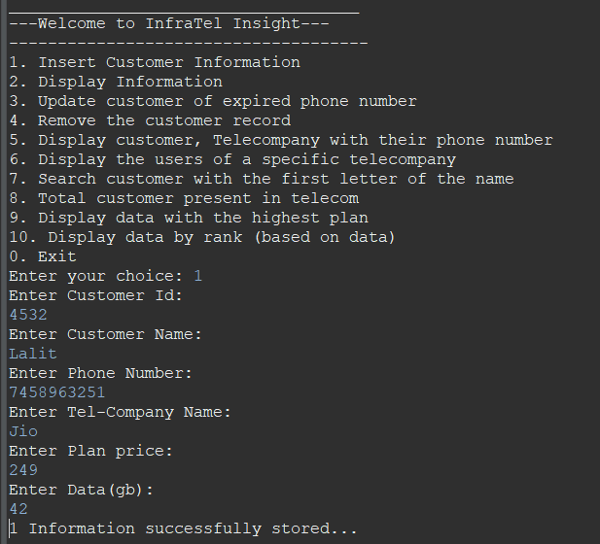

Fig-1. Insert Customer Information

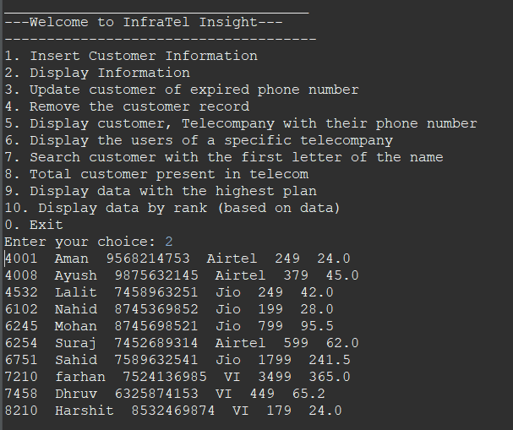

Fig-2. Display Telecom Information

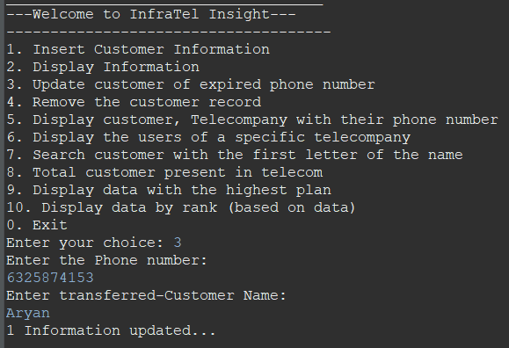

Fig-3. Update Customer Information

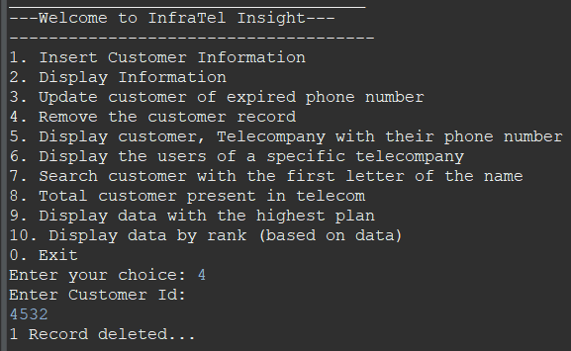

Fig-4. Remove Customer Record

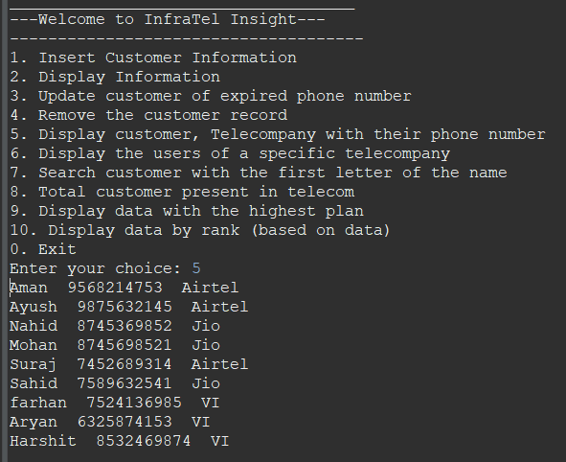

Fig-5. Display Important Information (customer name, phone number, and their telecom company)

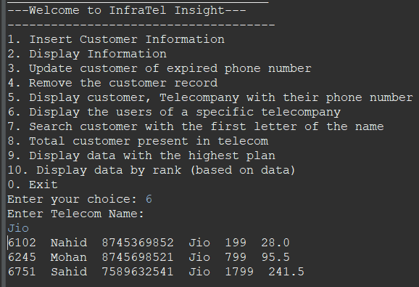

Fig-6. Display Data Based on Telecom Company Name

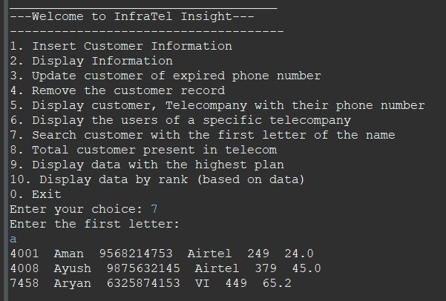

Fig-7. Display Data Based on Customer Name Alphabet

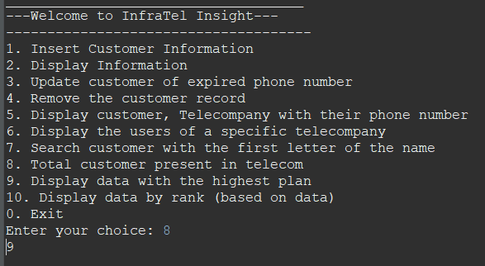

Fig-8. Display Number of Customers

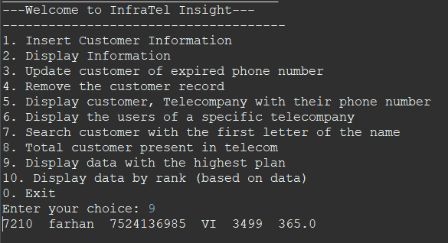

Fig-9. Display Highest Plan by a Customer

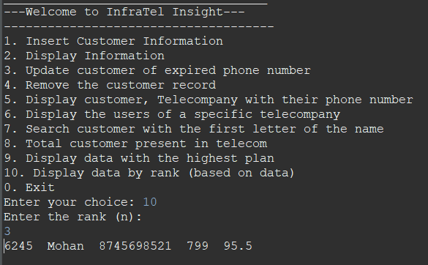

Fig-10. Display Data Based on Rank Order of Data

THANK YOU

