Stage 16N Geometry and Cycle-Jump Workflow
Plate-with-hole Abaqus benchmark using a NEML-equivalent Chaboche UMAT

Purpose
This document summarizes the Stage 16N benchmark geometry and the planned workflow for fixed and adaptive cycle-jump validation. The material model is kept fixed; the thesis contribution is the cycle-jump methodology and its accuracy-versus-cost evaluation on an inhomogeneous Abaqus model.

Geometry Used in Stage 16N
Item | Stage 16N setting
Benchmark type | Thin 3D plate with a central circular hole.
Dimensions | Length = 20.0, height = 10.0, thickness = 1.0.
Hole | Central hole with radius = 1.0 at the plate center.
Mesh spacing | Structured grid with dx = 0.25 and dy = 0.25.
Element type | C3D8 for Stage 16N NEML-equivalent Abaqus deck.
Nodes | 6642 generated nodes.
Elements | 3148 solid elements outside the hole.
Hole-ring set | 60 elements selected near the hole for local stress and STATEV tracking.
Boundary sets | 82 left-edge nodes and 82 right-edge nodes.
Anchors | Anchor A = node 1; Anchor B = node 3241, used to remove rigid-body motion.

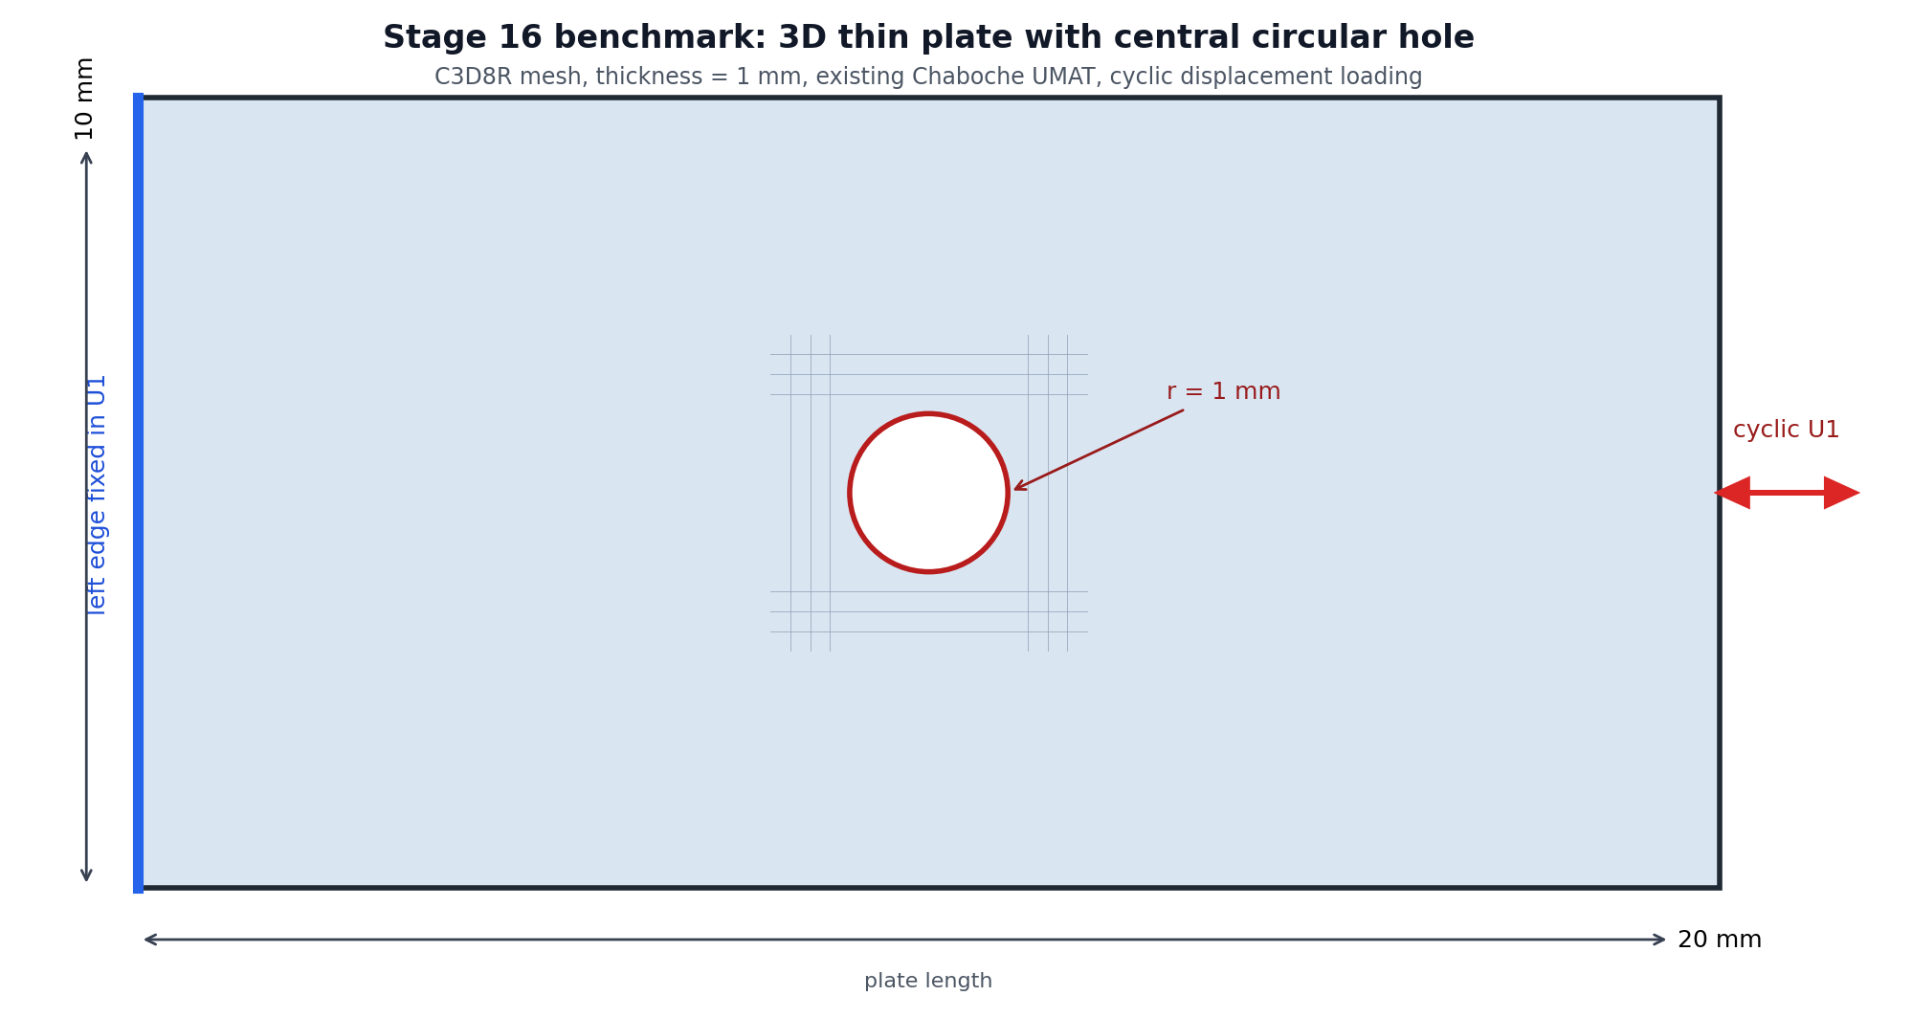
Figure 1. Stage 16 plate-with-hole geometry schematic.
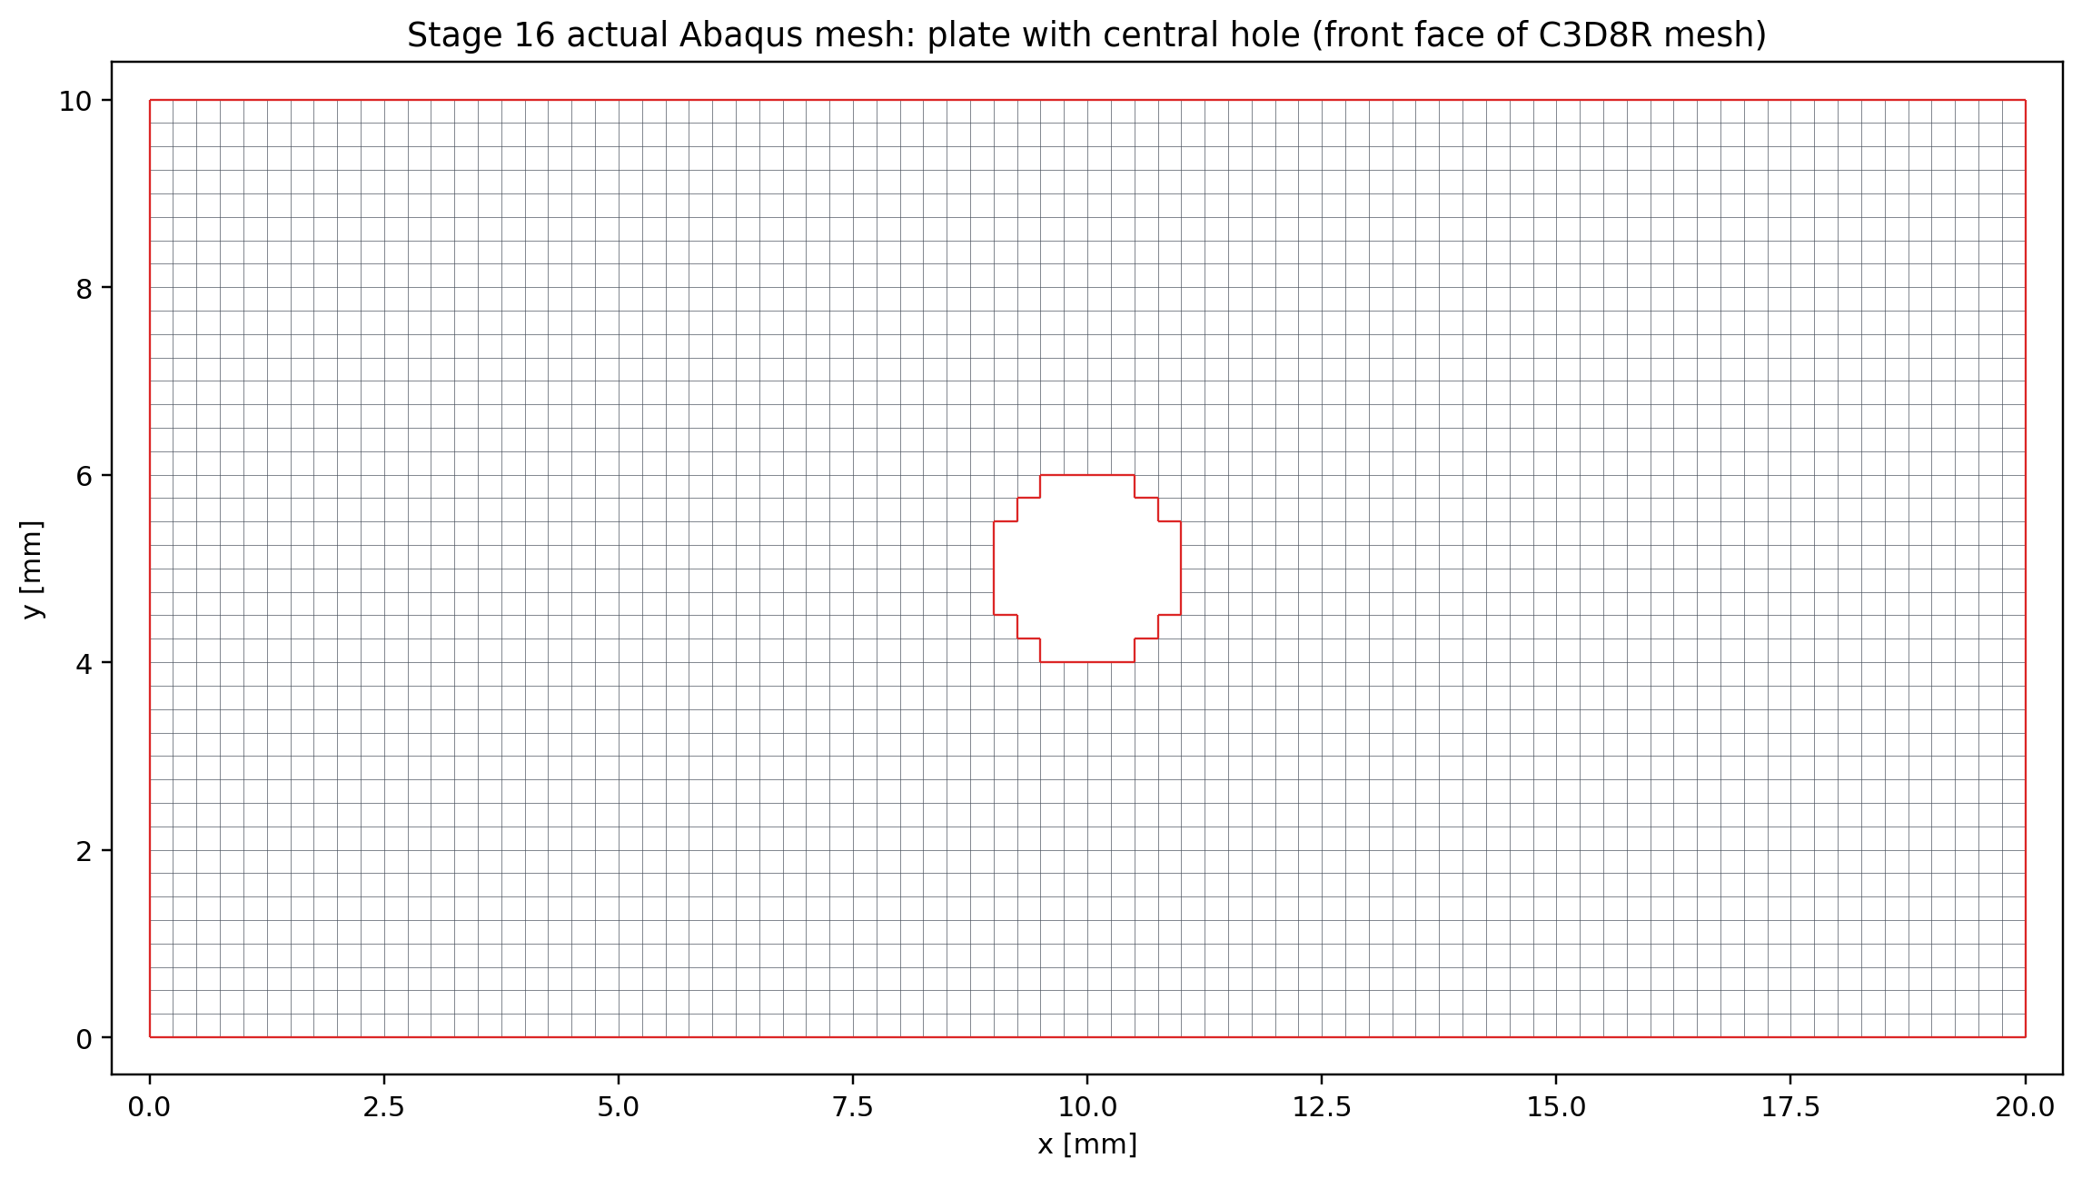
Figure 2. Generated plate-with-hole mesh used for the benchmark.

Loading, Material, and Output
Item | Stage 16N setting
Material model | NEML-equivalent Chaboche cyclic plasticity UMAT.
State variables | 27 solution-dependent state variables in the Stage 16N UMAT.
Elastic constants | E = 200000.0, nu = 0.3.
Chaboche-style parameters | yield = 100.0, Q = 50.0, b = 5.0, three backstress pairs: C1/g1, C2/g2, C3/g3.
Cycle definition | Separate static step for each cycle, with AMP_ONE_CYCLE tabular loading.
Right edge loading | Cyclic displacement U1 amplitude = +/-0.10 on RIGHT_EDGE.
Left edge constraint | LEFT_EDGE fixed in U1; anchor nodes constrain remaining rigid-body modes.
Reference run | 1000 full non-jump cycles completed as the accepted baseline.
Selected field cycles | 1, 2, 10, 50, 100, 250, 500, 750, and 1000.
Tracked outputs | RF1-U1 hysteresis, loop area, local hole-ring stresses, and selected STATEV values.

Reference Status
- The corrected full reference completed 1000 non-jump cycles.
- Abaqus parallelism was verified as 1 MPI rank x 30 threads for the completed full reference.
- Future production runs are configured to use 16 CPUs by default to reduce resource waste.
- The reference CSV files provide the baseline for fixed and adaptive cycle-jump validation.

Plan Flow Chart
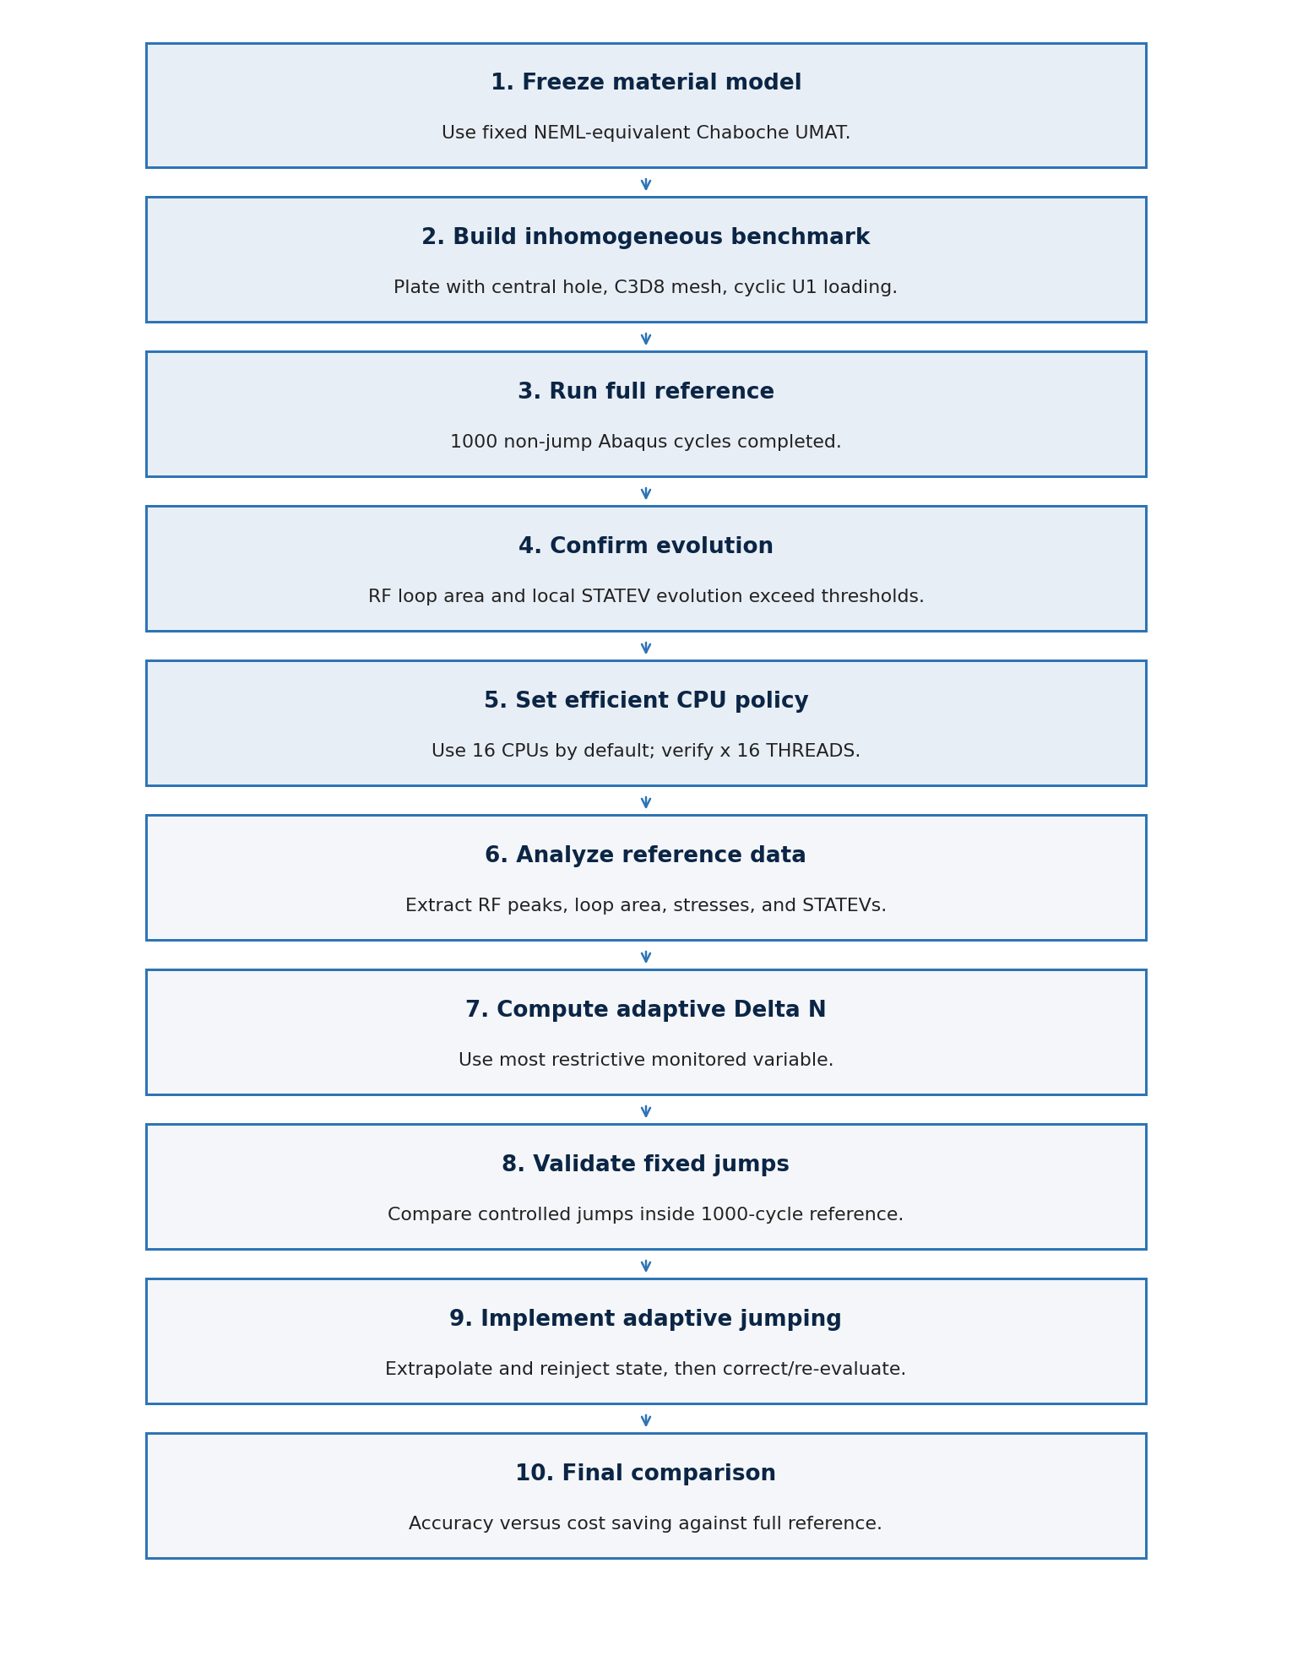
Figure 3. Proposed Stage 16N workflow from benchmark setup to final cycle-jump validation.

Key Decision Points
Item | Stage 16N setting
Benchmark suitability | Accepted: global loop evolution and local hole STATEV evolution are significant.
Early-cycle treatment | Do not jump the first cycles aggressively; simulate the transient normally.
Delta N control | Use local STATEV and local stress variables in addition to global RF1 and loop area.
Validation order | Run fixed controlled jumps before the full adaptive cycle-jump workflow.
CPU policy | Use 16 CPUs by default and verify the Abaqus message file reports x 16 THREADS.

Immediate Next Tasks
- Finish/check the 16-CPU benchmark and record the measured efficiency.
- Analyze the 1000-cycle full reference data.
- Compute the adaptive Delta N table from the full reference.
- Run fixed jump validation cases inside the 1000-cycle window.
- Implement adaptive cycle jumping after the fixed jumps pass the accuracy checks.

