Q1.

Assignment1.html

<!DOCTYPE html>

<html lang="en">

<head>

    <meta charset="UTF-8">

    <meta http-equiv="X-UA-Compatible" content="IE=edge">

    <meta name="viewport" content="width=device-width, initial-scale=1.0">

    <title>Assignment</title>

    <link rel="stylesheet" href="Assignment1.css">

</head>

<body>

    <div>

        <h1 class="exmp">CSS background-color example!</h1>

        <p>This is a text inside a div element.</p>

        <p class="p2">This paragraph has its own background color.</p>

        <p>We are still in the div element.</p>

        <p class="p4"> </p>

    </div>

</body>

</html>

Assignment1.css

body {

    margin: 0;

    padding: 0%;

    height: 200px;

    width: 600px;

    font-family: Arial, Helvetica, sans-serif;

}

.exmp {

    padding: 8px 0px 8px 0px;

    background-color: rgb(85, 129, 223);

}

div {

    background-color: rgb(136, 178, 202);

}

.p2 {

    padding: 15px 0px 15px 0px;

    background-color: rgb(143, 202, 197);

}

.p4 {

    padding: 12px;

    background-color: rgb(143, 202, 197);

}

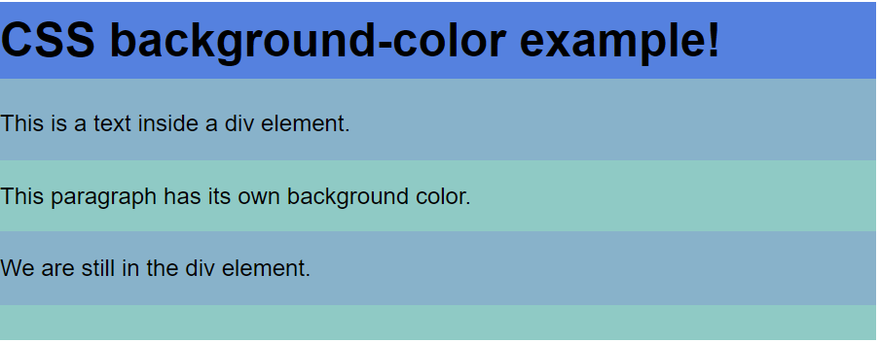

Q2.

<!DOCTYPE html>

<html lang="en">

<head>

    <style>

        body {

            background: aquamarine;

        }

        h1 {

            font-family: Arial, Helvetica, sans-serif;

        }

        h2 {

            text-decoration: line-through;

        }

        h3 {

            text-decoration: underline;

        }

    </style>

    <meta charset="UTF-8">

    <meta http-equiv="X-UA-Compatible" content="IE=edge">

    <meta name="viewport" content="width=device-width, initial-scale=1.0">

    <title>Assignment2</title>

</head>

<body>

    <h1>This is heading 1</h1>

    <h2>This is heading 2</h2>

    <h3>This is heading 3</h3>

    <h4>This is heading 4</h4>

</body>

</html>



Q3.

<!DOCTYPE html>

<html lang="en">

<head>

    <style>

        body {

            background-color: rgb(193, 248, 239);

        }

    </style>

    <meta charset="UTF-8">

    <meta http-equiv="X-UA-Compatible" content="IE=edge">

    <meta name="viewport" content="width=device-width, initial-scale=1.0">

    <title>Assignment3</title>

</head>

<body>

    <p>THIS IS SOME TEXT</p>

    <p>This is some text</p>

    <p>This is some text</p>

</body>

</html>



Q4.

<!DOCTYPE html>

<html lang="en">

<head>

    <style>

        a {

            color: red;

        }

        a:visited {

            color: green;

        }

    </style>

    <meta charset="UTF-8">

    <meta http-equiv="X-UA-Compatible" content="IE=edge">

    <meta name="viewport" content="width=device-width, initial-scale=1.0">

    <title>Assignment4</title>

</head>

<body>

    <div>

        <a href="https://www.w3schools.com/html/html_css.asp">This is a link</a>

    </div>

</body>

</html>





Q5.

<!DOCTYPE html>

<html lang="en">

<head>

    <style>

        table,

        tr,

        th,

        td {

            border: 1px solid black;

            border-collapse: collapse;

        }

    </style>

    <meta charset="UTF-8">

    <meta http-equiv="X-UA-Compatible" content="IE=edge">

    <meta name="viewport" content="width=device-width, initial-scale=1.0">

    <title>Assignment5</title>

</head>

<body>

    <table>

        <tr>

            <th>FirstName</th>

            <th>LastName</th>

        </tr>

        <tr>

            <td>Peter</td>

            <td>Griffin</td>

        </tr>

        <tr>

            <td>Lois</td>

            <td>Griffin</td>

        </tr>

    </table>

</body>

</html>

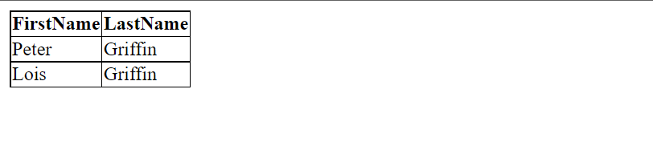

Q6.

<!DOCTYPE html>

<html lang="en">

<head>

    <style>

        table,

        tr,

        th,

        td {

            border: 1px solid green;

        }

        th {

            background-color: green;

            color: white;

        }

    </style>

    <meta charset="UTF-8">

    <meta http-equiv="X-UA-Compatible" content="IE=edge">

    <meta name="viewport" content="width=device-width, initial-scale=1.0">

    <title>Assignment6</title>

</head>

<body>

    <table>

        <tr>

            <th>FirstName</th>

            <th>LastName</th>

            <th>Savings</th>

        </tr>

        <tr>

            <td>Peter</td>

            <td>Griffin</td>

            <td>$100</td>

        </tr>

        <tr>

            <td>Lois</td>

            <td>Griffin</td>

            <td>$150</td>

        </tr>

        <tr>

            <td>Joe</td>

            <td>Swanson</td>

            <td>$300</td>

        </tr>

        <tr>

            <td>Cleavland</td>

            <td>Brown</td>

            <td>$250</td>

        </tr>

    </table>

</body>

</html>



Q7.

<!DOCTYPE html>

<html lang="en">

<head>

    <style>

        p {

            font-size: 20px;

            width: 500px;

            border: 3px dotted green;

        }

    </style>

    <meta charset="UTF-8">

    <meta http-equiv="X-UA-Compatible" content="IE=edge">

    <meta name="viewport" content="width=device-width, initial-scale=1.0">

    <title>Document</title>

</head>

<body>

    <p><strong>Note:</strong>IE8 supports the outline properties only if a !DOCTYPE is specified</p>

</body>

</html>

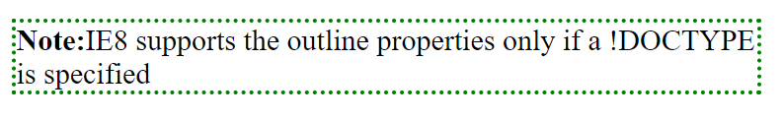

Q8.

<!DOCTYPE html>

<html lang="en">

<head>

    <style>

        .one {

            width: 500px;

            border: 8px solid black;

        }

        .two {

            width: 505px;

            border: 5px solid black;

        }

        .three {

            width: 513px;

            border: 1px solid black;

        }

    </style>

    <meta charset="UTF-8">

    <meta http-equiv="X-UA-Compatible" content="IE=edge">

    <meta name="viewport" content="width=device-width, initial-scale=1.0">

    <title>Assignment8</title>

</head>

<body>

    <p class="one">Some Text</p>

    <p class="two">Some Text</p>

    <p class="three">Some Text</p>

</body>

</html>

