Q1.

*import* java.util.Scanner;  
  
@FunctionalInterface  
*interface SiCalc*{  
 *int* calc(*int* p, *int* r, *int* t);  
}  
*public class* Assignment6Q1{  
 *public static void* main(String[] args) {  
 Scanner scanner = *new* Scanner(System.in);  
  
 *double* f = 0;  
  
 System.out.print("Enter Principal Amount ");  
 *int* p = scanner.nextInt();  
 System.out.print("Enter Intrest Rate ");  
 *int* r = scanner.nextInt();  
 System.out.print("Time in years ");  
 *int* t = scanner.nextInt();  
  
*// f = p \* (1 + r \* t);  
// System.out.println(f);  
  
 SiCalc* siCalc = ((p1, r1, t1) -> {  
 *return* ((p1 \* r1 \* t1) / 100);  
 });  
 System.out.println("Total intrest is equals "+siCalc.calc(p,r,t));  
  
 }  
}

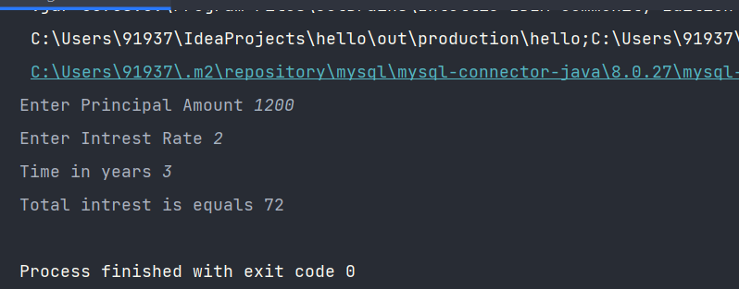

Q3.

*import* java.util.ArrayList;  
*import* java.util.Arrays;  
  
*public class* Assignment6Q3 {  
 *public static void* main(String[] args) {  
 ArrayList<String> arrayList = *new* ArrayList<>();  
  
 arrayList.add("A");  
 arrayList.add("quick");  
 arrayList.add("brown");  
 arrayList.add("fox");  
 arrayList.add("jumps");  
 arrayList.add("over");  
 arrayList.add("the");  
 arrayList.add("lazy");  
 arrayList.add("dog");  
  
 Object[] a = arrayList.toArray();  
 System.out.println(Arrays.*toString*(a));  
 }  
}

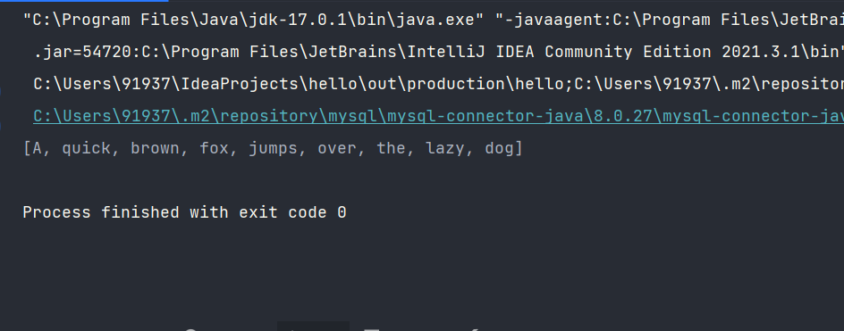

Q4.

*import* java.io.File;  
*import* java.io.IOException;  
*import* java.util.Scanner;  
  
*public class* Assignment6Q4 {  
 *public static void* main(String[] args) *throws* IOException {  
 File file = *new* File("C:\\Users\\91937\\Downloads\\StudentList.txt");  
 Scanner scanner = *new* Scanner(file);  
 *int* count = 0;  
 *while* (scanner.hasNext()){  
 String s = scanner.nextLine();  
 *if* (s.length() != 0){  
 System.out.println(s.trim());  
 count++;  
 }  
 }  
 System.out.println("Total students "+ count);  
 scanner.close();  
 }  
}

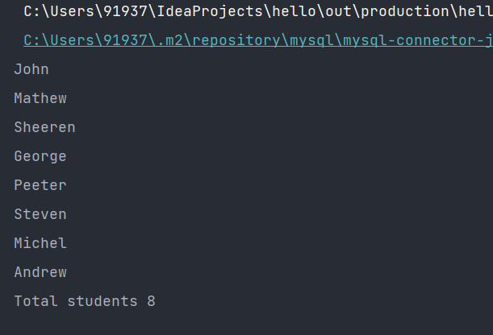

Q5.

import java.util.Locale;

import java.util.Scanner;

public class Assignment3Q2 {

public static String ordinal(int i) {

String[] suffixes = new String[]{"th", "st", "nd", "rd", "th", "th", "th", "th", "th", "th"};

switch (i % 100) {

case 11:

case 12:

case 13:

return i + "th";

default:

return i + suffixes[i % 10];

}

}

public static void main(String[] args) {

Scanner sc = new Scanner(System.in);

int count = 0;

int price,total = 0;

int choice;

do{

System.out.println("\t\t\*\*\*\*\*\*\*\*\*\*\*\*\*\*\*\*\*\*\*\*\*\*\*\*\*\*\*\*\*\*\t\t");

System.out.println("\t\t\*\* 1) INSERT NEW PRICE \*\*\t\t");

System.out.println("\t\t\*\* 2) VIEW PURCHASE TOTAL \*\*\t\t");

System.out.println("\t\t\*\* 3) EXIT \*\*\t\t");

System.out.println("\t\t\*\*\*\*\*\*\*\*\*\*\*\*\*\*\*\*\*\*\*\*\*\*\*\*\*\*\*\*\*\*\t\t");

System.out.print("\t\tENTER YOUR CHOICE: ");

choice = sc.nextInt();

switch (choice){

case 1:

String s = "Yes";

do{

System.out.print("\t\tInsert "+*ordinal*(count+1)+" price: ");

price = sc.nextInt();

total += price;

System.out.println("\t\tPrice has been saved to the file");

System.out.print("\t\tDo you want to enter price for more items? (Yes/No): ");

s = sc.next();

count++;

System.out.println();

}while(s.equalsIgnoreCase("Yes"));

break;

case 2:

System.out.println("\t\tTotal Price of all items is: "+total);

break;

case 3: System.*exit*(0);

default : System.out.println("\t\tPLEASE ENTER THE CORRECT CHOICE!");

}

}while(choice!=3);

}

}

