Q1.

Q2. *import* java.util.HashSet;  
*import* java.util.LinkedHashSet;  
*import* java.util.*Set*;  
*import* java.util.TreeSet;  
  
*public class* Assignment3Q2 {  
 *public static void* main(String[] args) {  
 System.out.println("=============================================");  
 System.out.println("[34, 43, 12, 36, 9]This is the order of input");  
 System.out.println("=============================================");  
 *Set*<Integer> set = *new* HashSet<>();  
 set.add(34);  
 set.add(43);  
 set.add(12);  
 set.add(36);  
 set.add(9);  
  
 System.out.println(set+"This is Hashset output");  
 System.out.println("=============================================");  
  
 *Set*<Integer> set1 = *new* LinkedHashSet<>();  
 set1.add(34);  
 set1.add(43);  
 set1.add(12);  
 set1.add(36);  
 set1.add(9);  
 System.out.println(set1+"This is LinkedHashSet");  
 System.out.println("=============================================");  
  
  
 }  
 }

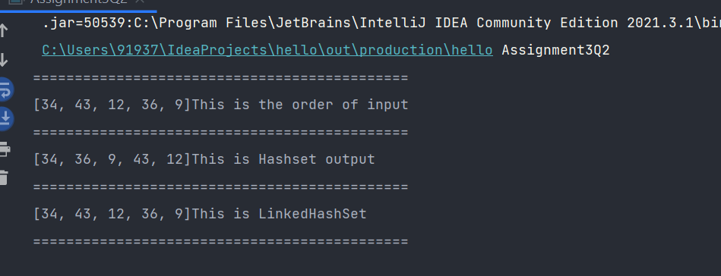

Q3.

*import* java.util.ArrayList;  
  
*public class* Assignment3Q3 {  
 *public static void* main(String[] args) {  
 ArrayList<Integer> list = *new* ArrayList<>();  
 list.add(12);  
 list.add(34);  
 list.add(54);  
 list.add(1);  
 ArrayList<Integer> list1 = *traverseReverse*(list);  
 System.out.println(list1);  
 }  
 *public static* ArrayList<Integer> traverseReverse(ArrayList<Integer> aList){  
 ArrayList<Integer> arrayList = *new* ArrayList<>();  
 *for* (*int* i = aList.size() - 1; i >= 0 ; i--) {  
 arrayList.add(aList.get(i));  
 }  
 *return* arrayList;  
 }  
}

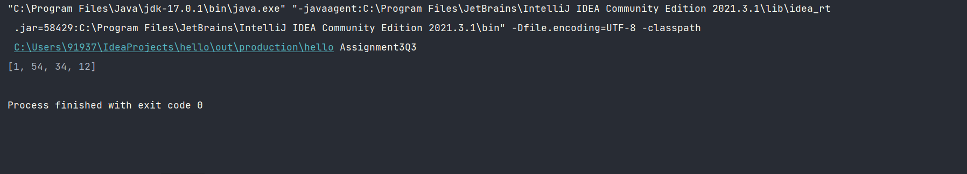

Q4.

*import* java.util.HashMap;  
*import* java.util.*Map*;  
*import* java.util.Objects;  
*class* DateClass{  
 *int* date;  
 *int* month;  
 *int* year;  
 *public* DateClass(*int* date, *int* month, *int* year) {  
 *this*.date = date;  
 *this*.month = month;  
 *this*.year = year;  
 }  
 *public int* getDate() {  
 *return* date;  
 }  
 *public void* setDate(*int* date) {  
 *this*.date = date;  
 }  
 *public int* getMonth() {  
 *return* month;  
 }  
  
 *public void* setMonth(*int* month) {  
 *this*.month = month;  
 }  
 *public int* getYear() {  
 *return* year;  
 }  
 *public void* setYear(*int* year) {  
 *this*.year = year;  
 }  
 @Override  
 *public boolean* equals(Object o) {  
 *if* (*this* == o) *return true*;  
 *if* (!(o *instanceof* DateClass)) *return false*;  
 DateClass dateClass = (DateClass) o;  
 *return* date == dateClass.date && month == dateClass.month && year == dateClass.year;  
 }  
  
 @Override  
 *public int* hashCode() {  
 *return* Objects.*hash*(date, month, year);  
 }  
 @Override  
 *public* String toString() {  
 *return* "Date = "+*this*.date+" Month = "+*this*.month+" Year = "+*this*.year;  
 }  
}  
  
*public class* Assignment3Q4{  
 *public static void* main(String[] args) {  
 *Map*<DateClass,String> map = *new* HashMap<>();  
 DateClass d1 = *new* DateClass(4,9,2001);  
 DateClass d2 = *new* DateClass(9,12,2004);  
 DateClass d3 = *new* DateClass(27,2,2020);  
  
 map.putIfAbsent(d1,"Pradumnya Ghadole");  
 map.putIfAbsent(d2,"Suleman khan");  
 map.putIfAbsent(d3,"Rahul J-ker");  
  
 System.out.println("Key-value pair in HashMap: ");  
  
 *for*(*Map*.*Entry*<DateClass,String> m:map.entrySet()){  
 DateClass key = m.getKey();  
 String value = m.getValue();  
  
 System.out.println(key+" : "+value);  
  
 }  
 }  
}

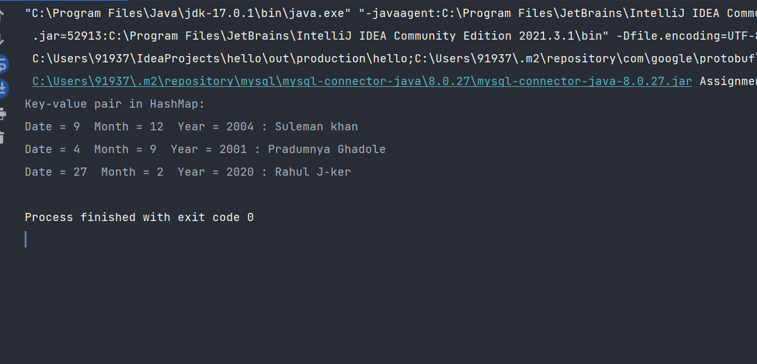

Q5.

*import* java.util.HashMap;  
*import* java.util.Hashtable;  
*import* java.util.*Map*;  
*import* java.util.Objects;  
  
*class* employee{  
 *private* String name;  
 *private int* id;  
  
 *public* String getName() {  
 *return* name;  
 }  
  
 *public void* setName(String name) {  
 *this*.name = name;  
 }  
  
 *public int* getId() {  
 *return* id;  
 }  
  
 *public void* setId(*int* id) {  
 *this*.id = id;  
 }  
  
 @Override  
 *public boolean* equals(Object o) {  
 *if* (*this* == o) *return true*;  
 *if* (!(o *instanceof* employee)) *return false*;  
 employee employee = (employee) o;  
 *return* id == employee.id && name.equals(employee.name);  
 }  
  
 @Override  
 *public int* hashCode() {  
 *return* Objects.*hash*(name, id);  
 }  
  
 @Override  
 *public* String toString() {  
 *return* "employee{" +  
 "name='" + name + '\'' +  
 ", id=" + id +  
 '}';  
 }  
  
 *public* employee(String name, *int* id) {  
 *this*.name = name;  
 *this*.id = id;  
 }  
}  
  
*public class* Assignment3Q5 {  
 *public static void* main(String[] args) {  
 *Map*<Integer, String> map = *new* HashMap<>();  
 employee e1 = *new* employee("pradumnya ghadole",12);  
 employee e2 = *new* employee("Rishikesh ghadole",11);  
 employee e3 = *new* employee("Ramdas ghadole",9);  
 employee e4 = *new* employee("Singita ghadole",21);  
 map.put(e1.getId(), e1.getName());  
 map.put(e2.getId(), e2.getName());  
 map.put(e3.getId(), e3.getName());  
 map.put(e4.getId(), e4.getName());  
 System.out.println("Key-Value pair in map: ");  
 *for* (*Map*.*Entry*<Integer,String> m:map.entrySet()){  
 *int* key = m.getKey();  
 String value = m.getValue();  
 System.out.println(key+" : "+value);  
 }  
  
 }  
}

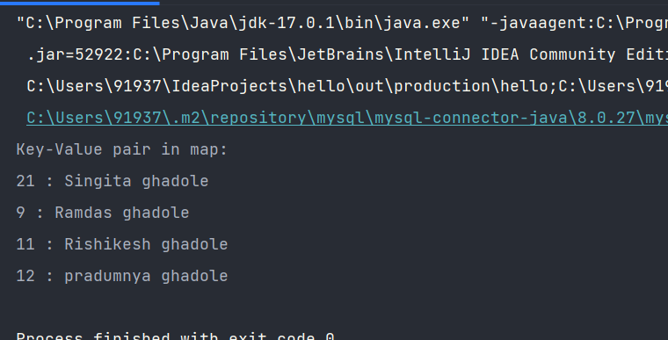

Q6.

*import* java.util.*;  
  
*class* Chatroom{  
 String name;  
 *Set*<String> username;  
 *List*<String> messages;  
  
 *public* String getName() {  
 *return* name;  
 }  
  
 *public Set*<String> getUsername() {  
 *return* username;  
 }  
  
 *public List*<String> getMessages() {  
 *return* messages;  
 }  
  
  
 Chatroom(){  
 *this*.name = "";  
 *this*.username = *new* HashSet<String>();  
 *this*.messages = *new* ArrayList<String>();  
 }  
  
 @Override  
 *public boolean* equals(Object o) {  
 *if* (*this* == o) *return true*;  
 *if* (!(o *instanceof* Chatroom)) *return false*;  
 Chatroom chatroom = (Chatroom) o;  
 *return* username.equals(chatroom.username);  
 }  
  
 @Override  
 *public int* hashCode() {  
 *return* Objects.*hash*(username);  
 }  
  
 *public boolean* removeUser(String username) {  
 *if*(*this*.username.contains(username)){  
 *this*.username.remove(username);  
 *return true*;  
 }  
 *return false*;  
 }  
}  
  
*class* User{  
  
 String username;  
 String password;  
 String firstName;  
 String lastName;  
  
 *public* User(){  
 username = "";  
 password = "";  
 firstName = "";  
 lastName = "";  
 }  
  
 *public* User(String username, String password, String firstName, String lastName) {  
 *this*.username = username;  
 *this*.password = password;  
 *this*.firstName = firstName;  
 *this*.lastName = lastName;  
 }  
  
 *public* String getUsername() {  
 *return* username;  
 }  
  
 *public void* setUsername(String username) {  
 *this*.username = username;  
 }  
  
 *public* String getPassword() {  
 *return* password;  
 }  
  
 *public void* setPassword(String password) {  
 *this*.password = password;  
 }  
  
 *public* String getFirstName() {  
 *return* firstName;  
 }  
  
 *public void* setFirstName(String firstName) {  
 *this*.firstName = firstName;  
 }  
  
 *public* String getLastName() {  
 *return* lastName;  
 }  
  
 *public void* setLastName(String lastName) {  
 *this*.lastName = lastName;  
 }  
  
 @Override  
 *public boolean* equals(Object o) {  
 *if* (*this* == o) *return true*;  
 *if* (!(o *instanceof* User)) *return false*;  
 User user = (User) o;  
 *return* username.equals(user.username);  
 }  
  
 @Override  
 *public int* hashCode() {  
 *return* Objects.*hash*(username);  
 }  
}  
  
  
*class* ChatApplication{  
  
 *Map*<String, Chatroom> chatrooms = *new* HashMap();  
 *Map*<String, User> users = *new* HashMap();  
 *Set*<String> loggedInUsers = *new* HashSet();  
 *int* chatroomCount = 0;  
 *int* userCount = 0;  
 *public boolean* isChatroomNameValid(String name) {  
 *for* (*Map*.*Entry*<String,Chatroom> mp: chatrooms.entrySet()){  
 Chatroom chatroom = mp.getValue();  
 *if*(chatroom.name.equals(name)){  
 *return true*;  
 }  
 }  
 *return false*;  
 }  
  
 *public boolean* isUsernameExists(String username) {  
 *for*(*Map*.*Entry*<String, User> mp: users.entrySet()){  
 User user = mp.getValue();  
 *if*(user.username.equals(username)){  
 *return true*;  
 }  
 }  
 *return false*;  
 }  
  
 *public boolean* authenticateUser(String username, String password) {  
 *for*(*Map*.*Entry*<String, User> mp: users.entrySet()){  
 User user = mp.getValue();  
 *if*(user.username.equals(username) && user.password.equals(password)){  
 *return true*;  
 }  
 }  
 *return false*;  
 }  
  
 *//UI Methods Below  
 public void* createChatroom() {  
 Chatroom chatroom = *new* Chatroom();  
 chatroom.messages = *new* ArrayList<>();  
 chatroom.username = *new* HashSet<>();  
  
 Scanner sc = *new* Scanner(System.in);  
 System.out.print("Enter the chatroom name: ");  
 chatroom.name = sc.nextLine();  
  
 System.out.print("Enter the chatroom username: ");  
 chatroom.username.add(sc.nextLine());  
  
 System.out.print("Enter the chatroom message: ");  
 chatroom.messages.add(sc.nextLine());  
  
 System.out.println(chatroom.getName());  
 System.out.println(chatroom.getUsername());  
 System.out.println(chatroom.getMessages());  
  
 *//Adding the message in map.* chatrooms.put(Integer.*toString*(chatroomCount+1),chatroom);  
 chatroomCount+=1;  
  
 }  
  
 *public void* addNewUser() {  
  
 User user = *new* User();  
 Scanner sc = *new* Scanner(System.in);  
  
 System.out.print("Enter the first name: ");  
 user.setFirstName(sc.nextLine());  
  
 System.out.print("Enter the last name: ");  
 user.setLastName(sc.nextLine());  
  
 System.out.print("Enter the username: ");  
 user.setUsername(sc.nextLine());  
  
 System.out.print("Enter the password: ");  
 user.setPassword(sc.nextLine());  
  
 *//Adding user in map* users.put(Integer.*toString*(userCount+1),user);  
 userCount +=1;  
  
 }  
  
 *public boolean* login() {  
 User user = *new* User();  
 Scanner sc = *new* Scanner(System.in);  
 String username, password;  
  
 System.out.print("Enter the username: ");  
 username = sc.next();  
 System.out.println("Enter the password: ");  
 password = sc.next();  
  
 *if*(user.username.equals(username) && user.password.equals(password)){  
 System.out.println("LOGIN SUCCESSFUL");  
 loggedInUsers.add(user.username);  
 *return true*;  
 }  
 *return false*;  
 }  
  
 *public void* sendMessage() {  
 Scanner sc = *new* Scanner(System.in);  
 System.out.print("Enter the Message: ");  
 String message = sc.next();  
  
 System.out.println("Message has been sent successfully!");  
 System.out.println("Message is: "+message);  
 }  
 *public void* printMessages() {  
 *for* (*Map*.*Entry*<String,Chatroom> mp: chatrooms.entrySet()){  
 Chatroom chatroom = mp.getValue();  
  
 System.out.println("Username: "+chatroom.username);  
 System.out.println("Message: "+chatroom.messages);  
 }  
 }  
  
 *public void* listUsersFromChatroom() {  
 System.out.println("All the users from the chatroom");  
 *for*(*Map*.*Entry*<String ,Chatroom> mp: chatrooms.entrySet()){  
 Chatroom chatroom = mp.getValue();  
 System.out.println("username: "+chatroom.name);  
 }  
 }  
  
 *public void* logout(){  
 System.out.println("LOGOUT SUCCESSFULLY");  
 System.*exit*(0);  
 }  
  
 *public void* deleteUser(){  
 Scanner sc = *new* Scanner(System.in);  
 System.out.print("Enter the username to be deleted: ");  
 String username = sc.next();  
  
 *for* (*Map*.*Entry*<String,User> mp: users.entrySet()){  
 User user = mp.getValue();  
 String key = "null";  
 *if*(user.username.equals(username)){  
 key = mp.getKey();  
 *break*;  
 }  
 users.remove(key);  
 System.out.println("User removed successfully!");  
 }  
 }  
  
 *public void* deleteChatRoom(){  
 Scanner sc = *new* Scanner(System.in);  
 System.out.println("Enter the chatroom username to be deleted: ");  
 String username = sc.next();  
  
 *for* (*Map*.*Entry*<String,Chatroom> mp: chatrooms.entrySet()){  
 Chatroom chatroom = mp.getValue();  
 String key = "null";  
 *if*(chatroom.username.equals(username)){  
 key = mp.getKey();  
 *break*;  
 }  
 users.remove(key);  
 System.out.println("User removed successfully!");  
 }  
 }  
  
  
 *public void* menu() {  
  
 Scanner sc = *new* Scanner(System.in);  
 *int* choice;  
 *do*{  
 System.out.println("1) Create a chatroom ");  
 System.out.println("2) Add the user ");  
 System.out.println("3) User login ");  
 System.out.println("4) Send a message ");  
 System.out.println("5) Display the messages from a specific chatroom ");  
 System.out.println("6) List down all users belonging to the specified chat room. ");  
 System.out.println("7) Delete an user ");  
 System.out.println("8) Delete the chat room. ");  
 System.out.println("9) Logout");  
 System.out.println("Please enter your option:");  
 choice = sc.nextInt();  
  
 *switch* (choice){  
 *case* 1: createChatroom();  
 System.out.println("ChatRoom Created Successfully!");  
 *break*;  
 *case* 2: addNewUser();  
 System.out.println("New User Added Successfuly!");  
 *break*;  
 *case* 3:  
 *if*(login()==*false*){  
 System.out.println("USERNAME OR PASSWORD IS INCORRECT PLEASE TRY AGAIN!");  
 }  
 *break*;  
 *case* 4: sendMessage();  
 *break*;  
 *case* 5: printMessages();  
 *break*;  
 *case* 6: listUsersFromChatroom();  
 *break*;  
 *case* 7: deleteUser();  
 *break*;  
 *case* 8: deleteChatRoom();  
 *break*;  
 *case* 9: logout();  
 *break*;  
 *default*:  
 System.out.println("PLEASE ENTER THE RIGHT CHOICE!!");  
 }  
 }*while*(choice!=9);  
  
 }  
}  
  
*public class* Assignment3Q6 {  
 *public static void* main(String[] args) {  
 ChatApplication chatApplication = *new* ChatApplication();  
 chatApplication.menu();  
 }  
}

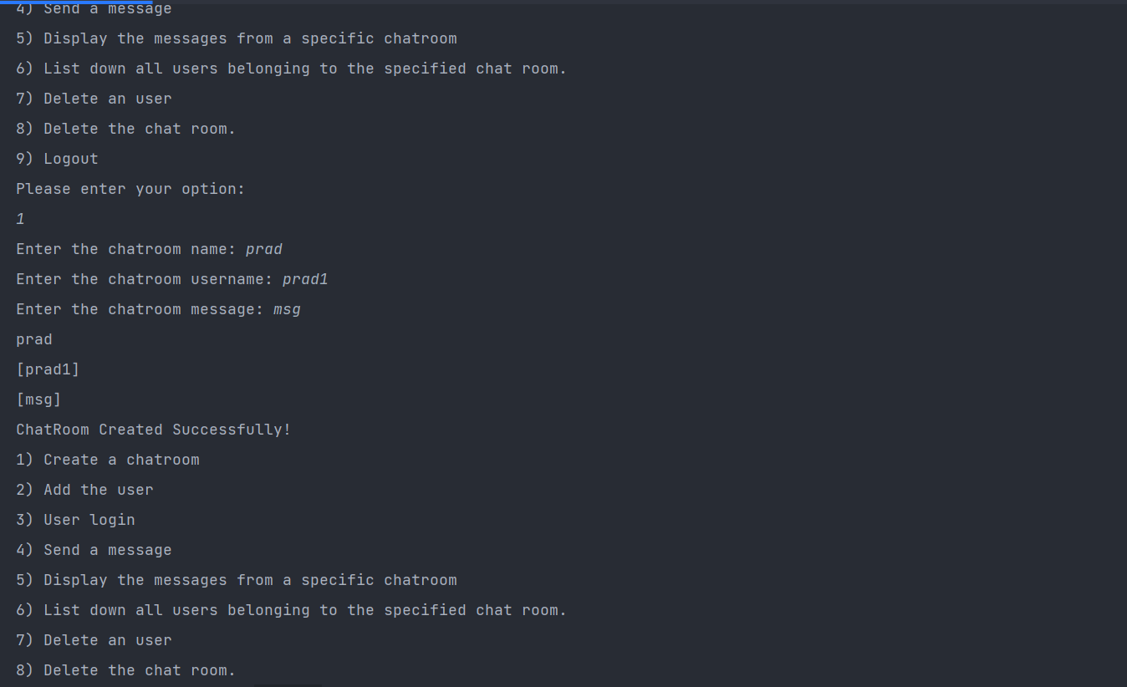

Q7.

*import* java.util.HashMap;  
*import* java.util.*Map*;  
*import* java.util.*Map*.*Entry*;  
*import* java.util.Scanner;  
  
*class* ParkingSlot {  
 *private* String ownerName;  
 *private int* carNumber;  
 *private int* token;  
 *private int* level;  
 *private int* section;  
 *private int* slot;  
  
 *public* String getOwnerName() {  
 *return* ownerName;  
 }  
  
 *public void* setOwnerName(String ownerName) {  
 *this*.ownerName = ownerName;  
 }  
  
 *public int* getCarNumber() {  
 *return* carNumber;  
 }  
  
 *public void* setCarNumber(*int* carNumber) {  
 *this*.carNumber = carNumber;  
 }  
  
  
 *public void* setLevel(*int* level) {  
 *this*.level = level;  
 }  
  
 *public int* getSection() {  
 *return* section;  
 }  
  
 *public void* setSection(*int* section) {  
 *this*.section = section;  
 }  
  
 *public int* getSlot() {  
 *return* slot;  
 }  
  
 *public void* setSlot(*int* slot) {  
 *this*.slot = slot;  
 }  
}  
  
*class* Parked_CarOwenerList *extends* Assignment3Q7{  
 *int* id = 1;  
 *int* levels = 3;  
 *int* sections = 4;  
 *int* slots = 20;  
 *Map*<Integer,Assignment3Q7> car = *new* HashMap<>();  
 *Map*<Integer,ParkingSlot> parkingSlotMap = *new* HashMap<>();  
  
 *public void* add_new_car(Assignment3Q7 obj){  
 Scanner sc = *new* Scanner(System.in);  
 System.out.print("Enter the name of the owner of car: ");  
 obj.setName(sc.nextLine());  
 System.out.print("Enter the car model: ");  
 obj.setCarModel(sc.nextLine());  
 System.out.print("Enter the car number: ");  
 obj.setCarNo(sc.nextInt());  
 System.out.print("Enter the owner mobile number: ");  
 obj.setMobileNumber(sc.nextInt());  
 System.out.print("Enter the address: ");  
 obj.setAddress(sc.nextLine());  
  
 car.put(id,obj);  
 id++;  
 System.out.println("User Registered Successfully!");  
 }  
 *public void* remove_car(String name,*int* carNo){  
 *int* key = 0;  
 *for* (*Map*.*Entry*<Integer, Assignment3Q7> mp: car.entrySet()){  
 Assignment3Q7 obj = mp.getValue();  
 *if*(obj.getName().equals(name)&&obj.getCarNo()==carNo){  
 key = mp.getKey();  
 *break*;  
 }  
 }  
 car.remove(key);  
 }  
 *public* String get_parked_car_location(*int* token){  
 Scanner sc = *new* Scanner(System.in);  
 ParkingSlot parkingSlot = *new* ParkingSlot();  
  
 System.out.print("Enter the ownerName: ");  
 parkingSlot.setOwnerName(sc.nextLine());  
  
 System.out.print("Enter the car number: ");  
 parkingSlot.setCarNumber(sc.nextInt());  
  
 System.out.print("Enter the level: ");  
 parkingSlot.setLevel(sc.nextInt());  
  
 System.out.print("Enter the Section: ");  
 parkingSlot.setLevel(sc.nextInt());  
  
 System.out.print("Enter the Slot: ");  
 parkingSlot.setSlot(sc.nextInt());  
  
 parkingSlotMap.put(token,parkingSlot);  
 *return* "CAR PARKED SUCCESSFULLY!";  
 }  
}  
  
*public class* Assignment3Q7 {  
 String name;  
 String carModel;  
 *int* carNo;  
 *int* mobileNumber;  
 String address;  
  
 *public* String getName() {  
 *return* name;  
 }  
  
 *public void* setName(String name) {  
 *this*.name = name;  
 }  
  
  
 *public void* setCarModel(String carModel) {  
 *this*.carModel = carModel;  
 }  
  
 *public int* getCarNo() {  
 *return* carNo;  
 }  
  
 *public void* setCarNo(*int* carNo) {  
 *this*.carNo = carNo;  
 }  
  
 *public void* setMobileNumber(*int* mobileNumber) {  
 *this*.mobileNumber = mobileNumber;  
 }  
  
 *public void* setAddress(String address) {  
 *this*.address = address;  
 }  
  
 *public void* menu(){  
 Parked_CarOwenerList parked_carOwenerList = *new* Parked_CarOwenerList();  
 Scanner sc = *new* Scanner(System.in);  
 *int* choice;  
 *do*{  
 System.out.println("1) ADD NEW CAR");  
 System.out.println("2) REMOVE CAR");  
 System.out.println("3) PARK THE CAR");  
 System.out.println("4) EXIT");  
 System.out.println("ENTER YOUR CHOICE");  
 choice = sc.nextInt();  
 *switch* (choice){  
 *case* 1: parked_carOwenerList.add_new_car(*new* Assignment3Q7());  
 *break*;  
 *case* 2: String name;  
 *int* number;  
 System.out.print("Enter the owner name: ");  
 name = sc.nextLine();  
 System.out.print("Enter the car number: ");  
 number = sc.nextInt();  
  
 parked_carOwenerList.remove_car(name,number);  
 *break*;  
 *case* 3:  
 System.out.println(parked_carOwenerList.get_parked_car_location(101));  
 *break*;  
 *case* 4:  
 System.*exit*(0);  
  
 *default*:  
 System.out.println("PLEASE ENTER THE CORRECT CHOICE!!");  
 }  
 }*while* (choice!=4);  
 }  
 *public static void* main(String[] args) {  
 Assignment3Q7 obj = *new* Assignment3Q7();  
 obj.menu();  
 }  
}

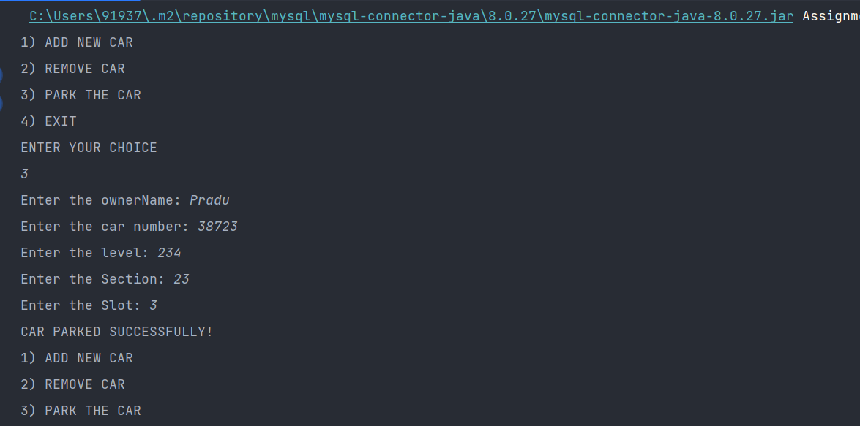

Q8.1

*import* java.util.HashMap;  
*import* java.util.*Iterator*;  
*import* java.util.*Map*;  
  
  
*public class* Assignment3Q8a {  
 *public static void* main(String[] args) {  
 *Map*<String, String> cityCode = *new* HashMap<String, String>();  
 cityCode.put("Delhi", "India");  
 cityCode.put("Moscow", "Russia");  
 cityCode.put("New York", "USA");  
  
 *Iterator* iterator = cityCode.keySet().iterator();  
  
 *while* (iterator.hasNext()) {  
 System.out.println(cityCode.get(iterator.next()));  
  
 cityCode.put("Istanbul", "Turkey");  
 }  
 }  
}

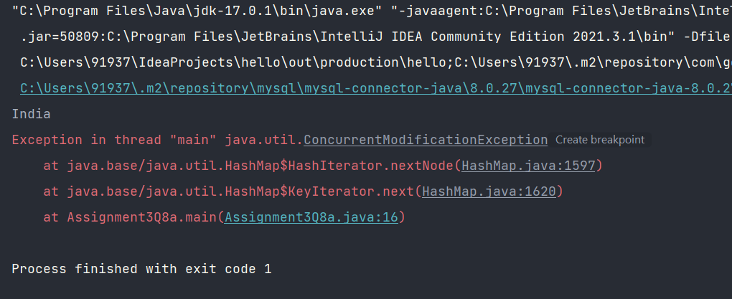

Q8.2

*import* java.util.concurrent.CopyOnWriteArrayList;  
*import* java.util.*Iterator*;  
  
*public class* Assignment3Q8b {  
 *public static void* main(String[] args) {  
 CopyOnWriteArrayList<Integer> list  
 = *new* CopyOnWriteArrayList<Integer>(*new* Integer[] { 1, 3, 5, 8 });  
 *Iterator* itr = list.iterator();  
 *while* (itr.hasNext()) {  
 Integer no = (Integer)itr.next();  
 System.out.println(no);  
 *if* (no == 8)  
  
 list.add(14);  
 }  
 }  
}

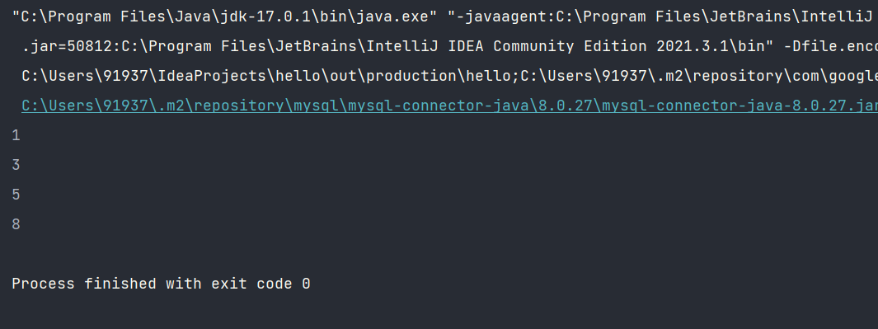

Q9

*import* java.util.*;  
  
*class* savingaccount {  
  
 *private double* acc_balance;  
 *private int* acc_ID;  
 *private* String accountHolderName;  
 *private boolean* isSalaryAccount;  
  
 *public double* getAcc_balance() {  
 *return* acc_balance;  
 }  
  
 *public void* setAcc_balance(*double* acc_balance) {  
 *this*.acc_balance = acc_balance;  
 }  
  
 *public int* getAcc_ID() {  
 *return* acc_ID;  
 }  
  
 *public void* setAcc_ID(*int* acc_ID) {  
 *this*.acc_ID = acc_ID;  
 }  
  
 *public* String getAccountHolderName() {  
 *return* accountHolderName;  
 }  
  
 *public void* setAccountHolderName(String accountHolderName) {  
 *this*.accountHolderName = accountHolderName;  
 }  
  
 *public boolean* isSalaryAccount() {  
 *return* isSalaryAccount;  
 }  
  
 *public void* setSalaryAccount(*boolean* salaryAccount) {  
 isSalaryAccount = salaryAccount;  
 }  
  
 *public void* withDraw(*double* amount){  
 *if*(*this*.acc_balance<amount){  
 System.out.println("YOUR ACCOUNT HAS INSUFFICIENT BALANCE");  
 }  
 *else*{  
 *this*.acc_balance-=amount;  
 System.out.println("MONEY WITHDRAWN SUCCESSFULLY");  
 System.out.println("ACCOUNT BALANCE = "+*this*.acc_balance);  
 }  
 }  
 *public void* Deposit(*double* amount){  
 *this*.acc_balance += amount;  
 System.out.println("MONEY ADDED SUCCESSFULLY");  
 System.out.println("ACCOUNT BALANCE = "+*this*.acc_balance);  
 }  
}  
*class* accountComparator *implements Comparator*<savingaccount>{  
  
 @Override  
 *public int* compare(savingaccount o1, savingaccount o2) {  
 *if*(o1.getAcc_ID()>o2.getAcc_ID()){  
 *return* -1;  
 }  
 *else if*(o1.getAcc_ID()<o2.getAcc_ID()){  
 *return* 1;  
 }  
 *else* {  
 *return* 0;  
 }  
 }  
}  
  
  
*class* BankAccountList{  
  
 TreeSet<savingaccount> savingAccounts = *new* TreeSet<>(*new* accountComparator());  
  
 *public boolean* addSavingAccount(savingaccount savingAccount) {  
 Scanner sc = *new* Scanner(System.in);  
  
 System.out.println("Enter the Account Id: ");  
 savingAccount.setAcc_ID(sc.nextInt());  
  
 System.out.println("Enter the Account holder name: ");  
 savingAccount.setAccountHolderName(sc.next());  
  
 System.out.println("Enter the Account Balance: ");  
 savingAccount.setAcc_balance(sc.nextDouble());  
  
 System.out.println("Is Saving Account (Yes/No): ");  
 String accountType = sc.next();  
 *if*(accountType.toUpperCase().equals("YES")){  
 savingAccount.setSalaryAccount(*true*);  
 }  
 *else*{  
 savingAccount.setSalaryAccount(*false*);  
 }  
  
 savingAccounts.add(savingAccount);  
 System.out.println("ACCOUNT REGISTERED SUCCESSFULLY");  
 *return true*;  
 }  
  
 *public List*<Integer> displaySavingAccountIds() {  
 *List*<Integer> id = *new* ArrayList<>();  
  
 *for*(savingaccount savingaccount: savingAccounts){  
 id.add(savingaccount.getAcc_ID());  
 }  
 *return* id;  
 }  
}  
  
  
*public class* Assignment3Q9 {  
 *public static void* main(String[] args) {  
 BankAccountList bankAccountList = *new* BankAccountList();  
 savingaccount savingaccount = *new* savingaccount();  
 Scanner sc = *new* Scanner(System.in);  
 *int* choice;  
 *do*{  
 System.out.println("1. ADD THE SAVING ACCOUNT");  
 System.out.println("2. DEPOSIT MONEY");  
 System.out.println("3. WITHDRAW MONEY");  
 System.out.println("4. DISPLAY THE SAVING ACCOUNT IDs");  
 System.out.println("ENTER YOUR CHOICE");  
 choice = sc.nextInt();  
 *switch* (choice){  
 *case* 1: bankAccountList.addSavingAccount(savingaccount);  
 *break*;  
  
 *case* 2:*double* amount;  
 System.out.println("Enter the amount to be deposit: ");  
 amount = sc.nextDouble();  
 savingaccount.Deposit(amount);  
 *break*;  
 *case* 3:  
 *double* amount1;  
 System.out.println("Enter the amount to be withdraw: ");  
 amount1 = sc.nextDouble();  
 savingaccount.withDraw(amount1);  
 *break*;  
 *case* 4: *List*<Integer> id = *new* ArrayList<>();  
 id = bankAccountList.displaySavingAccountIds();  
 System.out.println("Account Id: ");  
 *for*(Integer i: id){  
 System.out.println(i);  
 }  
 *break*;  
 *case* 5: System.*exit*(0);  
 *default*:  
 System.out.println("PLEASE ENTER THE VALID OPTION!");  
  
 }  
 }*while* (choice!=5);  
 }  
}

