1) Write a program that asks the user for a number n and prints the sum of the numbers 1 to n

<!DOCTYPE html>

<html lang="en">

<head>

    <meta charset="UTF-8">

    <meta http-equiv="X-UA-Compatible" content="IE=edge">

    <meta name="viewport" content="width=device-width, initial-scale=1.0">

    <title>Assignment 1</title>

</head>

<body>

</body>

<script>

    // program to display the sum of natural numbers

    // take input from the user

    const number = parseInt(prompt('Enter a positive integer: '));

    let sum = 0;

    // looping from i = 1 to number

    // in each iteration, i is increased by 1

    for (let i = 1; i <= number; i++) {

        sum += i;

    }

    document.write("The sum of the number 1 to " + number + " is: ", sum);

</script>

</html>

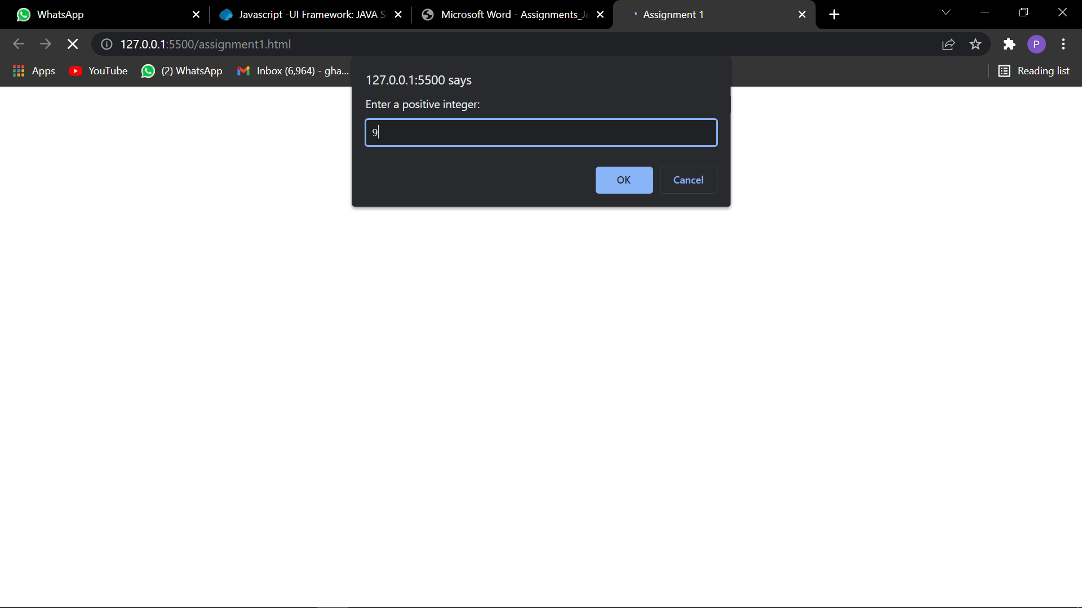

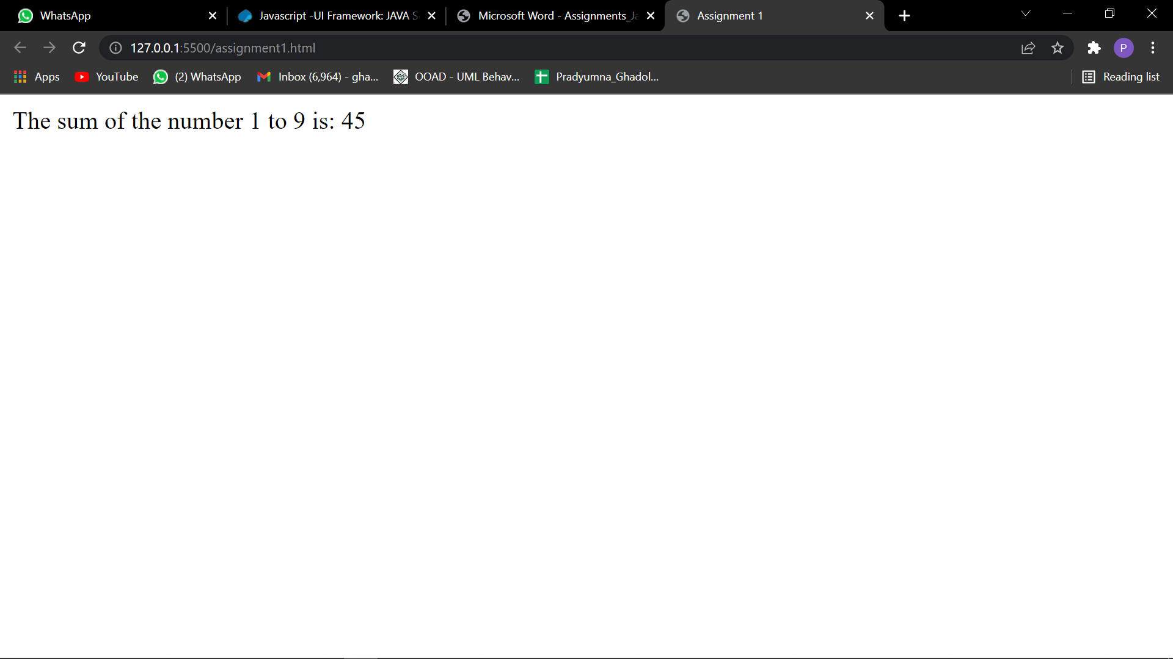

2) Modify the previous program such that only multiples of three or five are considered in the sum, e.g. 3, 5, 6, 9, 10, 12, 15 for n=17.

<!DOCTYPE html>

<html lang="en">

<head>

    <meta charset="UTF-8">

    <meta http-equiv="X-UA-Compatible" content="IE=edge">

    <meta name="viewport" content="width=device-width, initial-scale=1.0">

    <title>Assignment 2</title>

</head>

<body>

</body>

<script>

    // program to display the sum of natural numbers

    // take input from the user

    const number = parseInt(prompt('Enter a positive integer: '));

    let sum = 0;

    // looping from i = 1 to number

    // in each iteration, i is increased by 1

    for (let i = 1; i <= number; i++) {

        if (i % 3 == 0 || i % 5 == 0) {

            sum += i;

        }

    }

    document.write("The sum of the number 1 to " + number + " is: ", sum);

</script>

</html>

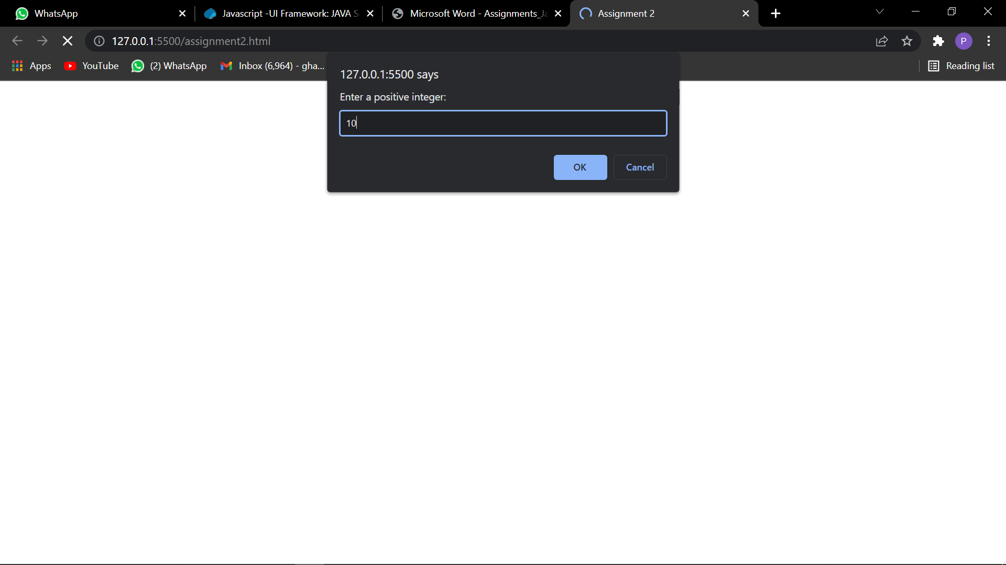

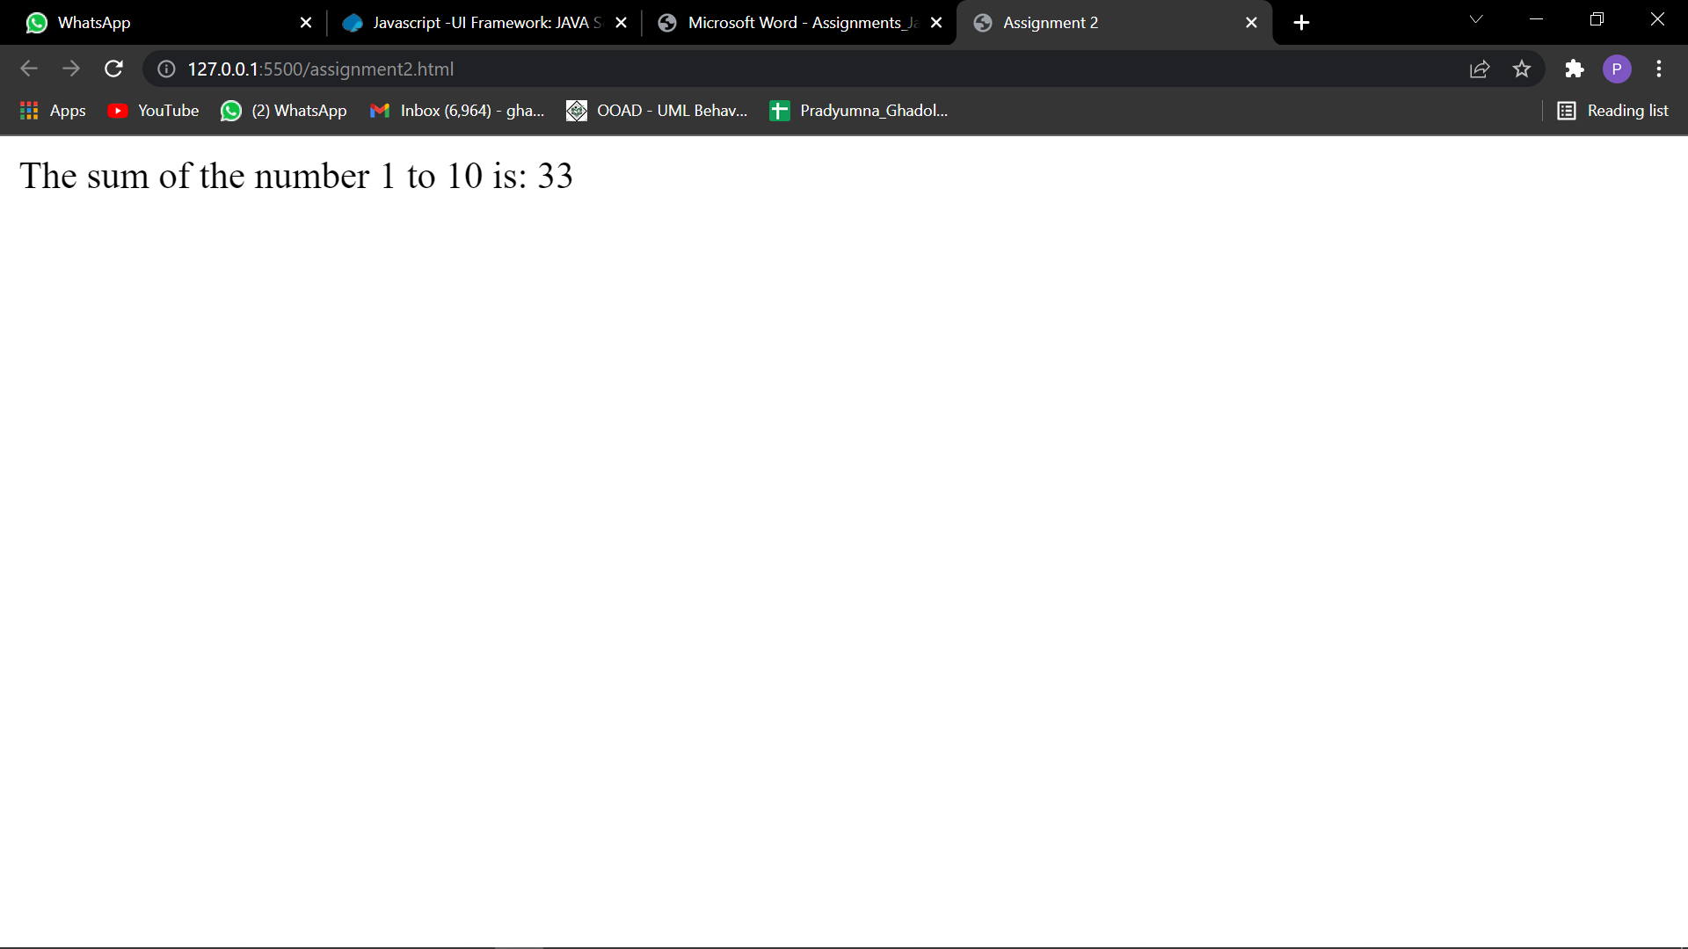

3) Make a function that returns “even” or “odd” depending on the number passed to it. parity(1); --> "odd" parity(2); --> "even"

<!DOCTYPE html>

<html lang="en">

<head>

    <meta charset="UTF-8">

    <meta http-equiv="X-UA-Compatible" content="IE=edge">

    <meta name="viewport" content="width=device-width, initial-scale=1.0">

    <title>Assignment 3</title>

</head>

<body>

</body>

<script>

    // program to display the sum of natural numbers

    // take input from the user

    const number = parseInt(prompt('Enter a positive integer: '));

    if (number % 2 == 0) {

        document.write("The number is Even!")

    } else {

        document.write("The number is Odd!")

    }

</script>

</html>

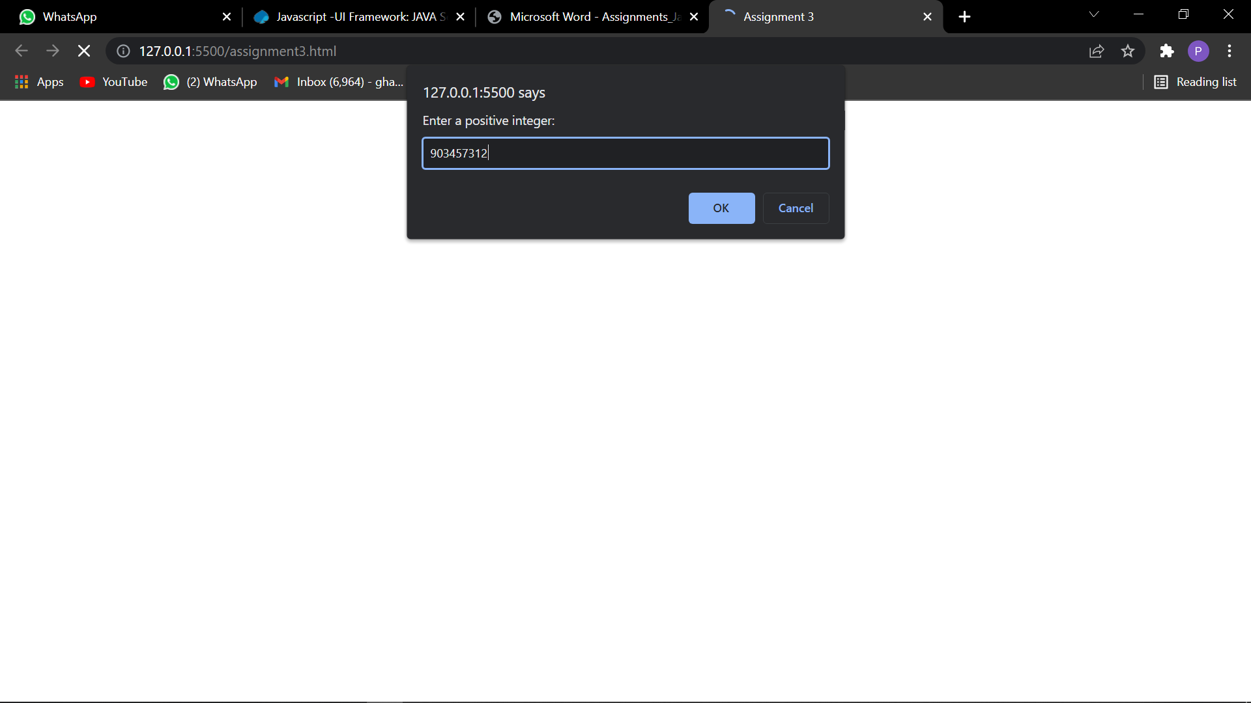

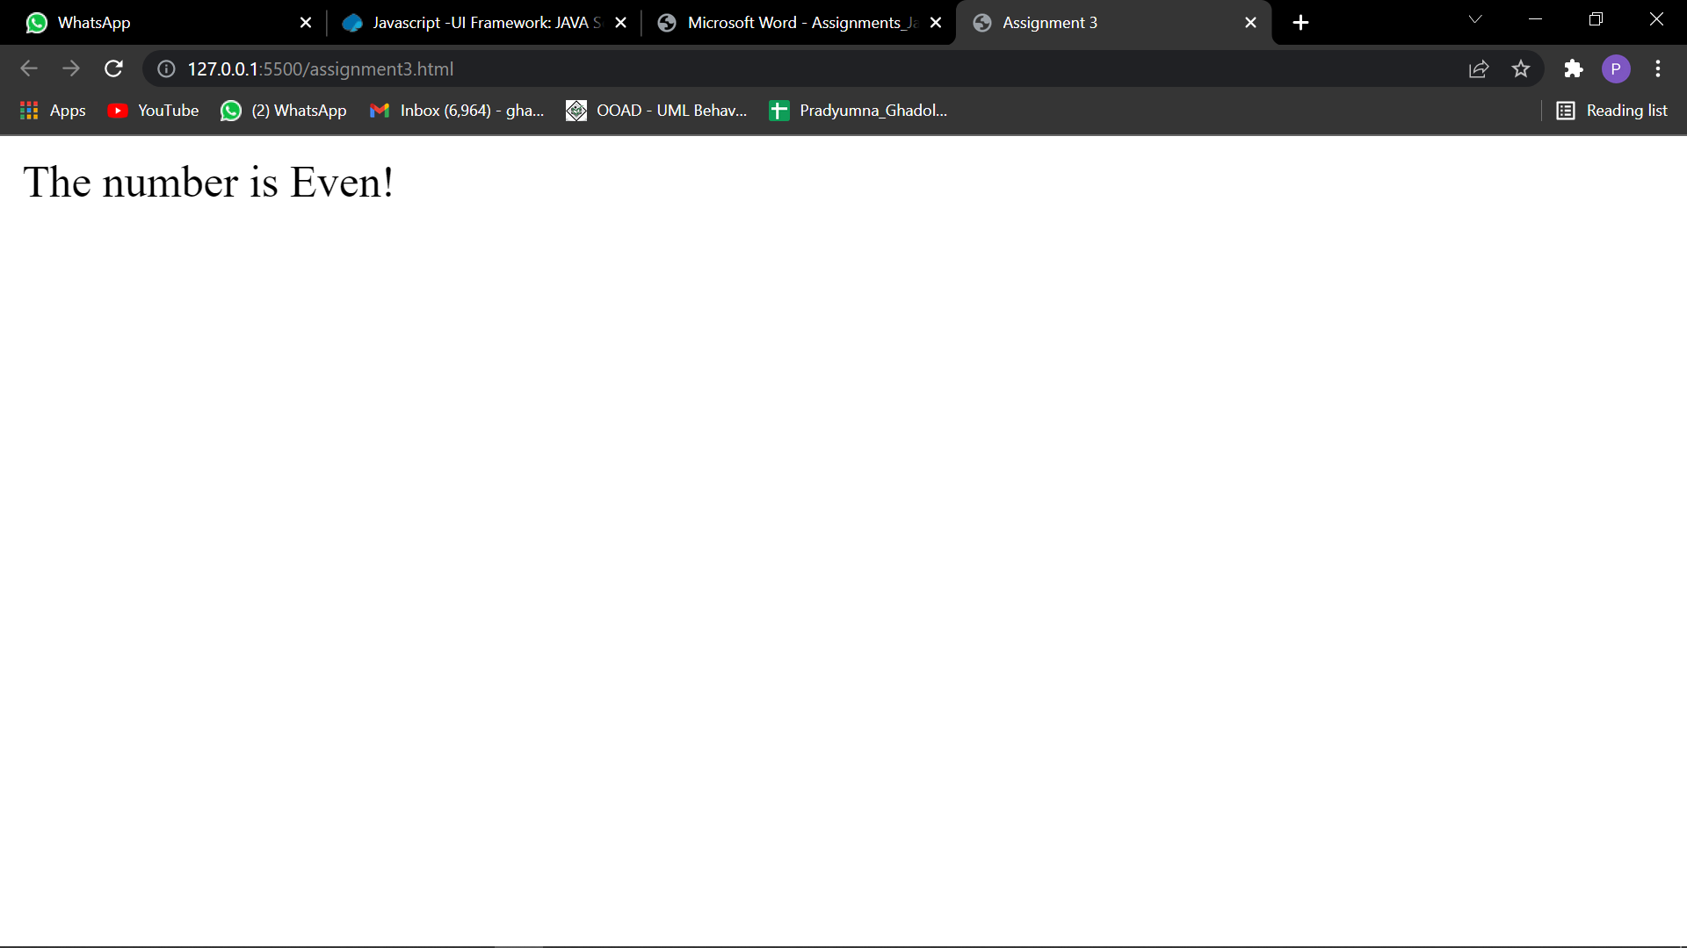

4) Make a function that takes number of flips as parameter and returns the fraction that were heads

headsRatio(10); --> 0.7

headsRatio(10); --> 0.4

headsRatio(10000); --> 0.5023

headsRatio(10000000); --> 0.4999948

5) Write a program that prints the next 20 leap years.

<!DOCTYPE html>

<html lang="en">

<head>

    <meta charset="UTF-8">

    <meta http-equiv="X-UA-Compatible" content="IE=edge">

    <meta name="viewport" content="width=device-width, initial-scale=1.0">

    <title>Assignment 5</title>

</head>

<body>

</body>

<script>

    let currentYear = parseInt(prompt("Enter the current year"));

    count = 0;

    while (count < 20) {

        if ((currentYear % 4 == 0) && (currentYear % 100 != 0) || (currentYear % 400 == 0)) {

            document.write(currentYear, ",");

            count++;

        }

        currentYear++;

    }

</script>

</html>

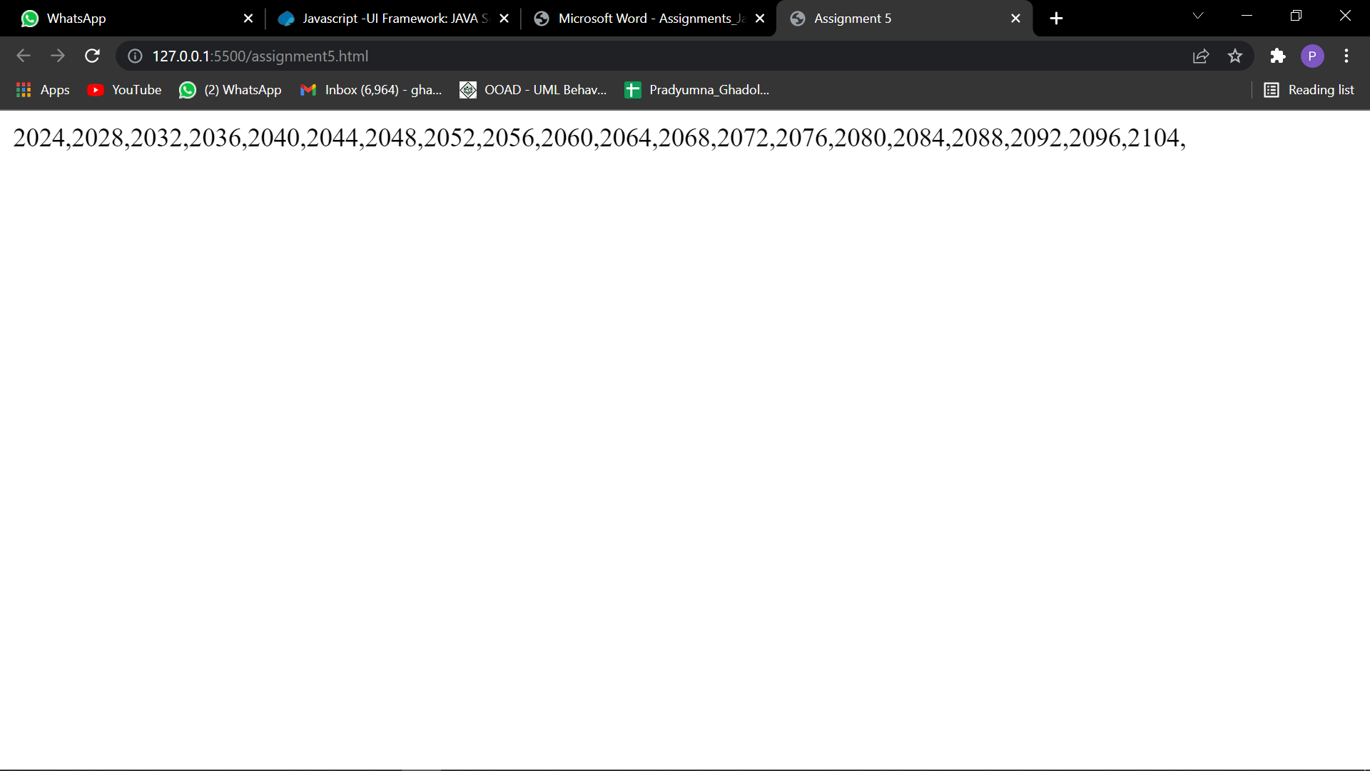

6) Write a function that takes a list of strings and prints them, one per line, in a rectangular frame. For example the list ["Hello", "World", "in", "a", "frame"] gets printed as:

\*\*\*\*\*\*\*\*\*

\* Hello \*

\* World \*

\* in \*

\* a \*

\* frame \*

\*\*\*\*\*\*\*\*\*

<!DOCTYPE html>

<html lang="en">

<head>

    <meta charset="UTF-8">

    <meta http-equiv="X-UA-Compatible" content="IE=edge">

    <meta name="viewport" content="width=device-width, initial-scale=1.0">

    <title>Assignment 6</title>

</head>

<body>

    <h3></h3>

</body>

<script>

    let list = ["Hello", "World", "In", "A", "Frame"];

    let element1 = document.createElement("h3");

    let element2 = document.createElement("h3");

    let element4 = document.createElement("h3");

    document.body.appendChild(element1);

    element2.innerHTML = "\*\*\*\*\*\*\*\*\*\*";

    document.body.appendChild(element2);

    list.forEach(function (element) {

        let element3 = document.createElement("h3");

        let str = element;

        str = "\*" + element + "\*";

        element3.innerText = str;

        document.body.appendChild(element3);

    });

    element4.innerHTML = "\*\*\*\*\*\*\*\*\*\*";

    document.body.appendChild(element4);

</script>

</html>

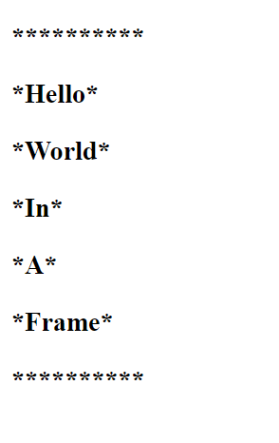

7) Create a Simple page that lets users enter a currency value in dollars and convert the value in other currencies.

E.g.1 dollar is:

a. 74.28 INR (Indian Rupee)

b. 109.14 Yen (Japanese Yen)

c. 0.84 Euro (Euro)

d. 0.72 Pound sterling (Pound sterling)

<!DOCTYPE html>

<html lang="en">

<head>

    <meta charset="UTF-8">

    <meta http-equiv="X-UA-Compatible" content="IE=edge">

    <meta name="viewport" content="width=device-width, initial-scale=1.0">

    <title>Document</title>

</head>

<body>

</body>

<script>

    let currency = prompt("Enter the currency value in dollars: ");

    const inr = currency \* 74.28;

    const yen = currency \* 109.14;

    const euro = currency \* 0.84;

    const pound = currency \* 0.72;

    let arr = {

        "Indian Rupee": inr,

        "Japanese Yen": yen,

        Euro: euro,

        "Pound Sterling": pound,

    };

    document.write(`<h3>Currency in dollars is = ${currency}</h3>`);

    for (const key in arr) {

        document.write(`<h3>${key} = ${arr[key]} </h3>`);

    }

</script>

</html>

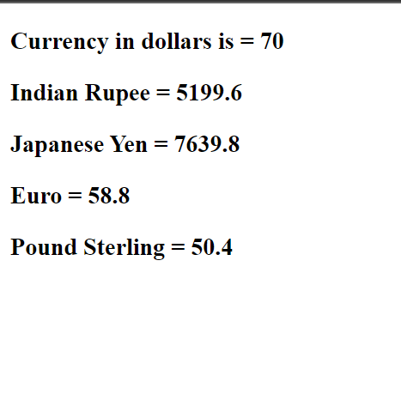

8) Write a function that concatenates two arrays [a,b,c], [1,2,3] -> [a,b,c,1,2,3]

<!DOCTYPE html>

<html lang="en">

<head>

    <meta charset="UTF-8">

    <meta http-equiv="X-UA-Compatible" content="IE=edge">

    <meta name="viewport" content="width=device-width, initial-scale=1.0">

    <title>Assignment 8</title>

</head>

<body>

</body>

<script>

    var inputArray = []

    var size = 5;

    for (let i = 0; i < size; i++) {

        inputArray[i] = prompt("Enter Element", i + 1);

    }

    var inputArray2 = []

    var size = 5;

    for (let i = 0; i < size; i++) {

        inputArray2[i] = prompt("Enter Element", i + 1);

    }

    document.write(inputArray)

    document.write("\n\n")

    document.write(inputArray2)

    const arr3 = inputArray.concat(inputArray2);

    document.write("The concatenated values are: ", arr3);

</script>

</html>

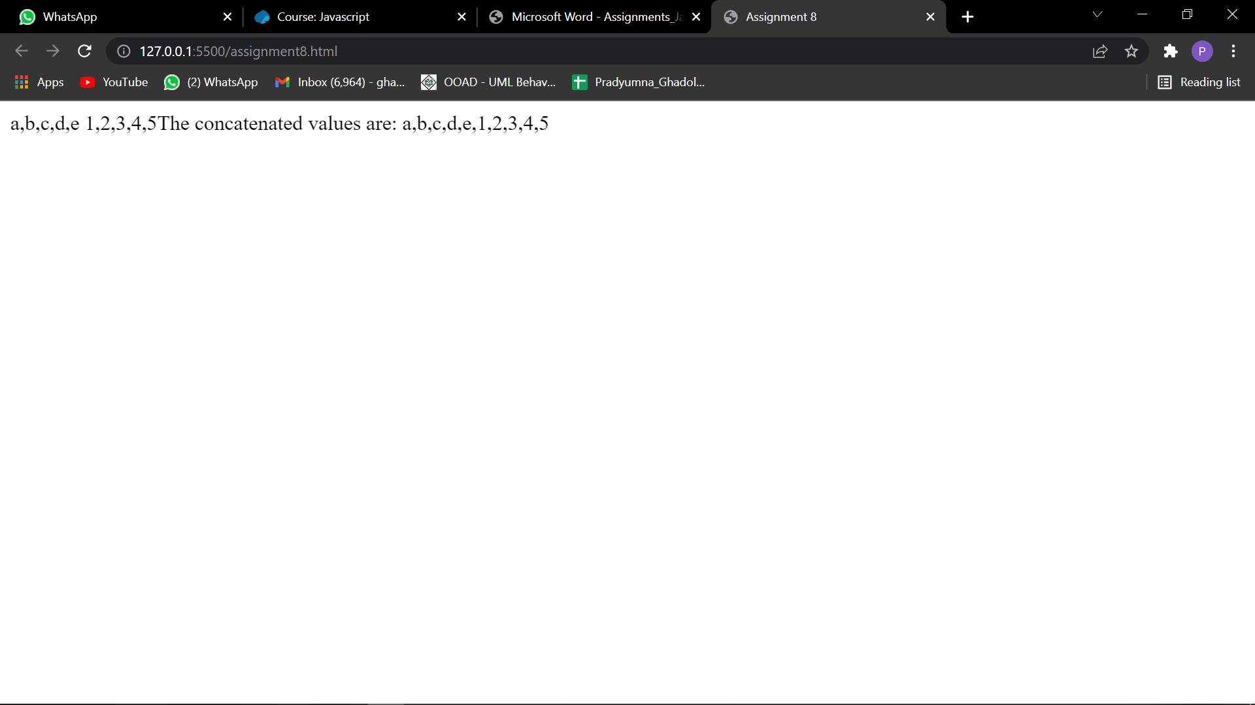

9) Write a function that combines two lists by alternatingly taking elements E.g. [a,b,c], [1,2,3] -> [a,1,b,2,c,3].

<!DOCTYPE html>

<html lang="en">

<head>

    <meta charset="UTF-8">

    <meta http-equiv="X-UA-Compatible" content="IE=edge">

    <meta name="viewport" content="width=device-width, initial-scale=1.0">

    <title>Assignment 8</title>

</head>

<body>

</body>

<script>

    var inputArray = []

    var size = 5;

    for (let i = 0; i < size; i++) {

        inputArray[i] = prompt("Enter Element", i + 1);

    }

    var inputArray2 = []

    var size = 5;

    for (let i = 0; i < size; i++) {

        inputArray2[i] = prompt("Enter Element", i + 1);

    }

    document.write(inputArray)

    document.write("\n\n")

    document.write(inputArray2)

    // function newList() {

    //     let l = inputArray.length + inputArray2.length;

    //     let arr3 = [];

    //     let j = 0, k = 0;

    //     for (let i = 0; i < l; i++) {

    //         if (i % 2 == 0) {

    //             arr3[i] = inputArray[j++];

    //         }

    //         else {

    //             arr3[i] = inputArray2[k++];

    //         }

    //     }

    //     return arr3;

    // }

    function newList() {

        let l = inputArray.length + inputArray2.length;

        let arr3 = [];

        let j = 0, k = 0;

        for (let i = 0; i < l; i++) {

            if (i % 2 == 0) {

                arr3[i] = inputArray[j]

                j++;

            }

            else {

                arr3[i] = inputArray2[k]

                k++;

            }

        }

        return arr3;

    }

    document.write(newList());

</script>

</html>

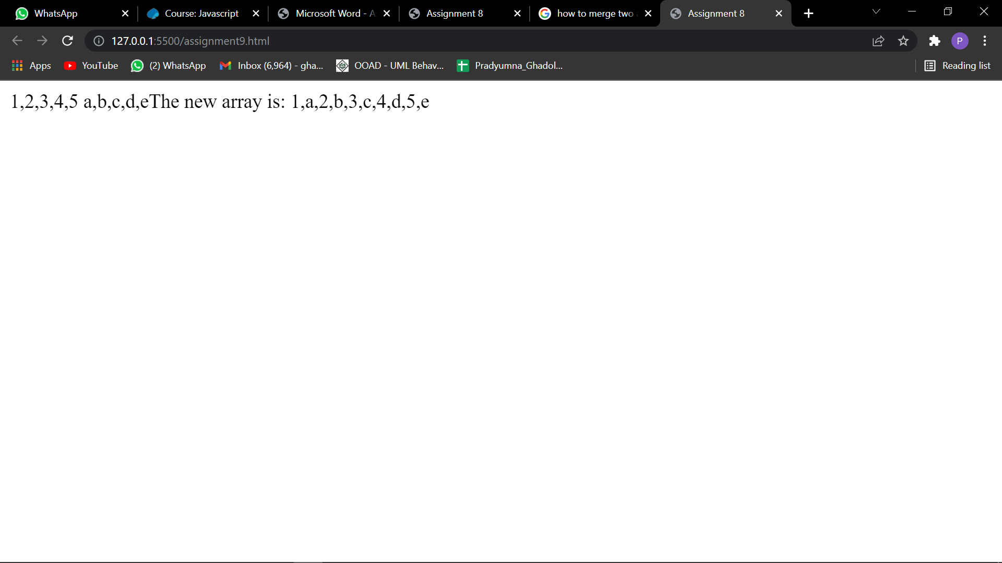

10) Write a function that computes the list of the first 100 Fibonacci numbers. The first two Fibonacci numbers are 1 and 1. The n+1-st Fibonacci number can be computed by adding the n-th and the n-1-th Fibonacci number. The first few are therefore 1, 1, 1+1=2, 1+2=3, 2+3=5, 3+5=8.

<!DOCTYPE html>

<html lang="en">

<head>

    <meta charset="UTF-8">

    <meta http-equiv="X-UA-Compatible" content="IE=edge">

    <meta name="viewport" content="width=device-width, initial-scale=1.0">

    <title>Assignment 10</title>

</head>

<body>

</body>

<script>

    const num = parseInt(prompt());

    let n1 = 1, n2 = 1, n3;

    document.write(n1, ",", n2);

    for (let i = 0; i < num; i++) {

        n3 = n1 + n2;

        document.write(",", n3);

        n1 = n2;

        n2 = n3;

    }

</script>

</html>

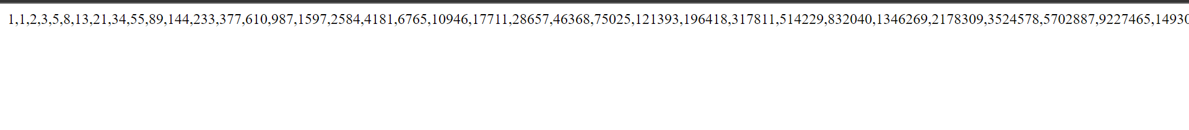

11) Write function that reverses an array of random values, preferably in place.

<!DOCTYPE html>

<html lang="en">

<head>

    <meta charset="UTF-8">

    <meta http-equiv="X-UA-Compatible" content="IE=edge">

    <meta name="viewport" content="width=device-width, initial-scale=1.0">

    <title>Assignment</title>

</head>

<body>

</body>

<script>

    const reverse = function (arr) {

        let newArr = [];

        let i = arr.length;

        while (i > 0) {

            newArr.push(arr[i]);

            i--;

        }

    }

    arr = [1, 2, 3, 4, 5];

    document.write("Orignal Array: ", arr, "<br/>")

    document.write("Reversed Array: ", arr.reverse());

</script>

</html>

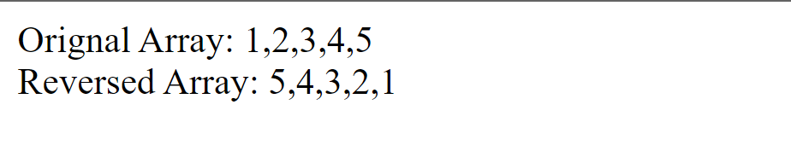

12) Write a function that, given a string, will return the longest token (consecutive string of characters) that contains neither an a nor a b.

longestToken("ababcdababefgababhiab"); --> "efg"

longestToken("aba"); --> ""

13) Write three functions that compute the sum of the numbers in an array: using

a. a for-loop,

b. a while-loop

c. a do-while-loop

<!DOCTYPE html>

<html lang="en">

<head>

    <meta charset="UTF-8">

    <meta http-equiv="X-UA-Compatible" content="IE=edge">

    <meta name="viewport" content="width=device-width, initial-scale=1.0">

    <title>Assignment</title>

</head>

<body>

</body>

<script>

    function sum(arr) {

        let sumOfArrayNum = 0;

        for (let i = 0; i < arr.length; i++) {

            sumOfArrayNum += arr[i];

        }

        return sumOfArrayNum;

    }

    function sum1(arr) {

        let sumOfArrayNum = 0;

        let i = 0;

        while (i < arr.length) {

            sumOfArrayNum += arr[i];

            i++;

        }

        return sumOfArrayNum;

    }

    function sum2(arr) {

        let sumOfArrayNum = 0;

        let i = 0;

        do {

            sumOfArrayNum += arr[i];

            i++;

        } while (i < arr.length);

        return sumOfArrayNum;

    }

    let arr = [1, 2, 3, 4, 5];

    document.write(arr, "<br/>");

    document.write("Using for loop: ", sum(arr), "<br/>");

    document.write("Using while loop: ", sum1(arr), "<br/>");

    document.write("Using dowhile loop: ", sum2(arr));

</script>

</html>

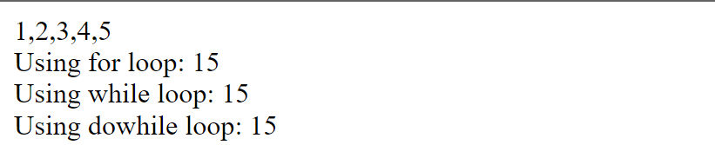

14) Create an array containing 100 random numbers.

a. Print the largest number amongst the 100

b. Print the smallest number amongst the 100

c. Print which count is high even count or odd count

d. Print the sum and average value

<!DOCTYPE html>

<html lang="en">

<head>

    <meta charset="UTF-8">

    <meta http-equiv="X-UA-Compatible" content="IE=edge">

    <meta name="viewport" content="width=device-width, initial-scale=1.0">

    <title>Assignment</title>

</head>

<body>

</body>

<script>

    function largest(array) {

        let max = array[0];

        for (let i = 0; i < array.length; i++) {

            if (array[i] > max) {

                max = array[i];

            }

        }

        return max;

    }

    function smallest(array) {

        let min = array[0];

        for (let i = 0; i < array.length; i++) {

            if (array[i] < min) {

                min = array[i];

            }

        }

        return min;

    }

    function sum(array) {

        let add = 0;

        for (let i = 0; i < array.length; i++) {

            add += array[i];

        }

        return add;

    }

    function avg(array) {

        let add = 0;

        for (let i = 0; i < array.length; i++) {

            add += array[i];

        }

        return add / 100;

    }

    const array = Array(100).fill().map(() => 1000 \* Math.random());

    document.write("Array of random numbers: ", array, "<br/>");

    document.write("Max element is: ", largest(array), "<br/>");

    document.write("Min element is: ", smallest(array), "<br/>");

    document.write("Sum element is: ", sum(array), "<br/>");

    document.write("Avg element is: ", avg(array), "<br/>");

</script>

</html>

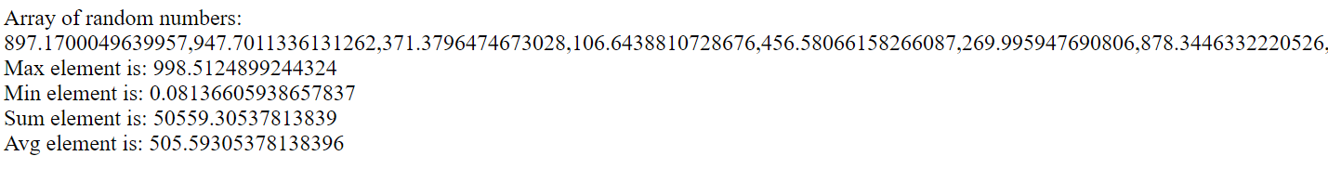

15) Given an array of size 20 filled with random positive values. Implement the following sorting Algorithms: a. Bubble sort b. Merge Sort (Optional)

<!DOCTYPE html>

<html lang="en">

<head>

    <meta charset="UTF-8">

    <meta http-equiv="X-UA-Compatible" content="IE=edge">

    <meta name="viewport" content="width=device-width, initial-scale=1.0">

    <title>Assignment</title>

</head>

<body>

</body>

<script>

    function swap(arr, xp, yp) {

        var temp = arr[xp];

        arr[xp] = arr[yp];

        arr[yp] = temp;

    }

    // An optimized version of Bubble Sort

    function bubbleSort(arr, n) {

        var i, j;

        for (i = 0; i < n - 1; i++) {

            for (j = 0; j < n - i - 1; j++) {

                if (arr[j] > arr[j + 1]) {

                    swap(arr, j, j + 1);

                }

            }

        }

    }

    /\* Function to print an array \*/

    function printArray(arr, size) {

        var i;

        for (i = 0; i < size; i++)

            document.write(arr[i] + " ");

        document.write("\n");

    }

    // Driver program to test above functions

    var arr = [64, 34, 25, 12, 22, 11, 90];

    var n = 7;

    document.write("UnSorted array: \n");

    printArray(arr, n);

    bubbleSort(arr, n);

    document.write("Sorted array: \n");

    printArray(arr, n);

</script>

</html>



16) Create an HTML page that will Prompt the user: It should take input for the number of rows and the number of columns Then it should create a table (HTML table) with the given number of row and columns Each cell of the table should contain the cell id (row#, col#).

<!DOCTYPE html>

<html lang="en">

<head>

    <meta charset="UTF-8">

    <meta http-equiv="X-UA-Compatible" content="IE=edge">

    <meta name="viewport" content="width=device-width, initial-scale=1.0">

    <title>Assignment</title>

</head>

<style>

    body {

        margin: 30px;

    }

</style>

<body>

    <table id="myTable" border="1"></table>

    <form>

        <input type="button" onclick="createTable()" value="Create the table">

    </form>

</body>

<script>

    function createTable() {

        row = parseInt(window.prompt("Input number of rows"));

        col = parseInt(window.prompt("Input number of columns"));

        for (let i = 0; i < row; i++) {

            var x = document.getElementById("myTable").insertRow(i);

            for (let j = 0; j < col; j++) {

                var y = x.insertCell();

                y.innerHTML = "Row-" + i + "Column" + j;

            }

        }

    }

</script>

</html>

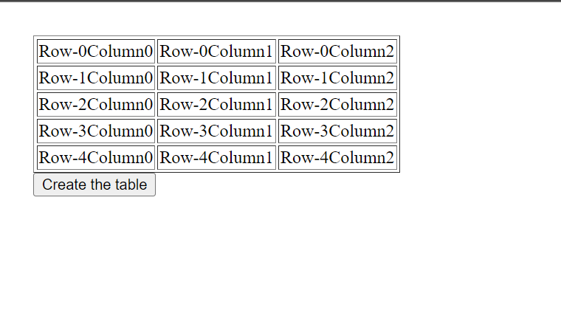

17) Write a function that rotates a list by k elements. For example [1,2,3,4,5,6] rotated by two becomes [3,4,5,6,1,2]. Try solving this without creating a copy of the list. How many swap or move operations do you need?

<!DOCTYPE html>

<html lang="en">

<head>

    <meta charset="UTF-8">

    <meta http-equiv="X-UA-Compatible" content="IE=edge">

    <meta name="viewport" content="width=device-width, initial-scale=1.0">

    <title>Document</title>

</head>

<body>

</body>

<script>

    const k = parseInt(prompt("Enter the swap turns"))

    var list = [1, 2, 3, 4, 5, 6, 7];

    document.write("Without swap: ", list, "<br/>");

    var myList = [];

    for (let i = k; i < list.length; i++) {

        myList.push(list[i]);

    }

    for (let j = 0; j < k; j++) {

        myList.push(list[j]);

    }

    document.write("This is after swap: ", myList)

    // console.log(myList);

</script>

</html>

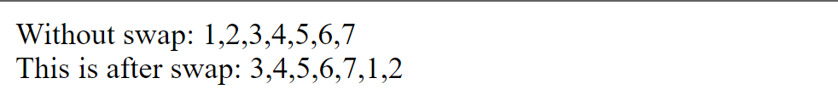

19) Design a simple calculator with a TextField and buttons for values 1,2…9,0 and symbols +,- ,\*,/ & =. Clicking on the button to display the content on the textfield and clicking the button with = should display the result e.g. clicking buttons with labels 2, +, 2 should show on the textfield “2 + 2” and when hit the button with equals sign should result as 4. Also, there should be a clear button to clear the textfield

<!DOCTYPE html>

<html lang="en">

<head>

    <meta charset="UTF-8">

    <meta http-equiv="X-UA-Compatible" content="IE=edge">

    <meta name="viewport" content="width=device-width, initial-scale=1.0">

    <title>Assignment</title>

    <style>

        .container {

            max-width: 300px;

            margin: 10vh auto 0 auto;

            box-shadow: 0px 0px 43px 17px rgba(153, 153, 153, 1);

        }

        #display {

            text-align: right;

            height: 70px;

            line-height: 70px;

            padding: 16px 8px;

            font-size: 25px;

        }

        .buttons {

            display: grid;

            border-bottom: 1px solid #999;

            border-left: 1px solid#999;

            grid-template-columns: 1fr 1fr 1fr 1fr;

        }

        .buttons>div {

            border-top: 1px solid #999;

            border-right: 1px solid#999;

        }

        .button {

            border: 0.5px solid #999;

            line-height: 80px;

            text-align: center;

            font-size: 15px;

            cursor: pointer;

        }

        #equal {

            background-color: rgb(85, 85, 255);

            color: white;

        }

        .button:hover {

            background-color: #323330;

            color: white;

            transition: 0.5s ease-in-out;

        }

    </style>

</head>

<body>

    <section>

        <div class="container">

            <div id="display"></div>

            <div class="buttons">

                <div class="button">C</div>

                <div class="button">/</div>

                <div class="button">\*</div>

                <div class="button">&larr;</div>

                <div class="button">7</div>

                <div class="button">8</div>

                <div class="button">9</div>

                <div class="button">-</div>

                <div class="button">4</div>

                <div class="button">5</div>

                <div class="button">6</div>

                <div class="button">+</div>

                <div class="button">1</div>

                <div class="button">2</div>

                <div class="button">3</div>

                <div class="button">.</div>

                <div class="button">(</div>

                <div class="button">0</div>

                <div class="button">)</div>

                <div id="equal" class="button">=</div>

            </div>

        </div>

    </section>

</body>

<script>

    let display = document.getElementById('display');

    let buttons = Array.from(document.getElementsByClassName('button'));

    buttons.map(button => {

        button.addEventListener('click', (e) => {

            switch (e.target.innerText) {

                case 'C':

                    display.innerText = '';

                    break;

                case '=':

                    try {

                        display.innerText = eval(display.innerText)

                    } catch {

                        display.innerText = "ERROR"

                    }

                    break;

                case '←':

                    if (display.innerText) {

                        display.innerText = display.innerText.slice(0, -1);

                    }

                    break;

                default:

                    display.innerText += e.target.innerText;

            }

        });

    });

</script>

</html>

