*Q1.*

*import* java.io.BufferedReader;  
*import* java.io.FileReader;  
*import* java.util.ArrayList;  
*import* java.util.*List*;  
  
*public class* StringAssignment {  
 *public static void* main(String[] args) *throws* Exception {  
 String line;  
  
 *List*<String> str = *new* ArrayList<>();  
  
 *int* count = 0;  
  
 FileReader file = *new* FileReader("C:\\students.txt");  
 BufferedReader br = *new* BufferedReader(file);  
 *while* ((line = br.readLine()) != *null*){  
 *if* (line.isEmpty()){  
 }  
 *else* {  
 str.add(line);  
 count++;  
 }  
 }  
 System.out.println(count);  
 System.out.println(str);  
 br.close();  
 }  
}

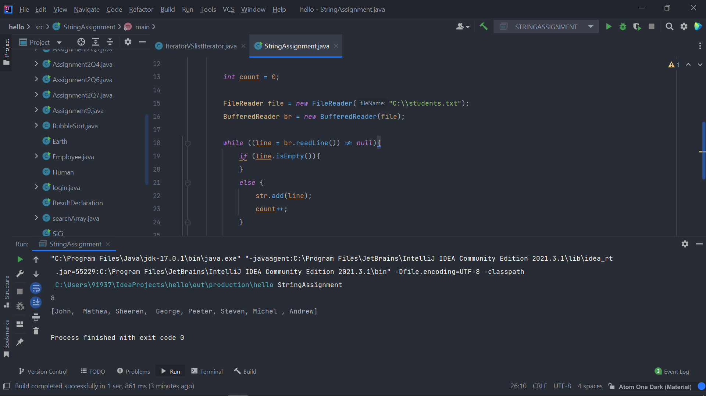

Q2.

import java.util.Scanner;

public class String_assignmentQ2 {

public static void main(String[] args){

Scanner sc = new Scanner(System.in);

int count =0;

int price,total=0;

int choice=0;

do{

System.out.println("1) INSERT NEW PRICE");

System.out.println("2) VIEW PURCHASE TOTAL");

System.out.println("3) EXIT");

System.out.println("ENTER YOUR CHOICE: ");

choice=sc.nextInt();

switch (choice){

case 1:

String s="yes";

do{

System.out.println("Insert" + (count+1) + "price");

price = sc.nextInt();

total += price;

System.out.println(" Price has been saved to the file");

System.out.println("Do you want to enter price for more items?(Yes/No)");

s = sc.next();

count++;

System.out.println();

}

while(s.equalsIgnoreCase("Yes"));

break;

case 2:

System.out.println("Total price of all items is: " +total);

break;

case 3:

System.exit(0);

default:

System.out.println("PLEASE ENTER THE CORRECT CHOICE!!!!");

}

}

while(choice !=3);

}

}

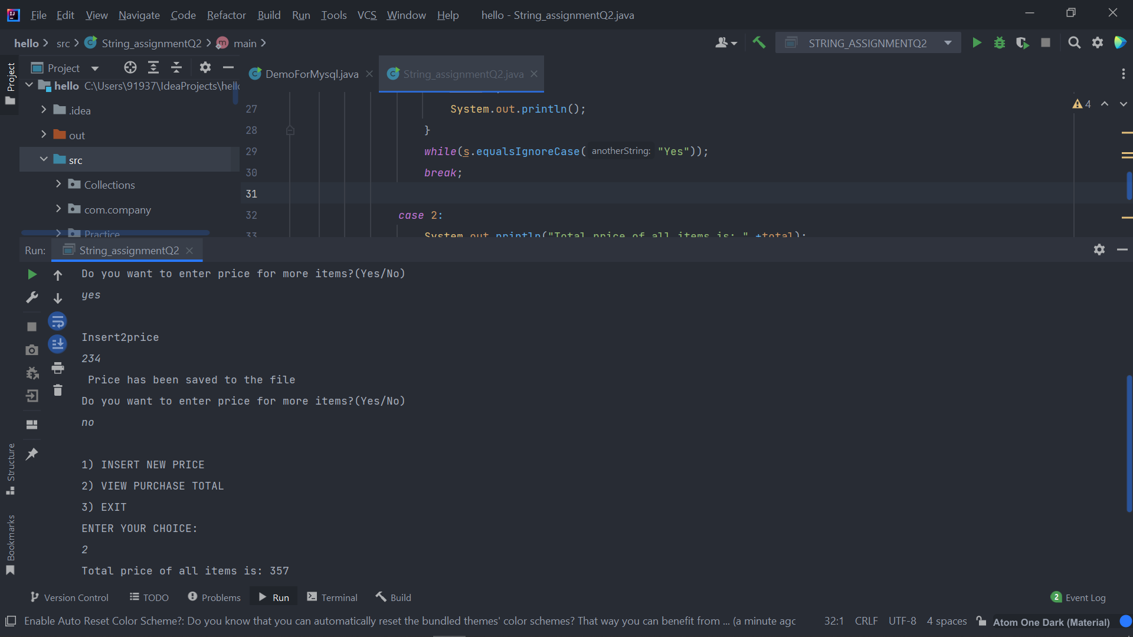

import java.io.BufferedReader;

import java.io.IOException;

import java.io.InputStreamReader;

import java.net.HttpURLConnection;

import java.net.URL;

import java.net.URLConnection;

import java.util.List;

import java.util.Map;

public class String_assignmentQ3 {

public static void main(String[] args) throws IOException {

try{

URL url= new URL("https://httpbin.org/get");

HttpURLConnection http= (HttpURLConnection)url.openConnection();

URLConnection urlcon = url.openConnection();

Map<String , List<String>>header = urlcon.getHeaderFields();

for(Map.Entry<String , List<String>> mp:header.entrySet())

{

System.out.println(mp.getKey() + ":");

System.out.println(mp.getValue().toString());

}

System.out.println("Get response header by key ...");

List<String> contentLength=header.get("Content-Length");

if(contentLength==null){

System.out.println("Content-Length doesn't present in header");

}

else{

for(String header1: contentLength){

System.out.println("Content=Length" + header1);

}

}

int statuscode = http.getResponseCode();

System.out.println("Status Code"+statuscode);

System.out.println();

System.out.println("complete source code of the URL is: ");

BufferedReader br= new BufferedReader(new InputStreamReader(urlcon.getInputStream()));

String i;

while((i= br.readLine()) != null){

System.out.println(i);

}

}

catch(Exception e)

{

System.out.println(e);

}

}

}

