Q.2

Controller.java

package org.example.controller;

import org.springframework.stereotype.Controller;

import org.springframework.ui.Model;

import org.springframework.web.bind.annotation.RequestMapping;

import org.springframework.web.bind.annotation.RequestMethod;

import org.springframework.web.bind.annotation.RequestParam;

//method = RequestMethod.POST

@Controller

public class controller {

@RequestMapping(path = "/simpleinterest",method = RequestMethod.POST)

public String simpleInterest(@RequestParam("principal")int principal,

@RequestParam("rate") int rate,

@RequestParam("time")int time,

Model model){

System.out.println("This is my simple interest page");

int si = (principal*time*rate)/100;

model.addAttribute("simpleinterest",si);

return "simpleinterest";

}

}

simpleIntrest.jsp

<%@ page language=*"java"* contentType=*"text/html; charset=ISO-8859-1"*

pageEncoding=*"ISO-8859-1"*%>

<%@ page isELIgnored=*"false"*%>

<!DOCTYPE html>

<html>

<head>

<meta charset=*"ISO-8859-1"*>

<title>Simple Interest</title>

</head>

<body>

<div class=*"container"*>

<h1>Simple interest is: ${simpleinterest}</h1>

</div>

</body>

</html>

Index.jsp

<!DOCTYPE html>

<html lang=*"en"*>

<head>

<meta charset=*"UTF-8"*>

<meta http-equiv=*"X-UA-Compatible"* content=*"IE=edge"*>

<meta name=*"viewport"* content=*"width=device-width, initial-scale=1.0"*>

<title>Simple Interest Calculator</title>

</head>

</style>

<body>

<div class=*"container"*>

<div class=*"title"*>Simple Interest Calculator</div>

<form method=*"post"* action=*"simpleinterest"* class=*"form"* name=*"SI"*

id=*"form"*>

<div class=*"user-details"*>

<div class=*"input-box"*>

<span class=*"details"*>Principal Amount</span> <input type=*"text"*

placeholder=*"Enter the principal amount"* name=*"principal"* required>

</div>

<div class=*"input-box"*>

<span class=*"details"*>Rate of Interest</span> <input type=*"text"*

placeholder=*"Enter the rate of interest"* name=*"rate"* required>

</div>

<div class=*"input-box"*>

<span class=*"details"*>Time Period</span> <input type=*"text"*

placeholder=*"Enter the time period"* name=*"time"* required>

</div>

</div>

<div class=*"button"*>

<input type=*"submit"* value=*"Calculate Simple Interest"*>

</div>

</form>

</div>

</div>

</body>

</html>

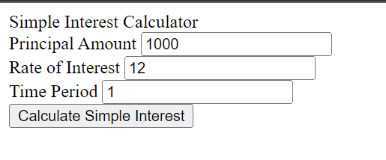

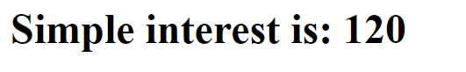

Q.3

Controller.java

package org.example.controller;

import org.springframework.stereotype.Controller;

import org.springframework.web.bind.annotation.RequestMapping;

import org.springframework.web.bind.annotation.RequestMethod;

import org.springframework.web.bind.annotation.RequestParam;

import org.springframework.web.servlet.ModelAndView;

@Controller

public class controller {

@RequestMapping(path = "/login",method = RequestMethod.POST)

public ModelAndView login(@RequestParam("username")String username, @RequestParam("password")String password){

UserModel userModel = new UserModel();

userModel.setEmail("abc@gmail.com");

userModel.setUsername("abc");

userModel.setPassword("123");

if(username.equals(userModel.getUsername()) && password.equals(userModel.getPassword())){

ModelAndView modelAndView = new ModelAndView("success");

modelAndView.addObject("user",userModel);

return modelAndView;

}

else {

return new ModelAndView("error");

}

}

}

UserModel.java

package org.example.controller;

import org.springframework.stereotype.Controller;

import org.springframework.web.bind.annotation.RequestMapping;

import org.springframework.web.bind.annotation.RequestMethod;

import org.springframework.web.bind.annotation.RequestParam;

import org.springframework.web.servlet.ModelAndView;

@Controller

public class controller {

@RequestMapping(path = "/login",method = RequestMethod.POST)

public ModelAndView login(@RequestParam("username")String username, @RequestParam("password")String password){

UserModel userModel = new UserModel();

userModel.setEmail("abc@gmail.com");

userModel.setUsername("abc");

userModel.setPassword("123");

if(username.equals(userModel.getUsername()) && password.equals(userModel.getPassword())){

ModelAndView modelAndView = new ModelAndView("success");

modelAndView.addObject("user",userModel);

return modelAndView;

}

else {

return new ModelAndView("error");

}

}

}

Index.jsp

<!DOCTYPE html>

<html lang=*"en"*>

<head>

<meta charset=*"UTF-8"*>

<meta http-equiv=*"X-UA-Compatible"* content=*"IE=edge"*>

<meta name=*"viewport"* content=*"width=device-width, initial-scale=1.0"*>

<title>Simple Interest Calculator</title>

</head>

<body>

<div class=*"container"*>

<div class=*"title"*>

LOGIN FORM

</div>

<form method = *"post"* action=*"login"* class=*"form"* name=*"form"* id=*"form"*>

<div class=*"user-details"*>

<div class=*"input-box"*>

<span class=*"details"*>USERNAME</span>

<input type=*"text"* placeholder=*"Enter the username"* name=*"username"* required>

</div>

<div class=*"input-box"*>

<span class=*"details"*>PASSWORD</span>

<input type=*"password"* placeholder=*"Enter the password"* name=*"password"* required>

</div>

</div>

<div class=*"button"*>

<input type=*"submit"* value=*"Login"*>

</div>

</form>

</div>

</div>

</body>

</html>

Success.jsp

<%@ page contentType=*"text/html;charset=UTF-8"* language=*"java"* %>

<%@ page isELIgnored=*"false"* %>

<html>

<head>

<title>Success Page</title>

</head>

<body>

<h1 color=*"green"*>Welcome ${user.username}</h1>

<hr>

<h1 color=*"green"*>Email Id is: ${user.email}</h1>

<hr>

<h1 color=*"green"*>Password is: ${user.password}</h1>

</body>

</html>

Error.jsp

<%@ page contentType=*"text/html;charset=UTF-8"* language=*"java"* %>

<html>

<head>

<title>Error Page</title>

</head>

<body>

<h1 align=*"center"* color=*"red"*>Username or password is incorrect</h1>

</body>

</html>

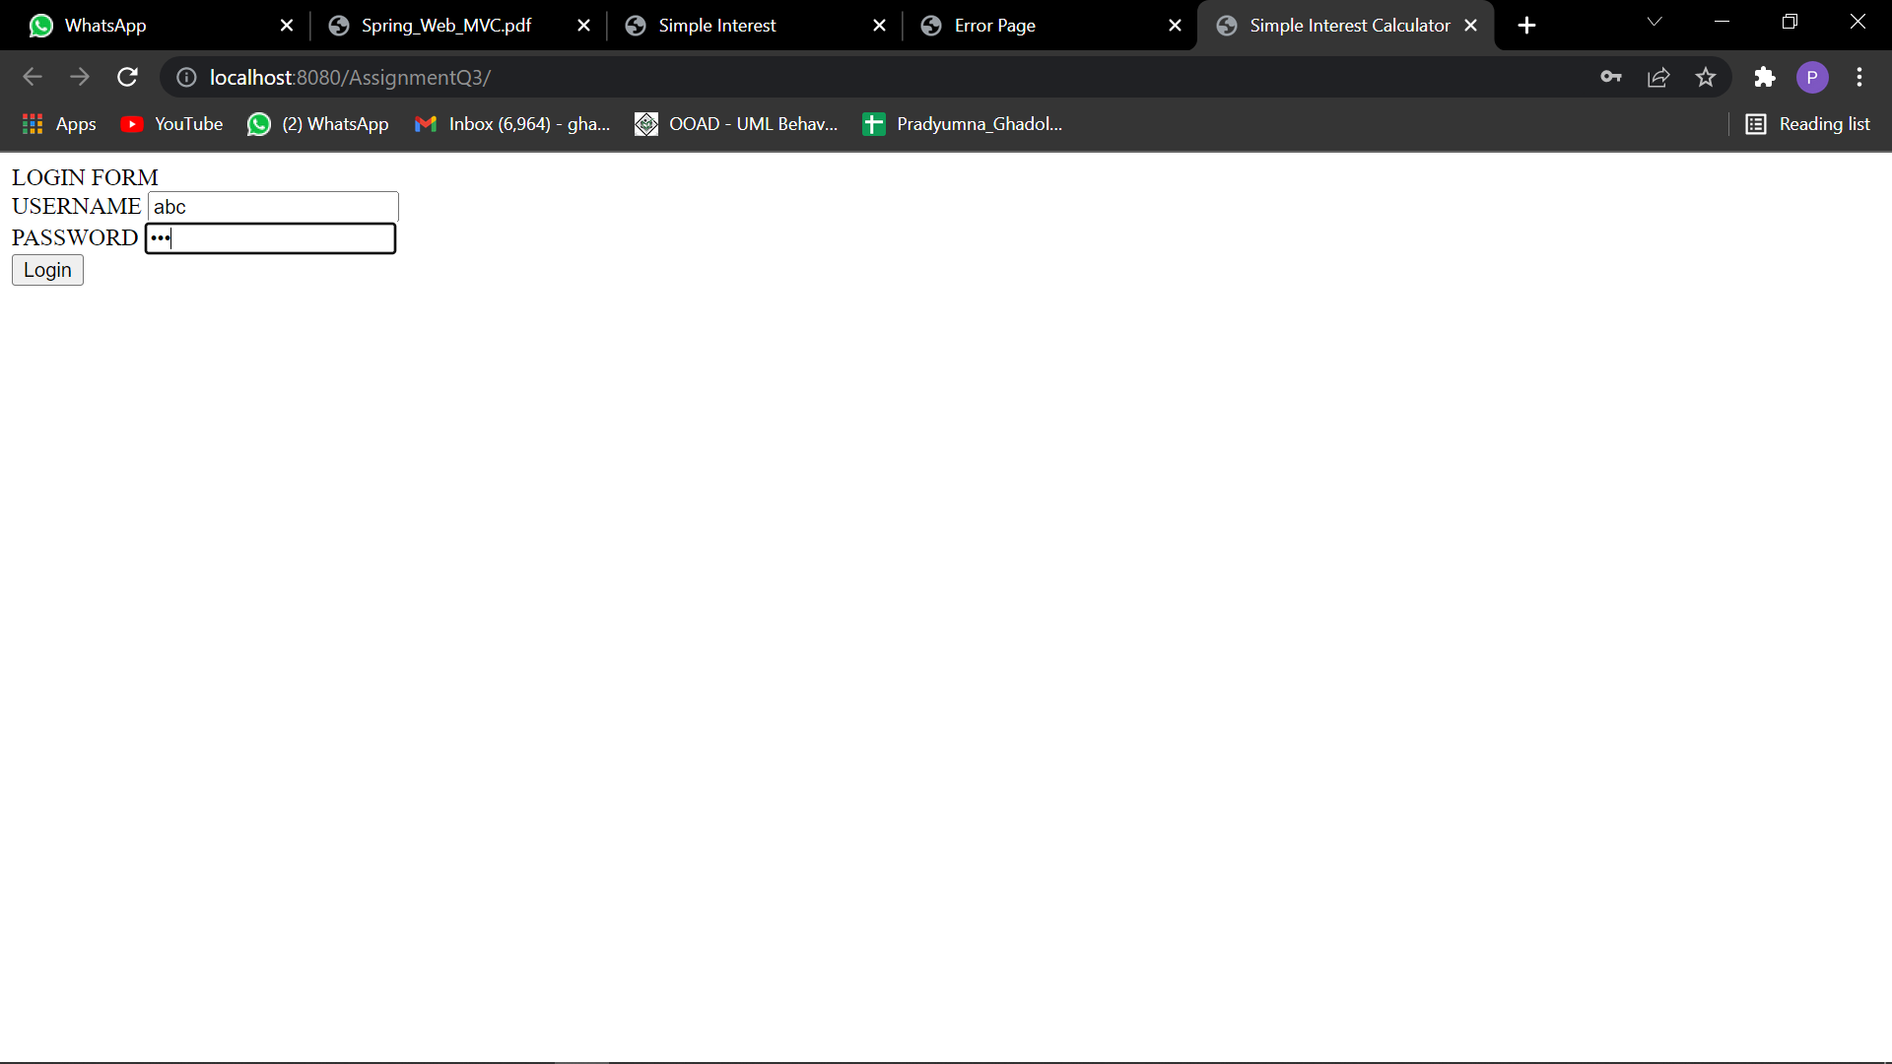

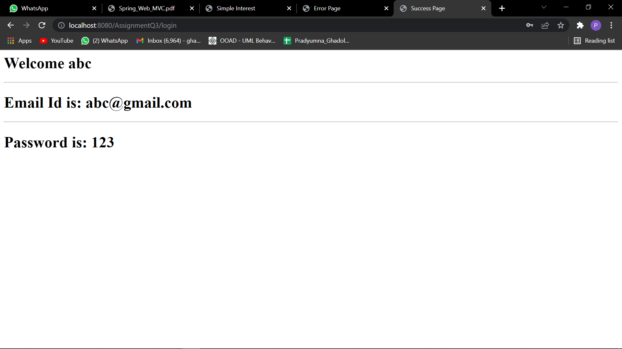

Q4.

userModel.java

**package** org.example.controller;

**public** **class** UserModel {

**private** String username;

**private** String email;

**private** String password;

**public** UserModel() {

}

**public** String getUsername() {

**return** username;

}

**public** **void** setUsername(String username) {

**this**.username = username;

}

**public** String getEmail() {

**return** email;

}

**public** **void** setEmail(String email) {

**this**.email = email;

}

**public** String getPassword() {

**return** password;

}

**public** **void** setPassword(String password) {

**this**.password = password;

}

@Override

**public** String toString() {

**return** "UserModel:[" +

"username='" + username + '\n' +

", email='" + email + '\n' +

", password='" + password + '\n' +

']';

}

}

Controller.java

package org.example.controller;

import org.springframework.stereotype.Controller;

import org.springframework.web.bind.annotation.RequestMapping;

import org.springframework.web.bind.annotation.RequestMethod;

import org.springframework.web.bind.annotation.RequestParam;

import org.springframework.web.servlet.ModelAndView;

import java.util.HashMap;

import java.util.Map;

import java.util.Objects;

@Controller

public class controller {

Map<String,String> users = new HashMap<>();

@RequestMapping(path = "/loginsuccess",method = RequestMethod.POST)

public ModelAndView login(@RequestParam("username")String username, @RequestParam("password")String password){

ModelAndView modelAndView = new ModelAndView();

for(Map.Entry<String,String> entry : users.entrySet()){

if(Objects.equals(entry.getKey(), username) && Objects.equals(entry.getValue(), password)){

modelAndView.setViewName("loginsuccess");

return modelAndView;

}

}

modelAndView.setViewName("error");

return modelAndView;

}

@RequestMapping(path="/success",method=RequestMethod.POST)

public ModelAndView success(@RequestParam("username")String username, @RequestParam("password")String password,

@RequestParam("username")String email){

ModelAndView modelAndView = new ModelAndView();

UserModel userModel = new UserModel();

userModel.setUsername(username);

userModel.setEmail(email);

userModel.setPassword(password);

users.put(userModel.getUsername(),userModel.getPassword());

modelAndView.addObject("user",userModel);

modelAndView.setViewName("success");

return modelAndView;

}

@RequestMapping("/error")

public String error(){

return "error";

}

@RequestMapping("/login")

public String login1(){

return "login1";

}

}

Index.jsp

<!DOCTYPE html>

<html lang=*"en"*>

<head>

<meta charset=*"UTF-8"*>

<meta http-equiv=*"X-UA-Compatible"* content=*"IE=edge"*>

<meta name=*"viewport"* content=*"width=device-width, initial-scale=1.0"*>

<title>Register form</title>

</head>

<body>

<div class=*"container"*>

<div class=*"title"*>

REGISTRATION FORM

</div>

<form method = *"post"* action=*"success"* class=*"form"* name=*"form"* id=*"form"*>

<div class=*"user-details"*>

<div class=*"input-box"*>

<span class=*"details"*>EMAIL ID</span>

<input type=*"text"* placeholder=*"Enter the email id"* name=*"email"* required>

</div>

</div>

<div class=*"user-details"*>

<div class=*"input-box"*>

<span class=*"details"*>USERNAME</span>

<input type=*"text"* placeholder=*"Enter the username"* name=*"username"* required>

</div>

<div class=*"input-box"*>

<span class=*"details"*>PASSWORD</span>

<input type=*"password"* placeholder=*"Enter the password"* name=*"password"* required>

</div>

</div>

<div class=*"button"*>

<input type=*"submit"* value=*"Register Yourself"*>

</div>

</form>

</div>

</div>

</body>

</html>

Loginsuccess.jsp

<%@ page contentType=*"text/html;charset=UTF-8"* language=*"java"* %>

<html>

<head>

<title>Login Successful</title>

</head>

<style>

**h1**{

color: *green*;

}

</style>

<body>

<h1>Login Successful</h1>

</body>

</html>

Login1.jsp

<!DOCTYPE html>

<html lang=*"en"*>

<head>

<meta charset=*"UTF-8"*>

<meta http-equiv=*"X-UA-Compatible"* content=*"IE=edge"*>

<meta name=*"viewport"* content=*"width=device-width, initial-scale=1.0"*>

<title>login form</title>

</head>

<body>

<div class=*"container"*>

<div class=*"title"*>

LOGIN FORM

</div>

<form method = *"post"* action=*"loginsuccess"* class=*"form"* name=*"form"* id=*"form"*>

<div class=*"user-details"*>

<div class=*"input-box"*>

<span class=*"details"*>USERNAME</span>

<input type=*"text"* placeholder=*"Enter the username"* name=*"username"* required>

</div>

<div class=*"input-box"*>

<span class=*"details"*>PASSWORD</span>

<input type=*"password"* placeholder=*"Enter the password"* name=*"password"* required>

</div>

</div>

<div class=*"button"*>

<input type=*"submit"* value=*"Login"*>

</div>

</form>

</div>

</div>

</body>

</html>

Success.jsp

<%@ page contentType=*"text/html;charset=UTF-8"* language=*"java"* %>

<%@ page isELIgnored=*"false"* %>

<html>

<head>

<title>Success Page</title>

</head>

<style>

**h1**{

color: *darkgreen*;

align: *center*;

}

</style>

<body>

<h1>Welcome ${user.username}</h1>

<hr>

<h1>Email Id is: ${user.email}</h1>

<hr>

<h1>Password is: ${user.password}</h1>

</body>

</html>

Error.jsp

<%@ page contentType=*"text/html;charset=UTF-8"* language=*"java"* %>

<html>

<head>

<title>Error Page</title>

</head>

<style>

**h1**{

color: *red*;

}

</style>

<body>

<h1 align=*"center"*>Username or password is incorrect</h1>

</body>

</html>

