Q1.

1) Create an Address class with the following attributes:- street, city, state, zip, country Create an Customer class with the following attributes:- customerId, customerName, customerContact, customerAddress. Inject the Address bean into Customer bean using setter injection Create a Test class with main() method, get Customer bean from ApplicationContext object and print details of Customer. Also write the JUnit Test cases for above program.

- Modify the above application and inject the bean using constructor injection

- Use XML based Configuraion.

Address.java

**package** com.springcore.assignment;

**public** **class** Address {

**private** String street;

**private** String city;

**private** String state;

**private** **int** zip;

**private** String country;

**public** String getStreet() {

**return** street;

}

**public** String getCity() {

**return** city;

}

**public** String getState() {

**return** state;

}

**public** **int** getZip() {

**return** zip;

}

**public** String getCountry() {

**return** country;

}

**public** **void** setStreet(String street) {

**this**.street = street;

}

**public** **void** setCity(String city) {

**this**.city = city;

}

**public** **void** setState(String state) {

**this**.state = state;

}

**public** **void** setZip(**int** zip) {

**this**.zip = zip;

}

**public** **void** setCountry(String country) {

**this**.country = country;

}

@Override

**public** String toString() {

**return** "Address [street=" + street + ", city=" + city + ", state=" + state + ", zip=" + zip + ", country="

+ country + "]";

}

}

Customer.java

**package** com.springcore.assignment;

**public** **class** Customer {

**private** String customerId;

**private** String customerName;

**private** String customerContact;

**private** String customerAddress;

**private** Address address;

**public** String getCustomerId() {

**return** customerId;

}

**public** String getCustomerName() {

**return** customerName;

}

**public** String getCustomerContact() {

**return** customerContact;

}

**public** String getCustomerAddress() {

**return** customerAddress;

}

**public** Address getAddress() {

**return** address;

}

**public** **void** setCustomerId(String customerId) {

**this**.customerId = customerId;

}

**public** **void** setCustomerName(String customerName) {

**this**.customerName = customerName;

}

**public** **void** setCustomerContact(String customerContact) {

**this**.customerContact = customerContact;

}

**public** **void** setCustomerAddress(String customerAddress) {

**this**.customerAddress = customerAddress;

}

**public** **void** setAddress(Address address) {

**this**.address = address;

}

**public** Customer(String customerId, String customerName, String customerContact, String customerAddress,

Address address) {

**super**();

**this**.customerId = customerId;

**this**.customerName = customerName;

**this**.customerContact = customerContact;

**this**.customerAddress = customerAddress;

**this**.address = address;

}

**public** Customer() {

**super**();

// **TODO** Auto-generated constructor stub

}

@Override

**public** String toString() {

**return** "Customer [customerId=" + customerId + ", customerName=" + customerName + ", customerContact="

+ customerContact + ", customerAddress=" + customerAddress + ", address=" + address + "]";

}

}

Test.java

**package** com.springcore.assignment;

**import** org.springframework.context.ApplicationContext;

**import** org.springframework.context.support.ClassPathXmlApplicationContext;

**public** **class** Test {

**public** **static** **void** main(String[] args) {

ApplicationContext context = **new** ClassPathXmlApplicationContext("com/springcore/assignment/custconfig.xml");

Customer customer = context.getBean("customer",Customer.**class**);

System.***out***.println(customer);

}

}

Custconfig.xml

<?xml version=*"1.0"* encoding=*"UTF-8"*?>

<beans xmlns=*"http://www.springframework.org/schema/beans"*

xmlns:xsi=*"http://www.w3.org/2001/XMLSchema-instance"*

xmlns:context=*"http://www.springframework.org/schema/context"*

xmlns:p=*"http://www.springframework.org/schema/p"*

xsi:schemaLocation=*"http://www.springframework.org/schema/beans*

*http://www.springframework.org/schema/beans/spring-beans.xsd*

*http://www.springframework.org/schema/context*

*http://www.springframework.org/schema/context/spring-context.xsd"*>

<bean class = *"com.springcore.assignment.Customer"* name = *"customer"*>

<property name=*"customerId"* value = *"101"*/>

<property name=*"customerName"* value = *"Pradumnya Ghadole"*/>

<property name=*"customerContact"* value = *"9370009006"*/>

<property name=*"customerAddress"* value = *"8th mile Nagpur"*/>

<property name=*"address"* ref = *"address"*/>

</bean>

<bean class = *"com.springcore.assignment.Address"* name = *"address"*>

<property name=*"street"* value = *"8th mile"*/>

<property name=*"city"* value = *"Nagpur"*/>

<property name=*"state"* value = *"Maharashtra"*/>

<property name=*"zip"* value = *"440023"*/>

<property name=*"country"* value = *"India"*/>

</bean>

</beans>

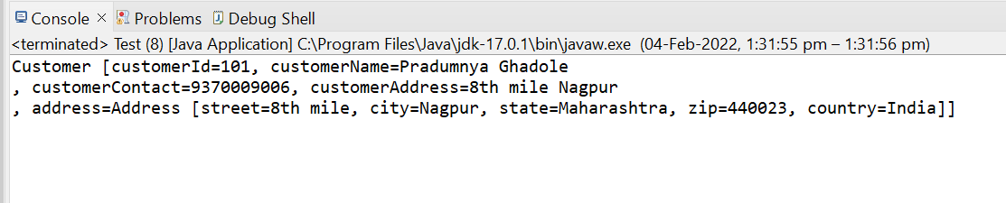

Q2.

Example of Injecting collections (List, Set and Map) Create a class Question with following attributes: questionId, question, answers. There are 3 cases for above program.

a. Write a program where answers is of type List or String []

b. Write a program where answers is of type Set

c. Write a program where answers is of type Map In case of Map, Integer value represents answer’s sequence number.

d. Create a Test class with main() method, get Question bean from ApplicationContext object and print question and its answers.

e. Also write the JUnit Test cases for above program. - Use XML based configuration.

Question.java

**package** com.springcore.assignment.Question2;

**import** java.util.List;

**import** java.util.Map;

**import** java.util.Set;

**public** **class** Question {

**private** String questionId;

**private** String question;

**private** List<String> answer1;

**private** Set<String> answer2;

**private** Map<Integer, String> answer3;

**public** String getQuestionId() {

**return** questionId;

}

**public** String getQuestion() {

**return** question;

}

**public** List<String> getAnswer1() {

**return** answer1;

}

**public** Set<String> getAnswer2() {

**return** answer2;

}

**public** Map<Integer, String> getAnswer3() {

**return** answer3;

}

**public** **void** setQuestionId(String questionId) {

**this**.questionId = questionId;

}

**public** **void** setQuestion(String question) {

**this**.question = question;

}

**public** **void** setAnswer1(List<String> answer1) {

**this**.answer1 = answer1;

}

**public** **void** setAnswer2(Set<String> answer2) {

**this**.answer2 = answer2;

}

**public** **void** setAnswer3(Map<Integer, String> answer3) {

**this**.answer3 = answer3;

}

**public** Question(String questionId, String question, List<String> answer1, Set<String> answer2,

Map<Integer, String> answer3) {

**super**();

**this**.questionId = questionId;

**this**.question = question;

**this**.answer1 = answer1;

**this**.answer2 = answer2;

**this**.answer3 = answer3;

}

**public** Question() {

**super**();

// **TODO** Auto-generated constructor stub

}

@Override

**public** String toString() {

**return** " Question [questionId= " + questionId + "]"+"\n"+" question= " + question + ","+"\n"+" List answer1= " + answer1 + ","+"\n"+" Set answer2="

+ answer2 + ","+"\n"+" Map answer3= " + answer3 + "]";

}

}

Test.java

**package** com.springcore.assignment.Question2;

**import** org.springframework.context.ApplicationContext;

**import** org.springframework.context.support.ClassPathXmlApplicationContext;

**public** **class** Test {

**public** **static** **void** main(String[] args) {

ApplicationContext context = **new** ClassPathXmlApplicationContext("com/springcore/assignment/Question2/collectionconfig.xml");

Question question = context.getBean("quest",Question.**class**);

System.***out***.println(question);

}

}

Collectionconfig.xml

<?xml version=*"1.0"* encoding=*"UTF-8"*?>

<beans xmlns=*"http://www.springframework.org/schema/beans"*

xmlns:xsi=*"http://www.w3.org/2001/XMLSchema-instance"*

xmlns:context=*"http://www.springframework.org/schema/context"*

xmlns:p=*"http://www.springframework.org/schema/p"*

xsi:schemaLocation=*"http://www.springframework.org/schema/beans*

*http://www.springframework.org/schema/beans/spring-beans.xsd*

*http://www.springframework.org/schema/context*

*http://www.springframework.org/schema/context/spring-context.xsd"*>

<bean class = *"com.springcore.assignment.Question2.Question"* name = *"quest"*>

<property name=*"questionId"* value = *"101A"*/>

<property name=*"question"* value= *"Tell me your mobile numbers"*/>

<property name=*"answer1"*>

<list>

<value>9370009006</value>

<value>8888527772</value>

<value>9370009006</value>

</list>

</property>

<property name=*"answer2"*>

<set>

<value>9370009006</value>

<value>8888527772</value>

<value>9370009006</value>

</set>

</property>

<property name=*"answer3"*>

<map>

<entry key = *"1"* value = *"9370009006"*/>

<entry key = *"2"* value = *"8888527772"*/>

<entry key = *"3"* value = *"9370212499"*/>

</map>

</property>

</bean>

</beans>

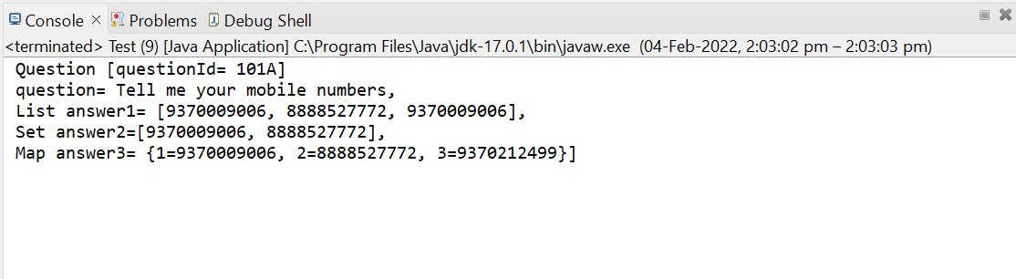

Q7.

Demo.java

**package** com.springcore.assignment.Question7;

**import** org.springframework.beans.factory.annotation.Value;

**import** org.springframework.stereotype.Component;

@Component

**public** **class** Demo {

@Value("#{22+11}")

**private** **int** x;

@Value("#{34+45}")

**private** **int** y;

**public** **int** getX() {

**return** x;

}

**public** **int** getY() {

**return** y;

}

**public** **void** setX(**int** x) {

**this**.x = x;

}

**public** **void** setY(**int** y) {

**this**.y = y;

}

@Override

**public** String toString() {

**return** "Demo [x=" + x + ", y=" + y + "]";

}

}

Test.java

**package** com.springcore.assignment.Question7;

**import** java.beans.Expression;

**import** org.springframework.context.ApplicationContext;

**import** org.springframework.context.support.ClassPathXmlApplicationContext;

**import** org.springframework.expression.spel.standard.SpelExpressionParser;

**public** **class** Test {

**public** **static** **void** main(String[] args){

ApplicationContext context = **new** ClassPathXmlApplicationContext("com/springcore/assignment/Question7/config.xml");

Demo demo = context.getBean("demo",Demo.**class**);

System.***out***.println(demo);

SpelExpressionParser expressionParser = **new** SpelExpressionParser();

org.springframework.expression.Expression expression = expressionParser.parseExpression("23+43");

System.***out***.println(expression.getValue());

}

}

Config.xml

<?xml version=*"1.0"* encoding=*"UTF-8"*?>

<beans xmlns=*"http://www.springframework.org/schema/beans"*

xmlns:xsi=*"http://www.w3.org/2001/XMLSchema-instance"*

xmlns:context=*"http://www.springframework.org/schema/context"*

xmlns:p=*"http://www.springframework.org/schema/p"*

xsi:schemaLocation=*"http://www.springframework.org/schema/beans*

*http://www.springframework.org/schema/beans/spring-beans.xsd*

*http://www.springframework.org/schema/context*

*http://www.springframework.org/schema/context/spring-context.xsd"*>

<context:component-scan base-package=*"com.springcore.assignment.Question7"*/>

</beans>

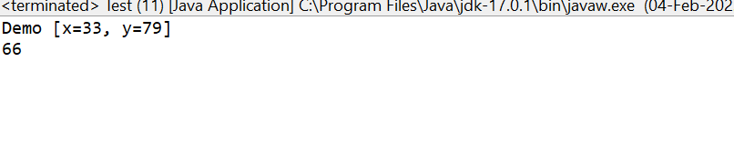

Q8.

Example1.

package com.springcore.lifecycle;

//lifecycle callbacks

import javax.annotation.PostConstruct;

import javax.annotation.PreDestroy;

public class Example {

private String subject;

public String getSubject() {

return subject;

}

public void setSubject(String subject) {

this.subject = subject;

}

public Example() {

super();

// TODO Auto-generated constructor stub

}

@Override

public String toString() {

return "Example [subject=" + subject + "]";

}

@PostConstruct

public void start() {

System.out.println("starting method");

}

@PreDestroy

public void end() {

System.out.println("ending method");

}

}

Example2.java

**package** com.springcore.assignment.Question8;

**import** org.springframework.beans.factory.DisposableBean;

**import** org.springframework.beans.factory.InitializingBean;

**public** **class** Example2 **implements** InitializingBean,DisposableBean {

**private** String name;

**public** String getName() {

**return** name;

}

**public** **void** setName(String name) {

**this**.name = name;

}

@Override

**public** String toString() {

**return** "Example2 [name=" + name + "]";

}

**public** Example2(String name) {

**super**();

**this**.name = name;

}

**public** Example2() {

**super**();

// **TODO** Auto-generated constructor stub

}

**public** **void** destroy() **throws** Exception {

// **TODO** Auto-generated method stub

System.***out***.println("Inside Destroy Method of Disposible Bean...");

}

**public** **void** afterPropertiesSet() **throws** Exception {

// **TODO** Auto-generated method stub

System.***out***.println("Inside afterPropertiesSet method of Initialization Bean");

}

}

Example3.java

**package** com.springcore.assignment.Question8;

**import** javax.annotation.PostConstruct;

**import** javax.annotation.PreDestroy;

**public** **class** Example3 {

**private** String name;

**public** String getName() {

**return** name;

}

**public** **void** setName(String name) {

**this**.name = name;

}

@Override

**public** String toString() {

**return** "Example3 [name=" + name + "]";

}

**public** Example3() {

**super**();

// **TODO** Auto-generated constructor stub

}

**public** Example3(String name) {

**super**();

**this**.name = name;

}

@PostConstruct

**public** **void** start() {

System.***out***.println("Inside Start method of @PostConstruct");

}

@PreDestroy

**public** **void** end() {

System.***out***.println("Inside End method of @PreDestroy");

}

}

Test.java

**package** com.springcore.assignment.Question8;

**import** org.springframework.context.ApplicationContext;

**import** org.springframework.context.support.AbstractApplicationContext;

**import** org.springframework.context.support.ClassPathXmlApplicationContext;

**public** **class** Test {

**public** **static** **void** main(String[] args) {

AbstractApplicationContext context = **new** ClassPathXmlApplicationContext("com/springcore/assignment/Question8/exconfig.xml");

Example example = context.getBean("example",Example.**class**);

System.***out***.println(example);

context.registerShutdownHook();

Example2 example2 = context.getBean("example2",Example2.**class**);

System.***out***.println(example2);

Example3 example3 = context.getBean("example3",Example3.**class**);

System.***out***.println(example3);

}

}

Exconfig.java

<?xml version=*"1.0"* encoding=*"UTF-8"*?>

<beans xmlns=*"http://www.springframework.org/schema/beans"*

xmlns:xsi=*"http://www.w3.org/2001/XMLSchema-instance"*

xmlns:context=*"http://www.springframework.org/schema/context"*

xmlns:p=*"http://www.springframework.org/schema/p"*

xmlns:util=*"http://www.springframework.org/schema/util"*

xsi:schemaLocation=*"http://www.springframework.org/schema/beans*

*http://www.springframework.org/schema/beans/spring-beans.xsd*

*http://www.springframework.org/schema/context*

*http://www.springframework.org/schema/context/spring-context.xsd"*>

<!-- <context:annotation-config/> -->

<!-- we can use -->

<bean class = *"com.springcore.assignment.Question8.Example"* name = *"example"* init-method=*"init"* destroy-method=*"destroy"*>

<property name=*"price"* value = *"12200"*/>

</bean>

<bean class = *"com.springcore.assignment.Question8.Example2"* name = *"example2"*>

<property name=*"name"* value = *"Pradumnya Ghadole"*/>

</bean>

<bean class = *"com.springcore.assignment.Question8.Example3"* name = *"example3"*>

<property name=*"name"* value = *"Ramdas Ghadole"*/>

</bean>

</beans>

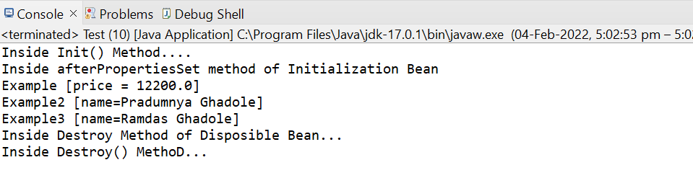

Q9.

Example1.

package com.springcore.lifecycle;

//lifecycle callbacks

import javax.annotation.PostConstruct;

import javax.annotation.PreDestroy;

public class Example {

private String subject;

public String getSubject() {

return subject;

}

public void setSubject(String subject) {

this.subject = subject;

}

public Example() {

super();

// TODO Auto-generated constructor stub

}

@Override

public String toString() {

return "Example [subject=" + subject + "]";

}

@PostConstruct

public void start() {

System.out.println("starting method");

}

@PreDestroy

public void end() {

System.out.println("ending method");

}

}

Example2.java

**package** com.springcore.assignment.Question8;

**import** org.springframework.beans.factory.DisposableBean;

**import** org.springframework.beans.factory.InitializingBean;

**public** **class** Example2 **implements** InitializingBean,DisposableBean {

**private** String name;

**public** String getName() {

**return** name;

}

**public** **void** setName(String name) {

**this**.name = name;

}

@Override

**public** String toString() {

**return** "Example2 [name=" + name + "]";

}

**public** Example2(String name) {

**super**();

**this**.name = name;

}

**public** Example2() {

**super**();

// **TODO** Auto-generated constructor stub

}

**public** **void** destroy() **throws** Exception {

// **TODO** Auto-generated method stub

System.***out***.println("Inside Destroy Method of Disposible Bean...");

}

**public** **void** afterPropertiesSet() **throws** Exception {

// **TODO** Auto-generated method stub

System.***out***.println("Inside afterPropertiesSet method of Initialization Bean");

}

}

Example3.java

**package** com.springcore.assignment.Question8;

**import** javax.annotation.PostConstruct;

**import** javax.annotation.PreDestroy;

**public** **class** Example3 {

**private** String name;

**public** String getName() {

**return** name;

}

**public** **void** setName(String name) {

**this**.name = name;

}

@Override

**public** String toString() {

**return** "Example3 [name=" + name + "]";

}

**public** Example3() {

**super**();

// **TODO** Auto-generated constructor stub

}

**public** Example3(String name) {

**super**();

**this**.name = name;

}

@PostConstruct

**public** **void** start() {

System.***out***.println("Inside Start method of @PostConstruct");

}

@PreDestroy

**public** **void** end() {

System.***out***.println("Inside End method of @PreDestroy");

}

}

Test.java

**package** com.springcore.assignment.Question8;

**import** org.springframework.context.ApplicationContext;

**import** org.springframework.context.support.AbstractApplicationContext;

**import** org.springframework.context.support.ClassPathXmlApplicationContext;

**public** **class** Test {

**public** **static** **void** main(String[] args) {

AbstractApplicationContext context = **new** ClassPathXmlApplicationContext("com/springcore/assignment/Question8/exconfig.xml");

Example example = context.getBean("example",Example.**class**);

System.***out***.println(example);

context.registerShutdownHook();

Example2 example2 = context.getBean("example2",Example2.**class**);

System.***out***.println(example2);

Example3 example3 = context.getBean("example3",Example3.**class**);

System.***out***.println(example3);

}

}

Exconfig.java

<?xml version=*"1.0"* encoding=*"UTF-8"*?>

<beans xmlns=*"http://www.springframework.org/schema/beans"*

xmlns:xsi=*"http://www.w3.org/2001/XMLSchema-instance"*

xmlns:context=*"http://www.springframework.org/schema/context"*

xmlns:p=*"http://www.springframework.org/schema/p"*

xmlns:util=*"http://www.springframework.org/schema/util"*

xsi:schemaLocation=*"http://www.springframework.org/schema/beans*

*http://www.springframework.org/schema/beans/spring-beans.xsd*

*http://www.springframework.org/schema/context*

*http://www.springframework.org/schema/context/spring-context.xsd"*>

<!-- <context:annotation-config/> -->

<!-- we can use -->

<bean class = *"com.springcore.assignment.Question8.Example"* name = *"example"* init-method=*"init"* destroy-method=*"destroy"*>

<property name=*"price"* value = *"12200"*/>

</bean>

<bean class = *"com.springcore.assignment.Question8.Example2"* name = *"example2"*>

<property name=*"name"* value = *"Pradumnya Ghadole"*/>

</bean>

<bean class = *"com.springcore.assignment.Question8.Example3"* name = *"example3"*>

<property name=*"name"* value = *"Ramdas Ghadole"*/>

</bean>

</beans>



Q10.

Triangle.java

**package** com.springcore.assignment.Question10;

**import** org.springframework.beans.BeansException;

**import** org.springframework.beans.factory.BeanNameAware;

**import** org.springframework.context.ApplicationContext;

**import** org.springframework.context.ApplicationContextAware;

**public** **class** Triangle **implements** ApplicationContextAware, BeanNameAware{

**private** ApplicationContext context = **null**;

**private** Point pointA;

**private** Point pointB;

**private** Point pointC;

**public** **void** setPointA(Point pointA) {

**this**.pointA = pointA;

}

**public** **void** setPointB(Point pointB) {

**this**.pointB = pointB;

}

**public** **void** setPointC(Point pointC) {

**this**.pointC = pointC;

}

**public** **void** draw()

{

System.***out***.println("PointA is ("+pointA.getX()+", "+pointA.getY()+")");

System.***out***.println("PointB is ("+pointB.getX()+", "+pointB.getY()+")");

System.***out***.println("PointC is ("+pointC.getX()+", "+pointC.getY()+")");

}

**public** **void** setBeanName(String name) {

System.***out***.println("Bean name is "+ name);

}

**public** **void** setApplicationContext(ApplicationContext context) **throws** BeansException {

**this**.context = context;

}

}

Point.java

**package** com.springcore.assignment.Question10;

**public** **class** Point {

**private** **int** x;

**private** **int** y;

**public** **int** getX() {

**return** x;

}

**public** **int** getY() {

**return** y;

}

**public** **void** setX(**int** x) {

**this**.x = x;

}

**public** **void** setY(**int** y) {

**this**.y = y;

}

}

Config.xml

<?xml version=*"1.0"* encoding=*"UTF-8"*?>

<beans xmlns=*"http://www.springframework.org/schema/beans"*

xmlns:xsi=*"http://www.w3.org/2001/XMLSchema-instance"*

xmlns:context=*"http://www.springframework.org/schema/context"*

xmlns:p=*"http://www.springframework.org/schema/p"*

xsi:schemaLocation=*"http://www.springframework.org/schema/beans*

*http://www.springframework.org/schema/beans/spring-beans.xsd*

*http://www.springframework.org/schema/context*

*http://www.springframework.org/schema/context/spring-context.xsd"*>

<bean autowire = *"byName"* class = *"com.springcore.assignment.Question10.Triangle"* id = *"triangle"*/>

<bean class = *"com.springcore.assignment.Question10.Point"* id = *"pointA"*>

<property name=*"x"* value = *"0"*/>

<property name=*"y"* value = *"0"*/>

</bean>

<bean class = *"com.springcore.assignment.Question10.Point"* id = *"pointB"*>

<property name=*"x"* value = *"-20"*/>

<property name=*"y"* value = *"0"*/>

</bean>

<bean class = *"com.springcore.assignment.Question10.Point"* id = *"pointC"*>

<property name=*"x"* value = *"20"*/>

<property name=*"y"* value = *"0"*/>

</bean>

</beans>

Test.java

**package** com.springcore.assignment.Question10;

**import** org.springframework.context.ApplicationContext;

**import** org.springframework.context.support.ClassPathXmlApplicationContext;

**public** **class** Test {

**public** **static** **void** main(String[] args) {

ApplicationContext context = **new** ClassPathXmlApplicationContext("com/springcore/assignment/Question10/config.xml");

Triangle triangle = (Triangle)context.getBean("triangle");

triangle.draw();

}

}

