Malignant-transformation risk in lower-grade glioma: an IDH-stratified Bayesian interval-censored analysis
Baran Atli^{1,2}, Maximilian Wartha^{1,2,*}, Matthias Gmeiner^{1,2}, Martin Aichholzer^{1,2}, Serge Weis^{3,4}, Dominik Vorhauer², Helga Wagner⁵, Tanja Hauer⁵, Carlo Serra^{6,7}, Petra Böhm¹, Michael Sonnberger⁸, Nico Stroh^{1,2}, Stefan Aspalter^{1,2}, Kathrin Aufschnaiter^{1,2}, Tobias Rossmann^{1,2}, Jawed Ziai¹¹, Annette Leibetseder⁹, Josef Pichler^{9,10}, Wolfgang Thomae^{1,2}, Christian Dorfer¹¹, Andreas Gruber^{1,2,12}, Harald Stefanits^{1,2}, Philip Rauch^{1,2,11}
¹ Department of Neurosurgery, Kepler University Hospital, Johannes Kepler University Linz, Austria. ² Johannes Kepler University Linz, Austria. ³ Division of Neuropathology, Department of Pathology and Molecular Pathology, Kepler University Hospital, Linz, Austria. ⁴ Clinical Research Institute for Neuroscience, Johannes Kepler University, Linz, Austria. ⁵ Institute of Statistics, Johannes Kepler University, Linz, Austria. ⁶ Department of Neurosurgery, Clinical Neuroscience Center, University Hospital, University of Zurich, Switzerland. ⁷ Machine Intelligence in Clinical Neuroscience (MICN) Lab, Clinical Neuroscience Center, University Hospital Zurich, University of Zurich, Switzerland. ⁸ Institute of Neuroradiology, Kepler University Hospital, Johannes Kepler University, Linz, Austria. ⁹ Department of Neurology, Kepler University Hospital, Johannes Kepler University Linz, Austria. ¹⁰ Department of Internal Medicine and Neurooncology, Neuromed Campus, Kepler University Hospital, Linz, Austria. ¹¹ Department of Neurosurgery, University Hospital St. Pölten, Karl Landsteiner University of Health Sciences, St. Pölten, Austria. ¹² Clinical Research Institute for Neuroscience, Johannes Kepler University Linz, Austria.
*Correspondence: Maximilian Wartha, MD — Department of Neurosurgery, Kepler University Hospital, Neuromed Campus, Wagner-Jauregg-Weg 15, 4020 Linz, Austria. Email: Maximilian.Wartha@kepleruniklinikum.at
Abstract
Background. Malignant transformation (MT) — progression of a lower-grade glioma (LGG) to high-grade malignancy — is the principal determinant of survival and dictates surveillance intensity and the timing of surgery. Because MT is detected only between two surveillance scans, never at onset, its timing is intrinsically interval-censored; treating it as occurring at the confirmatory scan can bias risk estimates, particularly when imaging intervals are long. Whether the imaging phenotype at diagnosis predicts MT differently across molecularly defined LGG subgroups is unresolved.
Methods. We analysed 155 adult-type WHO grade 2–3 LGG patients (77 MT events; 6 non-MT deaths; median surveillance among non-transformers 4.8 years). To accommodate interval censoring, competing risks, time-varying treatment, and 99 candidate radiomic features, we applied four complementary survival models and required the contrast-enhancement effect to be consistent across all four. The primary model was a Bayesian interval-censored Weibull with a horseshoe prior over 102 coefficients; the rest were Fine-Gray, Cox time-varying-covariate, and native interval-censored Fine-Gray (intccr) models.
Results. In IDH-mutant LGG, contrast enhancement at diagnosis was strongly associated with MT (Bayesian HR 92.2, 95 % CrI 26.9–416), the lower bound excluding the null by a wide margin. The full-cohort effect was consistent across all four models (HRs 13.3–22.1; intccr sHR 2.94). Gross total resection reduced post-surgical hazard by ~68 % (HR 0.32, 0.13–0.77). No radiomic feature was robust to shrinkage or to interval-censored analysis, indicating the apparent signatures were artefactual rather than biological. The model discriminated transformation risk with an optimism-corrected Harrell C of 0.83.
Conclusions. IDH-stratified pre-operative contrast enhancement identifies a molecularly defined LGG subgroup at markedly elevated MT risk. Together with extent of resection, it belongs alongside molecular classification in transformation-risk models that inform individualised surveillance and surgical timing.
Keywords: lower-grade glioma · malignant transformation · IDH stratification · Bayesian survival analysis · interval censoring · radiomics · extent of resection

Introduction
Adult-type diffuse gliomas of WHO grade 2 or 3 — collectively, lower-grade gliomas (LGGs) — typically follow a deceptively indolent course before malignant transformation (MT)¹⁻³, the biological inflection that drives long-term prognosis, adjuvant-therapy timing, and trial eligibility²ˍ³. The pre-operative imaging phenotype is the only risk information available before tissue is obtained; molecular classification under the 2021 WHO scheme⁴ˍ⁷ follows from the initial biopsy or resection and then defines the subgroup within which that phenotype must be interpreted. How strongly the imaging phenotype predicts transformation within each molecular class — and thus how the two should be combined to guide imaging cadence and surgical timing — has not been established⁵ˍ¹¹. The natural-history timing of MT under conservative management is itself poorly characterised: modern early-resection practice rarely allows the long, treatment-conservative follow-up needed to localise MT between two consecutive surveillance MRIs.
Three methodological gaps shape the published LGG-MT literature. First, almost all analyses treat MT as right-censored at the confirmatory MRI rather than interval-censored between two successive scans; the resulting mis-timing biases the estimator²⁰ˍ²¹. Second, radiomics pipelines now produce ≥ 100 candidate features per patient, but published analyses lean on unadjusted univariate screening or LASSO — both miscalibrated at the event counts typical of LGG cohorts¹⁶ˍ¹⁷ˍ²⁶ˍ³¹. The horseshoe prior¹³ is the principled alternative when most candidates are expected null, the regime of a 99-feature radiomics panel against 77 events. Third, LGG treatment is dynamic, inducing time-varying state changes that most Cox analyses ignore¹⁴ˍ¹⁹.
In this long term longitudinal cohort, we observe the full biological dynamic range of LGG⁸ˍ⁹. We address the three gaps in a Bayesian interval-censored analysis of a single-institution cohort¹⁰ and cross-check the CE hazard ratio across complementary survival models, each handling a different structural feature of the data.
Results
Cohort
Of 155 patients, 77 (49.7 %) underwent MT, 6 (3.9 %) died without documented MT, and 72 (46.5 %) were alive and transformation-free at last follow-up; among the 78 non-transformers, median imaging surveillance was 4.8 years (IQR 2.0–10.0; range 0.07–16.9), with 20/78 (25.6 %) followed ≥ 10 years and 5/78 (6.4 %) ≥ 15 years. IDH was mutant in 109 (70.3 %), wildtype in 42 (27.1 %), and indeterminate in 4 (2.6 %). Contrast enhancement at diagnosis was present in 34 patients (21.9 %); median pre-operative tumour volume at diagnosis was 35.6 cm³ (IQR 18.4–66.2). Final extent of resection (EOR) was GTR in 84 (54.2 %), STR in 47 (30.3 %), and biopsy in 24 (15.5 %); under the time-varying Cox specification — in which a patient enters the post-surgical EOR stratum only after surgery — the state at MT or censoring distributed as GTR 68 (43.9 %), STR 44 (28.4 %), biopsy 16 (10.3 %), pre-surgery 27 (17.4 %). Age at diagnosis ranged 0.7–77 years (median 40.1); 149 patients were ≥ 18 years; 6 were of paediatric age with adult-type histomolecular tumours. The heterogeneity of transformation latency across the cohort — from short-latency transformers to patients stable over many years of surveillance — is shown in Fig. 1, with transformers (panel a) and right-censored non-transformers (panel b) on a shared logarithmic time axis.
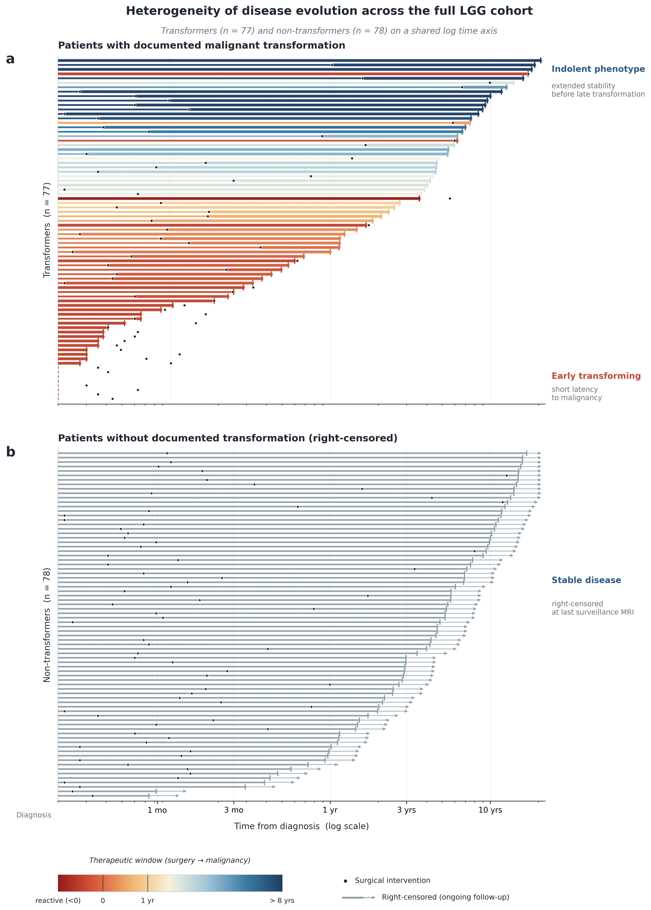
Fig. 1 | Heterogeneity of disease evolution across the full LGG cohort. Each horizontal bar is one patient; time from diagnosis is on a shared logarithmic axis. (a) The 77 patients with documented malignant transformation, ordered by latency from short-latency (“early transforming”) at the bottom to long-latency (“indolent”) at the top; the ordering is a continuum, not discrete subgroups. Bar colour encodes the therapeutic window between surgery and transformation (red = surgery at or after transformation, “reactive”, ≤ 0; blue = surgery > 8 years before transformation). (b) The 78 non-transformers, right-censored at last surveillance imaging and ordered by follow-up length; this panel includes the 6 patients censored at non-MT death. Black dots mark surgical interventions; arrows mark right-censoring. The figure illustrates the interval-censored, competing-risks structure that the analysis is designed to respect.
Pre-operative contrast enhancement is the dominant baseline predictor of malignant transformation
Contrast enhancement at diagnosis dominated transformation risk in every cohort (Table 1, Fig. 2). Bayesian full-cohort HR was 22.1 (95 % CrI 10.5–53.2; Pr(HR > 1) = 1.000), amplifying in IDH-mutant disease to 92.2 (26.9–416); the wide upper bound reflects the thin CE-positive stratum in IDH-mutant disease, while the lower bound of 26.9 rules out a null effect. The horseshoe-width sensitivity grid (par_ratio ∈ {0.05, 0.10, 0.20}; par_ratio is the prior ratio of non-zero to zero coefficients) gave full-cohort CE HRs of 21.7, 22.1, and 22.7, with no radiomic feature actively selected at any setting. In IDH-wildtype, CE reached HR 10.2 (0.99–168) with Pr(HR > 1) = 0.924, short of conventional credibility in a 42-patient subgroup. Age and baseline volume were null in all cohorts³⁶.
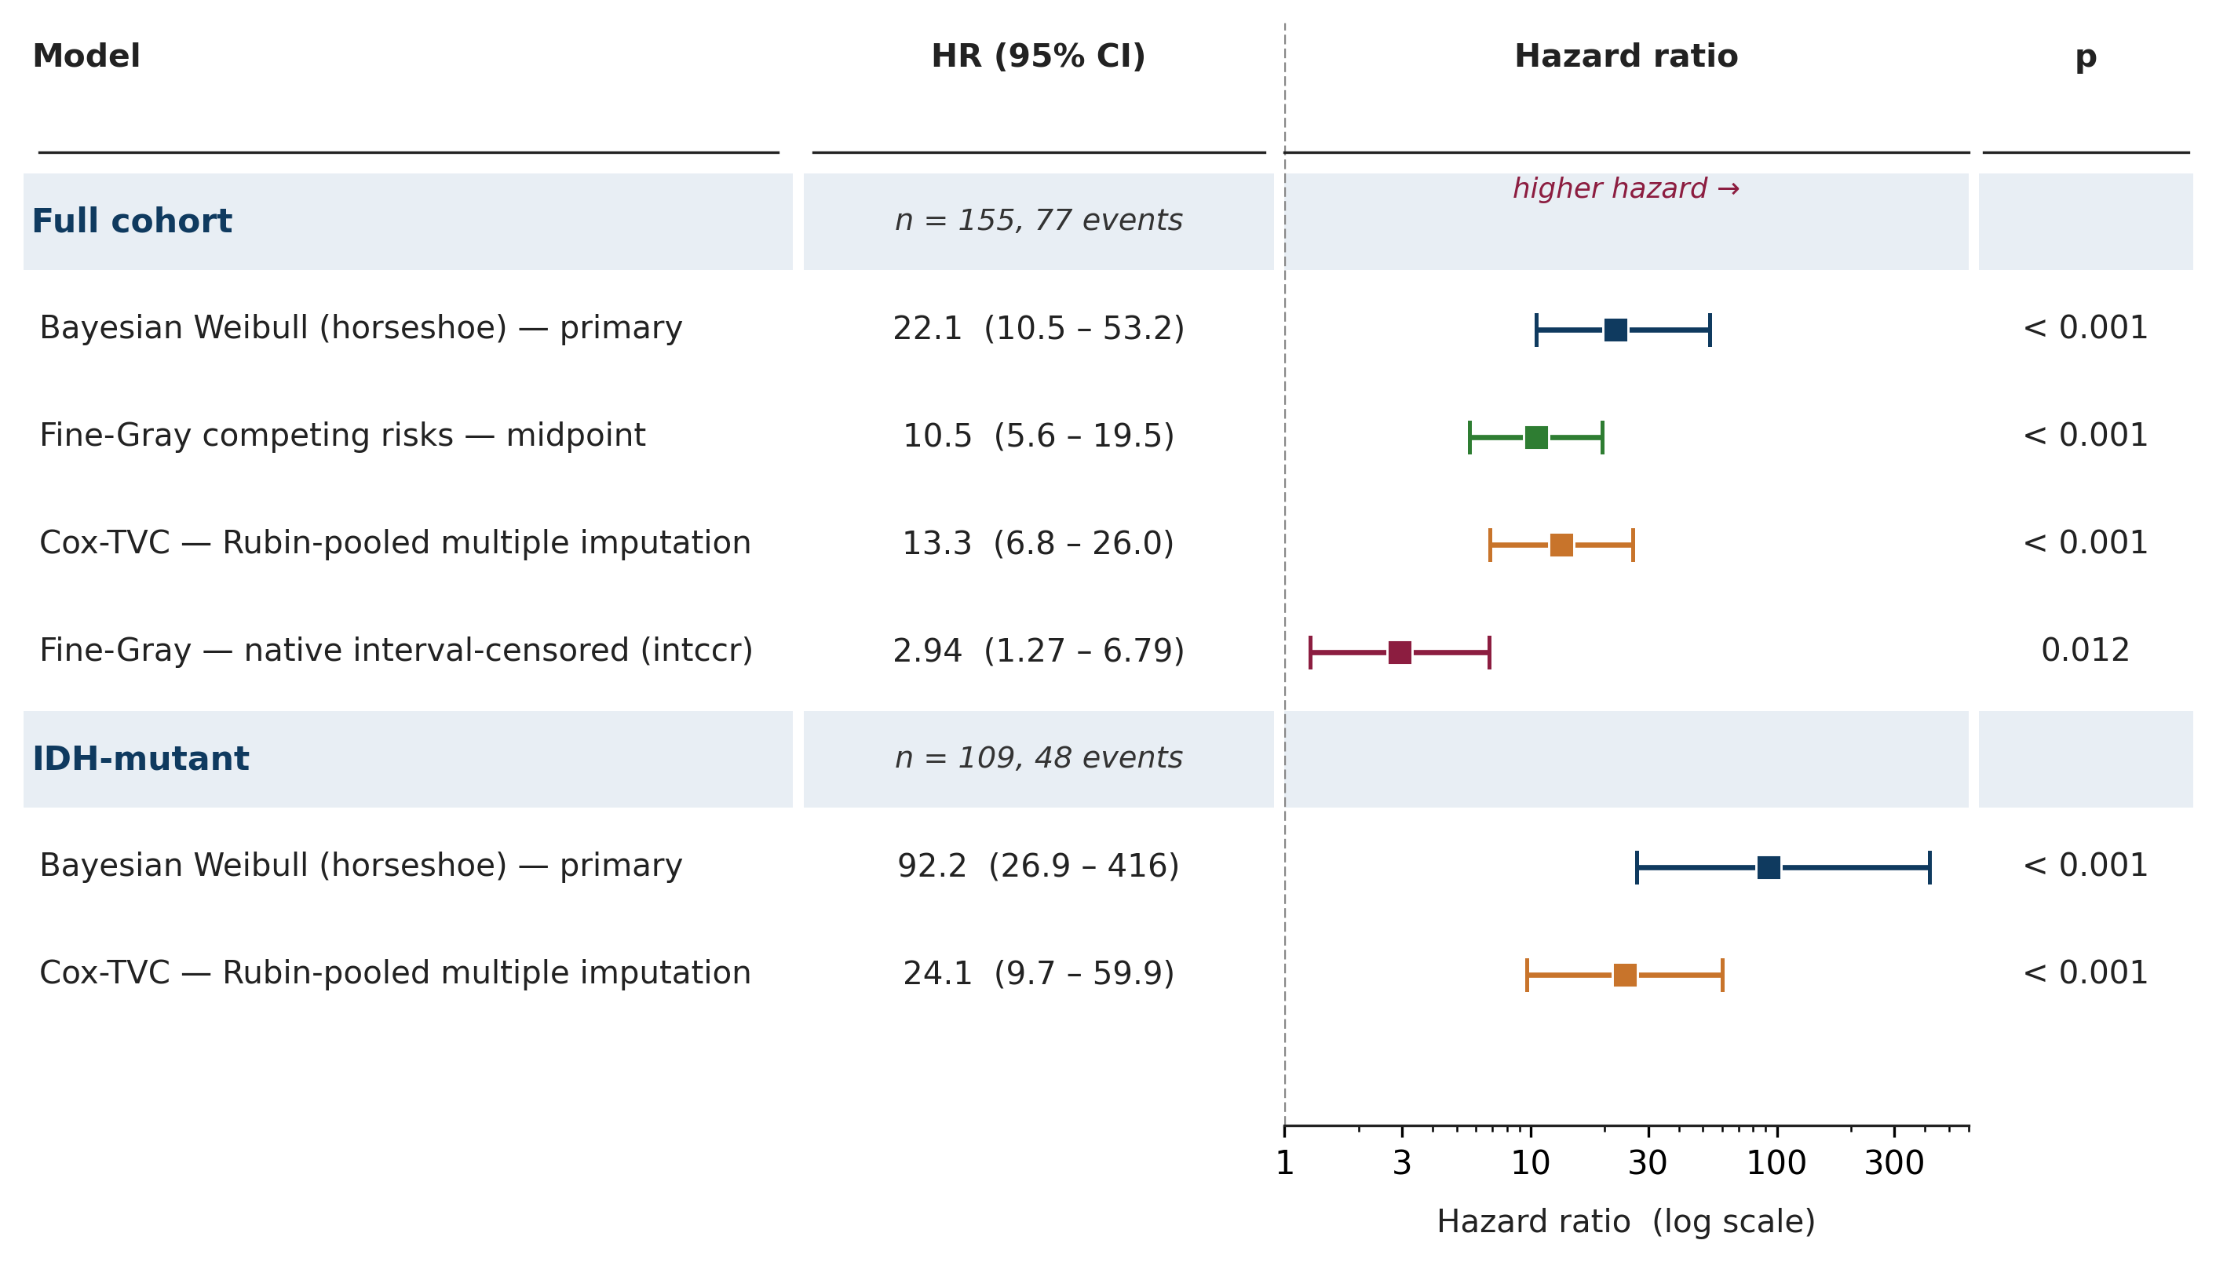
Fig. 2 | Pre-operative contrast enhancement is the dominant hazard for malignant transformation, consistent across four complementary survival models. Forest plot of hazard ratios on a log₁₀ scale. The Bayesian interval-censored Weibull is the primary specification of the study; its point is the posterior median, whiskers are 95 % credible intervals. The three frequentist models (midpoint Fine-Gray; Cox counting-process model with 20-fold Rubin-pooled multiple imputation of the interval-censored event time; native interval-censored Fine-Gray via sieve maximum likelihood, intccr) are reported as cross-checks: points are point estimates and whiskers are 95 % confidence intervals. The four models address different structural features of the data (interval censoring; competing risk of non-MT death; time-varying treatment exposures), and their agreement on direction and statistical significance is the study's central robustness argument. Results are shown for the full cohort and, where identifiable, for the IDH-mutant subgroup.
Table 1. Bayesian primary clinical effects
Cohort | Parameter | HR (95% CrI) | Pr(HR > 1)
Full (n = 155, 77 events) | Contrast enhancement | 22.1 (10.5, 53.2) | 1.000
 | Age (per year above 45) | 1.01 (1.00, 1.03) | 0.852
 | Volume (per cm³) | 1.00 (1.00, 1.01) | 0.806
IDH-mutant (n = 109, 48 ev.) | Contrast enhancement | 92.2 (26.9, 416) | 1.000
IDH-wildtype (n = 42, 26 ev.) | Contrast enhancement | 10.2 (0.99, 168) | 0.924
No individual radiomic feature survives horseshoe shrinkage or native interval-censoring
Across 99 candidate features, no feature's 95 % credible interval excluded the null in either the full cohort or the IDH-mutant subgroup (Fig. 3a). The horseshoe absorbs the implicit multiple-comparisons problem: at 77 events against 99 candidates, no single feature can support a credible individual claim¹³. The two signature features carried forward from prior internal bootstrap stability selection on the same cohort (Fig. 3b,c) were centred near HR = 1 with credible intervals crossing unity (GLSZM-T1c 0.97–1.15; GLDM-FLAIR 0.98–1.38). In midpoint Fine-Gray, one signature component crossed null (GLDM-FLAIR sHR 1.54, 1.13–2.10; raw p = 0.006, Bonferroni p = 0.012; GLSZM-T1c sHR 1.17, 0.99–1.37; Bonferroni p = 0.128; Supplementary Table S1a); multiple imputation reproduced this result (Table S1b). Native interval-censored Fine-Gray (intccr; Park & Bakoyannis 2021), which integrates the subdistribution-hazards likelihood over [L, R] rather than reducing it to a representative time, collapsed both components to null (GLDM-FLAIR sHR 1.04, 0.81–1.34, p = 0.77; GLSZM-T1c sHR 1.05, 0.86–1.26, p = 0.65; Table S1c). The signature is detectable only when the event time is compressed to a representative value; under either Bayesian horseshoe or native interval-censored frequentist analysis — two structurally independent corrections — no feature crosses the null¹⁵ˍ²⁵ˍ²⁶ˍ²⁹ˍ³⁴.
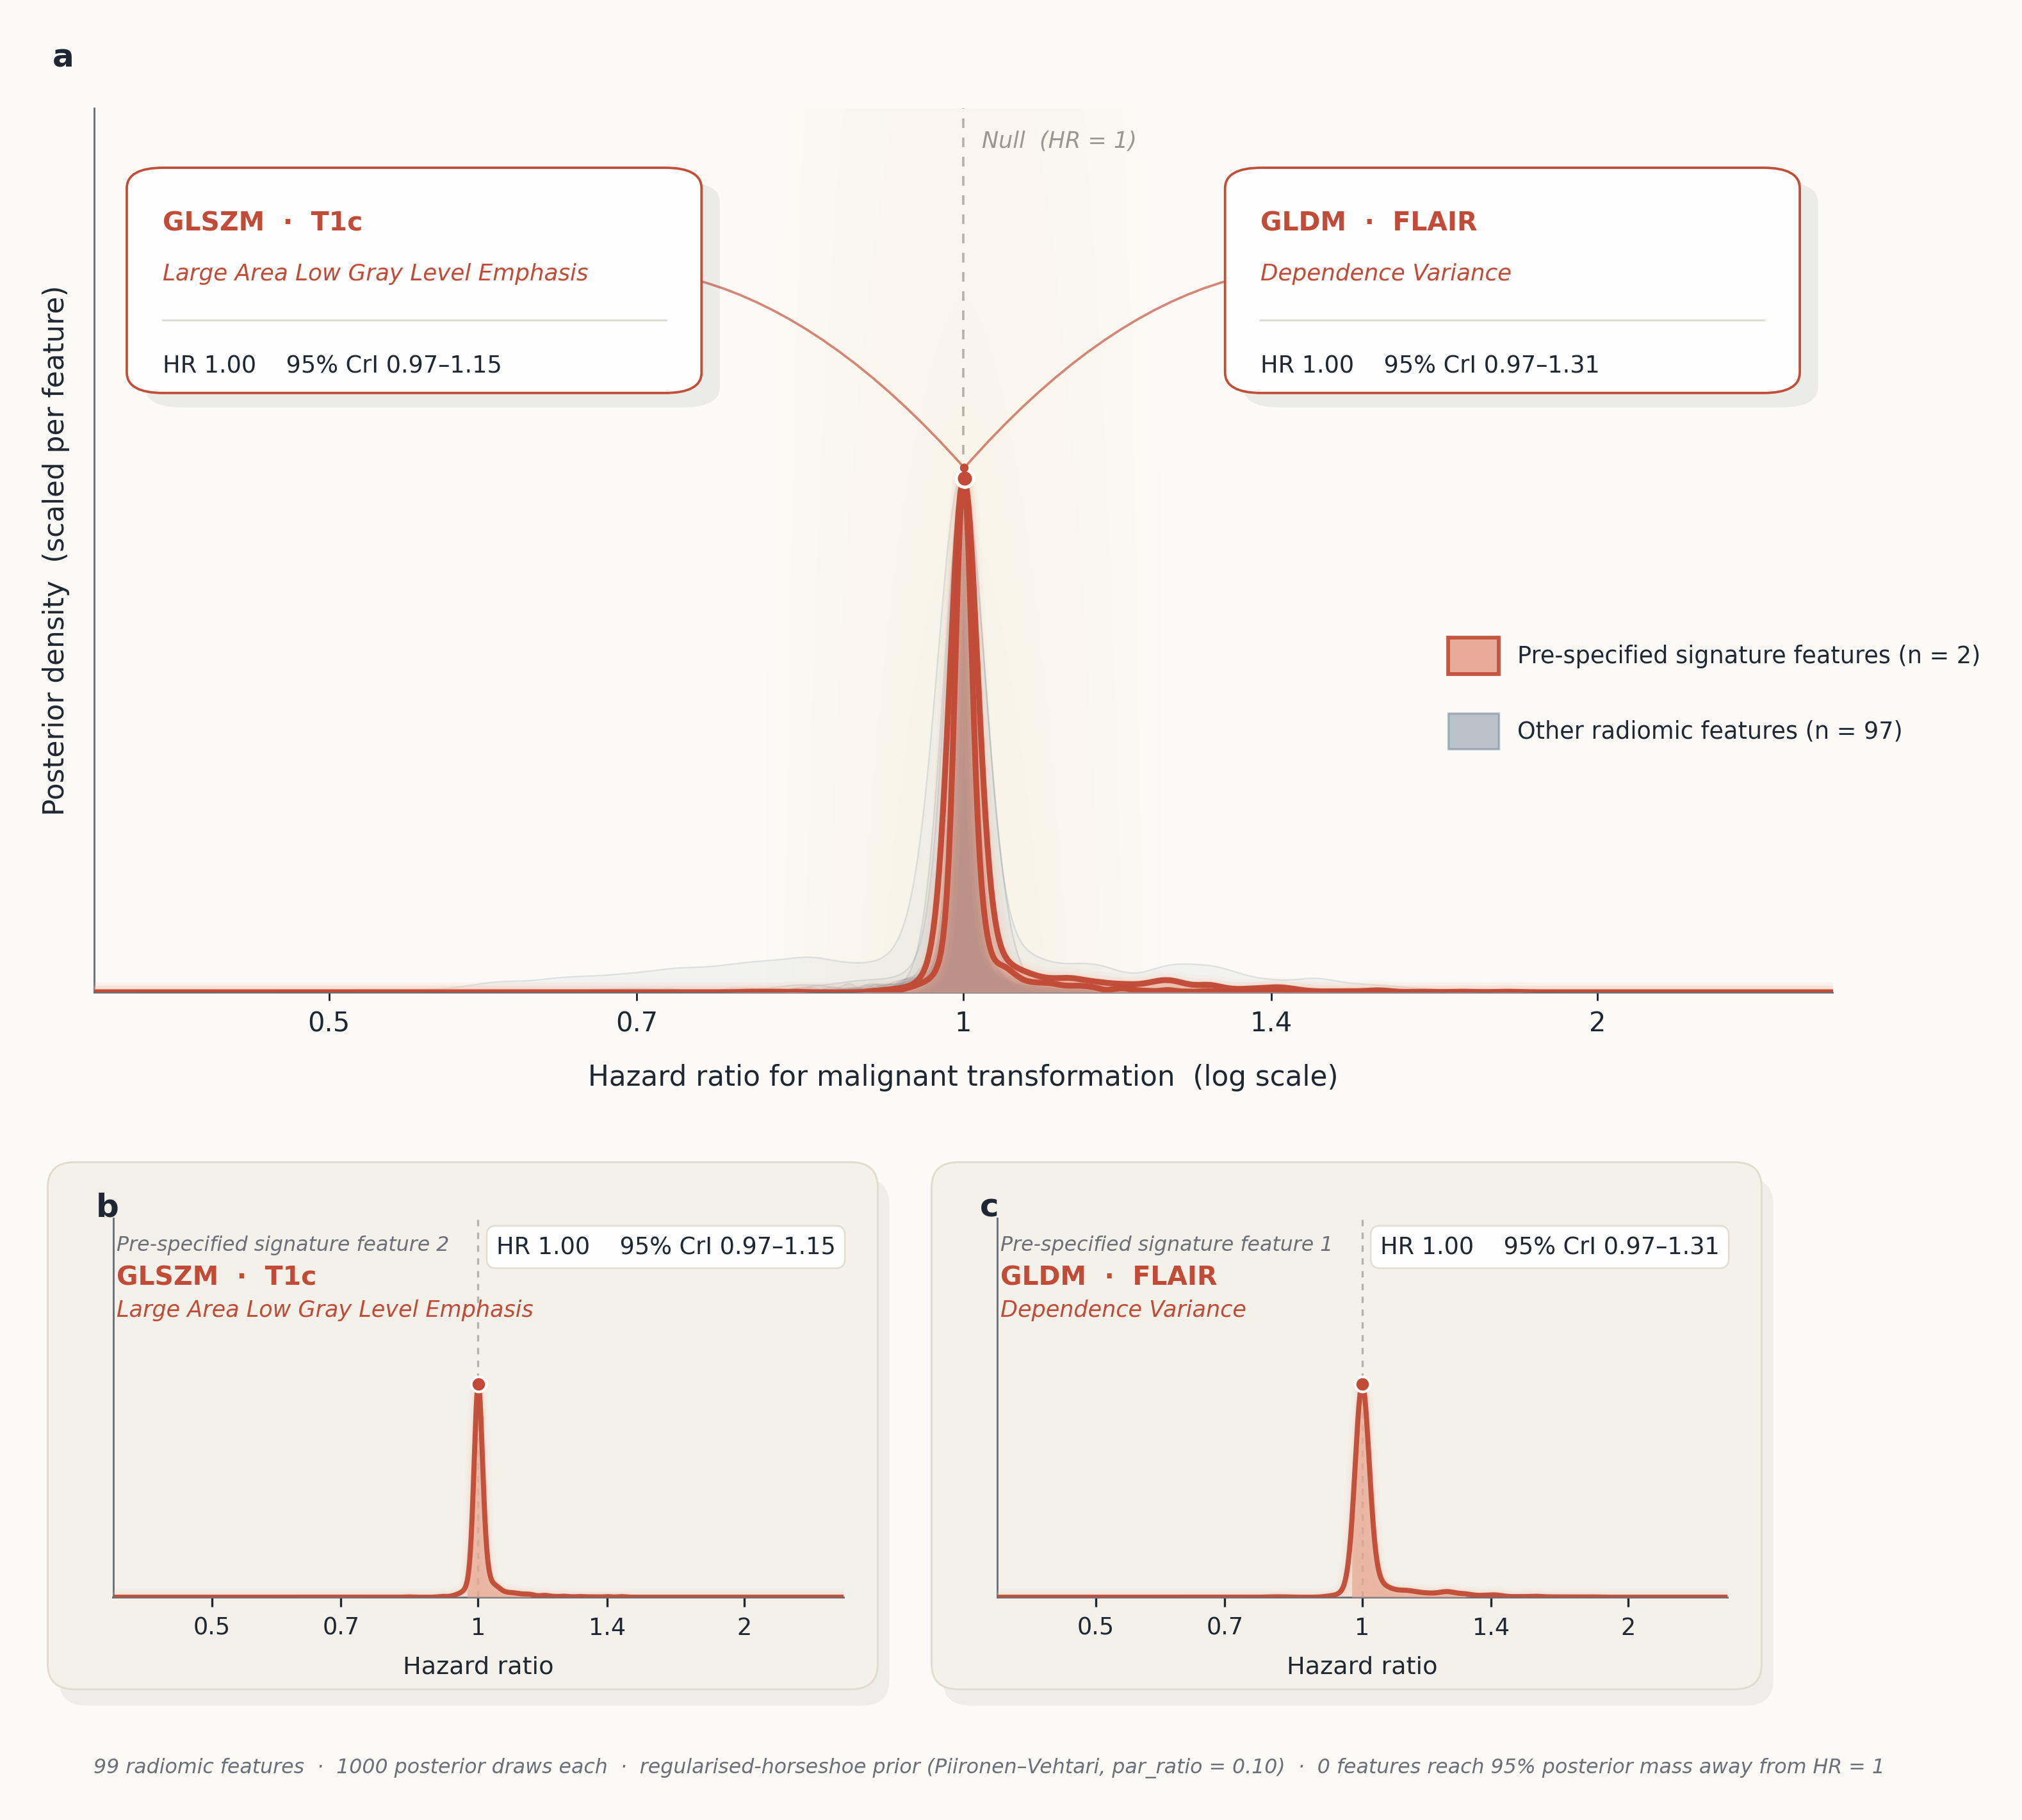
Fig. 3 | Under horseshoe shrinkage, every 95 % posterior credible interval among the 99 candidate radiomic features contains the null; the two signature features carried forward from prior internal bootstrap stability selection are also centred near HR = 1. The figure is shown to make this negative result concrete and to document the prior's effect at the per-feature level. (a) Posterior densities of the per-feature hazard-ratio coefficients for all 99 radiomic candidates in the full-cohort Bayesian interval-censored Weibull model with a horseshoe prior (par_ratio = 0.1). Inset labels report each signature feature's posterior median hazard ratio with its 95 % credible interval. No feature has 95 % posterior mass away from HR = 1. (b, c) Posterior density portraits of the two signature features.
Concordance across complementary models; gross total resection halves post-surgical hazard
Four models agreed on direction and statistical significance of the CE effect (Bayesian HR 22.1, 95 % CrI 10.5–53.2; midpoint Fine-Gray sHR 10.5, 95 % CI 5.6–19.5; Cox-TVC HR 13.3, 95 % CI 6.8–26.0; intccr sHR 2.94, 95 % CI 1.27–6.79; all p < 0.02). The native interval-censored estimate attenuates ~4-fold versus the midpoint and multiple-imputation estimates: integrating the subdistribution-hazards likelihood over the bracket [L, R] is the calibrated treatment of an interval-censored event. Direction and significance survive. Gray's test confirmed the CE effect acts on MT specifically and is not explained by the competing risk of non-MT death. Gross total resection produced a large reduction in post-surgical hazard (Fig. 4, Table 2): Cox-TVC GTR-vs-Biopsy HR 0.32 (0.13–0.77), p = 0.012 in the full cohort; 0.16 (0.05–0.53), p = 0.003 in IDH-mutant disease²³ˍ³⁰ˍ³⁵. STR did not differ from biopsy (HR 0.79, 0.32–1.92). A pre-specified binary EOR sensitivity (GTR vs non-GTR) reproduced the effect (HR 0.37, 0.18–0.76; p = 0.007, full cohort; Fig. 4). Full secondary outputs are in Supplementary Tables S1–S3.
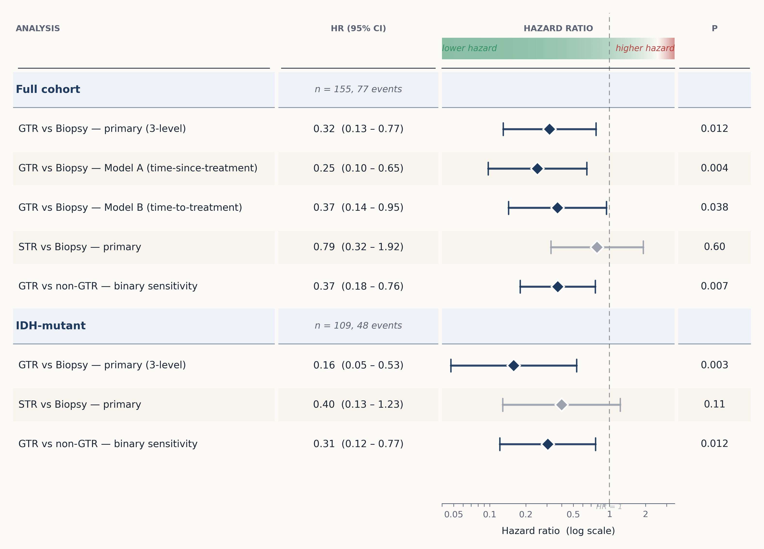
Fig. 4 | Gross total resection substantially reduces post-surgical transformation hazard; subtotal resection is not different from biopsy in this cohort size. Extent-of-resection contrasts from the Cox counting-process time-varying-covariate model with 20-fold multiple imputation of the interval-censored event time, pooled across imputations by Rubin's rules. Hazard ratios are plotted on a log₁₀ scale with 95 % confidence intervals. Contrasts are versus Biopsy unless otherwise labelled; the pre-specified binary sensitivity collapses STR and Biopsy into a single non-GTR reference.
Table 2. Extent-of-resection and contrast-enhancement effects (Cox counting-process time-varying-covariate model, 20-fold multiple imputation)
Contrast | Cohort | HR (95% CI) | p
Contrast enhancement | Full | 13.3 (6.83, 26.0) | < 0.0001
GTR vs Biopsy | Full | 0.32 (0.13, 0.77) | 0.012
GTR vs Biopsy | IDH-mutant | 0.16 (0.05, 0.53) | 0.003
STR vs Biopsy | Full | 0.79 (0.33, 1.92) | 0.60
GTR vs non-GTR † | Full | 0.37 (0.18, 0.76) | 0.007
GTR vs non-GTR † | IDH-mutant | 0.31 (0.12, 0.77) | 0.012
Hazard ratios are versus Biopsy unless labelled otherwise. † Pre-specified binary sensitivity collapsing STR and Biopsy into a single non-GTR reference. Full model output is in Supplementary Table S2 (Methods S1.4–S1.5).
Internal validation
Harrell's bootstrap-optimism procedure³⁸ on the primary Cox-TVC fit (500 patient-level resamples; 486 converged; single mid-interval imputation per replicate) returned apparent Harrell C-index 0.847, mean optimism 0.018, optimism-corrected C 0.83. The apparent CE log-hazard ratio (HR 12.1) attenuated to a bias-corrected HR of 8.5 (95 % bootstrap percentile interval 7.7–57 on the HR scale), consistent with the primary Rubin-pooled estimate (HR 13.3, 6.8–26.0). External validation in an independent multicentre cohort with a prospective temporal split remains the next step (Supplementary Table S5).
Biological validation of the imaging endpoint
A representative index case (Fig. 5) confirms the radiological endpoint captures a biological phase transition⁵ˍ⁶. An IDH1-mutant, 1p/19q-codeleted oligodendroglioma remained radiologically stable for ten years before developing new contrast enhancement and elevated relative cerebral blood volume; the recurrent lesion retained clonal IDH1 R132H but showed a Ki-67 surge from ~7 % to ~90 %⁹ˍ³²ˍ³³. The radiological inflection between two consecutive MRIs is a macroscopic surrogate for the microscopic acquisition of high-grade drivers — the substrate for any pre-operative predictor.
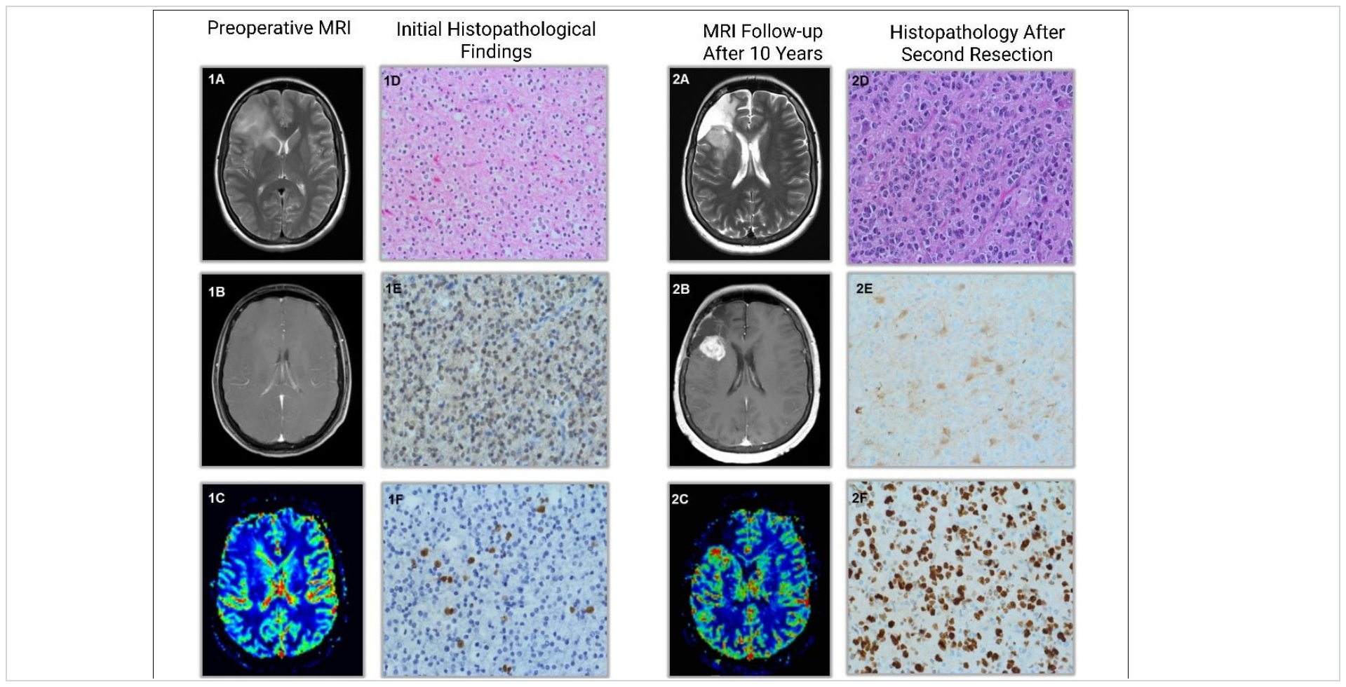
Fig. 5 | Paired longitudinal imaging and histology in an index oligodendroglioma confirm that the radiological endpoint captures a genuine biological phase transition. WHO grade 2, IDH1-mutant, 1p/19q-codeleted oligodendroglioma imaged across a ten-year interval. Baseline (panels 1A–1F): T2 hyperintensity without measurable post-contrast enhancement on T1c, low relative cerebral blood volume on perfusion MRI; histopathology shows IDH1 R132H-mutated tumour cells with Ki-67 ≈ 7 %. Ten-year follow-up (panels 2A–2F): new nodular contrast enhancement, elevated rCBV, retained IDH1 R132H clonal identity, anaplastic cytoarchitecture, and Ki-67 ≈ 90 %.
Discussion
In this cohort, the dominant baseline predictor of malignant transformation was contrast enhancement at diagnosis — outweighing age, tumour volume, and the entire panel of quantitative radiomic features¹⁰ — and its effect was sharply amplified by molecular context: in IDH-mutant glioma, contrast enhancement marked a subgroup at extreme transformation risk, with a hazard ratio of 92 whose lower credible bound alone exceeded the full-cohort effect²⁴ˍ²⁷. Extent of resection acted as a second, independent lever, gross total resection conferring an approximately two-thirds reduction in post-surgical hazard²³ˍ³⁰ˍ³⁵. The negative findings are as informative as the positive ones — no individual radiomic feature withstood shrinkage or native interval-censored analysis, and a previously reported two-feature signature dissolved once the event time was modelled honestly — and the headline results were unmoved by prior width, by exclusion of the paediatric-age cases, by an era split, and by a hypothetical WHO 2021 reclassification of the cohort (Supplementary Table S6).
Model agreement and the interval-censoring argument
The agreement of four complementary models on the CE effect is the study's most robust finding²⁰ˍ²². Each model handles a different structural feature — interval-censored event time, competing risk of non-MT death, time-varying treatment, 99 candidate radiomic features — under different assumptions on the baseline hazard, censoring mechanism, and competing events. Their agreement makes the CE signal more credible than the same effect from any single specification. The native interval-censored Fine-Gray estimate is ~4-fold smaller than the midpoint and multiple-imputation estimates: integrating the subdistribution-hazards likelihood over the full bracket [L, R] is the calibrated treatment of a genuinely interval-censored event. Direction and significance survive that calibration. In routine practice, MT is rarely diagnosed at biological onset; progression is inferred retrospectively, bracketed by two consecutive scans²¹. Right-censored Cox models implicitly equate radiological detection with transformation, introducing bias that grows with follow-up interval length¹⁴ — the precise regime of LGG surveillance.
Quantifying the natural history of transformation
Beyond the robustness of any single estimate, the present analysis offers a quantitative reading of the natural history of transformation. To our knowledge, the effects of pre-operative contrast enhancement and of extent of resection on the timing of MT have not previously been estimated within one longitudinal framework that treats surgery as a time-varying exposure while simultaneously respecting the interval-censored timing of the event; extent of resection has typically entered as a fixed baseline covariate, and transformation has been dated to the confirmatory scan¹⁴ˍ²⁰ˍ²¹. Recovered under the structure these data actually possess, the two effects describe the disease course itself — the rate at which a conservatively managed lower-grade glioma transforms, and the factors that move it — rather than associations contingent on a particular estimator. Characterising transformation in these terms, as a process with a quantifiable rate and a small number of modifiers, is in our view the more durable contribution of the work, and the footing on which contrast enhancement and extent of resection belong with molecular classification in models of transformation risk.
Clinical implications for individualised LGG management
For the individual patient, IDH-stratified pre-operative CE may help stratify surveillance interval and surgical timing — most plausibly in IDH-mutant, CE-positive disease, where the amplified hazard suggests that a shorter surveillance interval and a lower threshold for early maximal-safe resection merit prospective evaluation. Three implications follow. First, the magnitude and robustness of the CE effect, and its amplification in IDH-mutant disease, argue for elevating CE from qualitative descriptor to candidate input for individualised LGG risk models alongside molecular classification. Second, the GTR effect (~68 % hazard reduction) is large and stable enough that the resection-versus-function trade-off should be framed quantitatively at the patient level; the present estimates, once externally validated, could supply that anchor. Third, the horseshoe null at the individual-feature level is itself useful: at 77 events, a 99-feature panel cannot deliver individually credible biomarkers, and discovery should be re-scoped to focused, pre-defined panels or pursued in substantially larger multi-institutional cohorts²⁵ˍ²⁶. Beyond direct clinical use, calibrated, interval-aware hazard estimators of the kind reported here — uncertainty-quantified, molecularly stratified, robust to the censoring structure of imaging-based surveillance — are a prerequisite for the individualised-patient simulation frameworks (or 'digital twins') now being developed in precision oncology, whose clinical credibility ultimately depends on the survival-model layer being correctly specified rather than merely fit.
Limitations
This is a single-institution, retrospective cohort, and independent external validation remains the appropriate test of generalisation. That validation is, however, harder to assemble here than for most prognostic questions: resolving the natural history of transformation requires long, treatment-conservative surveillance — extending to nearly seventeen years in this cohort, with a quarter of non-transformers followed beyond a decade under a single institutional surveillance and segmentation protocol — and such follow-up is increasingly difficult to reproduce now that contemporary practice and the 2021 WHO scheme move many of these tumours to early resection or grade-appropriate therapy at diagnosis. A prospective multicentre dataset with a temporal split is nonetheless the next step, for which the present estimates are intended as a hypothesis-defining anchor. Bootstrap optimism shows the primary Cox-TVC model is modestly optimistic on discrimination (ΔC ≈ 0.02), which does not substitute for independent-cohort validation. Quantitative residual tumour volume was not available, precluding a within-STR volumetric analysis. Imaging spanned 19 scanner models from four manufacturers (0.4–3.0 T) without ComBat harmonisation; texture features may carry scanner variance. The events-per-variable ratio in the 99-feature model is ≈ 0.8 — the regime for which we deployed the horseshoe — and the resulting null reflects what 77 events can support, not a verdict on radiomics in general. The IDH-wildtype subgroup (n = 42) is at the lower limit of identifiability for a 99-feature horseshoe.
Conclusion
IDH-stratified pre-operative contrast enhancement is the strongest predictor of MT in LGG and identifies a molecularly defined subgroup (IDH-mutant, CE-positive) at markedly elevated risk, for whom shorter surveillance intervals and earlier surgical intervention warrant prospective evaluation. Four complementary survival models agree on the direction and significance of this effect. Gross total resection produces a large post-operative hazard reduction. No radiomic feature survives Bayesian shrinkage or native interval-censored analysis at this cohort size. Contrast enhancement and extent of resection belong alongside molecular classification in LGG transformation-risk models.
Methods
Cohort and endpoint
Patients were eligible if they met all of the following inclusion criteria: (i) a histologically confirmed adult-type diffuse glioma of WHO grade 2 or 3; (ii) primary diagnosis and management at our institution; (iii) a diagnostic-quality pre-operative multiparametric MRI including T1, contrast-enhanced T1 (T1c), T2, and FLAIR sequences; and (iv) at least one subsequent surveillance MRI permitting longitudinal assessment of transformation. Patients were excluded if they had (i) a tumour entity other than adult-type diffuse glioma (e.g., a circumscribed glioma or non-glial tumour) on histomolecular review; (ii) a primary glioblastoma (WHO 2016 grade 4) at diagnosis — i.e., classic glioblastoma morphology with ring-like contrast enhancement; (iii) prior tumour-directed treatment (surgery beyond diagnostic biopsy, radiotherapy, or chemotherapy) before the baseline pre-operative MRI; (iv) non-diagnostic baseline imaging or absence of one or more required sequences; or (v) loss to follow-up before the first surveillance MRI. ‘Adult-type’ denotes the histomolecular entity, not patient age: 149 patients were ≥ 18 years and 6 were of paediatric age (0.7–16.8 years) with tumours meeting adult-type histomolecular criteria on review; age at diagnosis ranged 0.7–77 years (median 40.1). IDH status was determinable in 151/155 patients; the four with indeterminate IDH status were retained in the full-cohort analyses but excluded from the IDH-stratified subgroup fits. The primary analysis retained all 155 patients; a pre-specified age-restricted sensitivity analysis (≥ 18 years, n = 149) is reported in the Supplement.
The cohort was histologically graded under the WHO 2016 classification of central nervous system tumours, in force at diagnosis; molecular markers were recorded where available and used to define the IDH-stratified subgroups. IDH-wildtype astrocytomas graded WHO 2016 grade 2 were eligible and retained, whereas primary glioblastomas (WHO 2016 grade 4) were excluded. Under the 2021 WHO classification⁴ˍ⁷, a proportion of the tumours classified here as IDH-wildtype WHO grade 2 would be reassigned to IDH-wildtype glioblastoma on molecular grounds (for example, TERT-promoter mutation, EGFR amplification, or combined +7/−10 copy-number change). These tumours were retained deliberately: the radiological and histopathological natural history of phenotypically low-grade but molecularly aggressive glioma under conservative management is no longer observable in contemporary practice, which reclassifies and treats such tumours as glioblastoma at diagnosis. The effect of a hypothetical WHO 2021 reclassification on the headline findings is quantified in Supplementary Table S6 and is addressed in the Limitations.
The primary endpoint was malignant transformation (MT), the transition of a low-grade glioma to high-grade malignancy, ascertained by one of two pre-specified routes. (a) Histopathological: an unequivocal increase in WHO grade established by a senior neuropathologist on tissue from repeat biopsy, resection, or autopsy; increased mitotic activity, an elevated Ki-67 proliferation index, microvascular proliferation, and necrosis were regarded as typical concomitants of upgrading but not, individually, as free-standing diagnostic criteria. (b) Radiological: progression by RANO low-grade-glioma criteria, defined as a new, measurable, nodular region of contrast enhancement (≥ 10 mm in its longest axis) that persisted on the subsequent surveillance MRI; equivocal studies were adjudicated by a senior neuroradiologist, and unresolved cases were discussed with the senior author³ˍ²⁴. Because transformation is detected only between two successive surveillance studies, and never at its biological onset, each event time was treated as interval-censored: the transformation time was bracketed by [L, R], where L is the date of the last study still classified as low-grade and R the date of the first study showing transformation (or of the transformation surgery, whichever came first); patients without documented transformation were right-censored at their last surveillance study (Supplementary S1.1; Supplementary Fig. S1). Death without documented MT (n = 6) was treated as the competing event in the Fine-Gray analyses. The study was approved by the JKU Ethics Committee (EK-2021-1042).
Interval censoring and radiomics
MT event time was encoded as an interval [L, R], with L the last pre-MT imaging study classified as low-grade and R the first study showing MT (or transformation surgery, whichever was earlier); non-transformers were right-censored at last follow-up²⁰ˍ²¹. Tumours were segmented on FLAIR (whole-tumour) and T1c (enhancing sub-compartment) with the deep-learning-assisted pipeline previously established for this cohort¹⁰, with neuroradiology review of every segmentation. PyRadiomics v3.0.1 was applied after intensity normalisation and 1-mm isotropic resampling (428 features per patient), reduced to 99 by Pearson-correlation filtering of redundant pairs¹⁰ˍ¹⁶ˍ²⁸ˍ³¹.
Primary Bayesian analysis
Bayesian interval-censored Weibull with a horseshoe prior¹³ on all 102 population-level coefficients (3 clinical predictors + 99 radiomic features; par_ratio = 0.1, scale_slab = 2, df_slab = 4, scale_global = 2), fitted with brms 2.23 / cmdstan 2.38¹⁸ (4 chains × 8 000 iterations, adapt_delta = 0.999). A single class-wide horseshoe was placed over clinical and radiomic coefficients together because brms 2.23 does not permit mixing a class-wide horseshoe with per-coefficient priors on the same coefficient class; the wide slab (scale_slab = 2) preserves strong clinical effects under shrinkage, and a prior-sensitivity refit at scale_global = 1 reproduced the clinical hazard ratios to three significant figures (Supplementary S1.2), indicating the shared global scale does not materially distort the contrast-enhancement estimate. brms parameterises Weibull as AFT with a log link on μ; hazard ratios for covariate j were computed draw-by-draw as HR = exp(−α·βj), preserving joint α/β uncertainty. α was drawn jointly with β where draw-level posteriors were stored, otherwise from its marginal posterior summary (mean 0.555, sd 0.065). Divergent-transition rates were 0.11 % (full), 0.07 % (IDH-mutant), 0.42 % (IDH-wildtype), concentrated in horseshoe auxiliary-scale hyperparameters; R-hat, ESS_bulk, and ESS_tail were within conventional criteria in every cohort.
Complementary models and sensitivity analyses
Three complementary frequentist models were fitted alongside the primary Bayesian analysis, each handling a structural feature not covered by the Bayesian Weibull. (i) Fine-Gray subdistribution-hazards model²² (cmprsk) — MT as the primary event, non-MT death as the competing event (one patient had a non-positive single-imputation event time and was dropped by cmprsk; n = 154), with the two-feature radiomic signature (GLDM-FLAIR dependence-variance; GLSZM-T1c large-area-low-gray-level-emphasis) as adjustment covariates. (ii) Cox counting-process time-varying-covariate (TVC) model with 20-fold multiple imputation³⁷ of the interval-censored event time, Rubin-pooled across imputations, specified with a time-varying treatment-state factor (pre-surgery; post-surgery by extent of resection {GTR, STR, Biopsy}; unknown), yielding post-surgical GTR-vs-Biopsy and STR-vs-Biopsy contrasts (Supplementary S1.4), with a pre-specified binary EOR sensitivity (GTR vs non-GTR) to remove the post-surgery/EOR rank-deficiency in the primary TVC specification. (iii) Fine-Gray refit with M = 20 multiple imputations of the event time from Uniform(L, R), Rubin-pooled (seeds matched to the Cox-TVC imputations); and a Fine-Gray fit with native interval-censored sieve maximum likelihood and B-spline approximation of the cumulative incidence functions (intccr; Park & Bakoyannis 2021), integrating the subdistribution-hazards likelihood directly over [L, R] instead of using a midpoint plug-in. Three sensitivities were performed on the primary Bayesian model: horseshoe par_ratio grid {0.05, 0.10, 0.20}, age ≥ 18 restriction, and era split at diagnosis year 2010. The study is reported in accordance with STROBE (cohort studies) and TRIPOD+AI 2024 (prediction-model studies); completed checklists are Supplementary Files S7 (STROBE) and S8 (TRIPOD+AI 2024).
The two-feature radiomic signature reported in the secondary analyses was identified in an earlier internal analysis of this cohort by bootstrap stability selection over the same 99-feature panel and was locked into the Statistical Analysis Plan before the present analysis was run. The pair is tested confirmatorily, on the same footing as the other 97 candidates inside the horseshoe. Because the prior selection used the same patients and outcome, the signature is an internally consistent prognostic marker, not an independently validated one; prospective external validation is the appropriate test of generalisation.
Data availability
De-identified radiomic feature matrix is available from the corresponding author on reasonable request. Individual-level clinical and imaging data cannot be publicly deposited due to data-protection regulations imposed by the JKU Ethics Committee but are available from the corresponding author on reasonable request, subject to institutional and ethical approval.
Code availability
All analysis code is publicly available at https://github.com/PRauch1/Malignant-transformation-in-lower-grade-glioma--a-Bayesian-interval-censored-analysis. Full numerical outputs and Supplementary Tables S1–S6 accompany this manuscript.
Acknowledgements
Supported by the Department of Neurosurgery, Kepler University Hospital, and Johannes Kepler University Linz, Austria. No external funding was received.
Author contributions
Conceptualisation, P.R. and B.A.; methodology, P.R., H.W. and D.V.; validation, H.W. and P.R.; formal analysis, T.H., H.W., D.V. and B.A.; investigation, P.R., H.S., C.S., A.G., S.W. and M.S.; resources, A.G., C.D. and C.S.; data curation, P.B., A.L., J.P. and M.W.; writing — original draft, B.A. and T.H.; writing — review and editing, all authors; visualisation, B.A., T.H., H.W., S.W. and P.R.; supervision, A.G., H.S., C.D., C.S. and P.R.; project administration, P.R., H.S., D.V., T.H. and H.W.; funding acquisition, P.R. and A.G. All authors have read and agreed to the published version of the manuscript.
Competing interests
The authors declare no competing interests.
AI acknowledgement
Generative-AI technologies were used during manuscript preparation solely to improve clarity and readability of the written text and to edit/format tables and figures. All AI output was reviewed and revised; the authors accept full responsibility for the final content.
References
1. Duffau, H. A personalized longitudinal strategy in low-grade glioma patients. J. Pers. Med. 12, 1621 (2022).
2. Kirby, A. J. & Finnerty, G. T. New strategies for managing adult gliomas. J. Neurol. 268, 3666–3674 (2021).
3. Satar, Z., Hotton, G. & Samandouras, G. Time to malignant transformation in low-grade gliomas. Neurooncol. Adv. 3, vdab101 (2021).
4. Louis, D. N. et al. The 2021 WHO classification of tumors of the central nervous system: a summary. Neuro-Oncology 23, 1231–1251 (2021).
5. Kirby, A. J. et al. Multicellular hotspots harbor high-grade potential in lower-grade gliomas. Neurooncol. Adv. 3, vdab026 (2021).
6. Griessmair, M. et al. Exploring molecular glioblastoma. Neurooncol. Adv. 6, vdae106 (2024).
7. Torp, S. H., Solheim, O. & Skjulsvik, A. J. The WHO 2021 classification of CNS tumours: practical update. Acta Neurochir. 164, 2453–2464 (2022).
8. Fawzy, P. & Karpin, T. Challenges facing level I evidence in treatment of low-grade gliomas. Egypt. J. Neurosurg. 39, 7 (2024).
9. Peng, J. et al. Single-cell profiling uncovers proliferative cells as key determinants of survival outcomes in lower-grade glioma. Discov. Oncol. 15, 445 (2024).
10. Rauch, P. et al. Deep learning-assisted radiomics facilitates multimodal prognostication for personalized treatment strategies in low-grade glioma. Sci. Rep. 13, 9494 (2023).
11. Shaheen, S., Aiman, U., Haque, Z. A. & Azad, Z. Navigating the complexities of low-grade glioma treatment. Neurosurg. Rev. 47, 788 (2024).
12. Duffau, H. The onco-functional balance in diffuse gliomas. Brain Spine 5, 104170 (2024).
13. Piironen, J. & Vehtari, A. Sparsity information and regularization in the horseshoe and other shrinkage priors. Electron. J. Stat. 11, 5018–5051 (2017).
14. Pallud, J. et al. Velocity of tumor spontaneous expansion predicts long-term outcomes for diffuse low-grade gliomas. Neuro-Oncology 15, 595–606 (2013).
15. Akeret, K. et al. Anatomical phenotyping and staging of brain tumours. Brain 145, 1162–1176 (2022).
16. Zhang, L., Giuste, F., Vizcarra, J. C., Li, X. & Gutman, D. Radiomics features predict CIC mutation status in lower-grade glioma. Front. Oncol. 10, 937 (2020).
17. Choi, Y. S., Ahn, S. S., Chang, J. H. et al. Machine learning and radiomic phenotyping of lower-grade gliomas. Eur. Radiol. 30, 3834–3842 (2020).
18. Bürkner, P.-C. brms: an R package for Bayesian multilevel models using Stan. J. Stat. Softw. 80, 1–28 (2017).
19. Aichholzer, M., Rauch, P., Kastler, L. et al. Tailored intraoperative MRI strategies in high-grade glioma surgery. Oper. Neurosurg. 26, 645–654 (2024).
20. Chen, R. & Wang, H. Time-to-event endpoints in imaging biomarker studies. J. Magn. Reson. Imaging (2024) https://doi.org/10.1002/jmri.29429.
21. Jo, J., van den Bent, M. J., Nabors, B., Wen, P. Y. & Schiff, D. Surveillance imaging frequency in adult patients with lower-grade gliomas. Neuro-Oncology 24, 1035–1047 (2022).
22. Fine, J. P. & Gray, R. J. A proportional hazards model for the subdistribution of a competing risk. J. Am. Stat. Assoc. 94, 496–509 (1999).
23. Chaichana, K. L., McGirt, M. J., Laterra, J., Olivi, A. & Quiñones-Hinojosa, A. Recurrence and malignant degeneration after resection of adult hemispheric low-grade gliomas. J. Neurosurg. 112, 10–17 (2010).
24. Murphy, E. S. et al. Risk factors for malignant transformation of low-grade glioma. Int. J. Radiat. Oncol. Biol. Phys. 100, 965–971 (2018).
25. Yang, X., Niu, W., Wu, K., Yang, G. & Zhang, H. MRI-based habitat imaging predicts high-risk molecular subtypes and early risk assessment of lower-grade gliomas. Cancer Imaging 25, 43 (2025).
26. Wang, Z., Wang, L. & Wang, Y. Radiomics in glioma: emerging trends and challenges. Ann. Clin. Transl. Neurol. 12, 460–477 (2025).
27. Neimantaite, A., Carstam, L., Gómez Vecchio, T. et al. Survival prediction with radiomics for patients with IDH-mutated lower-grade glioma. J. Neurooncol. 173, 505–514 (2025).
28. Beig, N. et al. Radiogenomic-based survival risk stratification of tumor habitat on Gd-T1w MRI. Clin. Cancer Res. 26, 1866–1876 (2020).
29. Zhang, S. et al. Texture analysis on conventional MRI images predicts early malignant transformation of low-grade gliomas. Eur. Radiol. 29, 2751–2759 (2019).
30. Smith, J. S. et al. Role of extent of resection in the long-term outcome of low-grade hemispheric gliomas. J. Clin. Oncol. 26, 1338–1345 (2008).
31. Singh, G. et al. Radiomics and radiogenomics in gliomas. Br. J. Cancer 125, 641–657 (2021).
32. Johnson, B. E. et al. Mutational analysis reveals the origin and therapy-driven evolution of recurrent glioma. Science 343, 189–193 (2014).
33. Bai, H. et al. Integrated genomic characterization of IDH1-mutant glioma malignant progression. Nat. Genet. 48, 59–66 (2016).
34. Liu, X. et al. A radiomic signature as a noninvasive predictor of progression-free survival in patients with lower-grade gliomas. Neuroimage Clin. 20, 1070–1077 (2018).
35. Jakola, A. S. et al. Comparison of early surgical resection vs watchful waiting in low-grade gliomas. JAMA 308, 1881–1888 (2012).
36. Krigers, A., Demetz, M., Thomé, C. & Freyschlag, C. F. Age is associated with unfavorable neuropathological and radiological features and poor outcome in WHO grade 2 and 3 gliomas. Sci. Rep. 11, 17380 (2021).
37. Rubin, D. B. Multiple Imputation for Nonresponse in Surveys. (Wiley, New York, 1987).
38. Harrell, F. E. Jr, Lee, K. L. & Mark, D. B. Multivariable prognostic models: issues in developing models, evaluating assumptions and adequacy, and measuring and reducing errors. Stat. Med. 15, 361–387 (1996).

