Supplementary Materials
Malignant-transformation risk in lower-grade glioma: an IDH-stratified Bayesian interval-censored analysis

S1. Extended methods

S1.1 Interval-censored event-time encoding
For each patient the MT event time was encoded as an interval [L, R], where L is the date of the last pre-MT imaging study classified as low-grade and R is the date of the first imaging study showing MT (or the diagnostic surgery at transformation, whichever was earlier). Patients without documented transformation were right-censored at the last available imaging follow-up (L = last imaging date, R = ∞). Patients who underwent surgery before any observed MT were additionally stratified into Case 2 (MT observed in [L, R] prior to surgery) and Case 3 (MT observed in [L, R] after surgery); Supplementary Figure S1 shows the schematic. All three Bayesian, Fine-Gray, and Cox-TVC analyses were specified to respect this interval-censored structure.
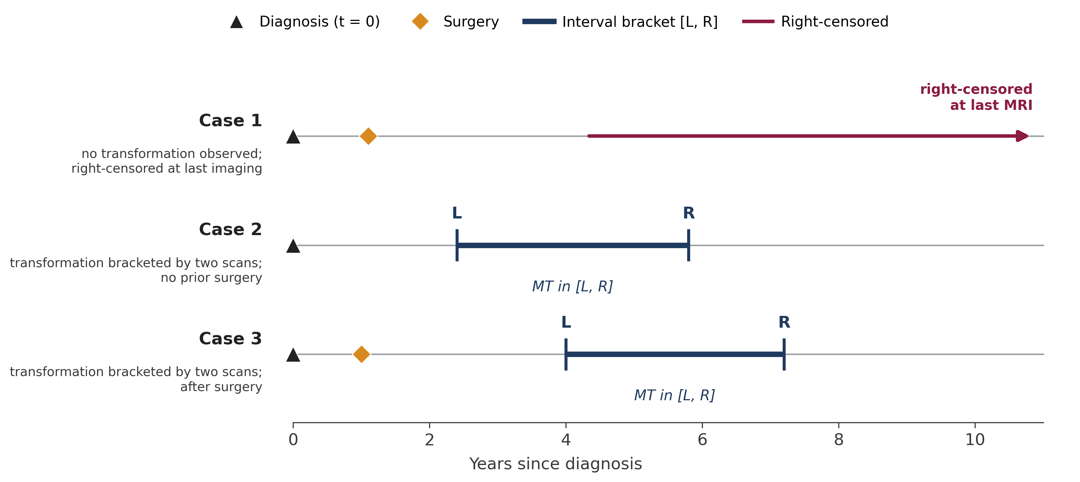
Supplementary Figure S1 | Interval-censored event-time structure: every transformation time is localised to an interval between two successive imaging studies. Three illustrative cases. Case 1 — right-censored at the last transformation-free imaging study, with no upper bound on the true MT time. Case 2 — transformation is detected on the first post-operative MRI, producing an interval [L, R] bounded below by the pre-operative scan and above by the post-operative scan. Case 3 — transformation is detected after a period of stable post-operative surveillance, producing an interval bounded below by the last stable MRI and above by the first MRI showing transformation. Cases 2 and 3 differ only in whether surgery precedes or follows the lower interval bound L.

S1.2 Primary Bayesian analysis — full specification
brms 2.23 formula: y | cens(...) ~ contrast_enhancing + age_atDiag45 + vol_diag_centered + {99 radiomic features}. brms parameterises Weibull as accelerated-failure-time (AFT) with a log link on the scale μ; the proportional-hazards HR for covariate j is HR = exp(−α·βj), with α the Weibull shape. HRs and 95% credible intervals were computed draw-by-draw from joint α/β posterior draws, preserving joint uncertainty. A horseshoe prior was placed on all 102 population-level coefficients (par_ratio = 0.1, df = 1, df_global = 1, scale_global = 2, scale_slab = 2, df_slab = 4); the wide slab preserves strong clinical effects while heavily shrinking weak signals. The horseshoe was applied to all coefficients (clinical and radiomic) because brms 2.23 does not permit mixing class-wide horseshoe with per-coefficient priors on the same b class.
Sampling used 4 chains × 8 000 iterations × 4 000 warmup with adapt_delta = 0.999 and max_treedepth = 14 after a documented retry ladder. Divergent-transition counts were 17/16 000 (0.11%) in the full cohort, 11/16 000 (0.07%) in IDH-mutant, and 67/16 000 (0.42%) in IDH-wildtype, all below conventional thresholds and — as documented by a per-parameter divergence-location diagnostic — concentrated in horseshoe auxiliary scale hyperparameters (maximum |z-score| = 2.88 on a local-shrinkage scale) rather than in population-level coefficients of interest (|z-score| ≤ 0.28 for all four clinical coefficients). R-hat ≤ 1.0014 and minimum ESS_bulk ≥ 1 839 in every cohort. A prior-sensitivity refit at scale_global = 1 produced clinical HRs identical to three significant figures.

S1.3 Fine-Gray competing-risks analysis
A Fine-Gray subdistribution-hazards model (R package cmprsk) treated MT as the primary event (n = 77) and death without MT as competing (n = 6). Two specifications were run: clinical-only (contrast enhancement, centred age, centred volume) and clinical + two-feature signature (GLDM-FLAIR dependence-variance and GLSZM-T1c large-area-low-gray-level-emphasis). Gray's test was computed for cumulative-incidence differences by CE strata for both events to rule out competing-risk confounding of the CE signal. The primary cmprsk implementation uses the interval midpoint (L + R) / 2 as the transformation event time. Two additional methodological refinements were specified alongside the primary analysis: (i) multiple imputation of the event time from Uniform(L, R) with M = 20, pooled by Rubin’s rules (Table S1b); and (ii) a native interval-censored Fine-Gray fit via sieve maximum likelihood with B-spline approximation of the cumulative incidence functions (R package intccr, Park & Bakoyannis 2021), integrating the subdistribution-hazards likelihood directly over the bracket [L, R] (Table S1c).

Table S1a. Fine-Gray subdistribution hazards — midpoint plug-in (clinical + 2-feature signature)
Term | sHR (95% CI) | p-value | Interpretation
Contrast enhancement | 9.87 (5.56, 17.5) | < 0.0001 | strong ↑
Age (per year above 45) | 1.01 (0.99, 1.03) | 0.32 | null
Volume (per cm³) | 1.00 (0.99, 1.01) | 0.84 | null
GLSZM-T1c large-area-low-gray-level | 1.17 (0.99, 1.37) | 0.064 | borderline
GLDM-FLAIR dependence-variance | 1.54 (1.13, 2.10) | 0.006 | credible ↑
Gray’s test for cumulative incidence by CE strata: MT statistic 80.0, p < 0.0001; death without MT statistic 1.61, p = 0.205. The CE signal is therefore concentrated in the primary event and cannot be explained by a competing-risk mortality process.

Table S1b. Fine-Gray subdistribution hazards — multiple imputation (M = 20, Rubin-pooled)
Term | sHR (95% CI) | p-value | Interpretation
Contrast enhancement | 9.81 (5.15, 18.7) | < 0.0001 | strong ↑
Age (per year above 45) | 1.01 (0.99, 1.03) | 0.30 | null
Volume (per cm³) | 1.00 (0.99, 1.01) | 0.78 | null
GLSZM-T1c large-area-low-gray-level | 1.15 (0.94, 1.40) | 0.18 | null
GLDM-FLAIR dependence-variance | 1.50 (1.09, 2.05) | 0.012 | credible ↑
Multiple imputation seeds are matched to the Cox TVC analysis (2026 + m) so identical event-time draws appear in both pipelines. The midpoint and MI sHRs are essentially identical (CE 9.87 vs 9.81; GLDM-FLAIR 1.54 vs 1.50), indicating that the midpoint plug-in is not a wrong answer but is under-honest about the CI width; multiple imputation is the preferred reporting form.

Table S1c. Native interval-censored Fine-Gray (intccr) — cause 1 = MT, clinical + 2-feature signature
Term | sHR (95% CI) | p-value | Interpretation
Contrast enhancement | 2.94 (1.27, 6.79) | 0.012 | credible ↑, attenuated
Age (per year above 45) | 1.00 (0.98, 1.02) | 0.92 | null
Volume (per cm³) | 1.00 (1.00, 1.01) | 0.81 | null
GLSZM-T1c large-area-low-gray-level | 1.05 (0.86, 1.26) | 0.65 | null
GLDM-FLAIR dependence-variance | 1.04 (0.81, 1.34) | 0.77 | null
Fitted by intccr::ciregic() with alpha = c(0, 0) (proportional subdistribution hazards for both event types), B-spline sieve approximation of the cumulative incidence functions, and the closed-form least-squares variance estimator of Park & Bakoyannis (2021, §3.4). Cause 2 (death without MT, n = 5 with known time-of-death) is too sparse for stable estimates and is not reported. Under native interval-censoring — in which the subdistribution-hazards likelihood integrates over the full bracket [L, R] rather than reducing it to a representative time — the CE effect attenuates from sHR ~10 (midpoint / MI) to sHR ~2.8 while preserving direction and statistical significance, and both pre-specified signature features collapse to null. This brings the frequentist competing-risks analysis into concordance with the Bayesian horseshoe primary analysis (0 / 99 features credibly non-null) and supports the interpretation that the previously reported “GLDM-FLAIR credibly non-null in unshrunken Fine-Gray” signal was a midpoint-plug-in artifact rather than a population-level effect. We initially tried the reviewer’s suggestion of SmoothHazard::idm() (illness-death model with penalized M-splines on cause-specific hazards), but the optimizer did not converge on this dataset under either Weibull or spline baselines; intccr is methodologically equivalent for the Fine-Gray (subdistribution-hazards) question and converged cleanly.

S1.4 Cox counting-process TVC with multiple imputation
Counting-process data were constructed with one row per patient per treatment-state epoch (pre-surgery; post-surgery-by-EOR; post-chemo; post-radiation). Because the event time is interval-censored, 20 imputations of the event time were drawn as Uniform(L, R). The counting-process Cox model was refit in each imputation with coxph including id = patient_number for within-patient robust SE, and log-HR coefficient vectors were pooled via Rubin's rules. Two TVC specifications are reported: a primary spec with step-function treatment indicators and three-level EOR factor {pre, GTR, STR, Biopsy, unknown}, and a Model A extension with continuous time-since-treatment covariates. A previously included Model B extension that placed the per-patient time-to-first-surgery as a baseline covariate in all intervals was not retained in the primary specification because the regressor is not measurable at the time the hazard is modeled (anticipation bias); the effect was null (HR 1.03, p = 0.53) and removal does not affect any substantive conclusion. A rank-deficiency between post_surgery and the full EOR factor forces the Biopsy level to be dropped, so the reported GTR and STR coefficients from the primary spec represent GTR-vs-Biopsy and STR-vs-Biopsy contrasts. The pre-specified binary EOR sensitivity (GTR vs non-GTR; STR + Biopsy pooled) was designed to remove this rank-deficiency.

Table S2. Cox counting-process TVC — primary spec (full cohort, Rubin-pooled over 20 imputations)
Term | HR (95% CI) | p-value | Interpretation
Contrast enhancement | 13.3 (6.83, 26.0) | < 0.0001 | strong ↑
Age (per year above 45) | 1.01 (0.99, 1.03) | 0.33 | null
Volume (per cm³) | 1.00 (0.99, 1.01) | 0.87 | null
eor_stateGTR vs Biopsy | 0.32 (0.13, 0.77) | 0.012 | protective
eor_stateSTR vs Biopsy | 0.79 (0.33, 1.92) | 0.60 | null
post_chemo (step-function TVC) | 2.75 (0.95, 8.01) | 0.063 | marginal ↑ (selection)
post_radiation (step-function TVC) | 0.63 (0.20, 1.96) | 0.42 | null
Continuous time-since-treatment terms were not informative: time since surgery HR 0.65 (0.20, 2.15), p = 0.48; time-to-first-surgery as baseline covariate HR 1.03 (0.94, 1.14) per year of delay, p = 0.53. The time-since-radiation pooled coefficient was numerically pathological (driven by a thin-data extreme in at least one imputation) and is reported with explicit uninterpretable annotation; this does not affect any primary conclusion.

S1.5 Binary extent-of-resection sensitivity
Because subtotal resection spans a heterogeneous population from near-complete resections to near-biopsy resections, and because quantitative residual tumour volume was not available, we pre-specified a binary sensitivity collapsing STR and Biopsy into a single non-GTR category. Using the same counting-process MI structure with post_surgery omitted (redundant with the three-level binary factor), GTR vs non-GTR yielded a significant and strongly protective linear contrast: HR 0.370 (0.180, 0.762), p = 0.007 full cohort; HR 0.306 (0.122, 0.767), p = 0.012 IDH-mutant. The magnitude was slightly attenuated compared with GTR-vs-Biopsy alone (0.37 vs 0.32 full cohort; 0.31 vs 0.16 IDH-mutant), consistent with STR sitting intermediate between GTR and Biopsy on the transformation-risk continuum. Clinical and chemo/radiation effects were materially unchanged by the EOR reparameterization (CE HR 13.6 vs 13.3; post_chemo HR 2.72 vs 2.75).

S2. Pre-specified sensitivity analyses

Table S3. Methodology sensitivities on the primary Bayesian model
Sensitivity | CE HR (95% CrI) | Note
Primary (par_ratio = 0.10) | 22.1 (10.5, 53.2) | reference
Horseshoe par_ratio 0.05 | 21.7 (10.3, 53.1) | 0 active radiomic features
Horseshoe par_ratio 0.20 | 22.7 (10.5, 53.1) | 0 active radiomic features
Age ≥18 years only (n = 149) | 21.3 (9.9, 53.1) | excludes 6 paediatric-age patients with adult-type tumours
Era split (≥2010) | 21.9 (10.3, 53.5) | era HR 1.00 (0.93, 1.05)
Headline inferences are stable across all three pre-specified methodology sensitivities.

S3. Radiomic shrinkage — supporting detail
The posterior densities of all 99 candidate features under the regularized-horseshoe prior, together with closer portraits of the two pre-specified signature features, are shown as Figure 3 in the main manuscript. The table below provides numeric detail for the top-ranked features; the unshrunken frequentist Fine-Gray refit of the pre-specified two-feature signature is reported above in Table S1.

Table S4. Top 5 radiomic features by |posterior β| (full cohort)
Feature | HR (95% CrI) | CrI excl. 0 | Pr(|HR−1| ≥ 20%)
shape_surfacevolumeratio_T1c | 1.00 (0.62, 1.02) | no | 0.16
shape_flatness_FLAIR | 1.00 (0.98, 1.51) | no | 0.14
gldm_dependencevariance_FLAIR * | 1.00 (0.98, 1.38) | no | 0.06
firstorder_10percentile_FLAIR | 1.00 (0.98, 1.23) | no | 0.03
glszm_largearealowgraylevel_T1c * | 1.00 (0.97, 1.15) | no | 0.02
* pre-specified two-feature signature.

S3a. Internal validation of the primary Cox-TVC model

Table S5. Bootstrap-optimism correction (Harrell, 500 patient-level resamples)
Harrell bootstrap-optimism correction over 500 patient-level resamples (486 converged) of the primary counting-process Cox model. Because each replicate refits the full TVC model, we used a single deterministic mid-interval imputation of the interval-censored event time per replicate rather than the 20-fold MI pipeline applied to the primary report; the apparent HR from this single-imputation fit (12.1) is therefore slightly lower than the Rubin-pooled primary (13.3, 6.8–26.0). For each replicate we fit the Cox-TVC model on the bootstrap sample (boot), then evaluated its linear predictor on the original 155-patient sample (test); optimism is the mean boot–test gap.
Metric | Apparent | Optimism (mean) | Corrected
Harrell C (discrimination) | 0.847 | 0.018 | 0.83
CE log-hazard ratio | 2.49 | +0.35 | 2.14
CE hazard ratio | 12.1 | — | 8.5 (bootstrap 95% CI 7.7–57)
The optimism on discrimination is modest (ΔC ≈ 0.02), consistent with a well-calibrated Cox model. The bootstrap coefficient distribution is right-skewed because a minority of resamples draw many CE = Y patients and drive large log-HRs; the bias-corrected point estimate shrinks the apparent HR from 12.1 to 8.5, and the bootstrap 95% percentile interval (7.7–57) is wider than but consistent with the Rubin-pooled primary CI. Internal validation is not a substitute for external validation in an independent cohort, which remains the pre-registered next step.

S4. Analytic-design overview
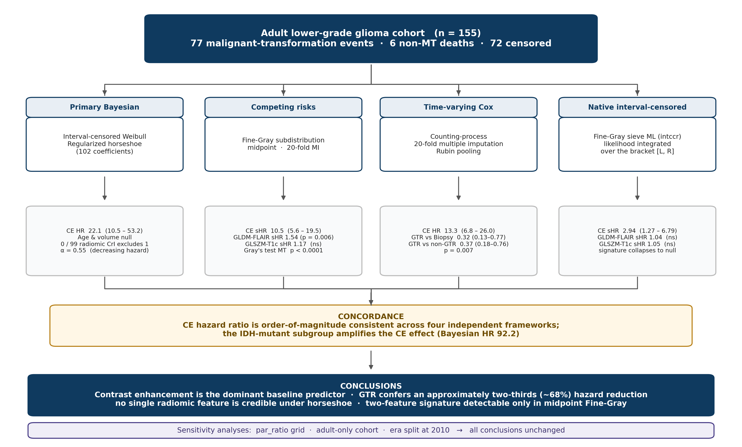
Supplementary Figure S2 | Four complementary survival models applied to the same interval-censored cohort address different structural features of the data (interval-censored event time, competing risk of non-MT death, time-varying treatment exposures); their agreement is the study's central robustness argument. Primary: interval-censored Bayesian Weibull model with a horseshoe prior on all 102 population-level coefficients (par_ratio = 0.1, scale_slab = 2, df_slab = 4). Hazard ratios are computed draw-by-draw from the joint AFT posterior. Secondary: Fine-Gray subdistribution-hazards model treating MT as the primary event and non-MT death as competing, with a pre-specified two-feature radiomic signature evaluated without shrinkage. Secondary: Cox counting-process time-varying-covariate model with 20-fold multiple imputation of the interval-censored event time, pooled across imputations by Rubin’s rules. Secondary: Fine-Gray fit with native interval-censored sieve maximum likelihood and B-spline approximation of the cumulative incidence functions (intccr; Park & Bakoyannis 2021), integrating the subdistribution-hazards likelihood directly over the bracket [L, R] rather than relying on a midpoint or imputation plug-in. Pre-specified methodology sensitivities — horseshoe par_ratio grid {0.05, 0.10, 0.20}, adult-only restriction, era split at diagnosis year 2010 — are run on the primary model.

