**Scatter plot for Hb vs Gestational age:**

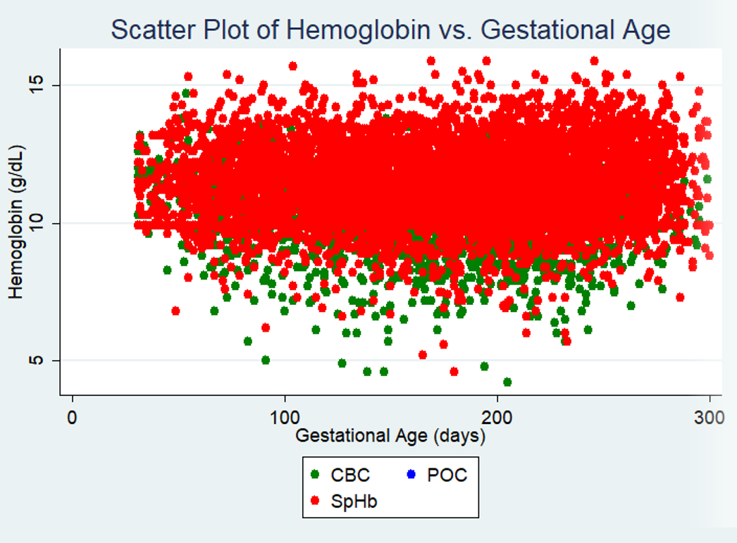

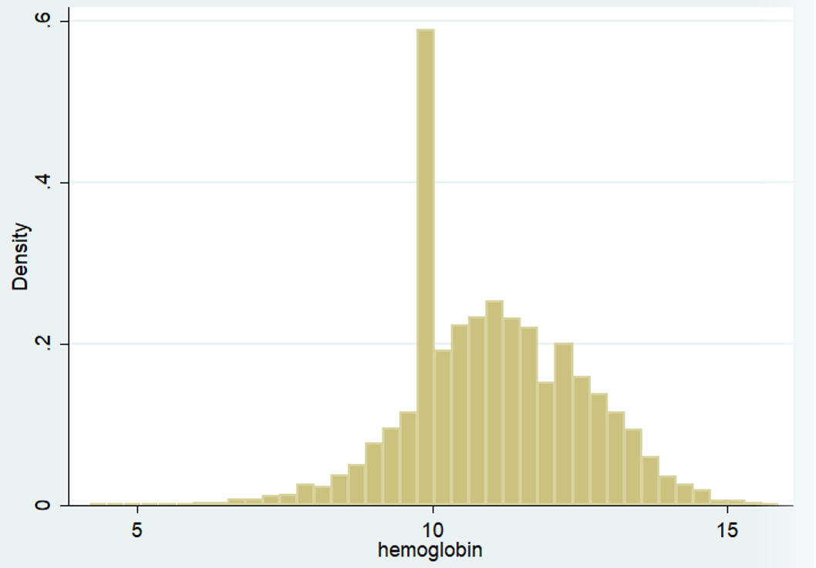**Histogram of Hemoglobin Levels:**

**Histogram of Hemoglobin Levels by trimester:**

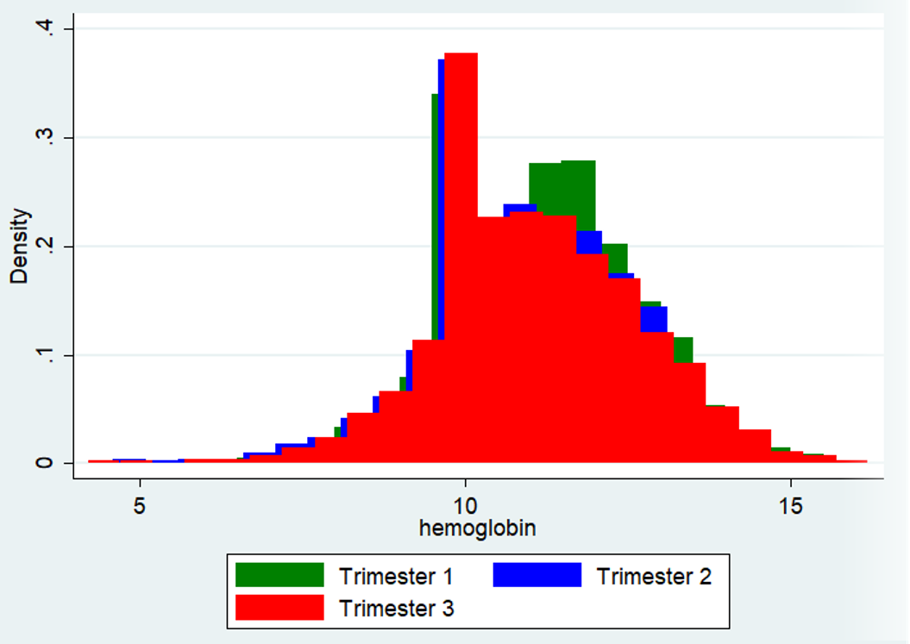

**Histogram of Hemoglobin Levels by trimester:**

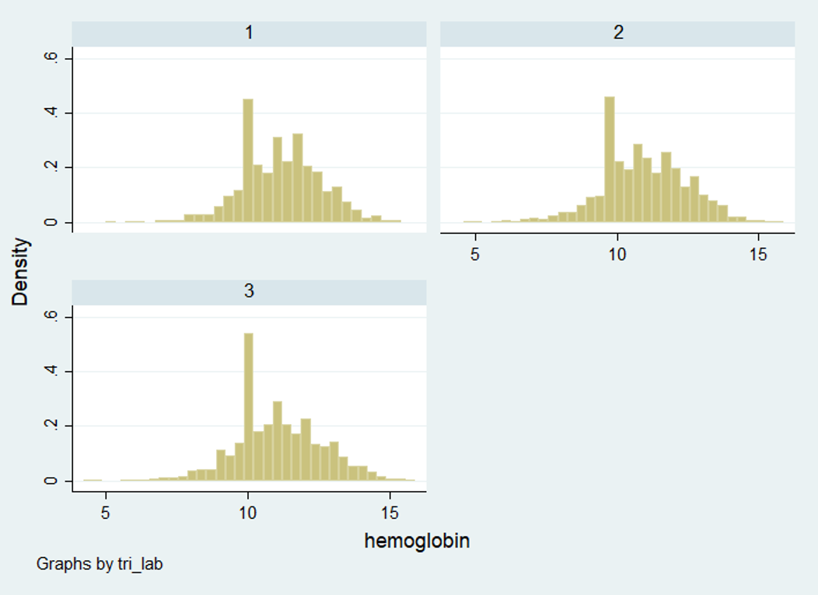

**Histogram of Hemoglobin Levels (CBC only):**

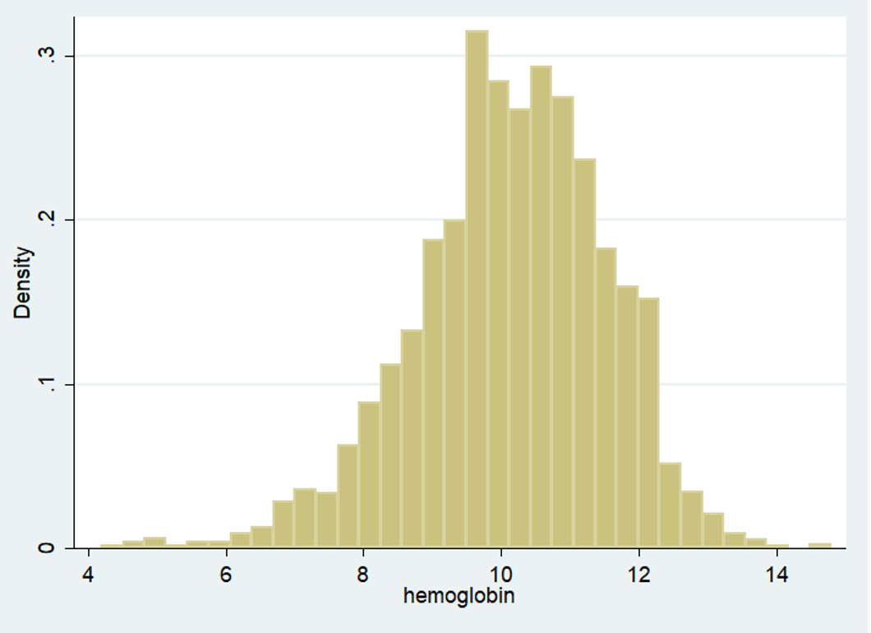

**Histogram of Hemoglobin Levels by trimester (CBC only):**

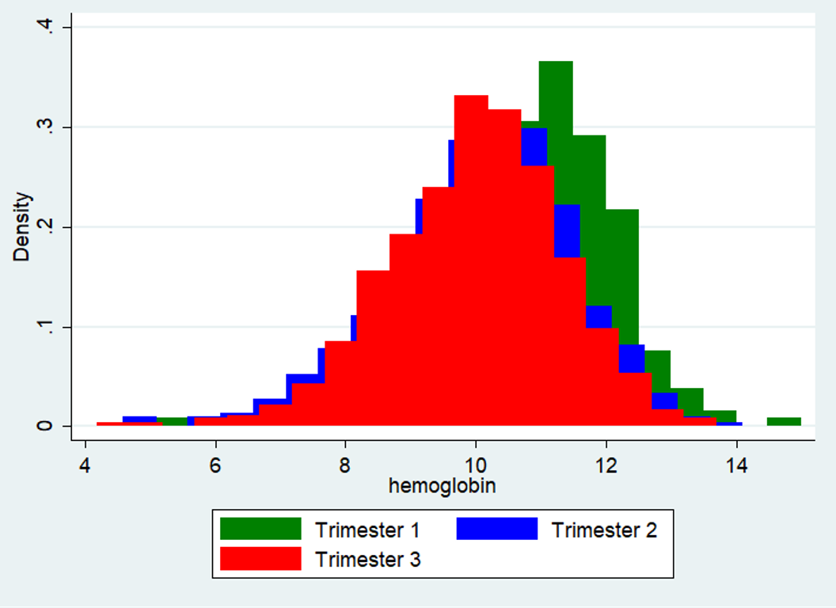

**Histogram of Hemoglobin Levels by trimester (CBC only):**

