Troubleshooting and Configuring EVE-NG on VMware: My Report

## Introduction

The following is a brief description of two issues that I encountered when installing and configuring an EVE-NG server via VMware on my Windows 11 machine.

Operating System: Windows 11 Home (Initially) Upgraded to Windows 11 Pro

Virtualization Software: VMware Workstation Pro

EVE-NG Version: Community

Processor: 13th Gen Intel(R) Core(TM) i5-13400F, 2500 Mhz, 10 Core(s), 16 Logical Processor(s)

RAM: 32 GB

Storage: 2 TB SSD

# ISSUE 1 Virtualized Intel VT-x/EPT is not supported on this platform

When starting up my EVE-NG virtual machine I encountered an error that indicated that Intel VT-x/EPT was not supported on the platform. This error was due to Windows Hyper-V services running on my Windows 11 Home Platform with no option to disable it. No matter how I tried to troubleshoot this I just could not seem to turn off Windows Hyper-V services while running Windows 11 Home. While on Windows 11 Home there were no options in “Windows Features” for Hyper-V, but as I turned off all the other Windows Hypervisor settings, System Information was continuing to indicate that a Hypervisor had been detected. I eventually upgraded my operating system to Windows 11 Pro and was able to easily disable Windows Hyper-V and EVE-NG server virtual machine has ran perfectly since then.

## Troubleshooting Steps

1. First I verified that all Virtualization settings were enabled in my UEFI settings.
2. Next I verified in Windows System Information that Virtualization was enabled.
3. I opened Windows PowerShell as an administrator and ran a series of commands.
   1. bcdedit /set hypervisorlaunchtype off
   2. DISM /Online /Disable-Feature:Microsoft-Hyper-V
   3. DISM /Online /Disable-Feature:VirtualMachinePlatform
   4. DISM /Online /Disable-Feature:WindowsHypervisorPlatform
   5. NOTE: Before I upgraded to Windows 11 Pro I tried to run the DISM /Online /Disable-Feature:Microsoft-Hyper-V command, but kept getting an error stating that the feature was not recognized.
4. I opened Windows Features and disabled everything that had to do with Windows Hypevisor.
   1. Virtual Machine Platform
   2. Windows Hypervisor Platform
   3. Hyper-V (This option was not able to disable while I was running Windows 11 Home)

## Resolution

While running Windows 11 Home, I disabled Virtual Machine Platform and Windows Hypervisor Platform that was all the Windows Hypervisor features available and even after running the commands in PowerShell and manually disabling those features in Windows Features, when I ran the ‘system info’ command in Command Prompt the system was still indicating that ‘Hyper-V Requirements: A hypervisor has been detected. Features required for Hyper-V will not be displayed.’ After wrestling with this issue for a few hours, I eventually saw on a message board that Windows Hyper-V service did not come with Windows 11 Home. It is my conclusion the Windows Hyper-V feature was indeed running on Windows 11 Home but the option to disable it was not present in Windows Features while on Windows 11 Home. That is when I got the idea to just upgrade to Pro. After upgrading to Pro I saw that Hyper-V was enabled. I disabled it restarted my computer and the EVE-NG VM started up perfectly and has every time since upgrading.

Throughout the process of troubleshooting and configuring EVE-NG on VMware, I gained some valuable insights when it comes to virtualization on Windows platforms. The errors and issues that I encountered and resolved have provided me with a deeper understanding of EVE-NG and VMware, which will be beneficial as I continue to dive into more complex network emulation projects.

# ISSUE 2 Virtual Interface Configuration

The next thing that I ran into after getting EVE-NG running was getting it configured the way that I wanted in order for it to operate both with my physical home lab as well as with my actual home network to connect to the internet. The biggest problem I ran into was while using ChatGPT 4o to troubleshoot a DHCP issue on the EVE-NG server GPT gave me some incorrect interface provisioning information. The information corrected my DHCP issue on the server, but it also deleted the ‘Management Cloud’ Network needed to bridge the virtual nodes to my primary virtual interface which was mapped to my Host machine’s wireless NIC connected to my main home network. So, it took digging in to the EVE-NG Docs and “EVE-NG Cookbook” in order to get the /etc/network/interfaces file configured correctly to accomplish what I wanted it to do.

*Virtual network to test EVE-NG server configuration.*

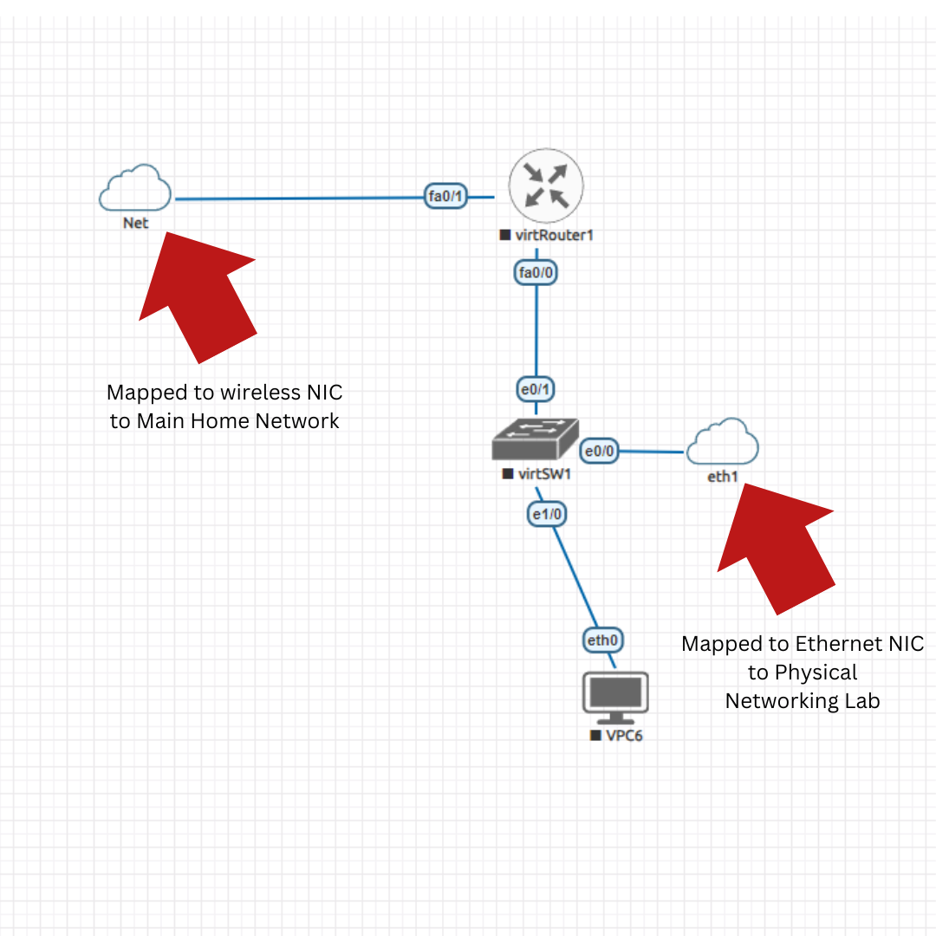

## Troubleshooting Steps:

1. After a considerable amount of trial and error, I identified the incorrect virtual interface provisioning provided by ChatGPT.
2. I consulted the EVE-NG documentation and EVE-NG Community Cookbook for accurate configuration and more accurate information on how EVE-NG’s virtual interfaces worked.
3. Reconfigured ‘/etc/network/interfaces’ to restore properly bridged network connections.

## Resolution

I was able to correctly configure the network interface file, getting the EVE-NG virtual nodes to properly operate with both my home and lab networks. I am glad that I had this error because I got to learn and dig deep into how the virtual interfaces work in EVE-NG.

*Correct configuration of EVE-NG interfaces in the interfaces file.*

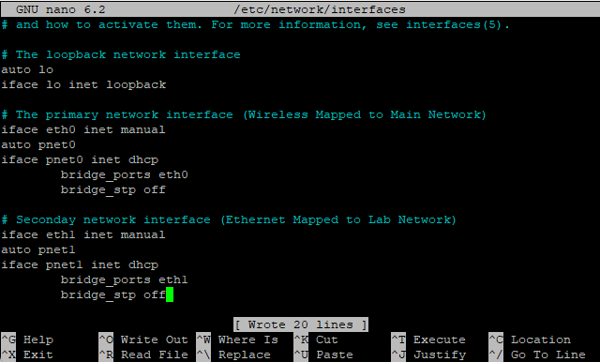

## CONCLUSION

*Diagram of the Test Topology I used to test EVE-NG configurations.*

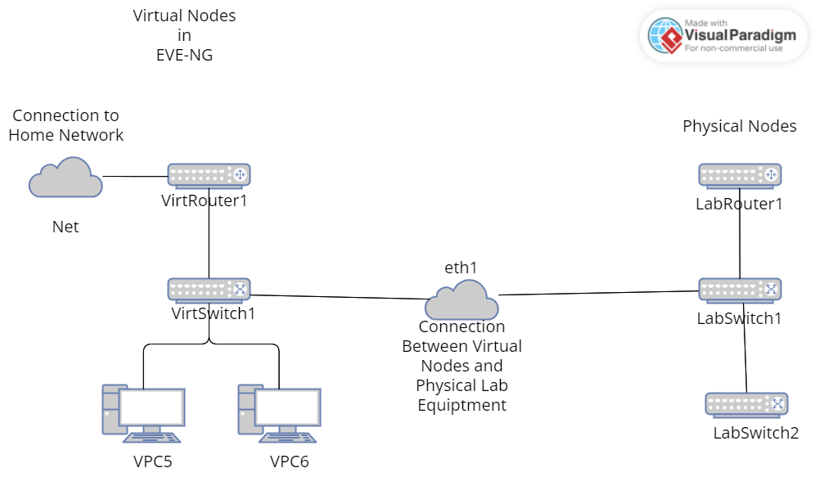

## Key Take Aways

1. Ensure that the version of the operating system that you are using fully supports virtualization features.
2. Windows 11 Pro is highly recommended when engaging in virtualization tasks.
3. Do not blindly trust GPT o4 when it comes to something as particular as virtual interface configuration. Go to the Docs.

I am happy I encountered the issues that I did because while digging through documentation, message boards, and manuals I gained valuable insights regarding EVE-NG and virtualization on Windows platforms overall. The issues that I encountered forced me to go much deeper into these technologies than I would have if everything worked perfectly out of the box.