SALES INTELLIGENCE
APPLICATION SERVING ARCHITECTURE
Design Document
Daily KPI computation • Iceberg analytical persistence • PostgreSQL low-latency serving • Operational write-back

Version | 1.0
Date | July 26, 2026
Status | Proposed Target Architecture
Classification | Internal Design

1. Executive Summary
The Sales Intelligence application requires predictable, low-latency access to curated sales KPIs. Querying Snowflake through a federated query during an interactive application request is too slow and creates an unnecessary dependency between user experience and analytical query performance. The proposed design moves KPI calculation into a controlled daily Databricks workflow and separates analytical persistence from application serving.
Architecture decision
Calculate KPIs once per day in Databricks, persist the authoritative KPI snapshot in an Iceberg table for enterprise analytics, and publish the same snapshot to PostgreSQL as a low-latency application-serving projection. Fivetran replicates only application operational data from PostgreSQL back to Snowflake.

- Snowflake remains the source of truth: Enterprise source data is read daily by the Databricks KPI workflow.
- Iceberg is the analytical KPI record: Daily KPI snapshots are retained for history, audit, reconciliation, and Snowflake consumption.
- PostgreSQL is the serving layer: The web application reads precomputed KPI data with predictable latency and stores operational records.
- Fivetran has a narrow scope: Only the PostgreSQL operational schema is replicated back to Snowflake; KPI-serving tables are excluded.
- Consistency is explicit: One calculation run creates one snapshot_id that is written to both Iceberg and PostgreSQL.

2. Business Context and Design Drivers
Driver | Current issue | Design response
Interactive latency | Federated Snowflake queries are too slow for application requests. | Serve precomputed KPIs from PostgreSQL.
Daily data cadence | Enterprise data changes once per day. | Use a scheduled batch workflow instead of streaming.
Enterprise history | KPI results must remain available for analytics and audit. | Persist daily KPI snapshots in an Iceberg table.
Operational write-back | The application generates operational records that must reach Snowflake. | Write to PostgreSQL and replicate only operational tables through Fivetran.
Data consistency | Two KPI destinations could diverge. | Publish from one calculation run using a shared snapshot_id and reconciliation checks.

The design intentionally avoids streaming, Redis, and direct application-to-Snowflake queries because the business data is refreshed daily and the primary requirement is reliable low-latency serving.

3. Target Logical Architecture
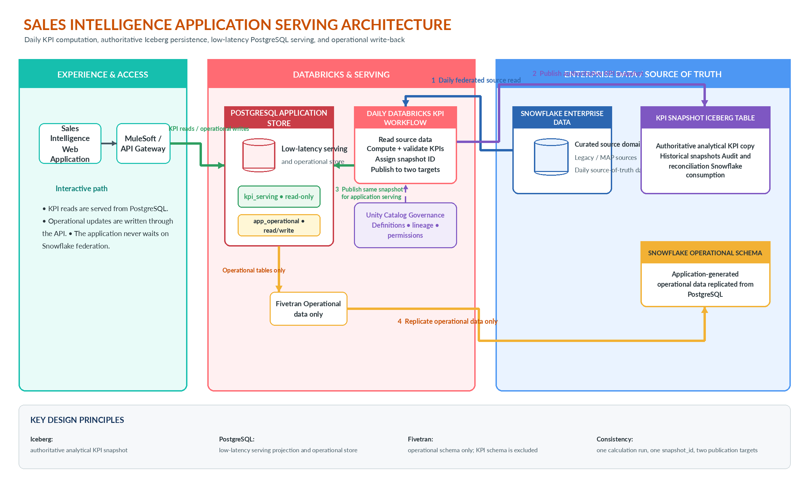
Figure 1. Target logical architecture and primary data flows.
Core principle
Iceberg is the authoritative analytical KPI store. PostgreSQL is an optimized serving copy of the exact same KPI snapshot, not an independent source of KPI truth.

4. End-to-End Data Flows

4.1 Daily KPI calculation and dual publication
- Snowflake enterprise data is finalized according to the agreed daily source-data cutoff.
- A scheduled Databricks job reads only the required source data through the federated connection.
- Databricks applies KPI definitions, aggregations, business rules, and data-quality checks.
- The job assigns a unique snapshot_id and records the business date and source-data watermark.
- The validated snapshot is committed to the KPI Iceberg table as the authoritative analytical record.
- The same snapshot is loaded into an inactive PostgreSQL staging or versioned partition.
- Iceberg and PostgreSQL totals are reconciled before the PostgreSQL snapshot becomes active.

4.2 Low-latency application serving
- The web application accesses KPI endpoints through MuleSoft or the API gateway.
- KPI queries are served from PostgreSQL kpi_serving tables, using indexes aligned with API filters and drill-down paths.
- The application does not issue interactive federated queries to Snowflake or Databricks.
- Every response can expose the snapshot date and source-data-through timestamp so users understand freshness.

4.3 Operational application data write-back
- Application-generated records such as comments, workflow status, overrides, or user actions are written to PostgreSQL app_operational tables.
- Fivetran replicates only app_operational tables from PostgreSQL into the Snowflake operational schema.
- PostgreSQL kpi_serving tables are excluded from Fivetran to prevent KPI duplication and circular data movement.
- The operational replication schedule is independent of the daily KPI-serving publication unless operational data must be included in the next KPI run.

5. Component Responsibilities
Component | Primary responsibility | Data ownership / access pattern
Sales Intelligence Web Application | Presents KPI dashboards and captures operational user actions. | Reads KPIs and writes operational data through APIs.
MuleSoft / API Gateway | Authentication, authorization, routing, throttling, and API contract enforcement. | No persistent data ownership.
PostgreSQL - kpi_serving | Fast application-facing copy of the active KPI snapshot. | Read-only to the application; refreshed by Databricks publication.
PostgreSQL - app_operational | Transactional storage for application-generated operational records. | Read/write application store; replicated by Fivetran.
Databricks Daily KPI Workflow | Reads source data, calculates and validates KPIs, and publishes one snapshot to two targets. | Owns KPI processing logic and run metadata.
Unity Catalog / Governance | Controls permissions, definitions, lineage, and discoverability of governed KPI assets. | Governance metadata and policy control.
KPI Iceberg Table | Authoritative analytical KPI snapshots for history, audit, reconciliation, and Snowflake analytics. | Append or merge by snapshot; not used for interactive app serving.
Snowflake Enterprise Data | Enterprise source-of-truth data and replicated operational analytics. | Source system for daily KPI calculation.
Fivetran | Replicates PostgreSQL operational data back to Snowflake. | Operational schema only; excludes KPI-serving schema.

6. Data Ownership and Storage Model
Dataset | Authoritative location | Secondary location | Direction
Enterprise sales source data | Snowflake | None required | Snowflake → Databricks
Daily KPI snapshot | Iceberg table | PostgreSQL kpi_serving | Databricks → Iceberg and PostgreSQL
Application operational data | PostgreSQL app_operational | Snowflake operational schema | PostgreSQL → Fivetran → Snowflake
Pipeline run metadata | Databricks control tables / logs | Optional operational dashboard | Databricks internal

Schema boundary
Configure Fivetran with an explicit include list for app_operational.* and an explicit exclusion for kpi_serving.*. This prevents the same KPI data from reaching Snowflake through both Iceberg and Fivetran.

7. Snapshot and Table Design
Each KPI record should carry enough metadata to prove which source cutoff and calculation run produced it. Recommended fields are shown below.
Field | Purpose
snapshot_id | Unique identifier shared by the Iceberg and PostgreSQL copies.
business_date | Business date represented by the KPI snapshot.
source_data_through_timestamp | Latest source-data timestamp included in the calculation.
calculated_at | Timestamp when Databricks completed KPI calculation.
published_at | Timestamp when the destination publication completed.
pipeline_run_id | Traceable identifier for logs, retries, and audit.
record_hash or reconciliation key | Optional control used to compare the two target copies.

PostgreSQL should retain the active snapshot and the number of previous snapshots required for rollback or user history. Iceberg can retain the longer analytical history according to enterprise retention policy.

8. Daily Orchestration and Consistency
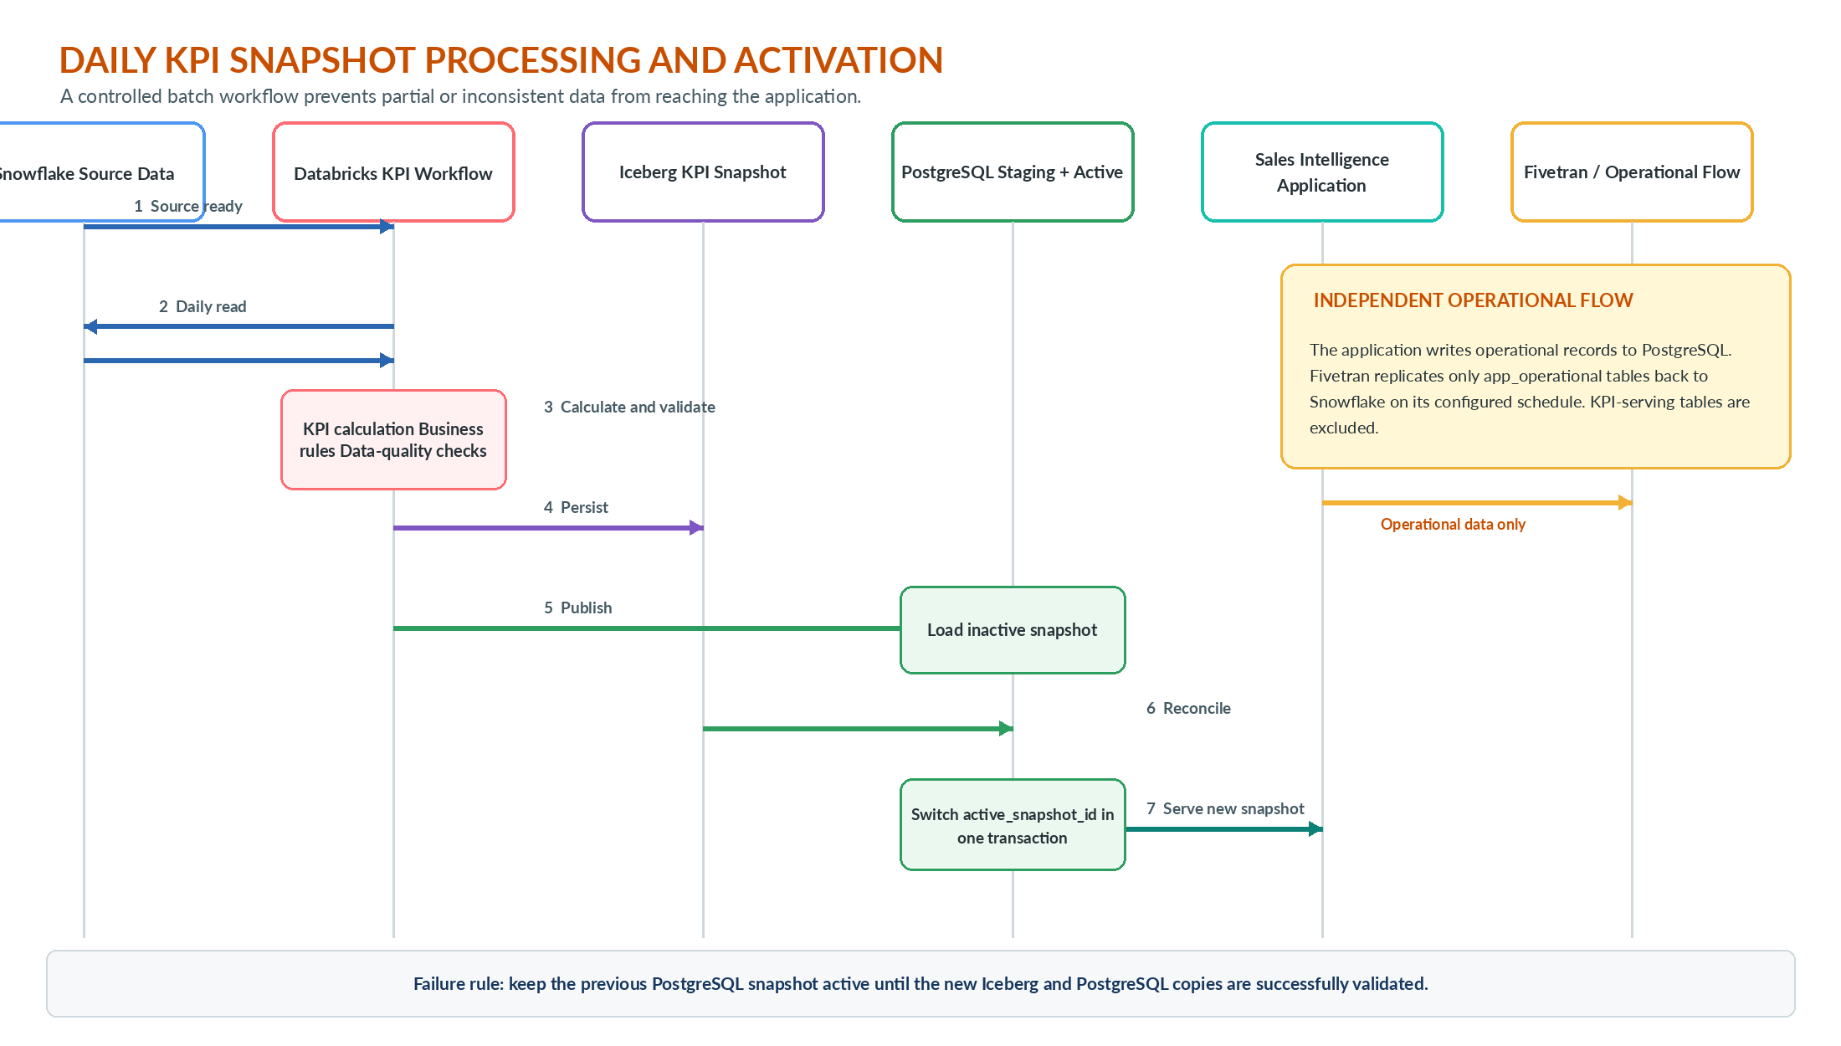
Figure 2. Recommended daily processing, reconciliation, and activation sequence.

8.1 Atomic PostgreSQL activation
The application must not see a partially loaded KPI snapshot. Load the new snapshot as inactive, validate it, and then switch a small control record such as active_snapshot_id in a single transaction. Until activation succeeds, the previous snapshot remains available.

8.2 Publication order
- Calculate and validate the KPI dataset once.
- Commit the authoritative Iceberg snapshot.
- Publish the exact same snapshot to PostgreSQL staging.
- Reconcile snapshot_id, row counts, control totals, and key KPI totals.
- Activate the PostgreSQL snapshot only after reconciliation succeeds.

8.3 Operational-data dependency
When application operational records must affect the next day’s KPI values, the workflow should wait for the required Fivetran sync watermark before starting the Databricks job. When operational records do not affect KPI calculations, the Fivetran schedule can remain independent.

9. Reliability and Failure Handling
Failure scenario | Required behavior
Federated source read fails | Do not produce a new snapshot; continue serving the previous PostgreSQL snapshot.
KPI calculation or validation fails | Stop publication and retain diagnostic results for investigation.
Iceberg commit fails | Do not publish or activate the PostgreSQL snapshot.
PostgreSQL load fails | Keep the Iceberg snapshot, retain the previous active PostgreSQL snapshot, and retry publication.
Reconciliation fails | Do not activate the new PostgreSQL snapshot; alert the support team.
Fivetran operational sync fails | Retain operational data in PostgreSQL and allow connector retry; KPI serving remains available.
Application or API outage | KPI data remains persisted; recover API or application independently.

10. Security and Governance
- Network isolation: Use private connectivity where available and avoid exposing PostgreSQL or data platforms directly to the public internet.
- Transport protection: Require TLS for application, API, PostgreSQL, Databricks, Snowflake, and Fivetran connections.
- Identity and least privilege: Use workload identities or service principals with separate permissions for source read, Iceberg write, PostgreSQL KPI publish, and operational replication.
- Secret management: Store database credentials and tokens in an approved secrets service; do not embed them in notebooks or pipeline definitions.
- Schema-level controls: Grant the application read access to kpi_serving and controlled read/write access to app_operational. Fivetran receives access only to app_operational.
- Governed KPI definitions: Maintain KPI definitions, lineage, ownership, and quality rules in the governance catalog.
- Sensitive data minimization: Publish only the dimensions and metrics required by the application; avoid copying unnecessary row-level or sensitive source data into PostgreSQL.

11. Observability and Operational Support
Area | Recommended monitoring
Daily job | Start/end status, duration, retry count, and failure reason.
Data freshness | Business date, source-data watermark, Iceberg publish time, and PostgreSQL activation time.
Data quality | Source row counts, output row counts, null checks, business-rule violations, and KPI control totals.
Cross-target consistency | Snapshot ID match, record counts, aggregate totals, and optional hash comparison.
PostgreSQL serving | API latency, query latency, connection utilization, locks, storage growth, and index effectiveness.
Fivetran | Connector status, replication lag, rejected records, and schema-change alerts.
Application/API | Request rate, error rate, p95/p99 latency, authentication failures, and endpoint health.

User-facing freshness
Display “Data current through” and “Last refreshed” timestamps in the Sales Intelligence application so users do not interpret daily data as real time.

12. Non-Functional Requirements and Acceptance Criteria
Category | Acceptance criterion
Freshness | A new KPI snapshot is published before the agreed business start time after the daily Snowflake cutoff.
Latency | KPI API requests meet the product’s agreed response-time target using PostgreSQL without invoking Snowflake federation.
Consistency | The active PostgreSQL snapshot matches the authoritative Iceberg snapshot by snapshot_id and reconciliation controls.
Availability | Failure of a new daily load does not remove the previous valid KPI snapshot from the application.
Recoverability | PostgreSQL publication can be retried from the committed Iceberg snapshot without recalculating KPIs.
Security | All connections are encrypted and all workload identities use least-privilege access.
Auditability | Every snapshot can be traced to its source watermark, calculation run, validation results, and publication timestamps.

13. Risks, Tradeoffs, and Mitigations
Risk / tradeoff | Impact | Mitigation
Federated daily read remains slow | The overnight batch may miss the publication window. | Optimize pushdown and source filters; if necessary, incrementally stage only the required source data before KPI calculation.
Two publication targets diverge | Users and analysts may see different KPI values. | Use one snapshot_id, publish from one validated dataset, and reconcile before activation.
PostgreSQL grows into a second warehouse | Cost and operational complexity increase. | Store only application-ready aggregates and required drill-down data; keep ad hoc analytics in Snowflake/Iceberg.
KPI tables replicated by Fivetran | Duplicate KPI paths and ownership confusion. | Use explicit schema include/exclude rules and periodically validate connector configuration.
Operational replication is late | Next-day KPIs may omit recent application data when it is required. | Use a watermark dependency between Fivetran completion and the Databricks job.
Partial PostgreSQL refresh | Application could expose incomplete data. | Use versioned snapshots or staging plus atomic active-snapshot switching.
Iceberg ownership is unclear | Competing writers can create operational risk. | Define one write owner and treat other platforms as consumers.

14. Recommended Implementation Plan
Phase | Scope | Exit criteria
1. Foundation | Define KPI contracts, snapshot metadata, schemas, identities, network paths, and governance ownership. | Approved data contracts and access model.
2. KPI pipeline | Implement daily source read, KPI calculation, quality checks, and Iceberg snapshot persistence. | A validated authoritative daily snapshot is available.
3. PostgreSQL serving | Create kpi_serving schema, indexes, staging/activation pattern, and API queries. | Application serves the new snapshot without federated queries.
4. Operational write-back | Create app_operational schema and configure Fivetran include/exclude rules. | Operational records replicate to Snowflake; KPI tables do not.
5. Hardening | Add reconciliation, alerting, retry, rollback, performance tests, and operational runbooks. | Production acceptance criteria are met.

15. Architecture Decision Summary
Decision | Outcome
Interactive reporting path | Application → MuleSoft/API → PostgreSQL.
KPI processing cadence | Daily scheduled Databricks workflow.
Enterprise KPI persistence | Authoritative KPI snapshot stored in an Iceberg table.
Application KPI persistence | Same snapshot copied to PostgreSQL for low-latency serving.
Operational write-back | PostgreSQL app_operational → Fivetran → Snowflake.
KPI write-back via Fivetran | Not allowed; kpi_serving is explicitly excluded.
Consistency control | Shared snapshot_id, watermarks, validation, reconciliation, and atomic activation.
Failure behavior | Continue serving the previous valid snapshot until the new snapshot is fully validated.

Final recommendation
Approve the design for a daily-refresh Sales Intelligence application. The architecture removes slow Snowflake federation from the interactive path while preserving an authoritative analytical KPI history in Iceberg and a controlled operational write-back path to Snowflake.

Appendix A. Suggested PostgreSQL Schema Structure
kpi_serving
active_snapshot
daily_sales_summary
customer_kpi
territory_kpi
sales_rep_kpi
forecast_kpi
app_operational
user_comments
workflow_status
saved_filters
user_overrides
user_preferences

Appendix B. Editable Diagram Package
The accompanying .drawio file contains two editable pages: “Logical Architecture” and “Daily Processing Sequence.” It uses standard draw.io shapes and connectors so it can be imported into Lucidchart and adjusted for environment-specific names, network boundaries, or security components.

