**CHANGE ALL LOGIN TO ERROR**

* Copy the log4j.proprties.template
* Remove the root category from WARN TO ERROR
* Rename the file as log4j.proprties

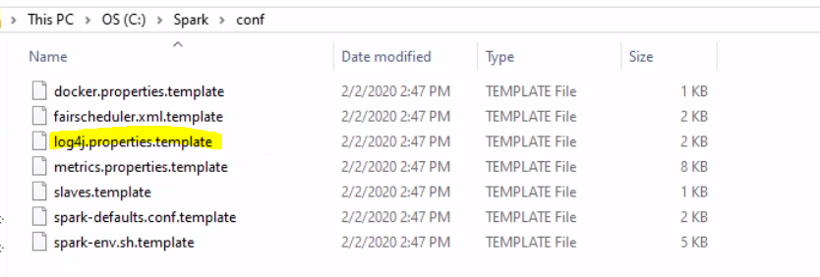

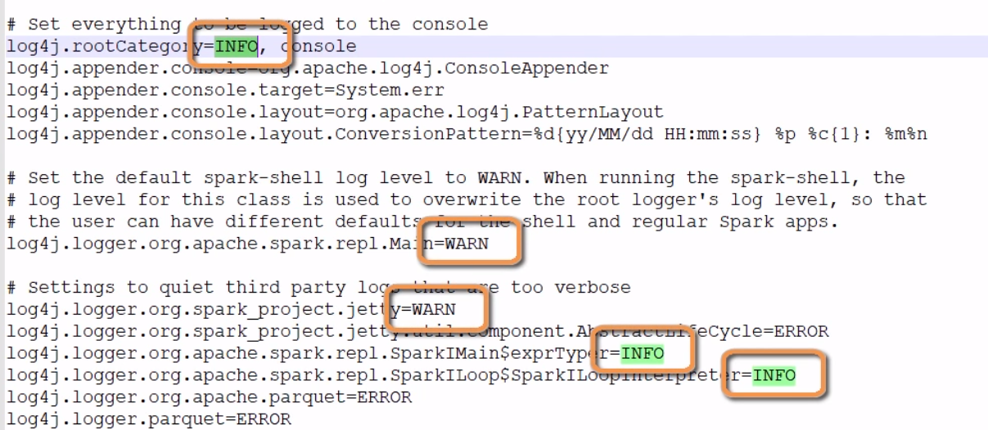

BEFORE

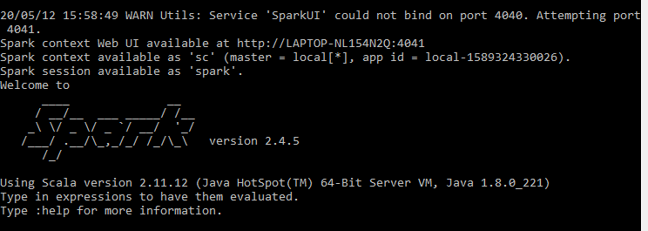

AFTER