WORKSPACE, SUBSCRIPTION AND RESOURCE GROUP

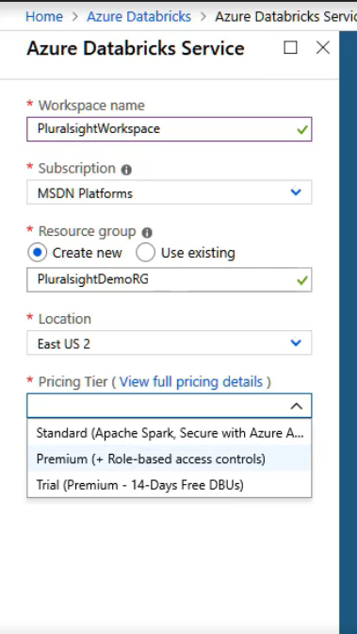

AZURE DATABRICKS

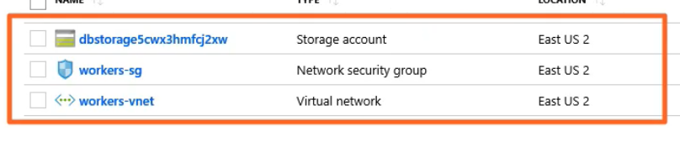

URL

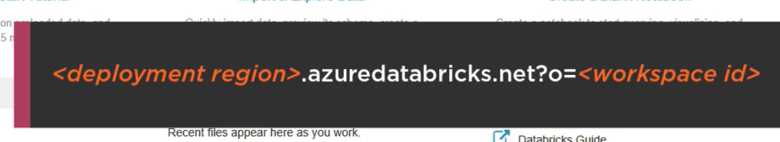

CLUSTERS

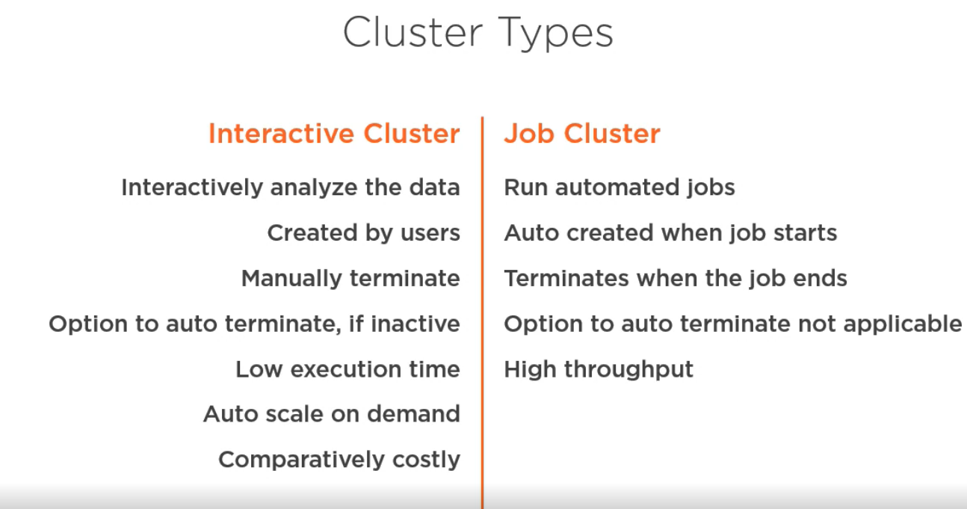

CREATING NEW CLUSTER

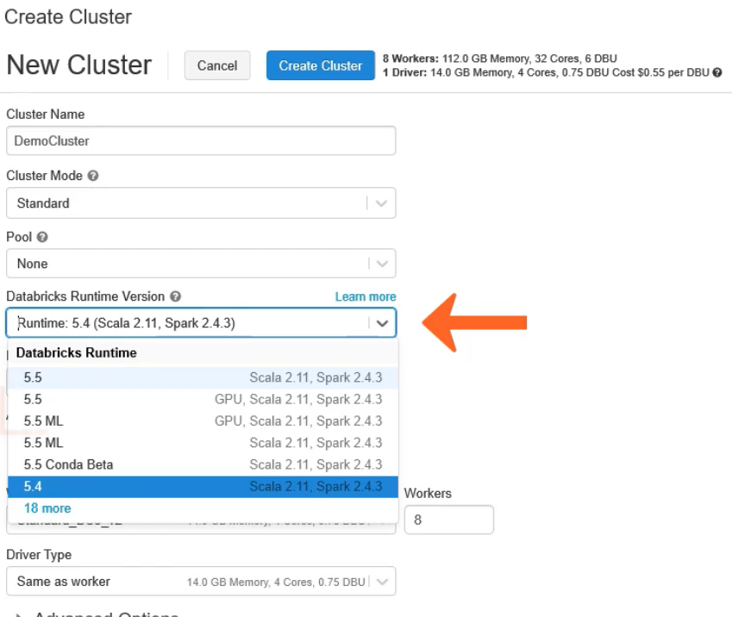

ENABLE AUTO SCALING

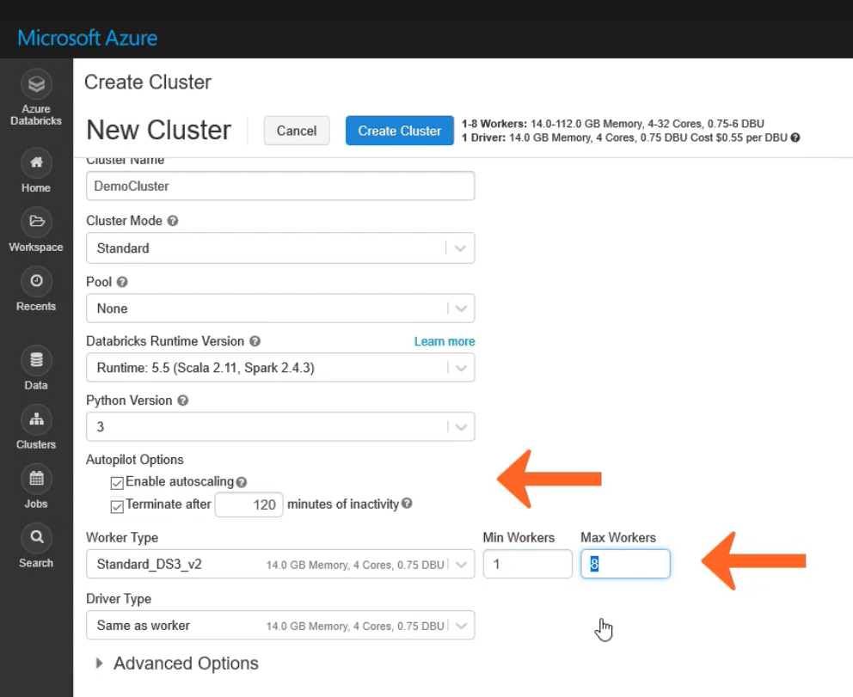

POOL CREATION

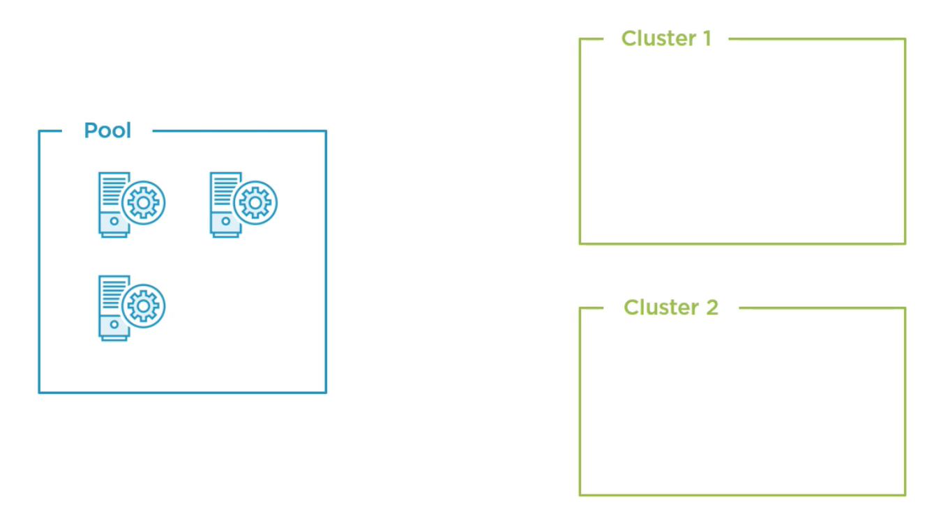

Here we have 2 instances allocated to cluster 1

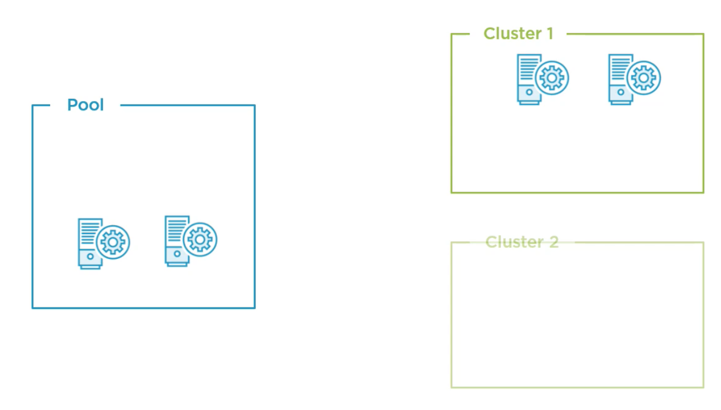

GIT INTEGRATION

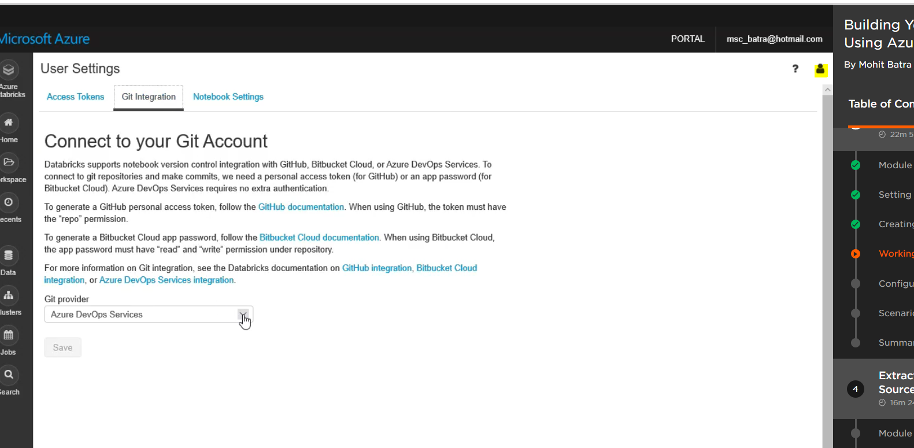

ADD USERS TO THE WORKSPACE

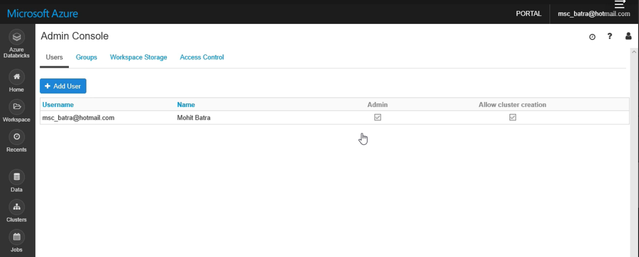

USER CLUSTER CREATION

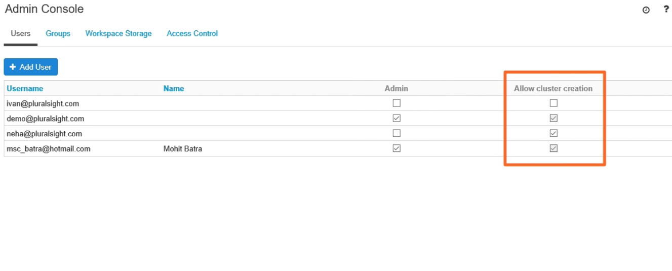

PERMISSIONS AT FOLDER LEVEL

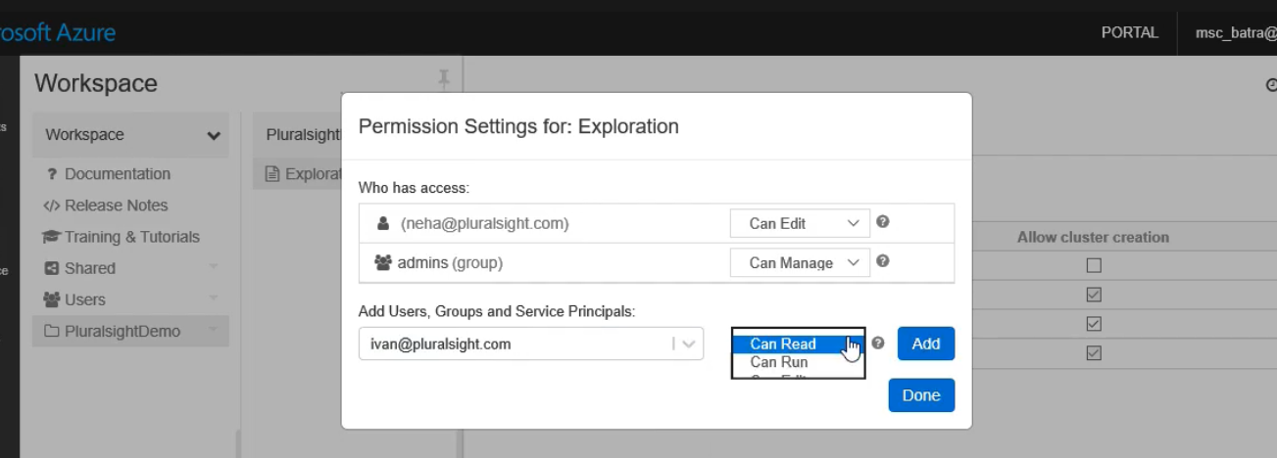

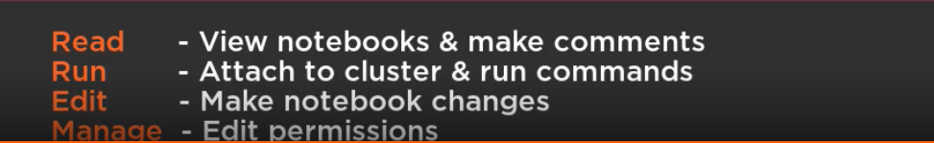

MOUNTING

Mounting to databricks

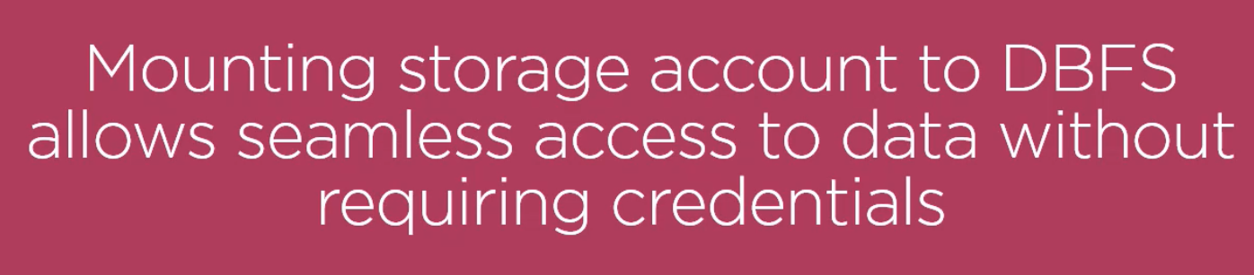

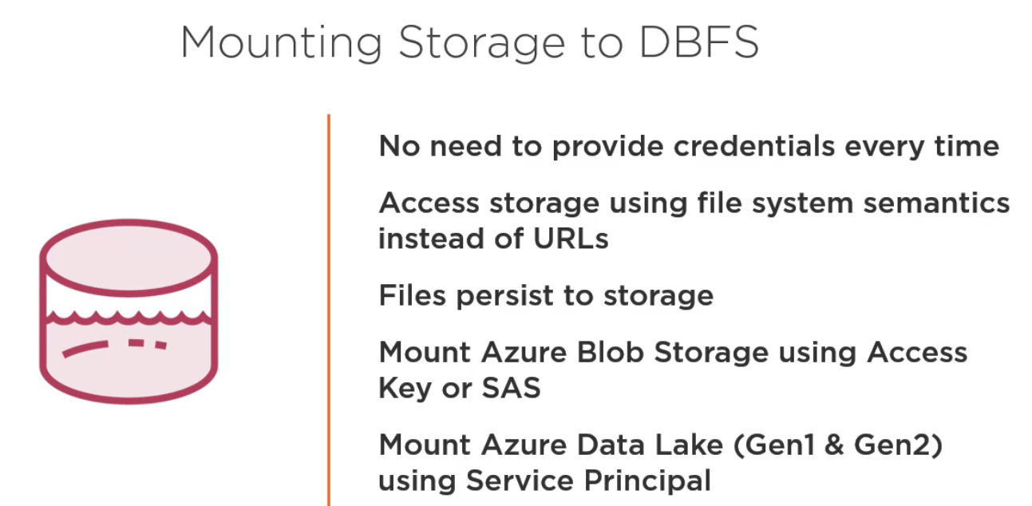

AZURE SERVICE PRINCIPAL

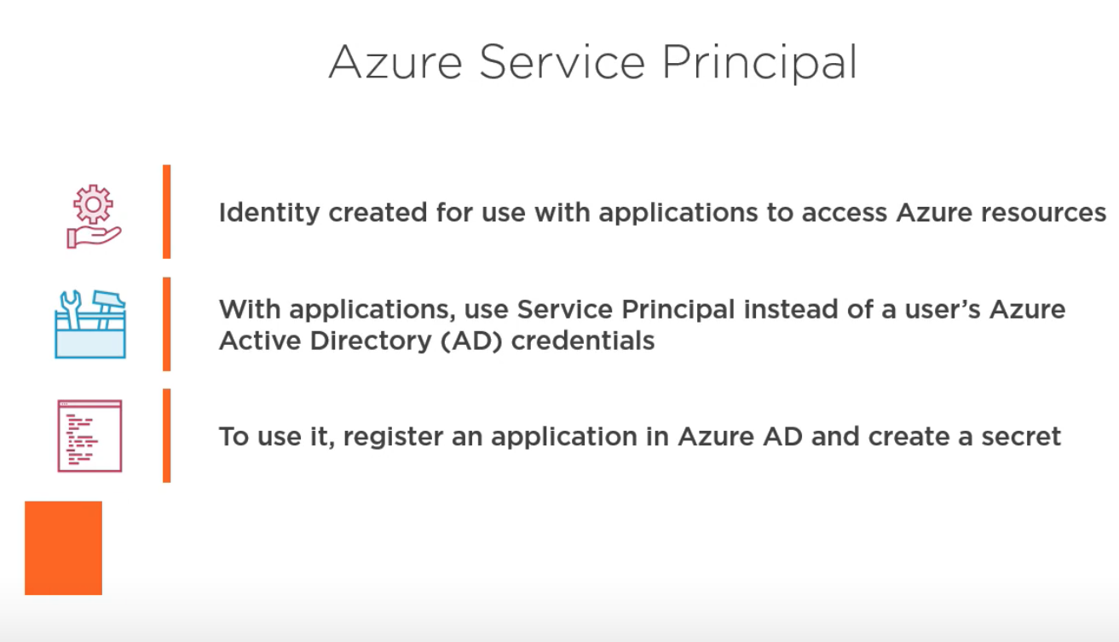

AZURE SERVIVCE PRINCIPAL

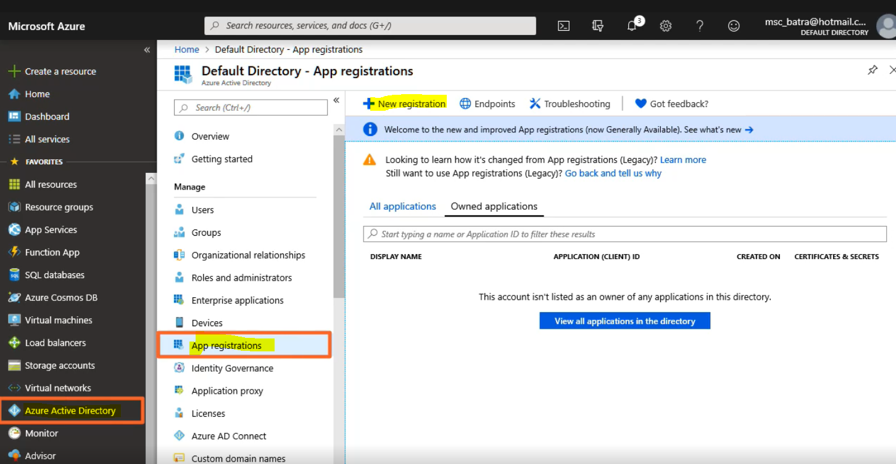

Appplication id and directory is created

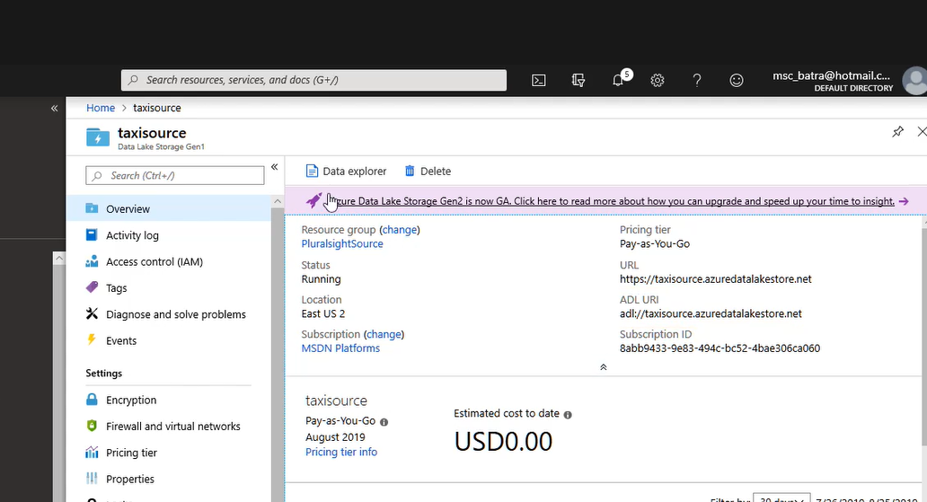

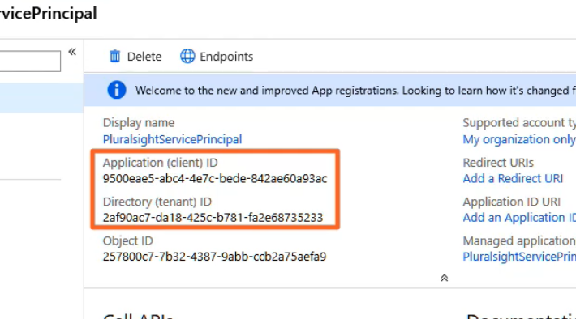

ASSIGN PERMISSIONS