1.Run the vm and open localhost with port for zepplin

2.Select interpretor ->

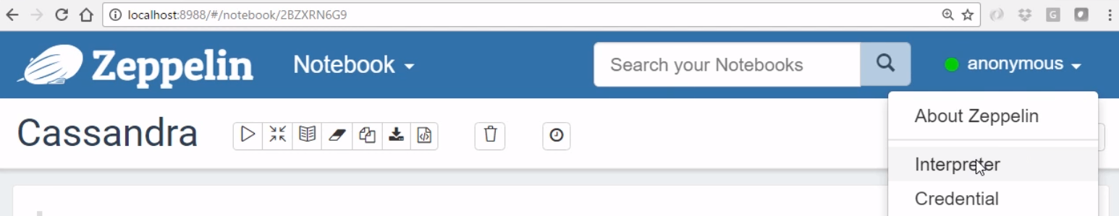

3. Here we would see the Cassandra interpreter

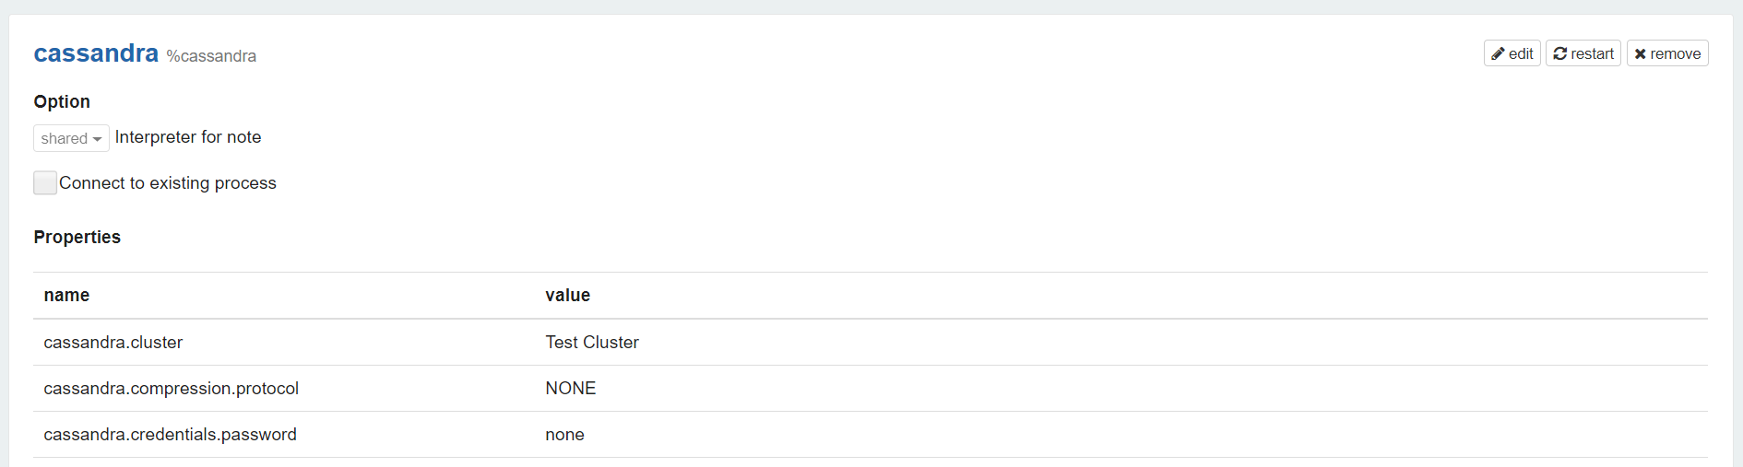



4. Set dependencies for spark

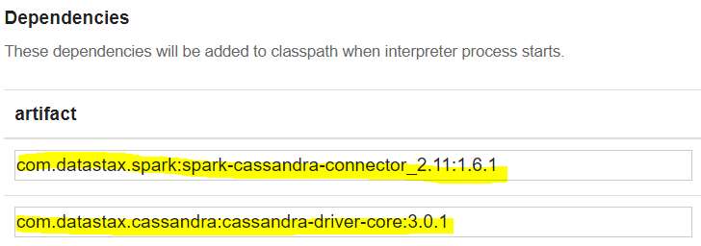

5.Look for keyspaces

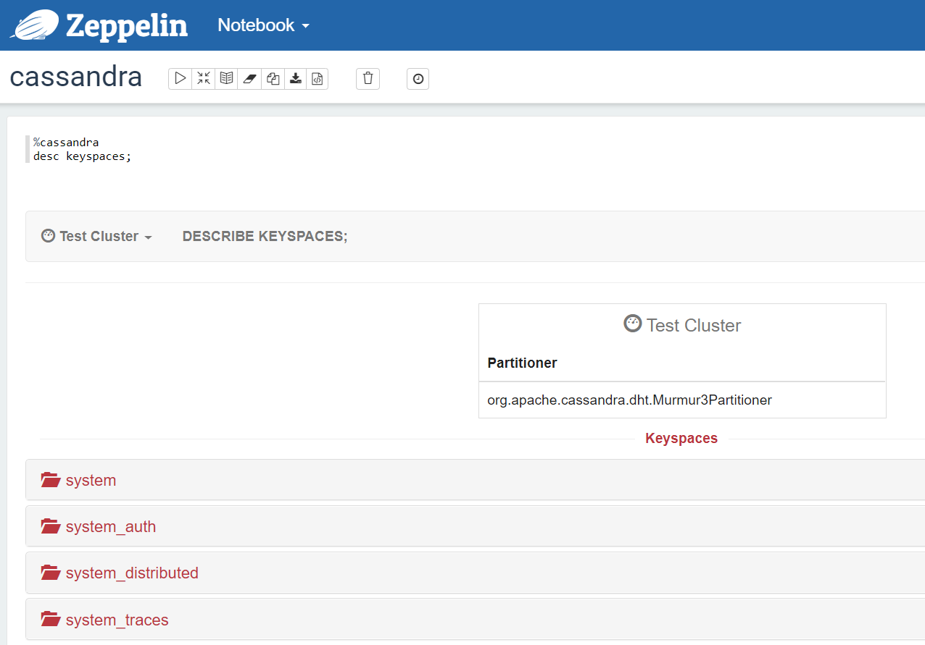

6.Create keyspace

