Installing and running **LaMa (Large Mask Inpainting)** on your GPU-enabled laptop involves the following steps:

**Step 1: Install Dependencies**

Before you begin, ensure that your system has the required dependencies.

**1.1 Install CUDA & cuDNN (For NVIDIA GPUs)**

* Check your GPU:
* nvidia-smi
* Install [CUDA Toolkit](https://developer.nvidia.com/cuda-toolkit) & [cuDNN](https://developer.nvidia.com/cudnn) if not already installed.

**1.2 Install Python & Git**

* Ensure Python 3.8+ is installed:
* python --version
* If missing, install it via:
* sudo apt update && sudo apt install python3 python3-pip git -y

**Step 2: Clone the LaMa Repository**

git clone https://github.com/saic-mdal/lama.git

cd lama

**Step 3: Set Up a Virtual Environment**

Create and activate a virtual environment to avoid conflicts:

python3 -m venv venv

source venv/bin/activate # On Windows use `venv\Scripts\activate`

**Step 4: Install Required Python Packages**

pip install --upgrade pip

pip install -r requirements.txt

**Step 5: Install PyTorch with CUDA and dependencies**

To enable GPU acceleration, install PyTorch with CUDA:

pip install torch torchvision torchaudio --index-url https://download.pytorch.org/whl/cu118

(Ensure you choose the right CUDA version for your system from [PyTorch's website](https://pytorch.org/get-started/locally/).)

**Run this command in wsl**

sudo apt update && sudo apt upgrade -y

sudo apt install build-essential python3-dev python3-pip python3-venv -y

sudo apt install cython libopenblas-dev liblapack-dev gfortran -y

sudo apt install python3-wheel python3-setuptools -y

pip install --upgrade pip setuptools wheel

pip install --upgrade cython

sudo apt install python3-distutils python3-setuptools -y

sudo apt install python3.10-venv python3.10-distutils -y

pip install --upgrade pip setuptools wheel

pip install --upgrade numpy

pip install --no-cache-dir scikit-image

**Step 5 : Install lama**

Register with meta

<https://www.llama.com/llama-downloads/>

**Step 6 : Install lama cli**

pip install llama-stack

pip install llama-stack -U

**Step 6 : Find Model list**

llama model list

**Select model**

llama model download --source meta --model-id meta-llama/Llama-3.3-70B-Instruct

Note : we have to paste the custom url

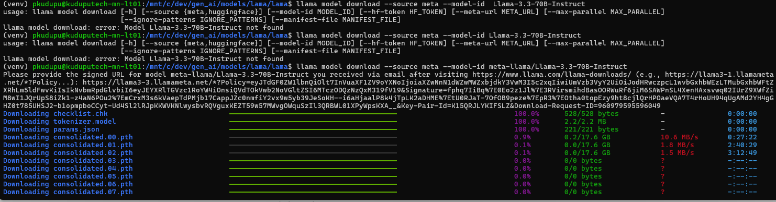

**AFTER INSTALLATION**

INSTALL PYTORCH

pip install torch torchvision torchaudio --index-url <https://download.pytorch.org/whl/cu118>

**UNINSTALL LARGE MODEL**

rm -rf ~/.cache/huggingface/transformers/llama-3.3-70b-instruct

**USING LOWER MODEL FOR**

lscpu

Memory

free -h

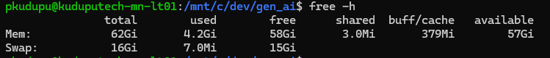

Storage

df -h

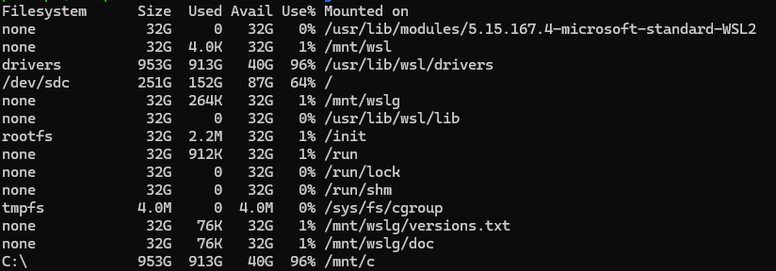

Gpu info

Nvidia-smi

**GPU Specifications my laptop**

* **GPU Name:** Quadro RTX 5000 with Max-Q Design
* **Driver Version:** 538.78
* **CUDA Version:** 12.2
* **Total Memory:** 16384MiB (16 GB)

**INSTALL DATASET ACCELERATOR**

pip install datasets accelerator

**LOAD LIBRARIES AND CHECK GPU IF AVAILABLE**

**LOAD THE MODULE**

**PREPARE TEAM DATASET**

**CONVERT SATA INTO A HUGGING FACE DATASET**

**TOKENIZE THE DATASET**

Convert text into numeric

**SPLIT THE DATASET**

Split the dataset into train and test

**DEFINE TRAINING**

**DEFINE THE TRAINER**

**FINE TUNE MODEL**

**EVALUATE THE MODEL**

**FINE TUNE THE MODEL**

**//////////////////////////////////////////////////////////////////////////////////////**

**EVALUATE YOUR MODEL**

**/////////////////////////////////////////////////////////////////////////////////////**

**PROMPT**

INITIAL RESPONSE FROM THE MODEL IS HALISUNATING

GPU being used

