**WINDOW**

* + Create new Dstream computed by applying window parameters to the old stream.
  + For example, you want to POST all the active users from the last five seconds to a web service, but you want to update the results every second.
  + These operations describe two parameters – windowLength and slideInterval.
  + REDUCE LAST 30 SECONDS OF DATA FOR EVERY 10 SECONDS
    - val windowedWordCounts = pairs.reduceByKeyAndWindow((a:Int,b:Int) => (a + b), Seconds(30), Seconds(10))

**TRANSFORM (func)**

* + Allows to drop down to RDD and operate against the rdd api
  + Higher order fuction like map
  + We can transform to an RDD of any other type

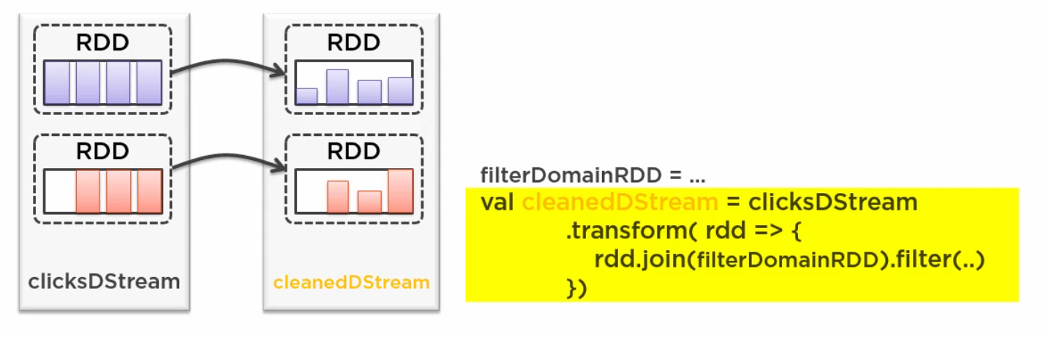

**FOR EACH RDD**

* + Similar to transform
  + Function returns a unit(void)

USE CASE

saving data to Cassandra

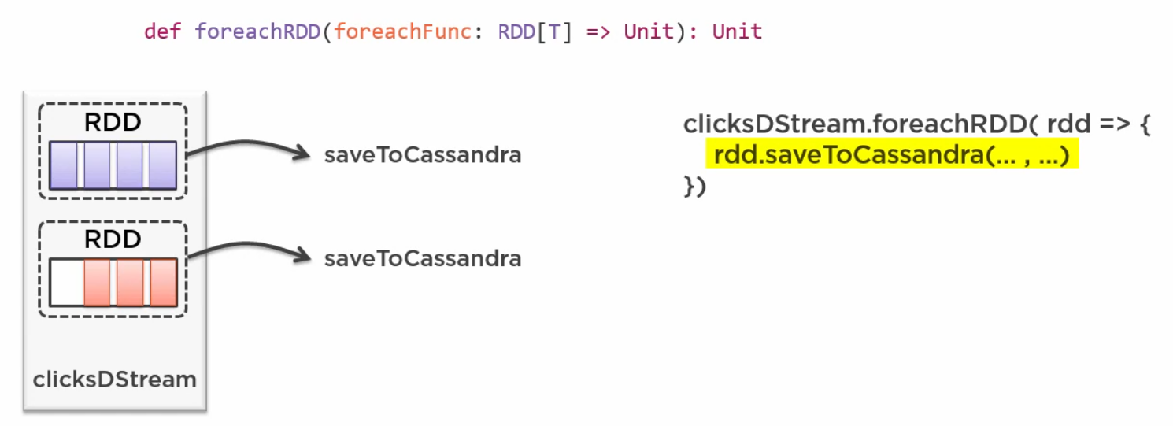

**SPARK RECIEVER MODEL**

* + Object that consumes a task and is responsible for receiving data from and storing it in spark memory for processing
  + Occupies a task for itself essentially eating up cpu core
  + If the data is more, we would want to free that memory for another task

TYPICAL ALLOCATION OF CORES

1 for receiver

1 for driver

1 for task processing

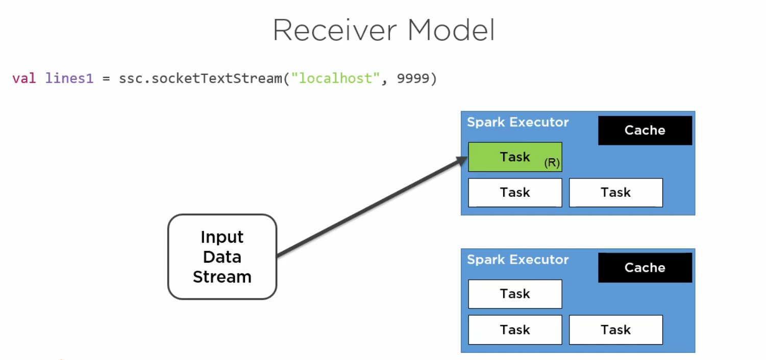

Note:

1. We can increase the parallelism by increasing the receiver inputs

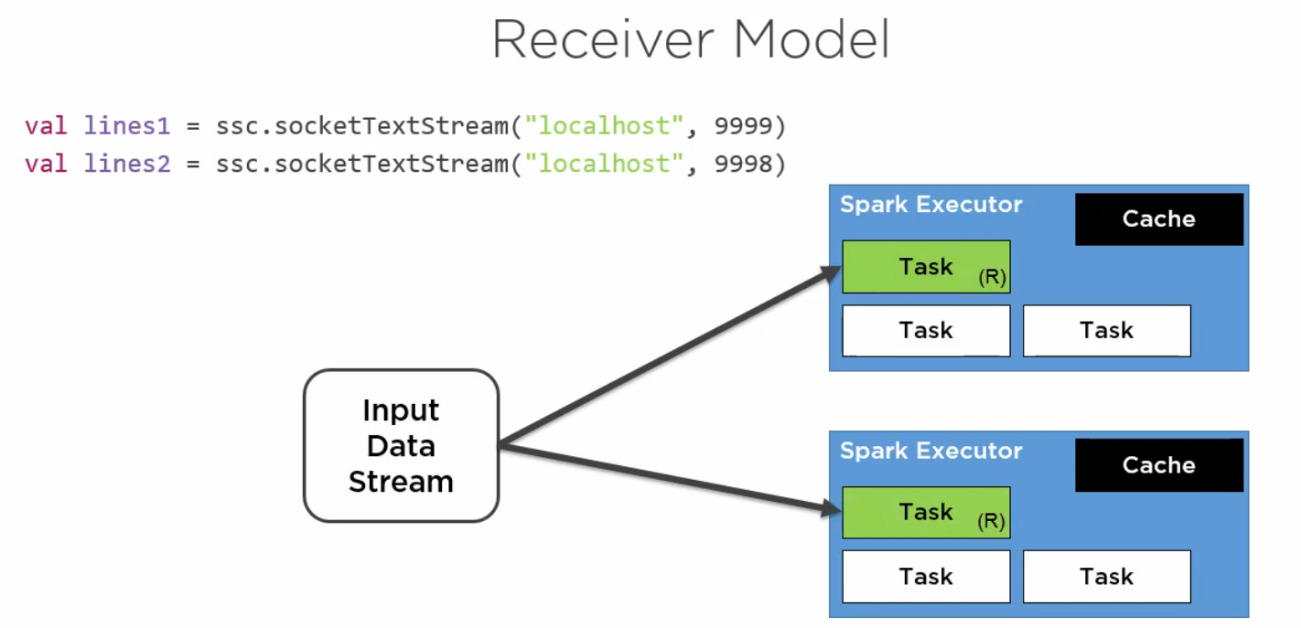

1. We can combine the results of the 2 receivers using union

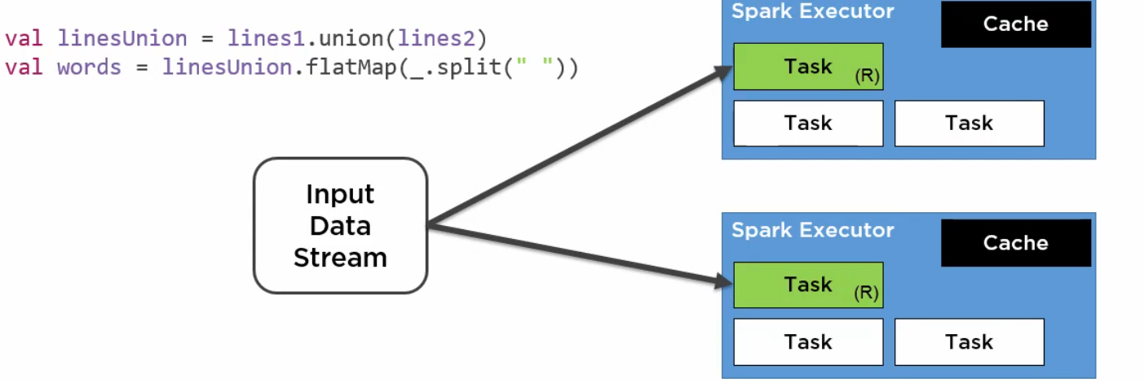

**CHECKPOINTING**

Can be used in normal spark applications

Required in streaming applications

**TWO TYPES OF CHECKPOINTING**

1)METADATA CHECKPOINTING (Driver recovery)

Configuration

Dstream operations

Incomplete batches

Note: Driver failures causes losing executors

2) DATA CHECKPOINTING (Stateful Transformation)

Stateful transformations using data across batches

