**KAFKA STREAMS**

1. Specify the necessary libraries in build.gradle file

compile group: 'org.apache.kafka', name: 'kafka-clients', version: '0.8.2.1'  
compile 'org.apache.kafka:kafka_2.11:0.8.2.1'

1. Import the necessary libraries
2. import org.apache.kafka.clients.producer.{KafkaProducer, Producer, ProducerConfig, ProducerRecord}
3. Create new log producer class
   1. It would have a single instance which would run on localhost in the vm which we have up and running or run zookeeper kafka brokers locally as shown below

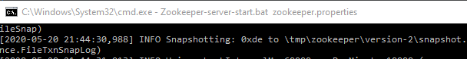

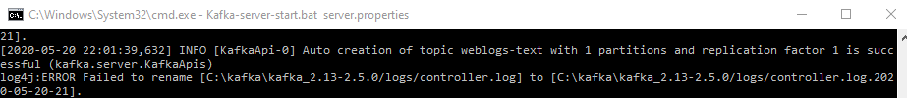

* 1. Specify which topic we want to send data to

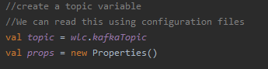

* 1. Create a new instance of kafka producer .It would have set of properties including brokers address,key serializers, acks_config and client_id_config

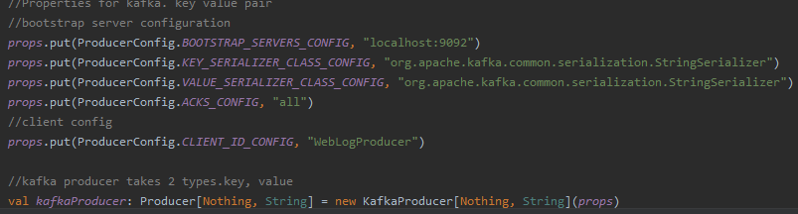

* 1. New instance of sting would be sent to kafka



1. Run the kafklogproducer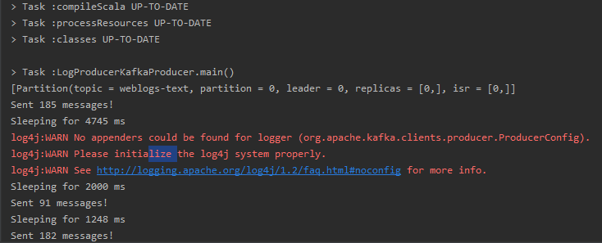
2. After running the kafka producer we can see that kafka producer has been created.

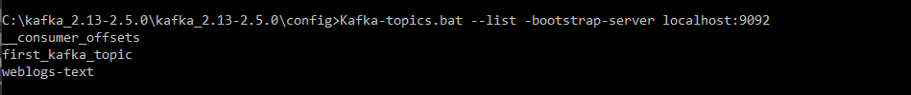

**KAFKA INTEGRATION**

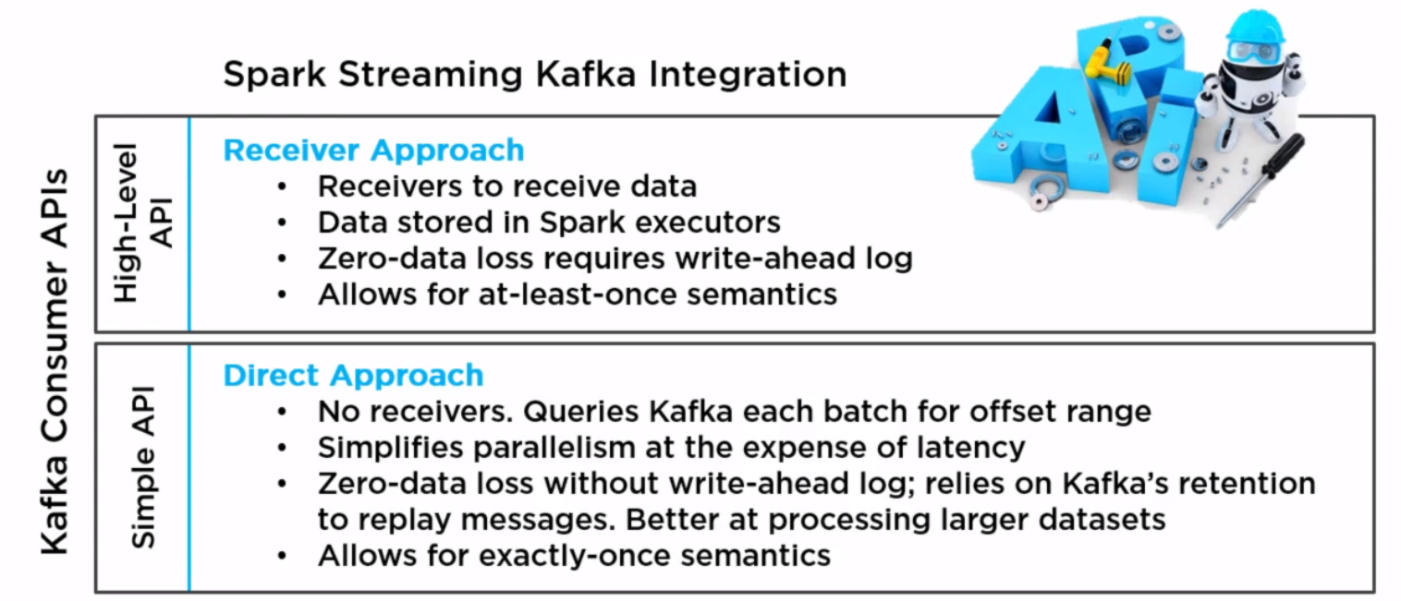

**KAFKA INTEGRATION WITH RECIEVERS**

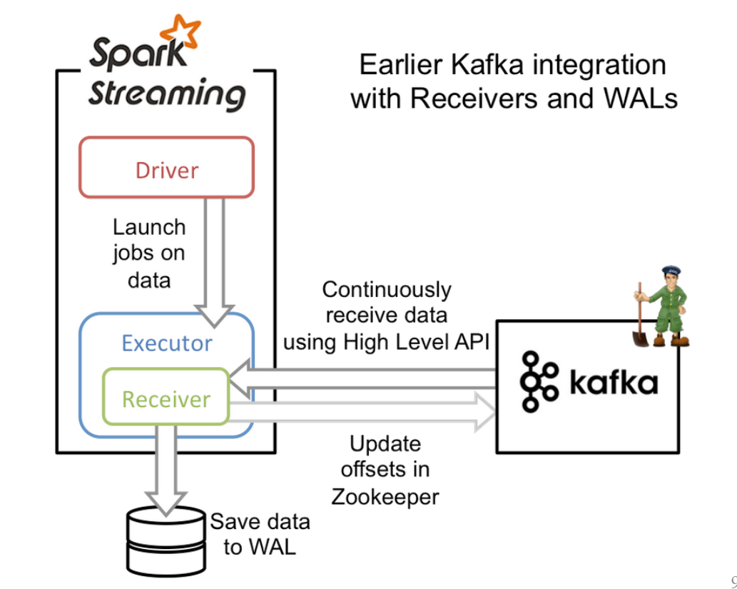

**Pro:**

* WAL design could work with non-Kafka data sources

**Con:**

* Long running receivers make parallelism awkward and costly
* Duplication of write operations
* Dependent on HDFS
* Must use idempotence for exactly-once
* No access to offsets, can't use transactional approach

Note:

1)We can increase the level of parallelism by increasing the no of receivers. We do that by using range collections, map over every item and create a stream

2) result would be sequence of RecieverInput stream

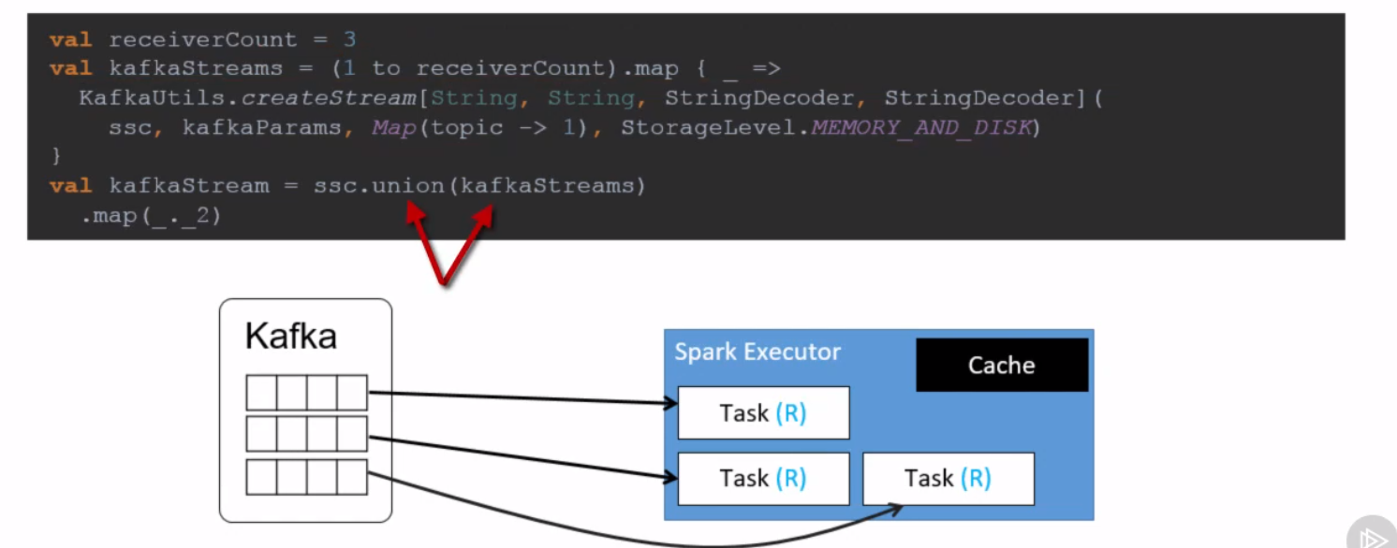

**KAFKA INTEGRATION WITHOUT USING RECIEVERS**

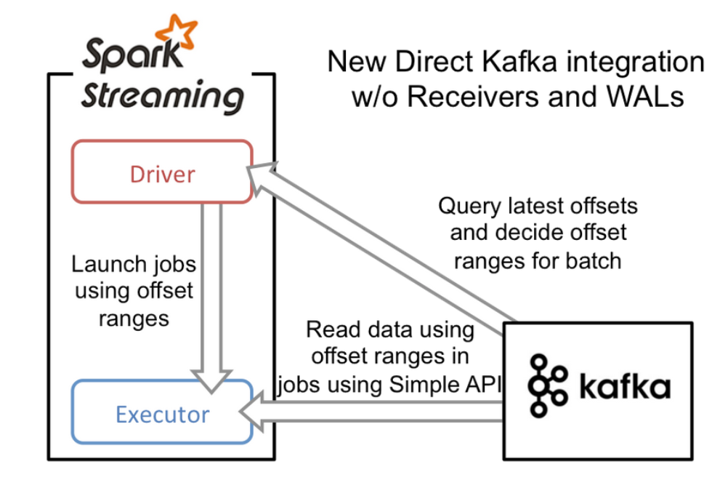

* Relies on spark checkpoint to save the offsets
* Does not rely on zookeeper

**Pro:**

* Spark partition 1:1 Kafka topic/partition, easy cheap parallelism
* No duplicate writes
* No dependency on HDFS
* Access to offsets, can use idempotent or transactional

**Con:**

* Specific to Kafka
* Need adequate Kafka retention (OffsetOutOfRange is your fault)
* Do not get option to control the parallelism. If kafka topic has 20 partitions (Not a high-volume topic), the driver ends up having to schedule and eventually consume 20 tasks on the executors

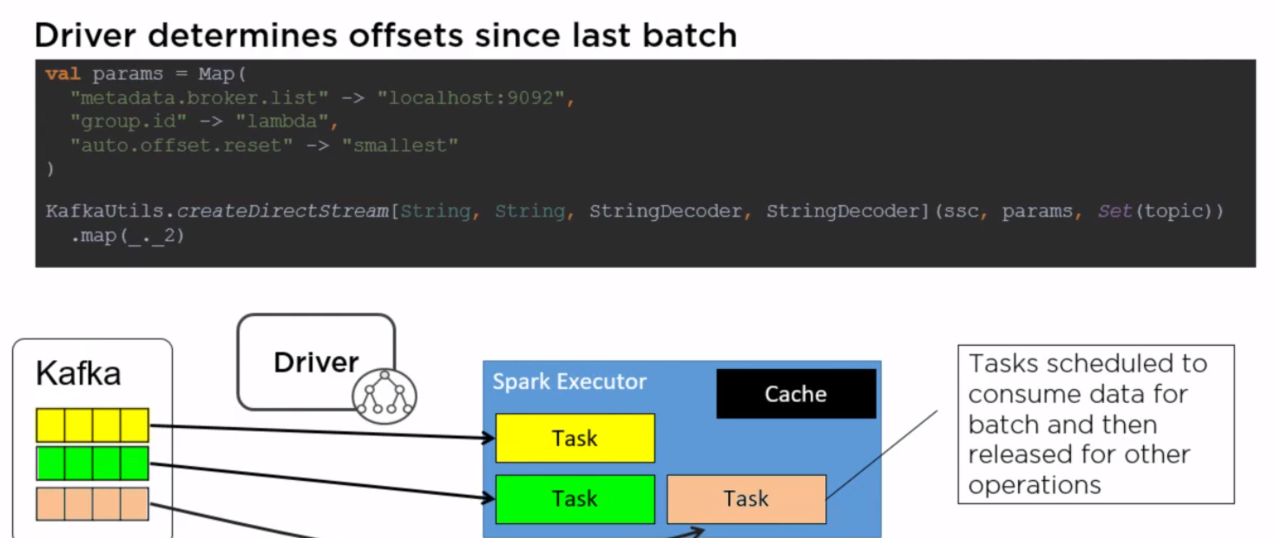

**KAFKA LOGS**

Kafka stores all messages in logs in their respective nodes at the location specified in log.dir. We should remove all these messages for a topic from all nodes



Note: we can manually delete files from this folder

**KAFKA RETENTION HOURS**

* Policy can bet set to delete segments after a period, or after given size has accumulated.
* A segment would be deleted whenever *either* of these criteria are met.
* Deletion always happens from the end of the log.

Note: These settings can be configured in server.properties file

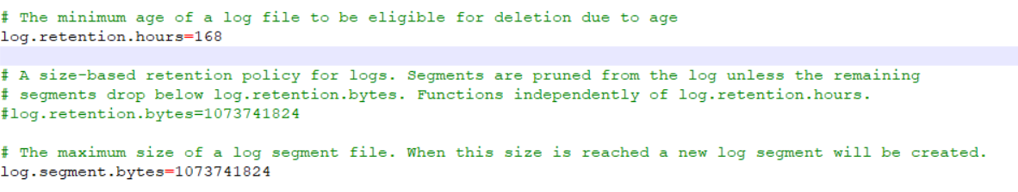

1. Run local instance of zookeeper and brokers
2. Kafkastreamingjob to insert data into topic

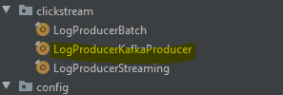

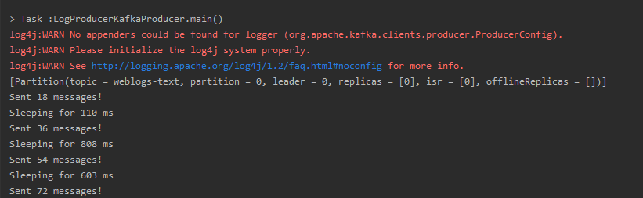

1. Run the spark streaming job which reads stream from kafka topic

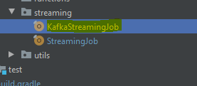

Note: We need to run both kafka producer and spark streaming together

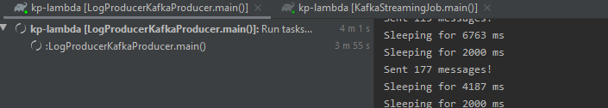

output

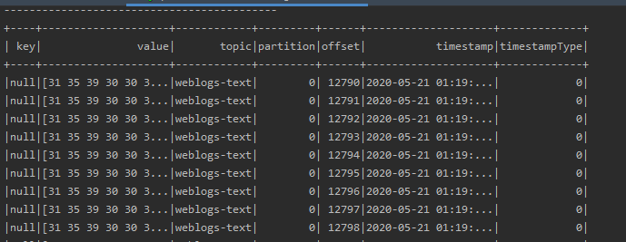

Output after filtering only values from the message topic

