1. Install Kubectl using choclotey

**choco install kubernetes-cli**

* Test to ensure the version you installed is up-to-date:
  + - kubectl version --client
* Navigate to your home directory:
  + - cd %USERPROFILE%
* Create the .kube directory:
  + - mkdir .kube
* Change to the .kube directory you just created:
  + - cd .kube

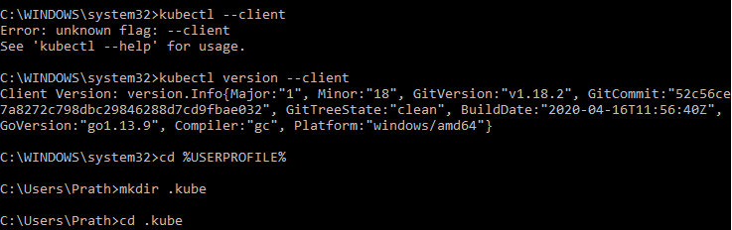

1. install minikube

**choco install minikube**

check if minikube has been installed.

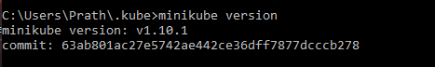

Note: Above step did not work. So followed 3rd and 4th step

1. Download latest version of minikube.exe and kubectl ex from

<https://github.com/kubernetes/minikube/releases>

Create a folder kube

Rename exe to minikube

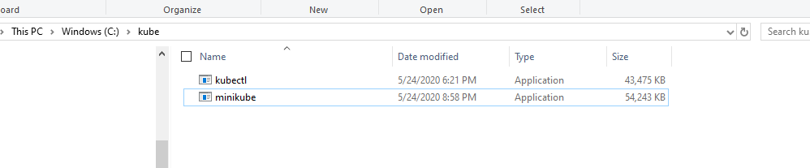

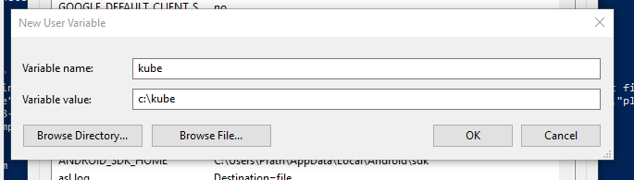

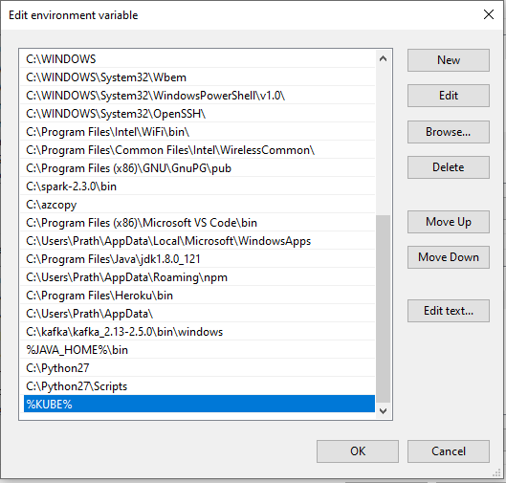

1. Run

**minikube start**

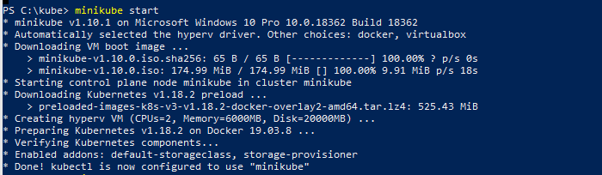

start minicube

.\minikube.exe start --kubernetes-version="v1.10.1" --vm-driver="hyperv" --memory=1024 --hyperv-virtual-switch="Minikube" --v=7 –alsologtostderr

5)verify if minikube and virtualbox are talking to each other

**Kubectl get nodes**



1. Run hello world application

kubectl run hw --image=karthequian/helloworld --port=80

pod/hw created

check for the running pods

kubectl get pods

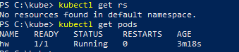

1. Expose it as service (nodeport)

Note: Failed to create services

kubectl apply -f https://k8s.io/examples/service/load-balancer-example.yaml

The preceding command creates a [Deployment](https://kubernetes.io/docs/concepts/workloads/controllers/deployment/) object and an associated [ReplicaSet](https://kubernetes.io/docs/concepts/workloads/controllers/replicaset/) object. The ReplicaSet has five [Pods](https://kubernetes.io/docs/concepts/workloads/pods/pod/), each of which runs the Hello World application.

1. Display information about the Deployment:

kubectl get deployments hello-world

kubectl describe deployments hello-world

1. Display information about your ReplicaSet objects:

kubectl get replicasets

kubectl describe replicasets

1. Create a Service object that exposes the deployment:

kubectl expose deployment hello-world --type=LoadBalancer --name=my-service

1. Display information about the Service:

kubectl get services my-service

The output is similar to this:

NAME TYPE CLUSTER-IP EXTERNAL-IP PORT(S) AGE

my-service LoadBalancer 10.3.245.137 104.198.205.71 8080/TCP 54s

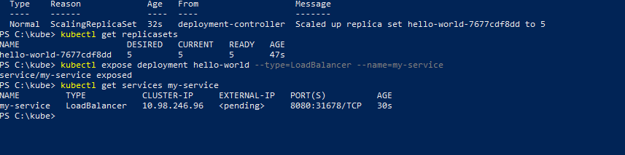

5.Run the service

Minicube service my-service

