**LABELS**

**1.**Labels are defined in helloworld-pod-with-labels file

This is a simple pod which has env:production

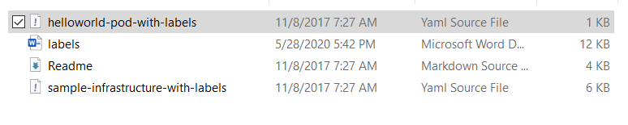

2. CREATE THE POD

**kubectl create -f helloworld-pod-with-labels.yml**



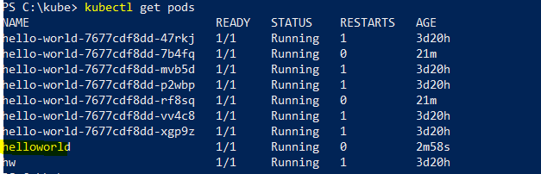

**3.** SEE THE LABELS

**kubectl get pods --show-labels**

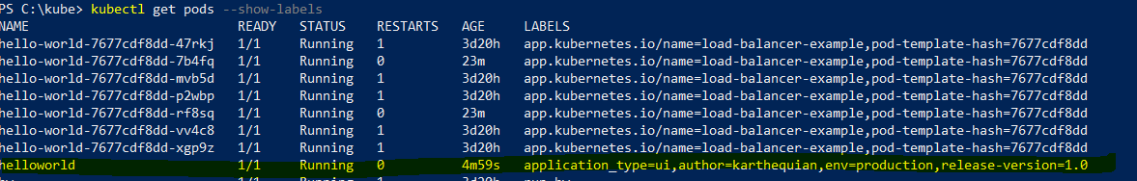

4. TAG A POD AFTER IT IS DEPLOYED

**kubectl label po/helloworld app=helloworldapp –overwrite**

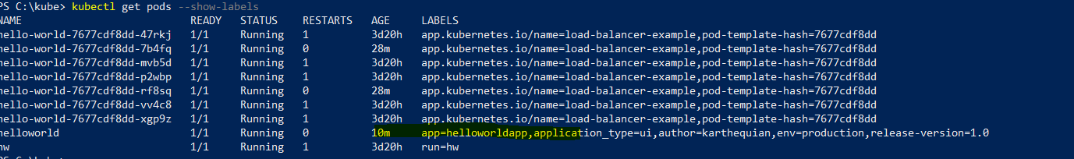

**5**.DELETE THE TAGGED LABEL

**kubectl label pod/helloworld app-**

